Creating Payor Programs for Clients:
Co-Payment

Contents
What are payor programs? 2
Co-Payment 3
How do I create a co-payment payor program for a client? 3
Adding the payor program to client services and billing premiums 12
Appendix A: glossary of terms 14

What are payor programs?

Payor programs allow you to configure a program at the client level to create a series of rules for determining which payors are invoiced for what portion of the billable items in a billing period.
Every payor program for a client contains a set of informational fields and benefit rules referred to as a policy or contract, depending on the type. The benefit rules for a policy or contract can consist of either a term or the combination of a term and a limit.
A term represents the base rule for determining how much of a service’s cost should be billed to the payor. You can define a term as a fixed amount or, in certain program types, as a percentage. If amount is selected as the term type, you are also required to select a term frequency to determine how the amount will be split and invoiced to the different bill-to parties.
A limit is a rule that imposes a cap on the term amount based on a set frequency. The possible limit types are amount, hours, or number of visits, all of which must be combined with a limit frequency.
You can create different versions of the benefit rules on a policy or contract with different effective dates. The effective dates of different policy/contract versions cannot overlap with one another.
The payor on the policy or contract is the bill-to party who will be invoiced for a portion of the billable items dictated by the rule set on the policy/contract. The guarantor is the bill-to party who will be invoiced for the remainder of the invoice balances after the program rules have been applied to the billable items.
Once you have created your payor program, you must attach it to any client services or billing premiums for which the rules on the program should apply. When adding a program to a service or client billing premium, you will select a rating funder. This rating funder will use the associated bill codes to determine the rates that will be used to bill for the service or premium during the invoice generation process.
Once items are approved and you begin the invoice generation process, the system will apply the rules on the payor program using the rates associated with the rating funder and generate the invoices for the different bill-to parties.
There are different types of payor programs. The type determines the kinds of rules you can set to determine how to split an invoice during the billing process. The type that you select for a payor program will dictate which rule fields and informational fields will be available for completion when adding a policy or contract to a client’s profile.

Co-Payment

Co-payment is a type of payor program that is used when there is an agreement that a client will share the cost of care with another provider. Co-payment works well in many split billing scenarios where government funding or another type of coverage will cover up to a certain amount of the client’s care, and the client/guarantor is responsible for the rest of the cost.
In co-payment, the set of rules added to a program is referred to as a contract. Only one contract can be added to a program (in other words, sequencing multiple contracts so that different rule sets are all in effect at one time is not possible). However, you can still create different versions of the contract rules with different effective dates.
The funder type of the guarantor can be client individual or funder individual for co-payment programs.

How do I create a co-payment payor program for a client?

Payor programs are set up at the client level.
You must be in a role configured with the View Payor Program and Manage Payor Program ACLs in Settings>Roles and Permissions to view, add, and edit payor programs for clients.
To add a new program, go to Accounting>Payor Invoicing on the client’s profile and select +Add Program.
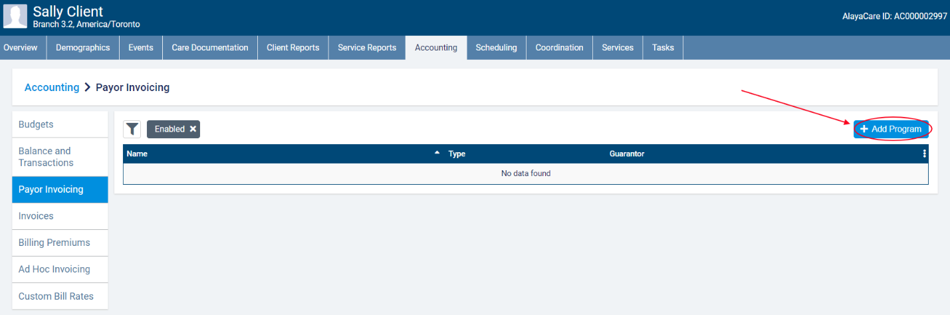
In the Add Payor Program dialogue, enter the Name of the Payor Program and select Co-Payment as the Type.
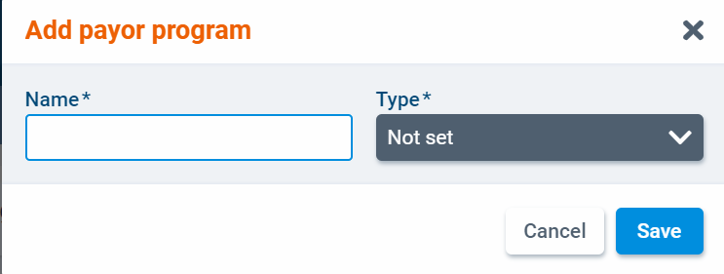
Select a funder to serve as the guarantor.
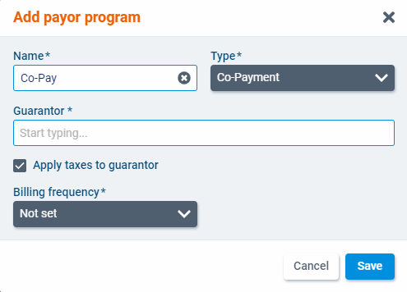
If you select a guarantor of type client individual, you will also need to choose a billing contact.
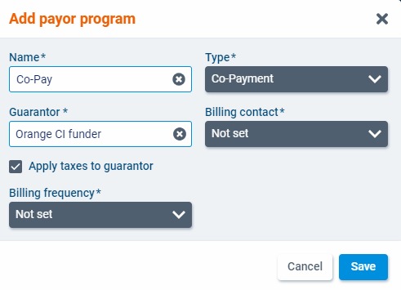
Check the box next to Apply taxes to guarantor if applicable. This setting will determine if taxes set at the bill code level should be applied to items billed to the guarantor.
Finally, select a billing frequency for the program. In payor invoicing, the billing periods are determined by the billing frequency. The available frequencies are 1 Week, 2 Weeks, 4 Weeks, and Calendar Month. When you have finished, click Save.
The program will open as a new screen. Select Edit to make changes to the program details.
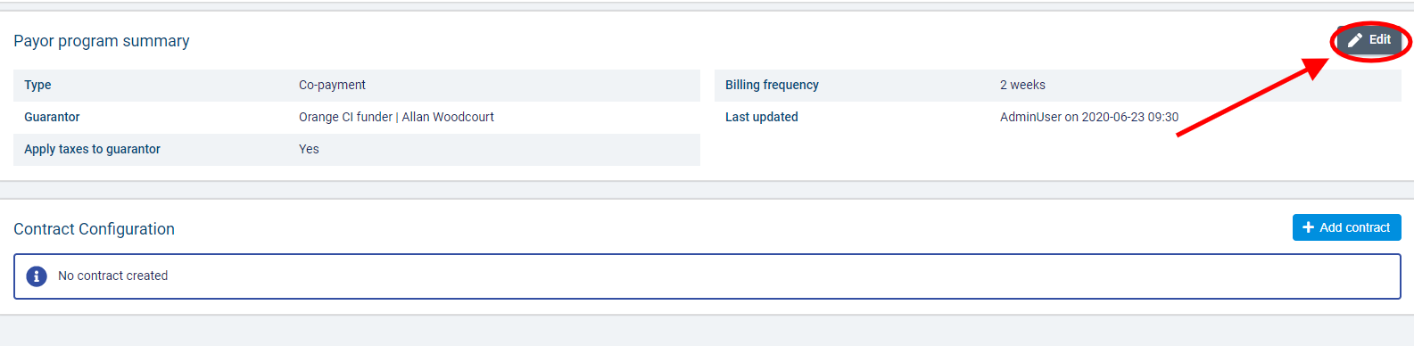
Once you have created a program, you can a contract. The contract specifies the benefit rules that will be used to determine how billable items linked to the program are invoiced. To add a contract to the program, select +Add contract.
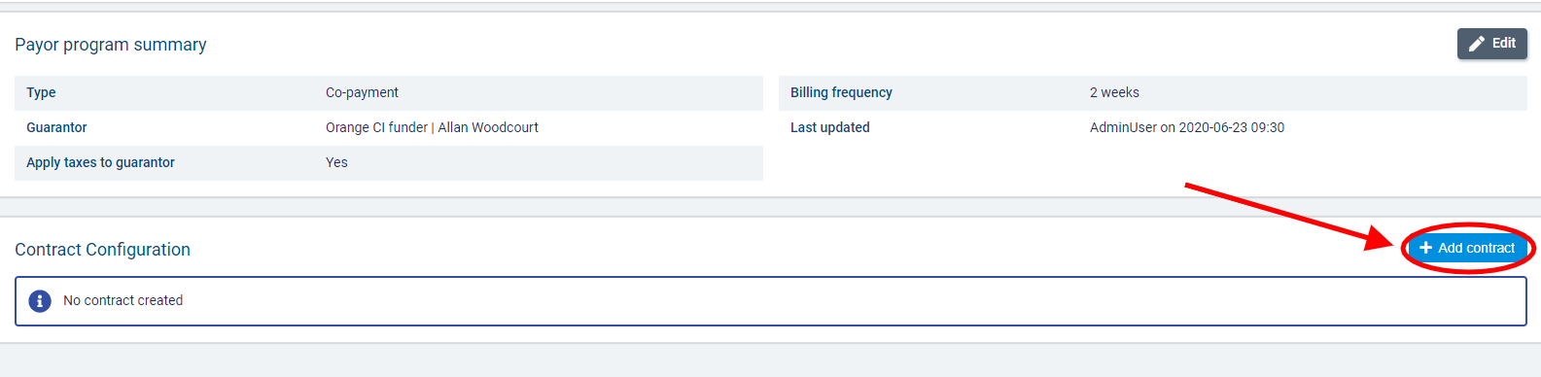
In the Add Contract dialogue, complete the required fields.
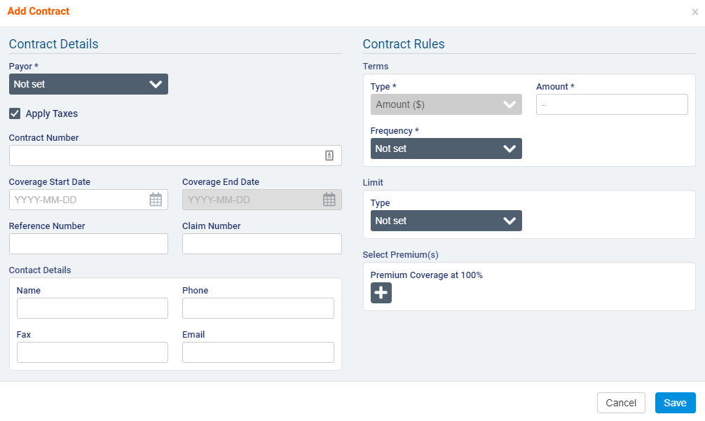
Under Contract Details, select a funder to represent the Payor. You can select any enabled funder individual or client individual funders available to the branch that the client belongs to. If necessary, enter the Contract Number, Coverage Start and End Date, Reference Number, and Claim Number and fill out the Contact Details section.
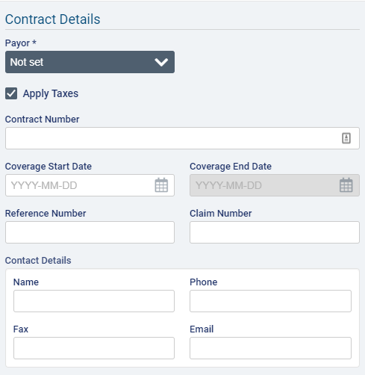
Use the Apply Taxes checkbox if you wish to apply taxes set at the bill code level to items covered by this contract.
Under Contract Rules, Amount will be pre-selected as the Term Type. Select a Term Frequency and enter the Term Amount. The available frequencies are Per Hour, Per Day, Per Week, Per Calendar Month, Per Calendar Year, and Per Benefit Year.
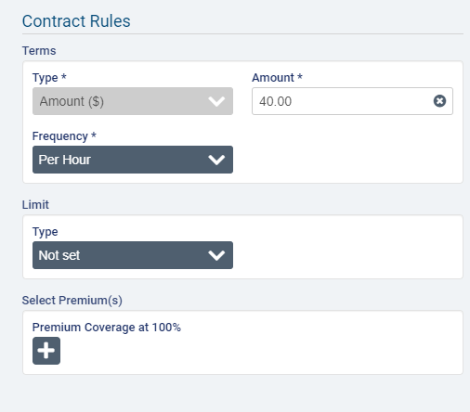
If you select Per Week as the frequency, you must also select a day for Start of Week.
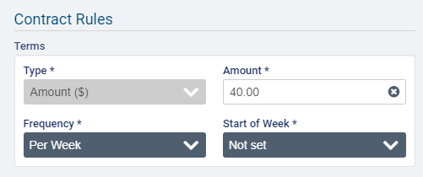
If you select Per Benefit Year as the Frequency, you must also select the Month and Day of the month on which the benefit year begins.
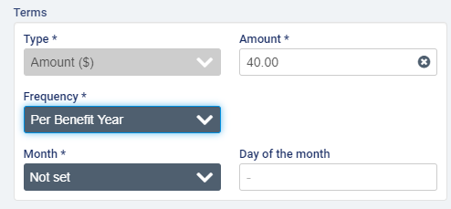
Example scenario for terms in amount: the amount specifies the maximum amount that the payor on the policy will cover for the length of time specified by the frequency. So if $400 is entered as the amount and Per Week is selected as the frequency, when generating invoices for a week in which 3 visits valued at $200 each occurred, the payor will be invoiced $400 for the first two visits and the next payor or the guarantor will be invoiced $200 for the last visit.
After adding the term details, you can also add a limit to the policy. The limit can be an amount or a number of hours or visits over a specific frequency. Per Hour is not an available frequency for limits.
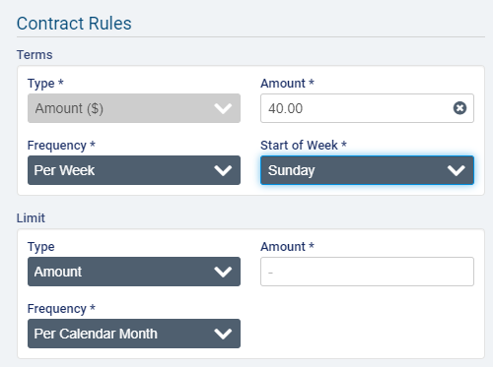
Note that when Amount is selected as the Limit Type, the Limit Frequency must always be larger than the Term Frequency (Per Day < Per Week < Per Calendar Month < Per Calendar Year/Benefit Year). If the term has the maximum frequency selected (Per Calendar Year or Per Benefit Year), then you will not be able to select Amount as the Limit Type.
Example scenario for limit in amount: The term amount is $50 per day and the limit is $100 per week, and the following visits occurred in one week (Monday visit: $120 and visit #2 cost $100). The payor will be invoiced $100 (because the total cost of both visits is over the weekly limit). The guarantor will be billed $120, the total remaining from both visits.

For Limits in Hours, the frequencies Per Day, Per Week, and Per Calendar Month will be available to select.
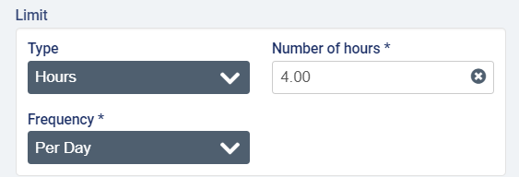
Example scenario with a limit in hours: there are two visits in one week; visit #1 lasted 3 hours and cost $150 and visit #2 lasted 2 hours and cost $100. If the term is a fixed amount of $60 per hour, and the limit is 2 hours per week, the payor will be invoiced $120 for the first visit ($60 x 2h), and the guarantor will be billed the remaining amount of $130.
For Limits in Visits, the frequencies Per Week, Per Calendar Month, Per Calendar Year, and Per Benefit Year will be available to select.
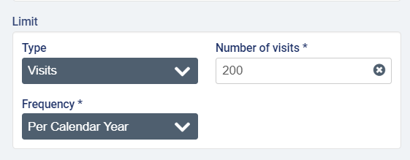
Example scenario with a limit in visits: The term is a fixed amount of $200/week and the limit is 2 visits/week, and there are two visits in one week (one on Monday charged at $120 and one on Wednesday charged at $100). The payor will be invoiced $120 for the first visit, and the guarantor will be invoiced $100 for the second visit, since the limit on the term has been reached.
If Per Week is selected as the Limit Frequency, you will also need to specify a day as the Start of Week.
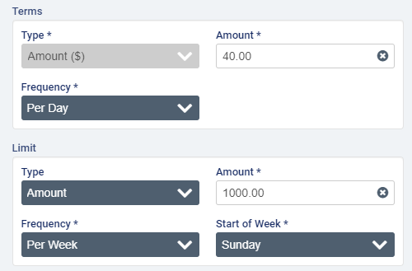
In the Select Premium(s) section, click to select one or more billing premiums configured in Accounting>Accounting Settings>Premiums that should be fully covered by the payor on the policy. Note that premiums must be 100% covered by either the payor or the guarantor (in other words, the cost of premiums cannot be split between two bill-parties if using a long-term care insurance payor program).
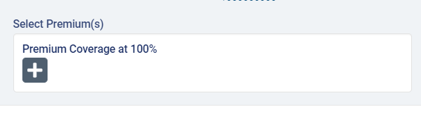
When you have completed on required fields, click Save.
The program page will open with the policy details listed under Contract Configuration. To make changes, select the Edit button.
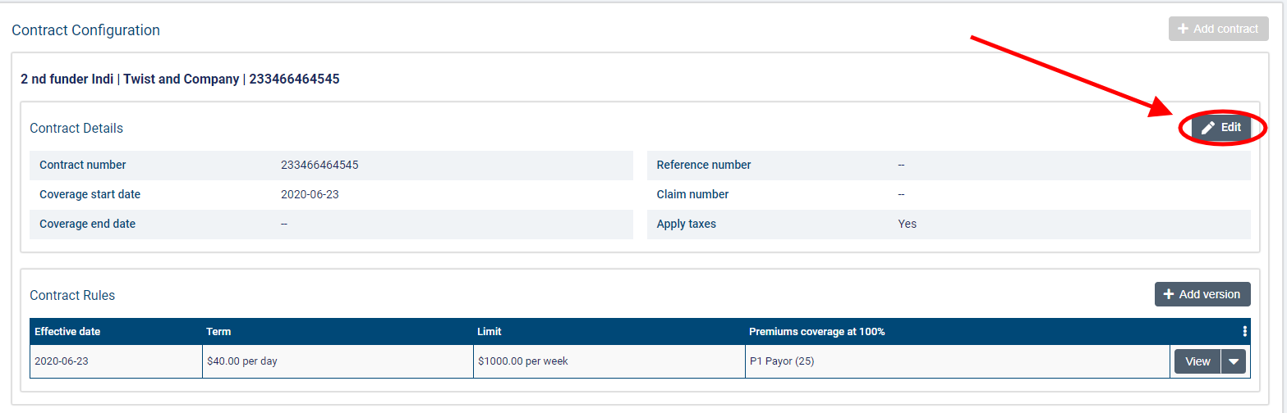
If the policy has never been used to generate invoices, you will be able to edit all the informational fields.
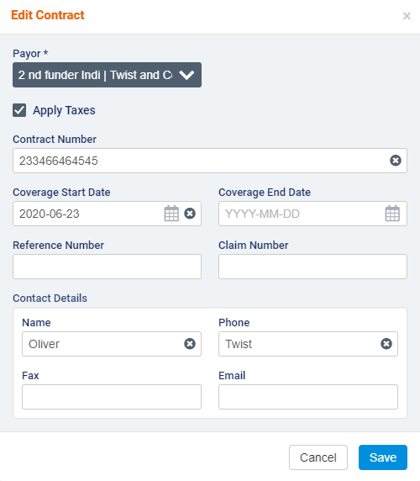
If any draft or sent invoices exist against the policy, certain fields will be disabled for editing (Payor, Contract Number, and Coverage Start Date).
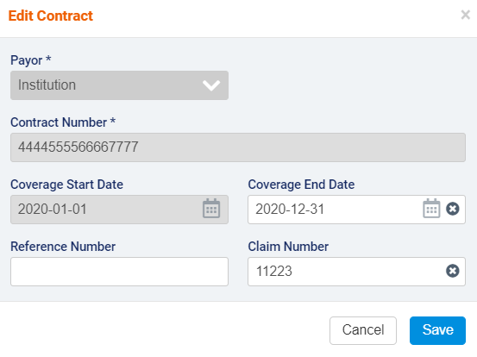

If you need to change the rules for a policy or contract, you can create a new version of the policy. Note that versions cannot have any gaps or overlaps in terms of dates.
To create a version, click the +Add Version button.
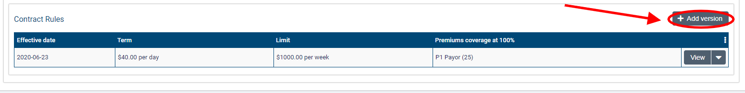
In the Add Version dialogue, enter the Effective Date on which the changes to the contract will apply. This date must be past the Coverage Start Date by at least one day. You will not be able to modify Term Type or Limit Type, but you can make changes to the Term Value, Term Frequency, Limit Value, and Limit Frequency or attach more premiums.
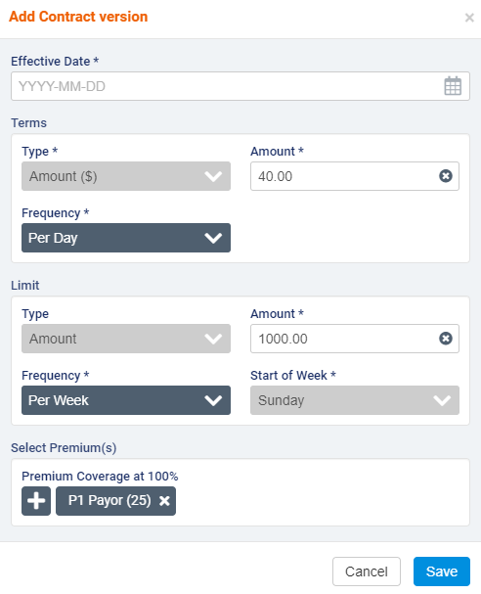
If more than one version of a contract exists, you will not be permitted to modify the Coverage Start Date. If Per Calendar Month is selected as the Term Frequency, note that the Coverage Start Date must be the first day of a month.
When you have finished, click Save to create the new version.
To edit or delete a version, select the downward arrow next to view and select Edit or Delete.
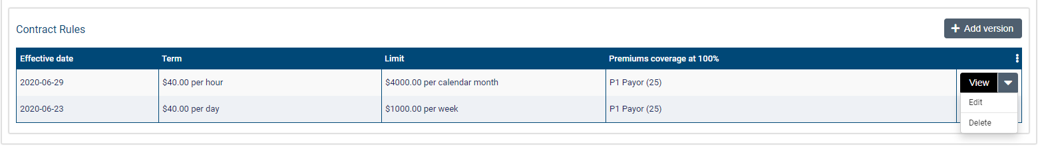
You will not be able to make changes if invoices have been generated for the version.
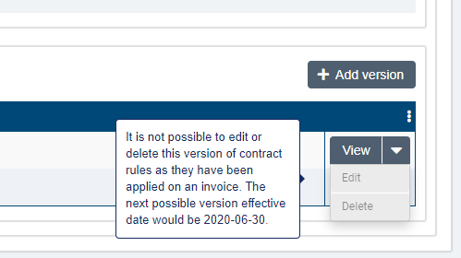
Note that having more than one version will lock the Coverage Start Date field for editing regardless of whether invoices exist against the contract.

Adding the payor program to client services and billing premiums

Once you have set up a program for a client, you can attach it to services and client billing premiums.
To add a program for a client, go to a Services list on the client’s profile and select +Create a Service.
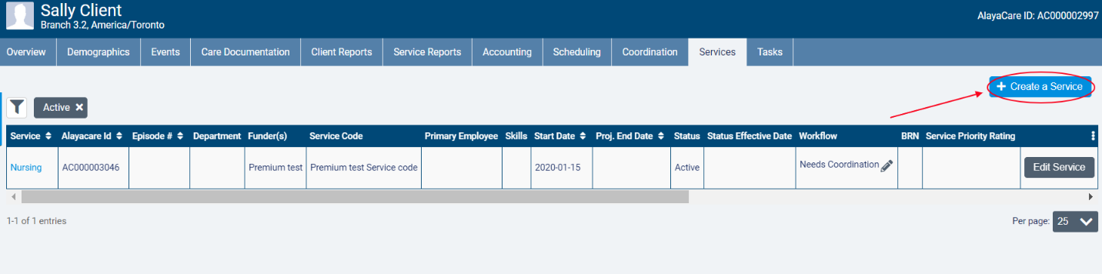
In the Funder Methodology dropdown, the different types of payor programs will be available for selection. Choose the type of the program you wish to apply. Next, select the name of the program in the Program dropdown and choose the correct Rating Funder. The funder you select here will determine which bill codes will be used to invoice billable items tied to the program.
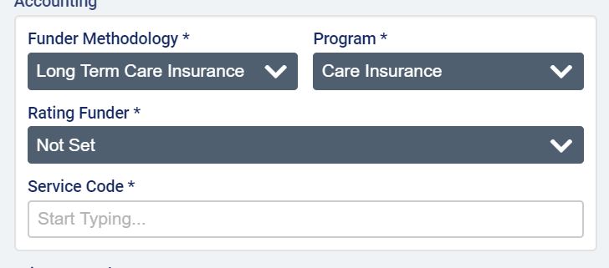
Note that the rating funder does not have to be the funder selected for either the payor or guarantor on the payor program. It is simply used to determine the rates that should be applied the billable items tied to the program.
When you have finished completing all required fields, click Create.
Note that the program on the service cannot be changed after an invoice is generated for the service.
To add a program to a client billing premium, go to Accounting>Billing Premiums on the client’s profile and select +Create Premium.
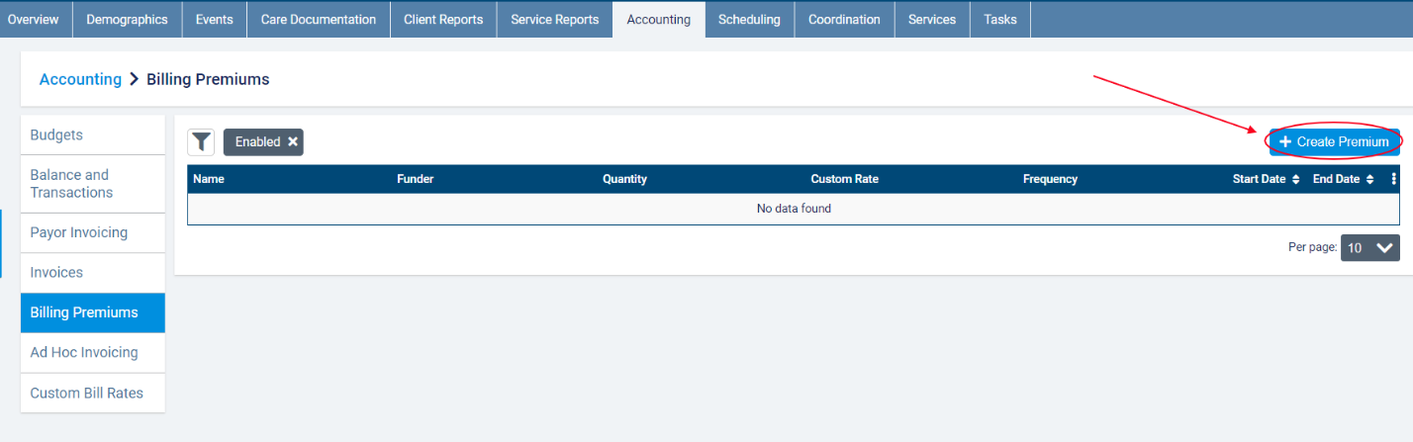
In the dialogue, select the name of the program as the Funder Methodology. After completing all required fields, click Save.
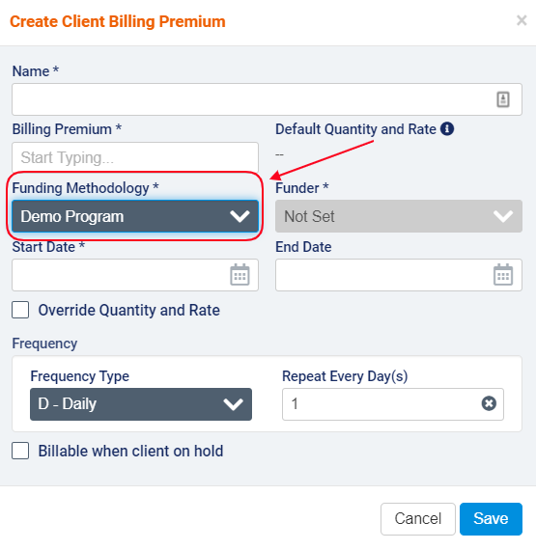
Note that the funder methodology cannot be modified on the client billing premium when there is an active invoice. A new premium will need to be created if the program no longer applies to the premium.

Appendix A: glossary of terms

- Billable item: any source item (visit, visit premium, or client billing premium) that has been approved for billing and has a rate.
- Billing periods: billing periods in payor invoicing must have a set frequency of 1 weeks, 2 weeks, 4 weeks, or per calendar month. When generating invoices for a billing period, any billable items tied to a program with that billing period frequency that have not yet been invoiced will be included. The end date serves as the cut-off date for the billing period. Start dates of billing periods cannot be modified to avoid gaps between billing periods.
- Bill-to party: the party to whom an invoice is addressed. In payor invoicing, the bill-to party will either be a payor or the guarantor.
- Contract: in co-payment, the name of the rule set that is added to a payor program.
- Co-payment: a payor program type used when there is an agreement that the client will pay for a portion of the services being covered.
- Guarantor: the bill-to party that is responsible for covering the remainder of invoice balances after the rules on any policies or contracts in effect have been applied.
- Limit: a cap on the term set on the contract/policy in amount, hours, or visits based on a set frequency.
- Long-term care insurance: a payor program type used when there is a long-term insurance policy that is activated to cover the services being provided.
- Master invoice: the master invoice contains information about all the billable items covered by a client’s payor program for a specific billing period. When viewing the master invoice screen, you will be able to see the breakdown of what will be invoiced to the payor(s) and what will be invoiced to the guarantor. Exporting invoices at the master invoice level will generate one invoice per bill-to party.
- Payor: the party that is subject to the rules defined on the program. The payor on the policy or contract will become the bill-to party that is invoiced for the amount dictated by the benefit rules on the policy/contract.
- Payor invoicing: an invoicing methodology where you create rules at the client level to determine how the cost of billable items will be split between different bill-to parties.
- Payor program: a billing configuration at the client level to which you can add rule sets (policies or contracts) to determine how a client’s services or client billing premiums will be invoiced. Once created, programs must be added to the client’s relevant services and billing premiums.
- Policy: in certain program types, the name of the rule set that is added to a payor program.
- Rating funder: a funder that is used to link bill codes and their rates to a service covered by a payor program. The rating funder will not be invoiced for any items.
- Term: the amount of a client’s services that will be covered by the payor on the policy/contract (either a fixed amount over a set frequency or, in certain program types, a percentage).

