Creating Payor Programs for Clients
Long-Term Care Insurance

Contents
￼
￼
￼
￼
￼

What are payor programs?

Payor programs are configured at the client level to create a series of rules for determining which payors are invoiced for what portion of the billable items in a billing period.
Every payor program for a client contains a set of informational fields and benefit rules referred to as a policy or contract, depending on the type. The benefit rules for a policy or contract can consist of either a term or the combination of a term and a limit.
A term represents the base rule for determining how much of a service’s cost should be billed to the payor. You can define a term as a fixed amount or, in certain program types, as a percentage. If amount is selected as the term type, you are also required to select a term frequency to determine how the amount will be split and invoiced to the different bill-to parties.
A limit is a rule that imposes a cap on the term amount based on a set frequency. The possible limit types are amount, hours, or number of visits, all of which must be combined with a limit frequency.
You can create different versions of the benefit rules on a policy or contract with different effective dates. The effective dates of different policy/contract versions cannot overlap with one another.
The payor on the policy or contract is the bill-to party who will be invoiced for a portion of the billable items dictated by the rule set on the policy/contract. The guarantor is the bill-to party who will be invoiced for the remainder of the invoice balances after the program rules have been applied to the billable items.
Once you have created your payor program, you must attach it to any client services or billing premiums for which the rules on the program should apply. When adding a program to a service or client billing premium, you will select a rating funder. This rating funder will use the associated bill codes to determine the rates that will be used to bill for the service or premium during the invoice generation process.
Once items are approved and you begin the invoice generation process, the system will apply the rules on the payor program using the rates associated with the rating funder and generate the invoices for the different bill-to parties.
There are different types of payor programs. The type determines the kinds of rules you can set to determine how to split an invoice during the billing process. The type that you select for a payor program will dictate which rule fields and informational fields will be available for completion when adding a policy or contract to a client’s profile.

Long-term care insurance

Long-term care insurance is one type of payor program. This type of program is specifically designed for situations in which a portion of a client’s care is covered by one or more long-term care insurance policies.
In long-term care insurance, the set of rules added to a program is referred to as a policy. You can add multiple policies to a single program and determine the sequence in which the policies will apply (in other words, once the rules on one policy have been applied to a billable item, the rules on the next policy in the sequence will be applied, as long as multiple policies are currently in effect).
Lifetime maximum is also an available term or limit frequency in long-term care insurance programs. The lifetime maximum is the total amount that can be used for coverage. The policy will no longer be in effect as soon as the lifetime maximum is reached.
Additionally, you have the option to add a deductible for long-term care insurance policies. You can either to choose to set a deductible amount that the guarantor will be invoiced for before the benefit rules on the policy go into effect or set an elimination period representing the number of days during which the guarantor will be invoiced for the full amount of the billable items until the benefit rules can be applied. You can select either Elimination by service days or Elimination by calendar days depending on how the policy determines the elimination period.
Note that the funder type of the guarantor must be client individual in long-term care insurance policies.

How do I add a long-term care insurance payor program for a client?

Payor programs are set up at the client level.
You must be in a role configured with the View Payor Program and Manage Payor Program ACLs in Settings>Roles and Permissions to view, add, and edit payor programs for clients.
To add a new program, go to Accounting>Payor Invoicing on the client’s profile and select +Add Program.
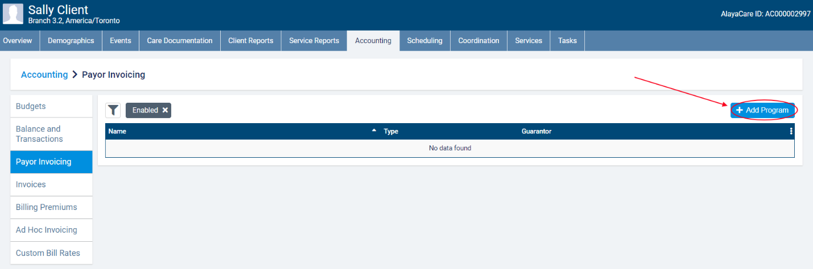
In the Add Payor Program dialogue, enter the Name of the Payor Program and select Long-Term Care Insurance as the Type.
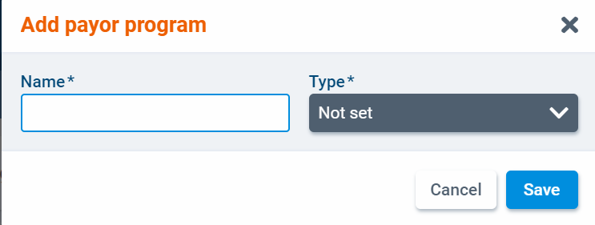
Next, select a client individual-type funder as the program guarantor. You will also need to select a billing contact.
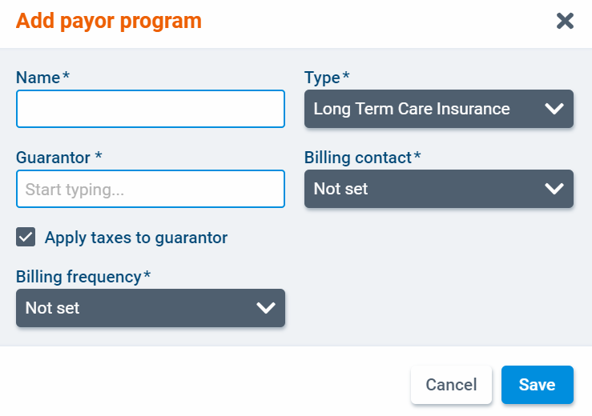
Check the box next to Apply taxes to guarantor if applicable. This setting will determine if taxes set at the bill code level should be applied to items billed to the guarantor.
Finally, select a billing frequency. In payor invoicing, billing periods are determined by the billing frequency. The available billing frequencies for payor programs are 1 Week, 2 Weeks, 4 Weeks, and Calendar Month. When you have finished, click Save.
The program will open as a new screen. Select Edit to make changes to the program details.
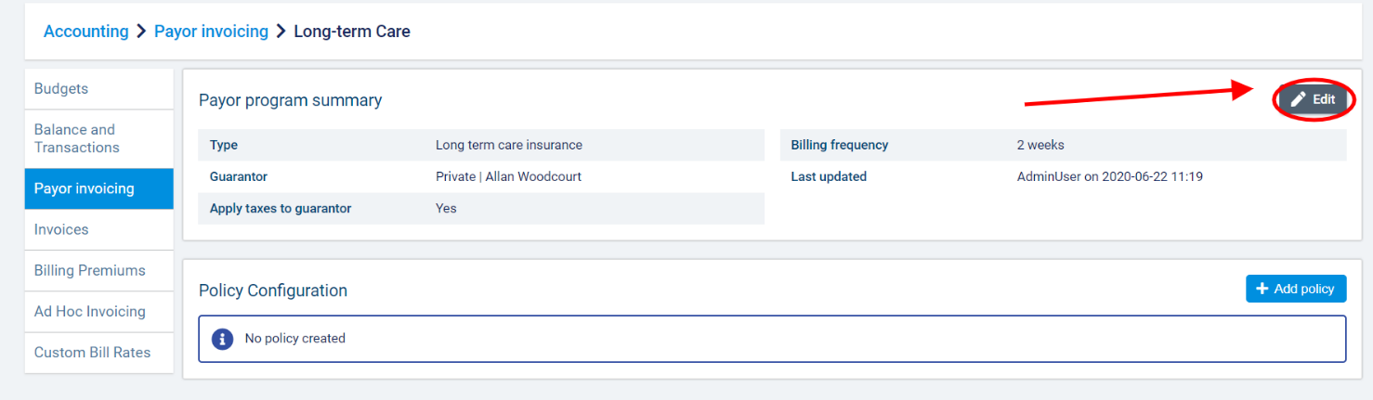
Once you have created a program, you can add one or more insurance policies. A policy specifies the benefit rules that will be used to determine how billable items linked to the program are invoiced. To add a policy to the program, select +Add Policy.
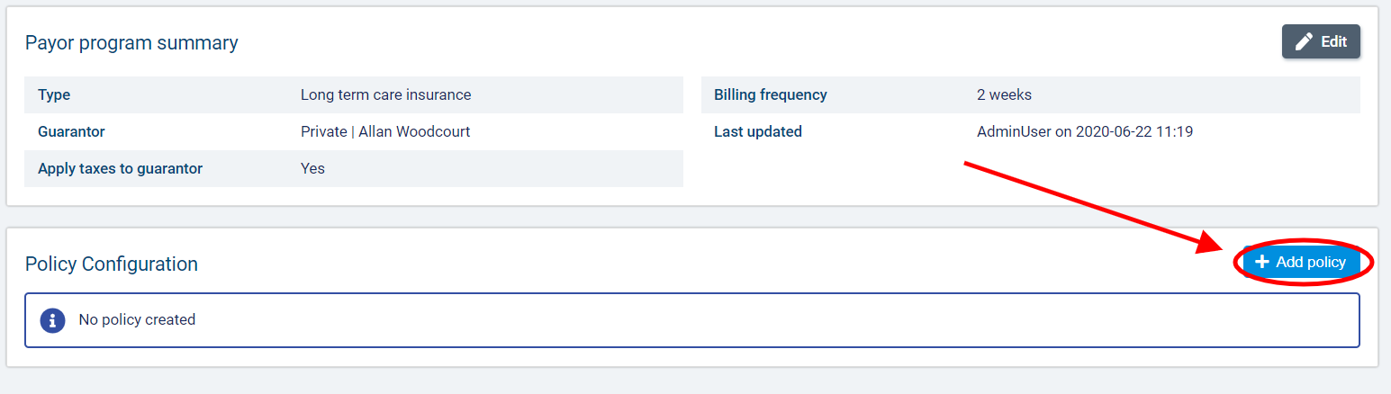
In the Add Policy dialogue, complete the required fields.
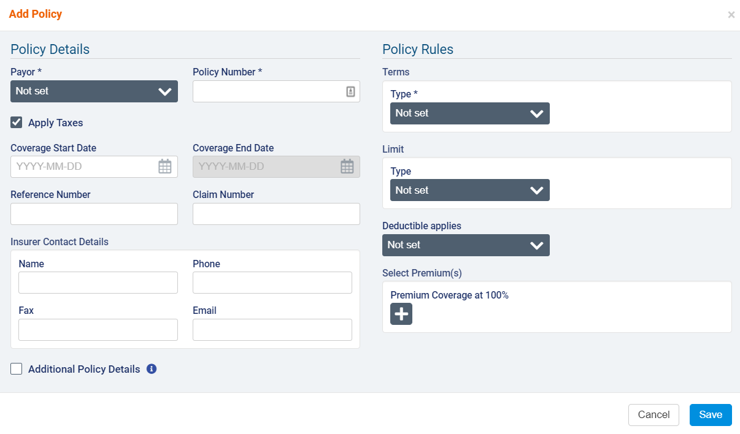

Under Policy Details, select a funder to represent the Payor. You can select any enabled funder individual or client individual funders available to the branch that the client belongs to. Next, enter the Policy Number. If necessary, enter the Coverage Start and End Date, Reference Number, and Claim Number and fill out the Insurer Contact Details section.
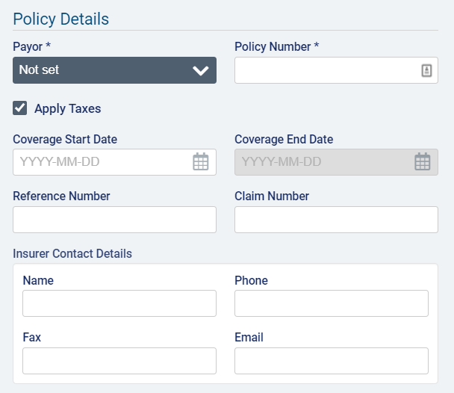
Use the Apply Taxes checkbox if you wish to apply taxes set at the bill code level to items covered by this contract.
Select the box next to Additional Policy Details to complete more informational fields specific to long-term care insurance. The fields are Inflation Rider (%), Anniversary Date, Restoration Policy (in number of days), and Assignment of Benefits (yes or no). Note that these fields are for informational purposes only and will not in any way affect how the rules are applied to billable items.
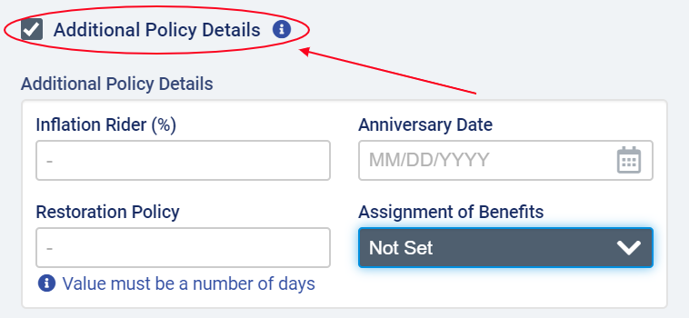

Under Policy Rules, select Amount or Percentage as the Term Type.
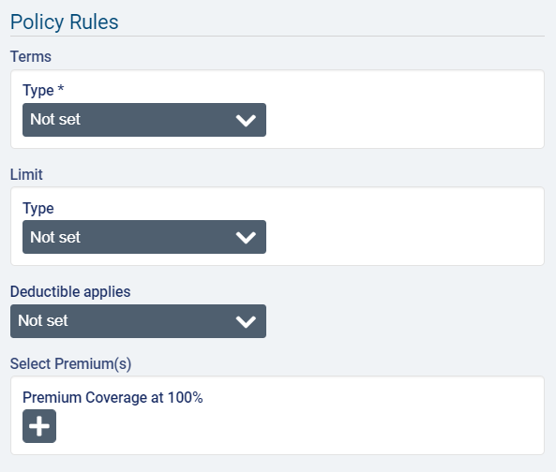
If you select Percentage, enter the value in the Percentage field.
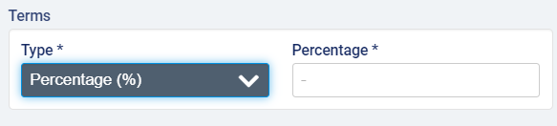
Example scenario for term in percentage: for instance, if you enter 60% as the percentage and do not enter a limit, the payor on the policy will be invoiced for 60% of a visit’s total cost once the program rules are applied during invoice generation for a billing period. The remaining amount will be passed down to the payor on the next policy or the guarantor. If there are multiple policies in effect with percentage terms, then the percentage rule for the second payor will be applied to the remaining amount (not the total amount) of the billable items.
If you select Amount, you must also select a frequency. The available frequencies are Per Hour, Per Day, Per Week, Per Calendar Month, Per Calendar Year, Per Benefit Year, and Lifetime Maximum.
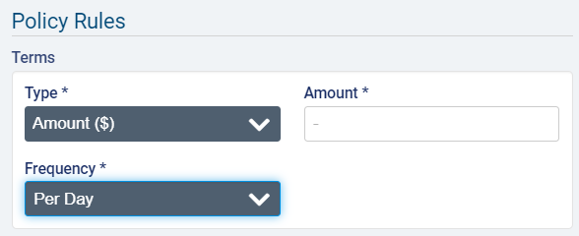

If you select Per Week as the frequency, you must also select a day for Start of Week.
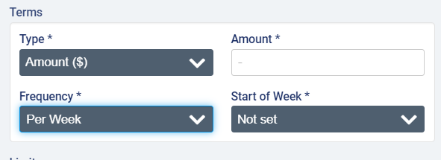

If you select Per Benefit Year as the Frequency, you must also select the Month and Day of the month on which the benefit year begins.
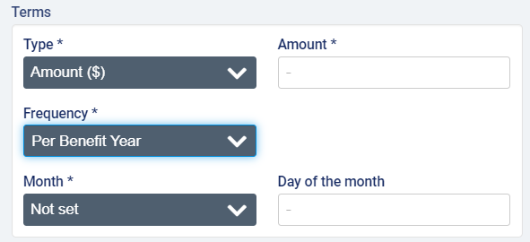
If you select Lifetime Maximum as the Frequency, you also have the option to enter any Outside Expenditures that have already counted toward the lifetime maximum. This could be used in cases where a client has recently transferred and has already used up a portion of their lifetime maximum or in any scenario where you are creating payor programs for clients who have already gone through a portion of the lifetime maximum on a policy. Entering a value here will reduce the lifetime maximum when the policy rules are applied during invoice generation.
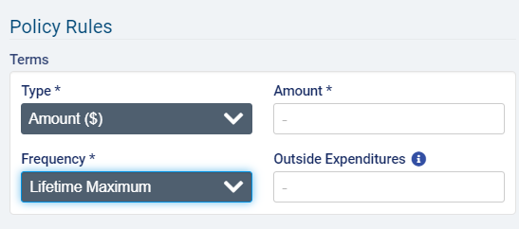
Example scenario for terms in amount (frequency not lifetime maximum): the amount specifies the maximum amount that the payor on the policy will cover for the length of time specified by the frequency. So if $400 is entered as the amount and Per Week is selected as the frequency, when generating invoices for a week in which 3 visits valued at $200 each occurred, the payor will be invoiced $400 for the first two visits and the next payor or the guarantor will be invoiced $200 for the last visit.
Example scenario for terms in amount with lifetime maximum frequency: if lifetime maximum is selected as the frequency, the payor on the policy will no longer be invoiced for any portion of the billable items once the lifetime maximum is reached. For example, if the lifetime maximum is $4000, once the payor has been invoiced for a total of $4000, the rules on the policy will no longer be in effect, and all services tied to the program will be billed to the next payor or guarantor.
After adding the term details, you can also add a limit to the policy. The limit can be an amount or a number of hours or visits over a specific frequency. Per Hour is not an available frequency for limits.
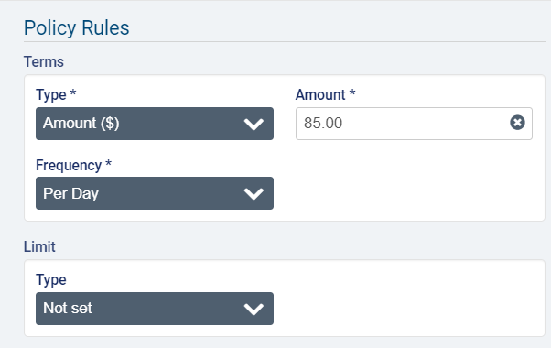
Note that when Amount is selected as the Term Type and Limit Type, the Limit Frequency must always be larger than the Term Frequency (Per Day < Per Week < Calendar Month < Calendar Year/Benefit Year < Lifetime Maximum). If the term has the maximum frequency selected (Lifetime Maximum), then you will not be able to select Amount as the Limit Type.
Example scenario for limit in amount: For instance, the term percentage is 50% and the limit is $100 per week, and the follow visits occurred in one week (visit #1 cost $120 and visit #2 cost $100). The payor will be invoiced $100 (because 50% of visit #1 + 50% of visit #2 = $110, which is over the weekly limit). The guarantor will be billed $120, the total remaining from both visits.
For Limits in Hours, the frequencies Per Day, Per Week, and Per Calendar Month will be available to select.
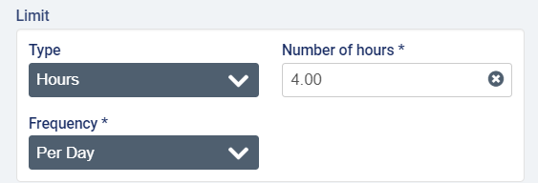
Example scenario with a limit in hours: there are two visits in one week; visit #1 lasted 3 hours and cost $150 and visit #2 lasted 2 hours and cost $100. If the term is a fixed amount of $60 per hour, and the limit is 2 hours per week, the payor will be invoiced $120 for the first visit ($60 x 2h), and the guarantor will be billed the remaining amount of $130.
For Limits in Visits, the frequencies Per Week, Per Calendar Month, Per Calendar Year, and Per Benefit Year will be available to select.
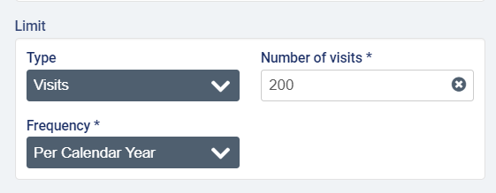
Example scenario with a limit in visits: The term is a fixed amount of $200 per week and the limit is 2 visits per week, and there are two visits in one week (one on Monday charged at $120 and one on Wednesday charged at $100). The payor will be invoiced $120 for the first visit, and the guarantor will be invoiced $100 for the second visit, since the limit on the term has been reached.
If Per Week is selected as the Limit Frequency, you will also need to specify a day as the Start of Week.
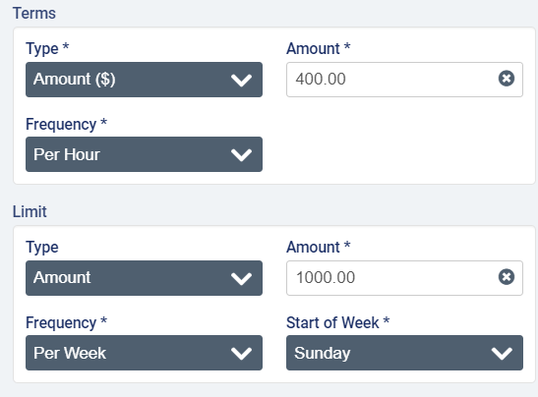

If Amount is selected as the Term Type, the Limit Type is Amount, and the Term Frequency is NOT Lifetime Maximum, you can select Lifetime Maximum as the Limit Frequency and enter the Limit Amount. You will also have the option to enter Outside Expenditures.
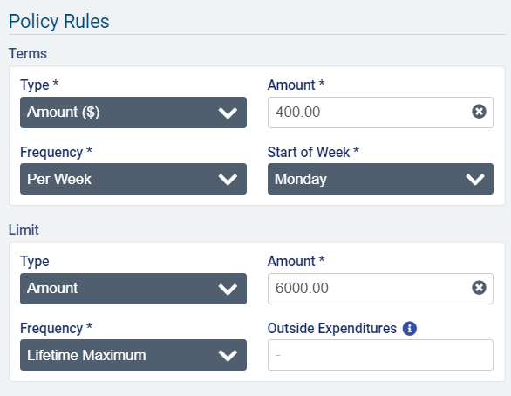
To set a deductible or elimination period on the policy, select an option from the Deductible applies dropdown.
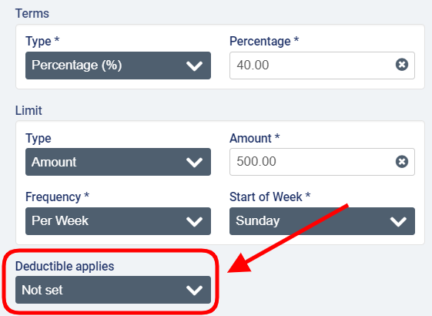
To set an elimination period, select either Elimination by Calendar Days or Elimination by Service Days and then enter the number of days in the period.
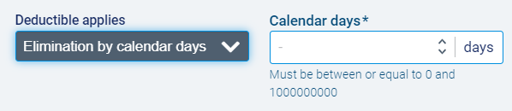

To enter an amount, select deductible amount and enter the value of the deductible.
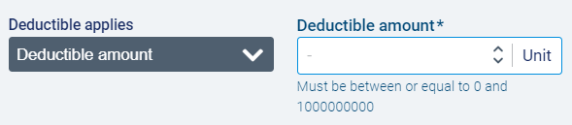
In the Select Premium(s) section, click to select one or more billing premiums configured in Accounting>Accounting Settings>Premiums that should be fully covered by the payor on the policy. Note that premiums must be 100% covered by either the payor or the guarantor (in other words, the cost of premiums cannot be split between two bill-parties if using a long-term care insurance payor program).
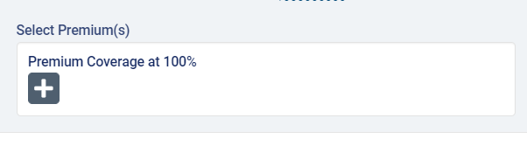
When you have completed on required fields, click Save.
The program page will open with the policy details listed under Policy Configuration. To make changes, select the Edit button.
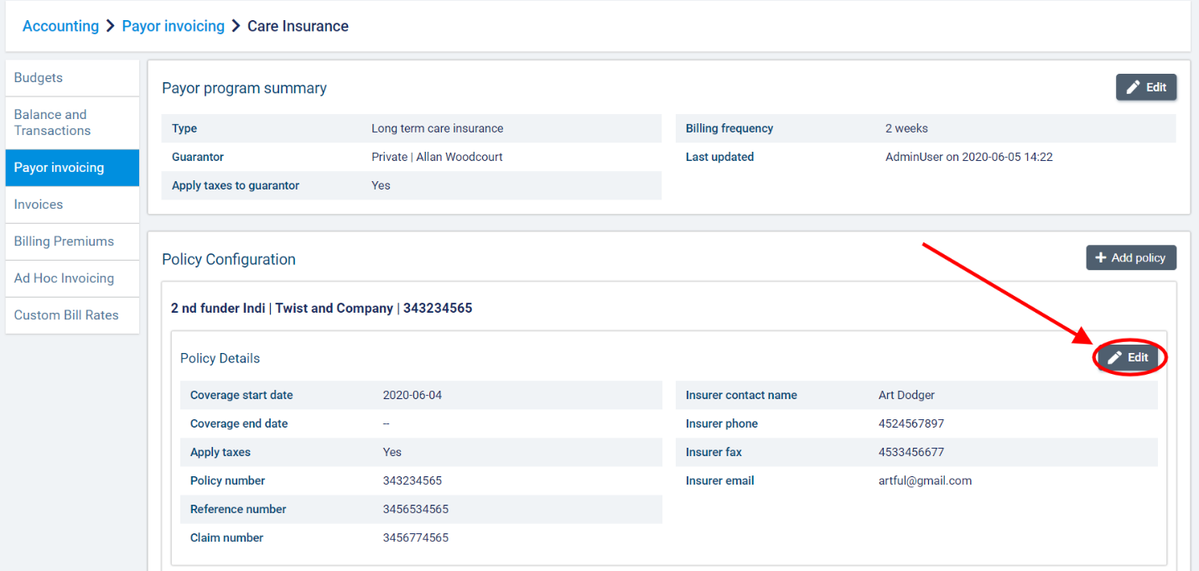

If the policy has never been used to generate invoices, you will be able to edit all the informational fields.
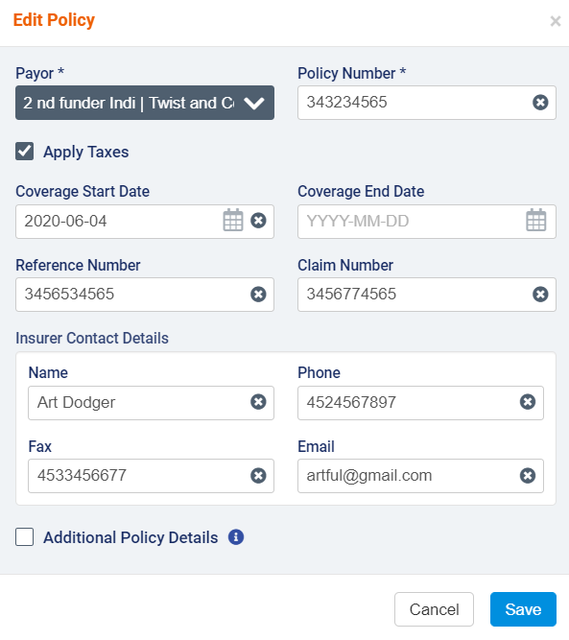
If any draft or sent invoices exist against the policy, certain fields will be disabled for editing (Payor, Policy Number, and Coverage Start Date).
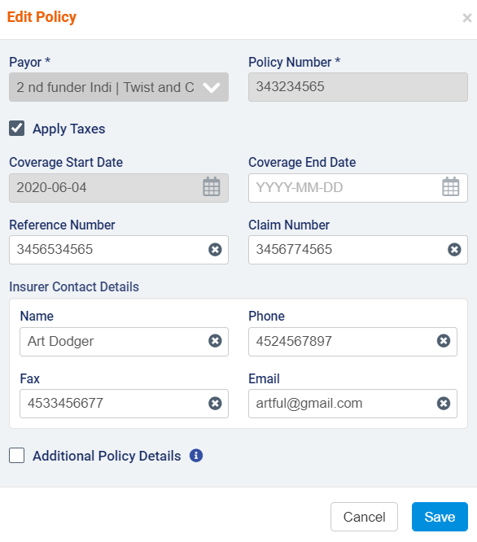

If you need to change the rules for a policy or contract, you can create a new version of the policy. Note that versions cannot have any gaps or overlaps in terms of dates.
To create a version, click the +Add Version button.
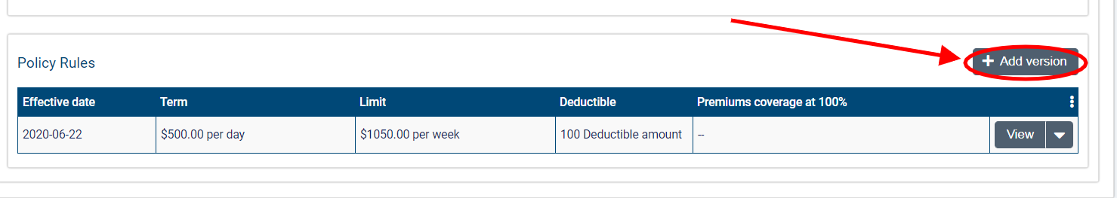
In the Add Version dialogue, enter the Effective Date on which the changes to the policy/contract will apply. This date must be past the Coverage Start Date by at least one day. You will not be able to modify Term Type or Limit Type, but you can make changes to the Term Value, Term Frequency, Limit Value, and Limit Frequency or attach more premiums.
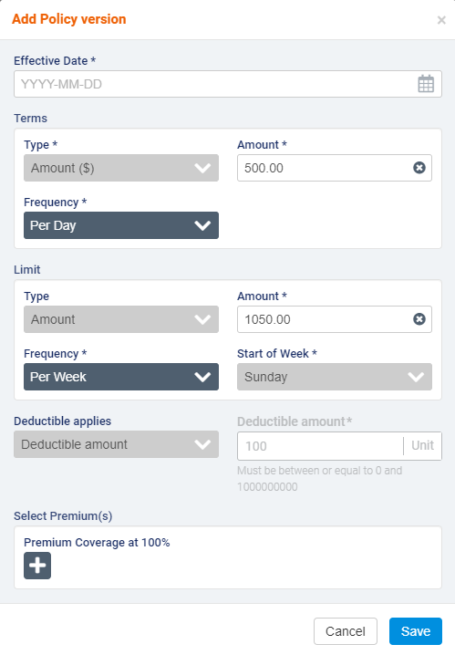
If more than one version of a policy exists, you will not be permitted to modify the Coverage Start Date. If Per Calendar Month is selected as the Term Frequency, note that the Coverage Start Date must be the first day of a month.
When you have finished, click Save to create the new version.
To edit or delete a version, select the downward arrow next to view and select Edit or Delete.
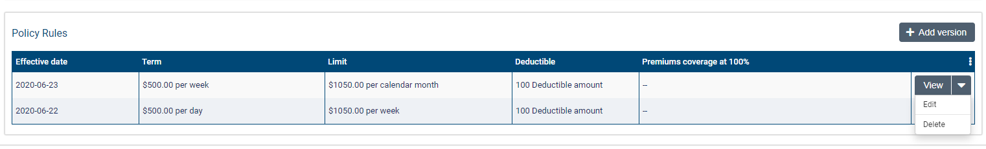
You will not be able to make changes if invoices have been generated for the version.
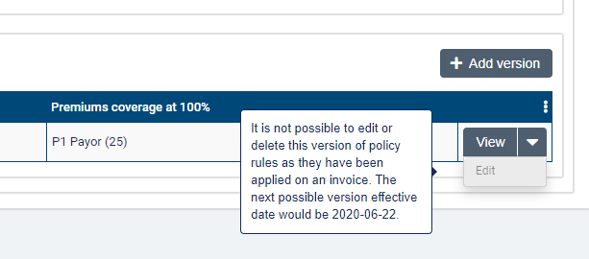
Note that having more than one version will lock the Coverage Start Date field for editing regardless of whether invoices exist against the policy.
You can multiple policies to long-term care insurance policies. Click +Add Policy again to add a new policy to the program.
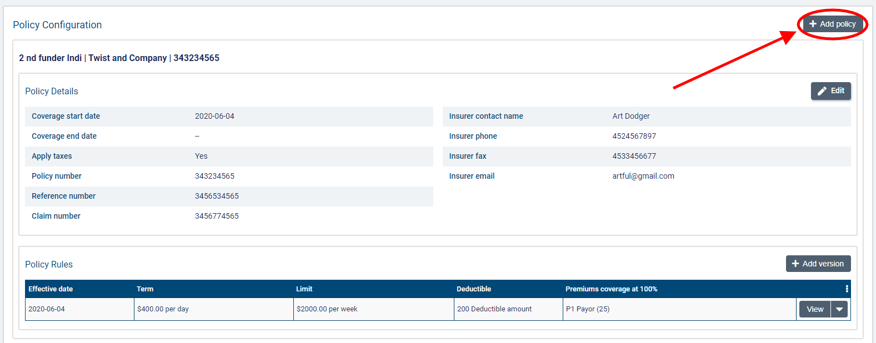

Once you have added another policy, you can choose the sequence in which the policies should apply. Click the Sequence Policies button to adjust the sequencing order as permitted.
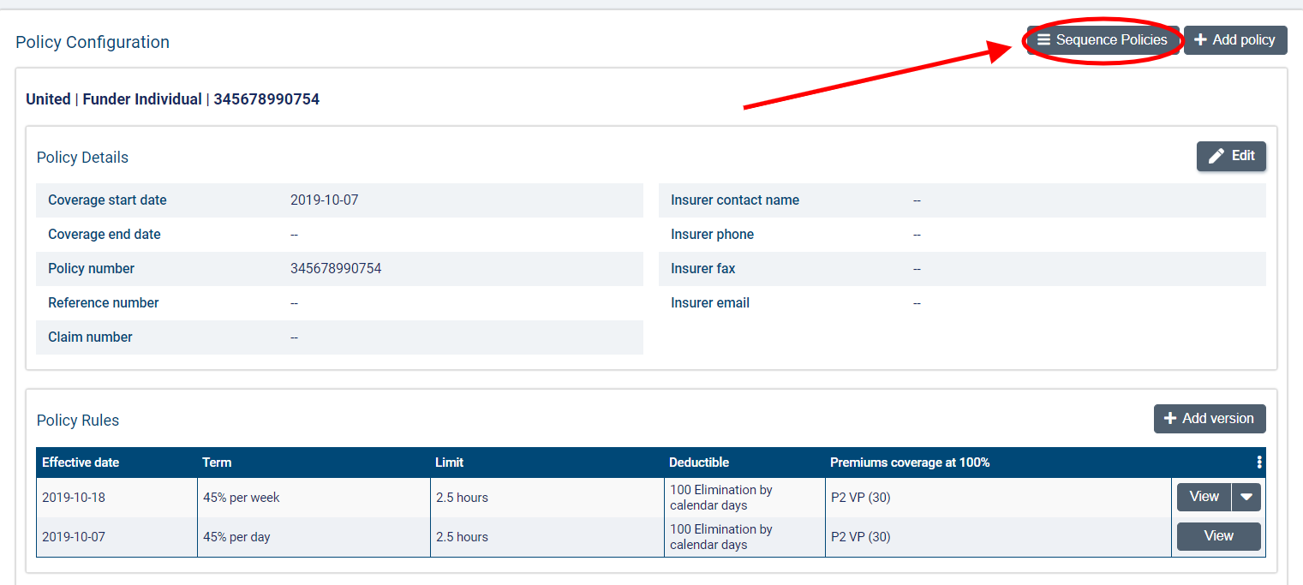
You can then drag and drop the policies into the order in which they should apply. Click Confirm when you are ready to save the order.
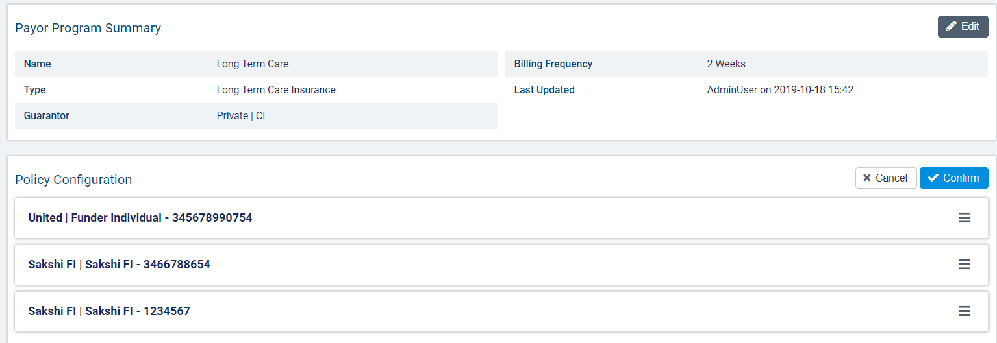
Note that policies with a limit in hours must be sequenced before policies with a limit in amount. Once a policy has invoices against it, it will no longer be available for sequencing.
If you try to sequence the policies in an order that is not permitted, you will receive an error message.
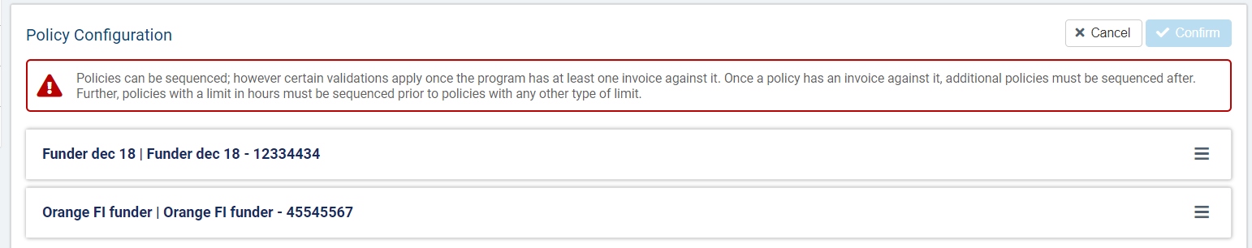

Adding the payor program to client services and billing premiums

Once you have set up a program for a client, you can attach it to services and client billing premiums.
To add a program for a client, go to a Services list on the client’s profile and select +Create a Service.
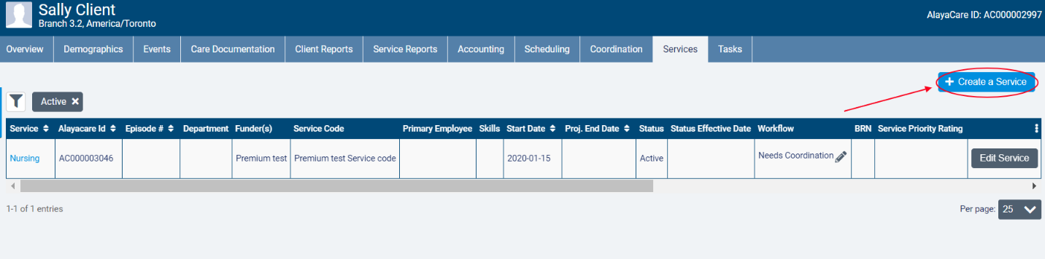
In the Funder Methodology dropdown, the different types of payor programs will be available for selection. Choose the type of the program you wish to apply. Next, select the name of the program in the Program dropdown and choose the correct Rating Funder. The funder you select here will determine which bill codes will be used to invoice billable items tied to the program.
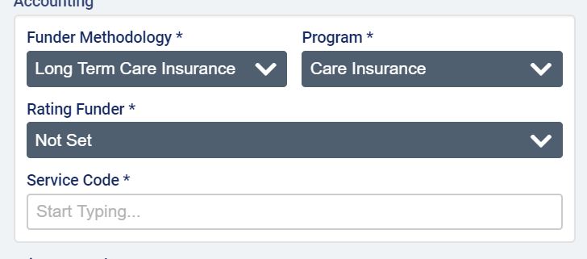
Note that the rating funder does not have to be the funder selected for either the payor or guarantor on the payor program. It is simply used to determine the rates that should be applied the billable items tied to the program.
When you have finished completing all required fields, click Create.
Note that the program on the service cannot be changed after an invoice is generated for the service.
To add a program to a client billing premium, go to Accounting>Billing Premiums on the client’s profile and select +Create Premium.
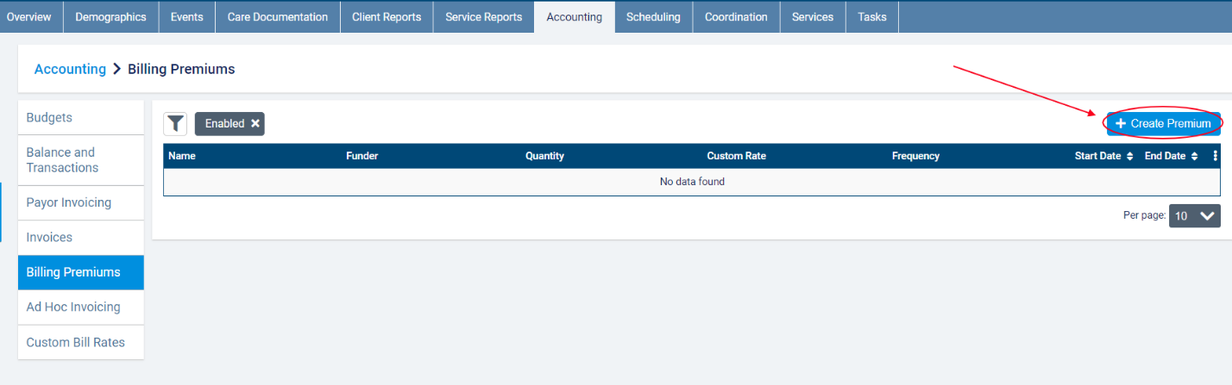
In the dialogue, select the name of the program as the Funder Methodology. After completing all required fields, click Save.
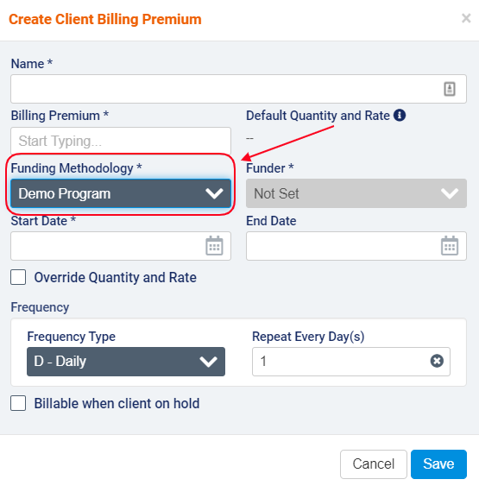
Note that the funder methodology cannot be modified on the client billing premium. A new premium will need to be created (and the current one disabled) if the program no longer applies to the premium.

Appendix A: glossary of terms

- Billable item: any source item (visit, visit premium, or client billing premium) that has been approved for billing and has a rate.
- Billing periods: billing periods in payor invoicing must have a set frequency of 1 weeks, 2 weeks, 4 weeks, or per calendar month. When generating invoices for a billing period, any billable items tied to a program with that billing period frequency that have not yet been invoiced will be included. The end date serves as the cut-off date for the billing period. Start dates of billing periods cannot be modified to avoid gaps between billing periods.
- Bill-to party: the party to whom an invoice is addressed. In payor invoicing, the bill-to party will either be a payor or the guarantor.
- Contract: in certain program types, the name of the rule set that is added to a payor program.
- Co-payment: a payor program type used when there is an agreement that the client will pay for a portion of the services being covered.
- Guarantor: the bill-to party that is responsible for covering the remainder of invoice balances after the rules on any policies or contracts in effect have been applied.
- Limit: a cap on the term set on the contract/policy in amount, hours, or visits based on a set frequency.
- Long-term care insurance: a payor program type used when there is a long-term insurance policy that is activated to cover the services being provided.
- Master invoice: the master invoice contains information about all the billable items covered by a client’s payor program for a specific billing period. When viewing the master invoice screen, you will be able to see the breakdown of what will be invoiced to the payor(s) and what will be invoiced to the guarantor. Exporting invoices at the master invoice level will generate one invoice per bill-to party.
- Payor: the party that is subject to the rules defined on the program. The payor on the policy or contract will become the bill-to party that is invoiced for the amount dictated by the benefit rules on the policy/contract.
- Payor invoicing: an invoicing methodology where you create rules at the client level to determine how the cost of billable items will be split between different bill-to parties.
- Payor program: a billing configuration at the client level to which you can add rule sets (policies or contracts) to determine how a client’s services or client billing premiums will be invoiced. Once created, programs must be added to the client’s relevant services and billing premiums.
- Policy: in certain program types, the name of the rule set that is added to a payor program.
- Rating funder: a funder that is used to link bill codes and their rates to a service covered by a payor program. The rating funder will not be invoiced for any items.
- Term: the amount of a client’s services that will be covered by the payor on the policy/contract (either a fixed amount over a set frequency or, in certain program types, a percentage).

