AlayaCare Standard PDF Invoice

User Guide

Version 1.5

Contents
What is the AlayaCare Standard Invoice? 2
Configuring the AlayaCare Standard Invoice 2
AlayaCare Standard Invoice: template overview 4
Invoice header 4
Additional header examples 7
Invoice details 8
Additional invoice details examples 10
Additional Details 10
Footer 11
Multi-page invoice: template overview 12
Summary page: header 12
Summary page: invoice summary 14
Additional account summary examples 15
Statement Summary Page: Additional Details 15
Statement Summary Page: Footer 16
Page 2: Invoice Details 16
Requesting changes to the new invoice 18

What is the AlayaCare Standard Invoice?

The AlayaCare Standard Invoice is a new PDF invoice template in AlayaCare. The improved design of the new invoice allows for an optimal printing experience as well as more flexibility and customization at the agency level.
The AlayaCare Standard Invoice is available in both a condensed single-page format (AC Standard Invoice) and a multi-page format (AC Standard Invoice with Summary Page).
You can export the new invoice for funders of type client individual and funder individual, regardless of whether you are using the old billing cycles or the new billing module. If you are not using payor programs, you will not see some of the invoice fields that contain information specific to payor programs.
Keep in mind that for the AlayaCare Standard Invoice billing period dates are inclusive, meaning that transactions that occur on the start and end date will be included on the invoice.
Please note that the terms funder and payor are used interchangeably in this guide. While funder is the term used in the system today, AlayaCare will be gradually moving toward the payor model as more users start to adopt the new billing methodology.

Configuring the AlayaCare Standard Invoice

To enable the AlayaCare standard invoice, go to Settings>System Settings>Accounting. Under Enabled AC Standard Export Types, check the box next to AC Standard Invoice to enable the single-page invoice. For the multi-page format, select AC Standard Invoice with Summary Page.
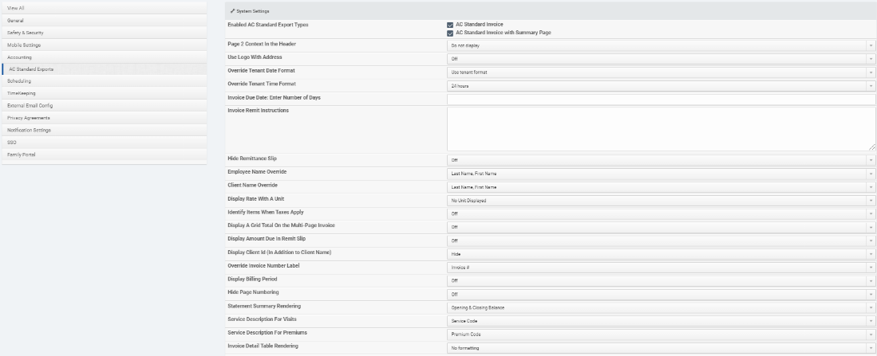
The following settings found under allow you to configure the new standard invoice according to your organization’s preferences:
Page 2 Context in the Header: select from the following options if you wish to include information in the header of the second page of the multi-page invoice: Client Name, Invoice Number, Client Name | Invoice Number, Client Name | Client ID, and Client Name | Invoice Date. The setting will default to Do not display.
Use Logo with Address: turn this setting On or Off depending on whether you wish to use the logo in place of the agency address on the AC Standard Invoice. When this setting is turned on, the logo will be placed so that it covers the agency address and related information.
Override Tenant Date Format: use this setting to select a different date format then the one currently configured for your organization in the Date Format field in Settings>Locale. By default, Use Tenant Format will be selected. If you wish to use a different format on invoices, select another date format from the list.
Override Time Format: use this field to choose AM/PM, 24 hours, or Hide as the time format for invoices. Selecting Hide will remove the time display for a visit below the date in the invoice detail table.
Invoice Due Date: Enter Number of Days: use this field to automatically set the invoice due date to be a fixed number of days after the invoice date. If this field is left empty, the Invoice Due Date will not appear on the invoice. If you enter 0 in this field, then the Invoice Due Date will be the same as the Invoice Date.
Invoice Remit Instructions: this field allows you to enter a custom message that will appear along the line separating the payment stub from the rest of the invoice. To see how this message will appear on the invoice, please see the next section.
Hide Remittance Slip: select On if you wish to hide the remittance slip from the invoice.
Employee Name Override: use this setting to select how you wish the employee’s name to appear on invoices. You can choose Initials; Last Name, First Name; First Initial Last Name; First Name Last Initial; First Name Last Name; First Name Last Name – Certification Number; Last Initial, First Name; or Hide if you wish to prevent employee names from appearing on invoices altogether. Note that the employee certification number will be pulled from Employment>Employment Settings on the employee profile.
Client Name Override: use this setting to select how you wish the client’s name to appear on invoices. You can choose Initials; Last Name, First Name; First Initial Last Name; First Name Last Initial; First Name Last Name; Last Initial, First Name; or Hide if you wish to prevent client names from appearing on invoices altogether.
Display Rate with a Unit: use this setting to display a unit for per hour and per visit bill rates. The following options are available to select: No Unit Displayed (default), hour | visit, /hour | /visit, or per hour | per visit.
Identify Items When Taxes Apply: use this setting to display an asterisk (*) next to any billable items listed on the invoice for which taxes apply. *plus applicable taxes will appear below the grid.
Display a Grid Total on the Multi-Page Invoice: turn this setting On if you wish to display a total amount billed on the grid appearing on the second page of the multi-page invoice.
Display Amount Due in Remit Slip: turn this setting On if you wish to display the invoice total including taxes on the remittance slip. You can disable the setting if you do not wish to display the amount due.
Display Client ID (in addition to Client Name): if you wish to display the client’s ID as well as name, select AlayaCare ID or External ID. Select Hide (default option) to prevent the client’s ID from being displayed on the invoice.
Override Invoice Number Label: if you wish to label the invoice number field something other than Invoice #:, select Tax Invoice #:, Invoice:, Tax Invoice:, Invoice Number:, or Tax Invoice Number:. The field will default to Invoice #:.
Display Billing Period: select On if you wish to display the dates of the billing period/billing cycle on the invoice. Note that if you are using the old billing cycles, the last date shown will be one day before the end date as the dates are exclusive rather than inclusive.
Hide Page Numbering: select On for this setting if you wish to hide page numbers that appear in the top right corner of the invoice.
Statement Summary Rendering: use this setting to choose how you wish the statement summary section to appear on the invoice. Select Opening & Closing Balances to display the client’s opening and closing account balances, Hide Statement Summary Section to remove these fields from the invoice, or Display Client Address (applies on AC Standard invoice only) if you wish to display the client’s address in this section instead.
Service Description for Visits: use this setting to select what information is displayed as the service description for visits on the invoice. The available options are Service Code, Bill Code, Service Name, Service Code – Bill Code, Bill Code – Service Code, Service Name – Service Code, and Service Name – Bill Code Rate ID.
Service Description for Premiums: use this setting to select what information is displayed as the service description for premiums on the invoice. The available options are Premium Code, Bill Code, Visit Premium Description/Client Billing Premium Name, Premium Code – Bill Code, Description/Name – Premium Code, and Premium Name – Bill Code Rate ID.
Invoice Detail Table Rendering: this setting allows you to determine how the table on the invoice containing the billable items is formatted. You can select Shading, Lines, or No Formatting. See the invoice template sections below for examples of each of the formats.
Note that if a currency is selected in the Invoice Currency Override system setting, the AlayaCare standard invoice will display that currency symbol rather than the dollar sign.

AlayaCare Standard Invoice: template overview

This section gives an overview of the various parts of the single-page AlayaCare standard invoice and explains where each field maps to in the AlayaCare web application.

Invoice header

The following fields make up the header:
Example 1: Hide Page Numbering turned On, Use Logo with Address turned Off, Opening & Closing Balances selected for Statement Summary Rendering, Hide selected for Display Client ID (in addition to Client Name)
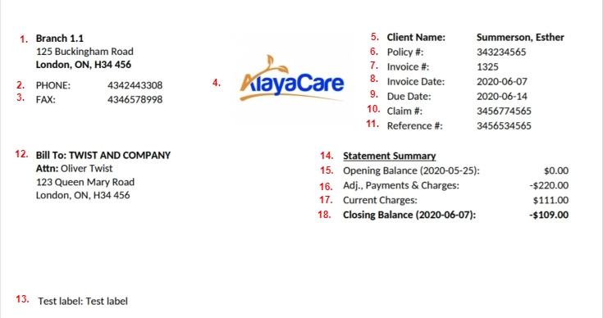
Example 2: draft invoice example (Hide Page Numbering turned Off, Use Logo with Address turned Off, Opening & Closing Balances selected for Statement Summary Rendering, AlayaCare ID selected for Display Client ID (in addition to Client Name), Display Billing Period turned On):
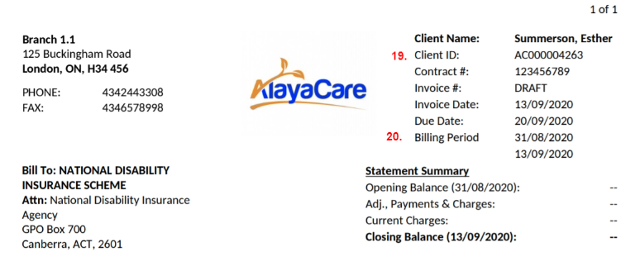
Number in Example | Field | Description
1 | Agency name and address | If an agency profile has been selected for the funder, the information for the profile will pull from Settings>Agency Information>Agency Contacts. If not, the address will be the name and address set for the agency or branch in Agency Information.  Note that this section will not appear if the Use Logo With Address setting is enabled.
2 | Agency phone number | If a phone number has been entered for the agency contact or agency/branch (when no agency contact is set on the funder) in Settings>Agency Information (phone_main form context field or phone_other if phone_main does not exist) then that phone number will appear in this line. If no phone number has been entered, this field will not appear on the invoice.  Note that this section will not appear if the Use Logo With Address setting is enabled.
3 | Fax | If a fax number has been entered for the agency contact or agency/branch in Settings>Agency Information, then the fax number will appear in this line. If no fax number has been entered, this field will not appear on the invoice.  Note that this section will not appear if the Use Logo With Address setting is enabled.
4 | Agency logo | If an agency contact is selected for the funder, the image will pull from the logo set on the agency contact profile. If no agency profile is selected for the funder, then the invoice logo in Settings>Agency Information>Logos>Invoice Logo will appear on the invoice.  Note that the logo will replace sections 1-3 if the Use Logo With Address setting is enabled.
5 | Client Name | The client name will appear in the format selected in the Client Name Override system setting.
6 | Policy/contract # | For agencies using payor invoicing this field will appear display the contract or policy number (depending on the program type) for the contract/policy it was generated for.
7 | Invoice # | This field will display the invoice number. If printing a draft of an invoice, DRAFT will appear in this field instead of a number.
8 | Invoice Date | This field will display the invoice posting date in the preferred format configured in Settings>System Settings>Override Tenant Date Format (or Settings>Locale>Date Format if Use Tenant Format is selected).
9 | Due Date | This field will appear on an invoice if a value is entered in the Invoice Due Date field in Settings>System Settings>Accounting. The due date will be calculated by adding the number of days entered in the system setting to the invoice posting date. If the Invoice Due Date field is empty in system settings, this field will not appear on the invoice.
10 | Claim # | If you are using payor invoicing, this field will display the claim number entered on the policy/contract. If no claim number is entered, the field will not appear.
11 | Reference # | If you are using payor invoicing, this field will display the reference number entered on the policy/contract. If no reference number is entered, the field will not appear.
12 | BILL-TO | This is the name of the billing contact for the client’s funder. If the funder is type client individual, the name of the billing contact will be displayed here followed by their address. If the funder is type funder individual, the funder name will be displayed here followed by the address set for the funder. If a specific contact is defined for the payor, a line with ATTN followed by the insurer contact name will appear between the funder name and address.
13 | Invoice labels | Any invoice labels added to one of the client services billed on the invoice will appear in this part of the document. One label will appear per line. If the same invoice label is attached to more than one service on the invoice, the label will only appear once on the invoice.
14 | Statement Summary | This section title and the following four lines will only be displayed if Opening & Closing Balances are selected in the Statement Summary Rendering system setting. Select Hide Statement Summary Section in the Statement Summary Rendering setting if you wish to hide items 14-18 from the invoice (see example 2 below) or select Client Address if you wish to display the client’s address instead of the account balance details (see example 3).
15 | Opening Balance | This field will display the balance for the specific funder and client (for types client individual and funder individual) up to the billing period start date.
16 | Adj., Payments, Charges | This field displays the total value of transactions that occurred during the billing period not including the current invoice amount.
17 | Current Charges | This field displays the total amount owed on the invoice for the funder/payor.
18 | Closing Balance | This represents the total account balance as of the billing period end date based on adding together the amounts in the Opening Balance, Current Charges, and Adj., Payments, Charges fields.
19 | Client ID | If AlayaCare ID or External ID is selected for the Display Client ID (In Addition to Client Name) system setting, then the corresponding client ID will be displayed here.
20 | Billing Period | If the Display Billing Period system setting is enabled, then the dates of the billing period/cycle will be displayed. Note that if you are using the old billing module, the last date will be the day before the end date of the billing cycle as the start and end dates of the old billing cycles were exclusive not inclusive.

Note: not all labels should be enabled to display at once as the header can become very crowded. Make sure to enable only the fields you require.

Additional header examples

Example 3: Hide Page Numbering turned Off, Use Logo with Address turned On, Hide Statement Summary Section selected for Statement Summary Rendering, Hide selected for Display Client ID, Off selected for Display Billing Period):
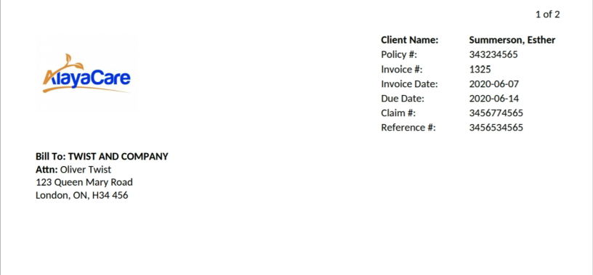

Example 4: Hide Page Numbering turned Off, Use Logo with Address turned On, Client Address selected for Statement Summary Rendering, Hide selected for Display Client ID, Off selected for Display Billing Period):

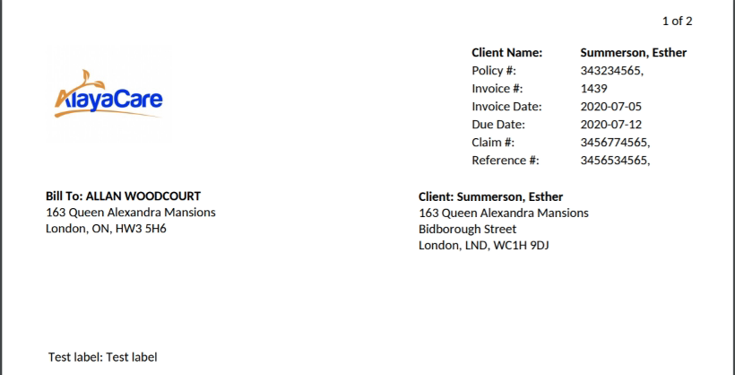

Invoice details

The invoice details section of the invoice displays information about each visit, premium, or miscellaneous charge that make up the total amount charged on the invoice.
Example 1: No Formatting selected for the Invoice Detail Table Rendering system setting, AM/PM selected for Override Time Format, per hour | per visit selected for Display Rate with a Unit, On selected for Identify Items When Taxes Apply
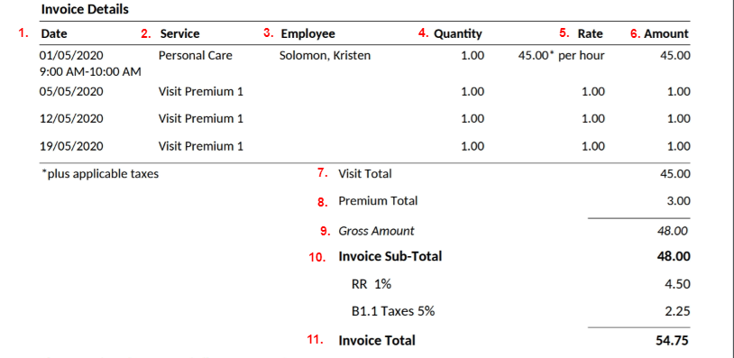

The following details will be shown for each billable item:
Number in sample | Field name | Description
1 | Date | If applicable, the date of the visit in the format specified in the Override Tenant Date Format field in Settings>System Settings>Accounting. For client billing premiums, the date shown will be the date on which the billing premium was applied (according to the frequency).  A time range may also appear if the billable item is a visit.  If the setting is not set to Hide, the visit’s scheduled start time and end time display in the format specified in the Override Tenant Time Format field in Settings>System Settings>Accounting.
2 | Service | For visits and premiums, the service description will correspond to the value selected in the Service Description for Visits and Service Description for Premiums system settings. If the item is a miscellaneous charge, the Description will appear in this field.
3 | Employee | If applicable, the name of the employee who completed the visit in the format specified in the Employee Name Override setting in Settings>System Settings>Accounting. Note that if you select Hide, the column will not appear.
4 | Quantity | The quantity of the approved billable item.
5 | Rate | The bill rate applied to the billable item. If an option other than No unit displayed was selected for Display Rate with a Unit, then the unit will appear after the rate as well.
6 | Amount | The total amount charged for the billable item.

After listing the details about each billable item on the invoice, the following totals will be listed:
Number in sample | Field name | Description
7 | Visit Total | The total value of all visits and visit premiums on the invoice.
8 | Premium Total | The total value of all non-visit billing premiums.
9 | Gross Total  (specific to payor programs) | This field will only appear if using payor programs. It represents the sum of all billable items for the billing period including amounts that will be billed to other payors.
10 | Invoice Sub-Total | This field will appear if taxes will be charged for billable items on the invoice. It displays the total amount that will be charged to the payor before taxes. The amount in taxes will appear below.
11 | Invoice Total | When using payor programs, this total represents the actual amount owed by the bill-to party on the invoice based on the benefit and premium rule calculations including any taxes. In other billing models, it will simply be the sum of all billable items with the applicable taxes applied.

Additional invoice details examples

Example 2: Shading selected for the Invoice Detail Table Rendering system setting, Hide selected for Override Time Format, /hour | /visit selected for Display Rate with a Unit, Off selected for Identify Items When Taxes Apply
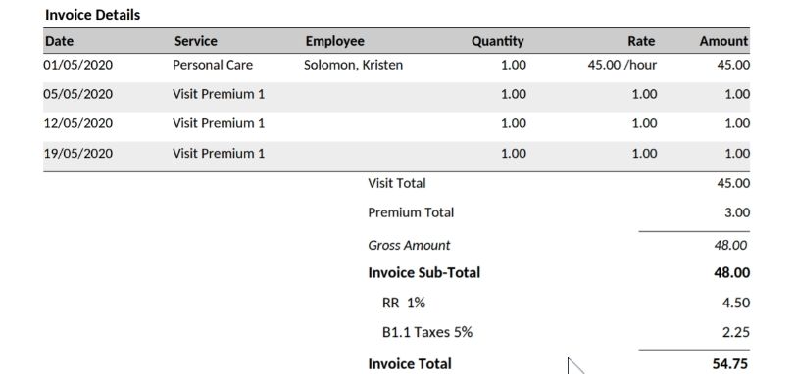
Example 3: Lines selected for Invoice Detail Table Rendering, Hide selected for Override Time Format, No unit displayed selected for Display Rate with a Unit, Off selected for Identify Items When Taxes Apply, Hide selected for Employee Name Override
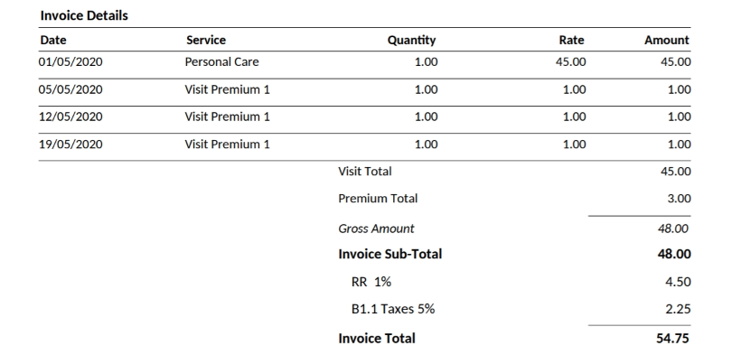

Additional Details

The two fields in this section allows you to provide billing contacts with more information about where to direct questions and how to make payments on the invoice:
Number in sample | Field | Description
1. | Invoice questions | This field will display the text entered in the Invoice Questions to box in Settings>System Settings>Accounting.
2. | Payment instructions | This field will display the text entered in the Payment Instructions box in Settings>System Settings>Accounting.

Footer

The invoice footer consists of a remittance stub that can be detached from the rest of the invoice and returned with the payment to the agency. You can remove this section of the invoice by selecting On for the Hide Remittance Slip system setting.
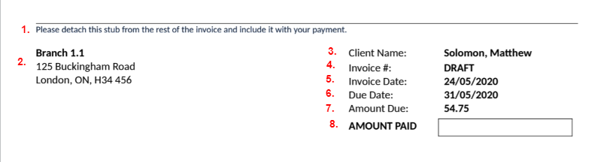
Number in sample | Field name | Description
1 | Remit instructions | The text under the line for the remittance stub will be pulled from the text entered in the Remit Instructions field in Settings>System Settings>Accounting.
2 | Agency information | This field will display the same agency contact information found in the header.
3 | Client name | The client’s name will appear in the same format as in the heading.
4 | Invoice # | The invoice number from the header will appear again.
5 | Invoice Date | The invoice date from the header appear again.
6 | Due Date | If an invoice due date appeared in the header, it will appear again here.
7 | Amount Due | This field will only be displayed if On is selected for the Display Amount Due in Remit Slip system setting.
8 | Amount Paid | This box is hardcoded and will appear in the remittance stub on each invoice.

Multi-page invoice: template overview

This section gives an overview of the various parts of the multi-page AlayaCare standard invoice and explains where each field maps to in the AlayaCare web application.

Summary page: header

The following fields make up the header:
Example 1: Hide Page Numbering turned On, Use Logo with Address turned Off, Hide selected for Display Client ID (in addition to Client Name)
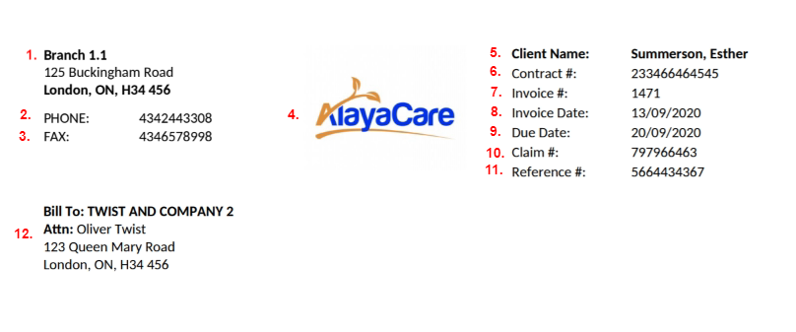
Example 2: Hide Page Numbering turned Off, Use Logo with Address turned Off, AlayaCare ID selected for Display Client ID (in addition to Client Name), Display Billing Period turned On
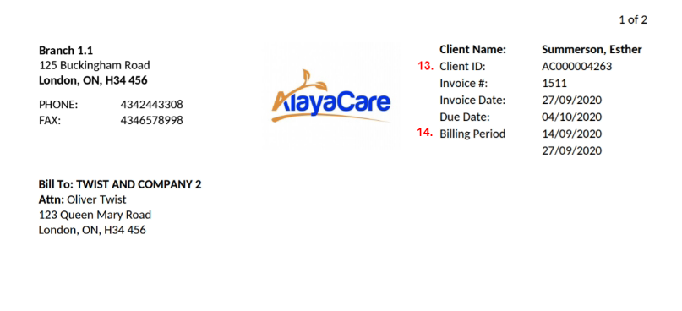

Number in Example 1 | Field | Description
1 | Agency name and address | If an agency profile has been selected for the funder, the information for the profile will pull from Settings>Agency Information>Agency Contacts. If not, the address will be the name and address set for the agency or branch in Agency Information.  Note that this section will not appear if the Use Logo With Address setting is enabled.
2 | Agency phone number | If a phone number has been entered for the agency contact or agency/branch (when no agency contact is set on the funder) in Settings>Agency Information (phone_main form context field or phone_other if phone_main does not exist) then that phone number will appear in this line. If no phone number has been entered, this field will not appear on the invoice.  Note that this section will not appear if the Use Logo With Address setting is enabled.
3 | Fax | If a fax number has been entered for the agency contact or agency/branch in Settings>Agency Information, then the fax number will appear in this line. If no fax number has been entered, this field will not appear on the invoice.  Note that this section will not appear if the Use Logo With Address setting is enabled.
4 | Agency logo | If an agency contact is selected for the funder, the image will pull from the logo set on the agency contact profile. If no agency profile is selected for the funder, then the invoice logo in Settings>Agency Information>Logos>Invoice Logo will appear on the invoice.  Note that the logo will replace sections 1-3 if the Use Logo With Address setting is enabled.
5 | Client Name | The client name will appear in the format selected in the Client Name Override system setting.
6 | Policy/contract # | For agencies using payor invoicing this field will appear display the contract or policy number (depending on the program type) for the contract/policy it was generated for.
7 | Invoice # | This field will display the invoice number. If printing a draft of an invoice, DRAFT will appear in this field instead of a number.
8 | Invoice Date | This field will display the invoice posting date in the preferred format configured in Settings>System Settings>Override Tenant Date Format (or Settings>Locale>Date Format if Use Tenant Format is selected).
9 | Due Date | This field will appear on an invoice if a value is entered in the Invoice Due Date field in Settings>System Settings>Accounting. The due date will be calculated by adding the number of days entered in the system setting to the invoice posting date. If the Invoice Due Date field is empty in system settings, this field will not appear on the invoice.
10 | Claim # | If you are using payor invoicing, this field will display the claim number entered on the policy/contract. If no claim number is entered, the field will not appear.
11 | Reference # | If you are using payor invoicing, this field will display the reference number entered on the policy/contract. If no reference number is entered, the field will not appear.
12 | BILL-TO | This is the name of the billing contact for the client’s funder. If the funder is type client individual, the name of the billing contact will be displayed here followed by their address. If the funder is type funder individual, the funder name will be displayed here followed by the address set for the funder. If a specific contact is defined for the payor, a line with ATTN followed by the insurer contact name will appear between the funder name and address.
13 | Client ID | If AlayaCare ID or External ID is selected for the Display Client ID (In Addition to Client Name) system setting, then the corresponding client ID will be displayed here.
14 | Billing Period | If the Display Billing Period system setting is enabled, then the dates of the billing period/cycle will be displayed. Note that if you are using the old billing module, the last date will be the day before the end date of the billing cycle as the start and end dates of the old billing cycles were exclusive not inclusive.

Summary page: invoice summary

This section displays the client’s account balance details along with an overview of the total amount owed on the invoice.
Example 1: (Opening &Closing Balances selected for Statement Summary Rendering)
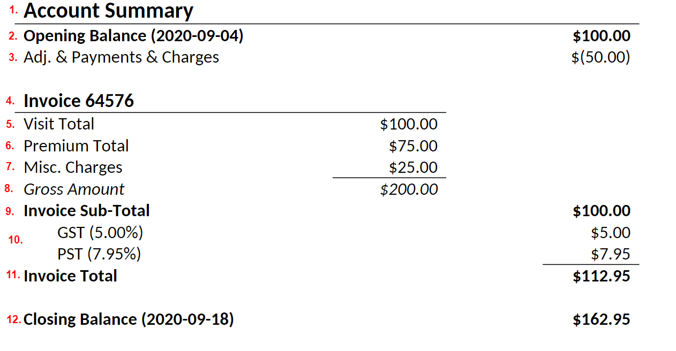
1 | Account Summary | This section title along with Opening Balance; Adj., Payments, Charges; and Closing Balance fields will only be displayed if Opening & Closing Balances are selected in the Statement Summary Rendering system setting. Select Hide Statement Summary Section in the Statement Summary Rendering setting if you wish to hide from the invoice (see example 2 below) or select Client Address if you wish to display the client’s address instead of the account balance details (see example 3).
2 | Opening Balance | This field will display the balance for the specific funder and client (for types client individual and funder individual) up to the billing period start date.
3 | Adj., Payments, Charges | This field displays the total value of transactions that occurred during the billing period not including the current invoice amount.
4 | Invoice | This field will display the invoice number again.
5 | Visit Total | The total value of all visits and visit premiums on the invoice.
6 | Premium Total | The total value of all non-visit billing premiums.
7 | Misc. Charges | The total value of all miscellaneous charges (automatic or manual).
8 | Gross Total  (payor programs specific) | This field will only appear if using payor programs. It represents the sum of all billable items for the billing period including amounts that will be billed to other payors.
9 | Invoice Sub-Total | When using payor programs, this total represents the amount owed by the bill-to party on the invoice based on the benefit and premium rule calculations before taxes. In other billing models, it will simply be the sum of all billable items before taxes.
10 | Taxes | Any taxes that apply to the invoice will be displayed here.
11 | Invoice Total | When using payor programs, this total represents the actual amount owed by the bill-to party on the invoice based on the benefit and premium rule calculations after any taxes have been applied. In other billing models, it will simply be the sum of all billable items after any taxes have been applied.
12 | Closing Balance | This represents the total account balance as of the billing period end date based on adding together the amounts in the Opening Balance, Current Charges, and Adj., Payments, Charges fields.

Additional account summary examples

Example 2: Hide Statement Summary Section selected for Statement Summary Rendering, no taxes or miscellaneous charges:
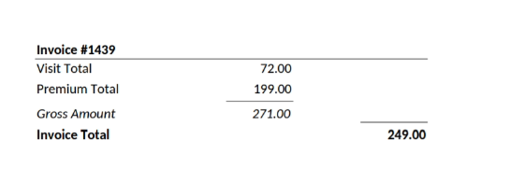

Statement Summary Page: Additional Details

The two fields in this section allows you to provide billing contacts with more information about where to direct questions and how to make payments on the invoice:
Number in sample | Field | Description
1. | Invoice questions | This field will display the text entered in the Invoice Questions to box in Settings>System Settings>Accounting.
2. | Payment instructions | This field will display the text entered in the Payment Instructions box in Settings>System Settings>Accounting.

Statement Summary Page: Footer

The invoice footer consists of a remittance stub that can be detached from the rest of the invoice and returned with the payment to the agency. You can remove this section of the invoice by selecting On for the Hide Remittance Slip system setting.
Number in sample | Field name | Description
1 | Remit instructions | The text under the line for the remittance stub will be pulled from the text entered in the Remit Instructions field in Settings>System Settings>Accounting.
2 | Agency information | This field will display the same agency contact information found in the header.
3 | Client name | The client’s name will appear in the same format as in the heading.
4 | Invoice # | The invoice number from the header will appear again.
5 | Invoice Date | The invoice date from the header appear again.
6 | Due Date | If an invoice due date appeared in the header, it will appear again here.
7 | Amount Due | This field will only be displayed if On is selected for the Display Amount Due in Remit Slip system setting.
8 | Amount Paid | This box is hardcoded and will appear in the remittance stub on each invoice.

Page 2: Invoice Details

The invoice details pages of the invoice display information about each visit, premium, or miscellaneous charge that make up the total amount charged on the invoice.
Example: Lines selected for the Invoice Detail Table Rendering system setting, Client Name | Invoice Number selected for Page 2 Context in the Header, /hour | /rate selected for Display Rate with Unit
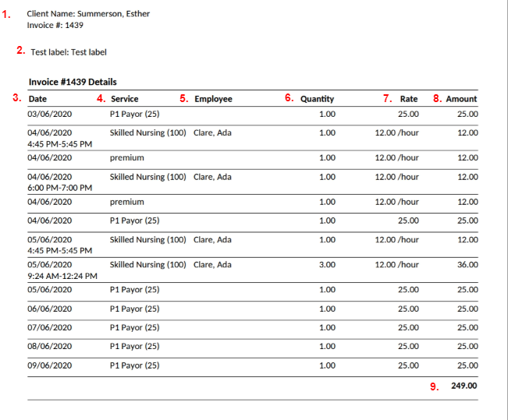
Number in sample | Field name | Description
1 | Multi-page header | If an option other than Do not display is selected in the Page 2 Context in the Header system setting, the selected information will be displayed here.
2 | Invoice labels | Any invoice labels added to one of the client services billed on the invoice will appear in this part of the document. One label will appear per line. If the same invoice label is attached to more than one service on the invoice, the label will only appear once on the invoice.
3 | Date/Time | If applicable, the date of the visit in the format specified in the Override Tenant Date Format field in Settings>System Settings>Accounting. For client billing premiums, the date shown will be the date on which the billing premium was applied (according to the frequency).  A time range may also appear if the billable item is a visit.  If the setting is not set to Hide, the visit’s scheduled start time and end time will display in the format specified in the Override Tenant Time Format field in Settings>System Settings>Accounting.
4 | Service | For visits and premiums, the service description will correspond to the value selected in the Service Description for Visits and Service Description for Premiums system settings. If the item is a miscellaneous charge, the Description will appear in this field.
5 | Employee | If applicable, the name of the employee who completed the visit in the format specified in the Employee Name Override setting in Settings>System Settings>Accounting. Note that if you select Hide, this column will not appear.
6 | Quantity | The quantity of the approved billable item.
7 | Rate | The bill rate applied to the billable item. If an option other No unit displayed is selected for Display Rate with Unit, the unit will also be displayed.
8 | Amount | The total amount charged for the billable item.
9 | Total | The total amount billed on the invoice will be displayed here if On is selected for the Display a Grid Total on the Multi-Page Invoice system setting.

Requesting changes to the new invoice

If you require custom changes to the new invoice, please reach out to your Client Success Manager or Client Relationship Manager. Our team will evaluate whether your request can be incorporated into the generic template or whether a customized version will need to be developed and priced out for you.

