Single Payor Billing

User Guide

Version 1.1
Contents
Introduction to single payor 2
Selecting single payor as the funding methodology 2
Creating the billing periods 3
Generating the invoices 5
Reviewing single payor invoices 8

Introduction to single payor

AlayaCare’s new single payor billing methodology allows you to invoice a single bill-to party for a client’s billable items for a billing period based on a set frequency. A billable item refers to a source item (visit, visit premium, or client billing premium) that has been approved and has a rate.
Please note that equipment and supplies, and income items are not currently supported.
Billing periods for single payor follow a set frequency of 1 weeks, 2 weeks, 4 weeks, or per calendar month. Once you create a billing period for a specific frequency, you will not be able to choose the start date for the period because there can be no gaps between billing periods of the same frequency.
To use this methodology, you must select single payor as the funding methodology on the client’s services and premiums and select a billing frequency. When you are ready to bill for the services and premiums, you will create a billing period for the frequency and generate the invoices for all billable items that fall within the billing period for the client and payor. Any billable items that have not yet been included in a billing period will also be invoiced.

Selecting single payor as the funding methodology

You can set single payor as the funding methodology on services and client billing premiums.
When creating a service for a client, select single payor as the funding methodology.
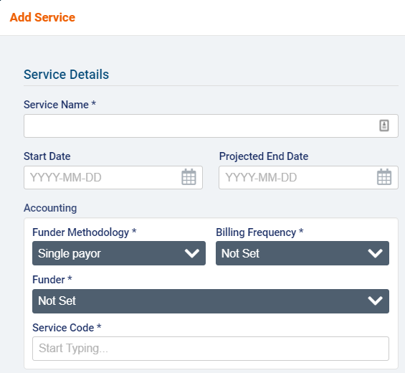
Next, select a billing frequency (1 week, 2 weeks, 4 weeks, calendar month), funder (client individual or funder individual), and service code.

When adding a new client billing premium, select single payor as the funding methodology. Then select a billing frequency and funder.
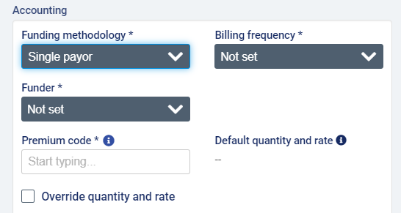
Note that you will not be able to edit the funding methodology on a service or client billing premium that is currently included on active invoices. To edit the funding methodology, you would need to first delete or void the invoices the service or premium is included on.

Creating the billing periods

To generate invoices for single payor services and client billing premiums, you will need to create a billing period for the frequency you wish to bill for by going to Accounting>Billing>Billing Period for Payor Program.
You will see all existing billing periods by frequency listed along with their Billing Frequency, Branch (if applicable), Start Date, End Date, Duration, Invoice Date, number of Draft Invoices, number of Sent Invoices, and status of any Background Jobs listed here. Note that billing periods are created by branch and billing frequency. There can be no overlap between periods in terms of branch and frequency.
Select +Create Billing Period.
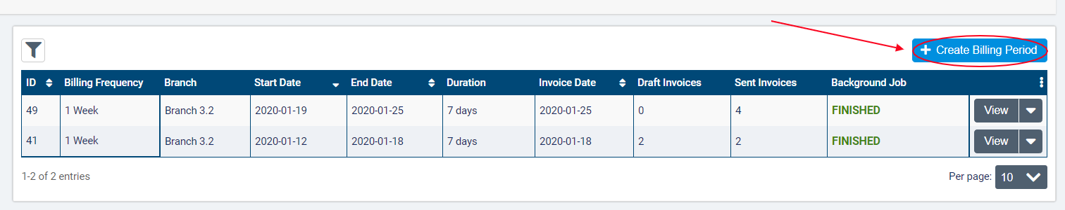
In the dialogue, select the Branch and Billing Frequency (1 Week, 2 Weeks, 4 Weeks, or Calendar Month) and enter a Start and End Date along with an Invoice Date. The Start Date can only be set on the first period created for the Billing Frequency (of the same branch).
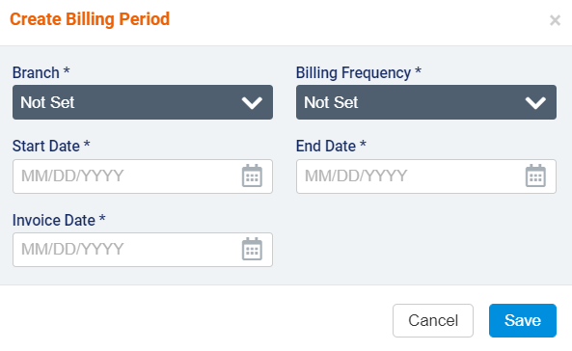
If a billing period already exists for the Billing Frequency selected, the Start Date will be set to the End Date of the previous period plus one day.
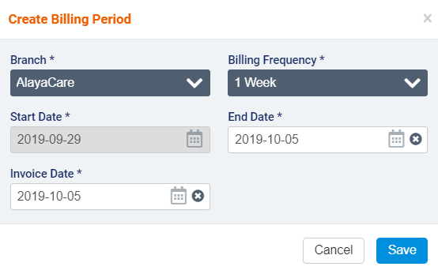
When you have finished, click Save.
Click the downward arrow next to View if you need to Edit or Delete the billing period or Restrict New Shifts.
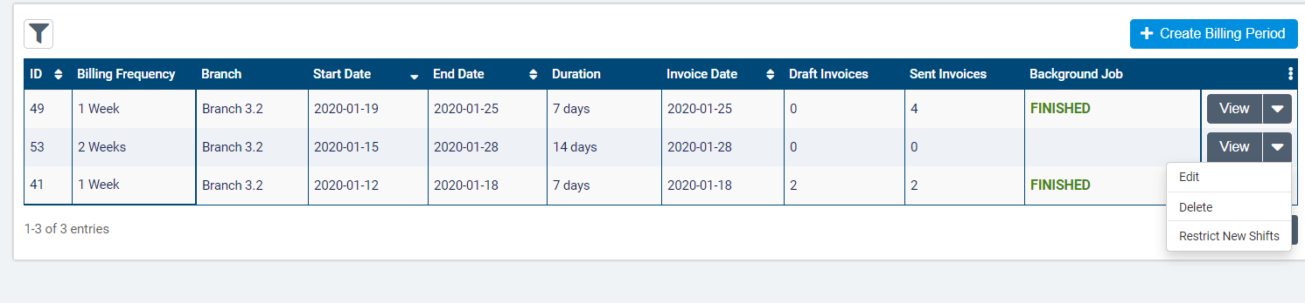
Note that you can only edit the most recent billing period for the branch and frequency. You can modify the Invoice Date, End Date, and Start Date (if it is the first billing period for the branch and frequency) as long as there are no invoices for the billing period yet. If invoices have already been generated for the billing period, you will not be able to edit it.
The status in the Background Job column refers to the status of invoice generation and regeneration processes. If a status of Failed or Partial Success is displayed, you can click the icon to view more details.
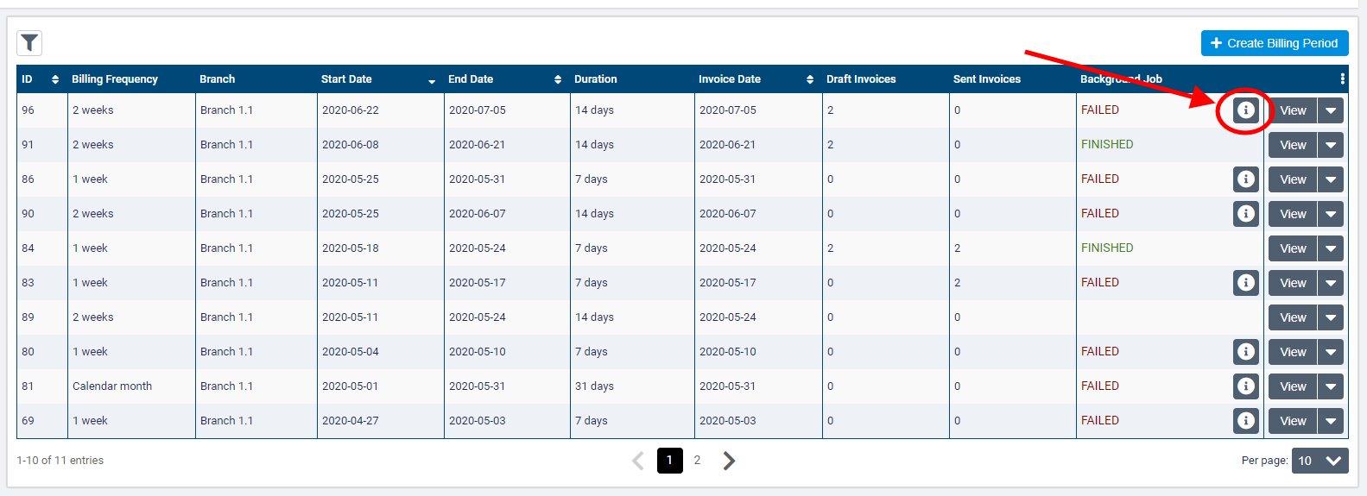

Generating the invoices

When you are ready to proceed with the invoicing process, click View to open the billing period. Note that if your organization is multi-office, the application will switch to the branch that owns the billing period and filter content accordingly.
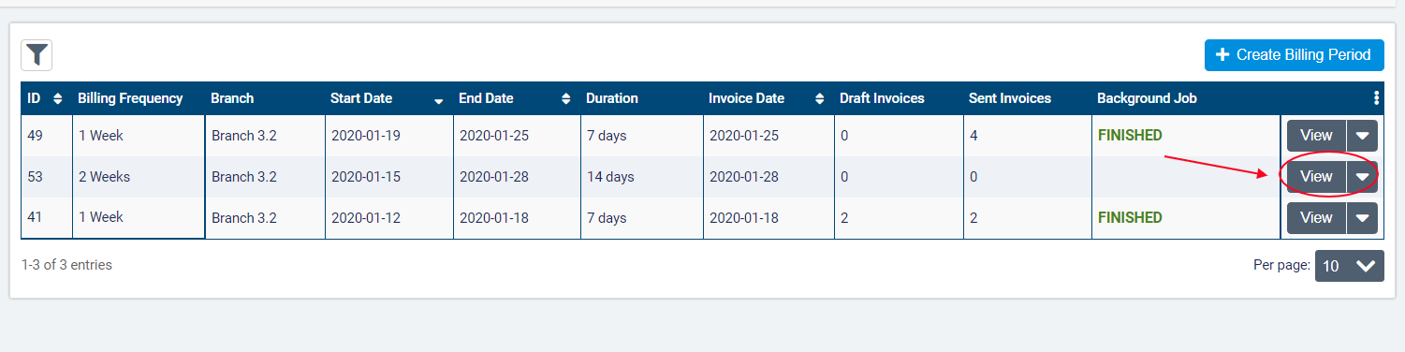

Clicking View will open the Visits tab within the billing period. From here, you can approve all visits and premiums included in the billing period and resolve any unscheduled visits as you would before generating invoices using the old billing methodology in AlayaCare.
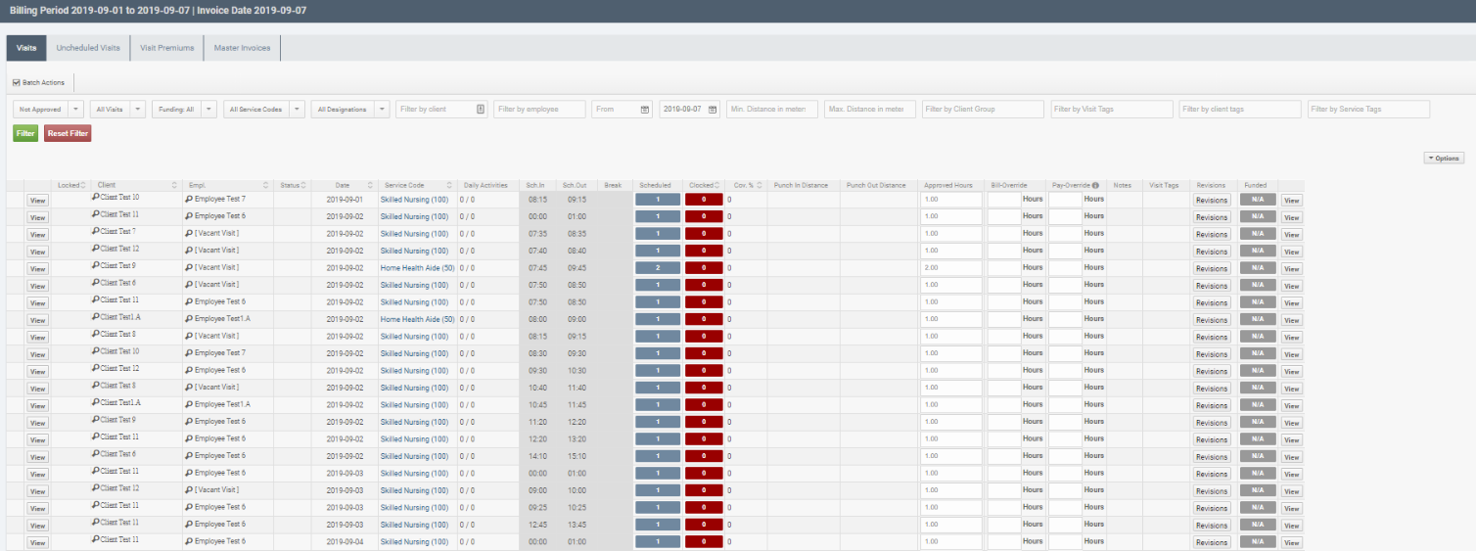
When you have finished approving source items, click on the Master Invoices tab and select Generate Invoices. This action will queue a background job to generate invoices.
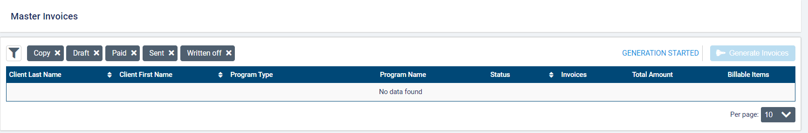
Once you click to generate the invoices for the approved source items during the billing process, the system will check each billable item in the billing period to see if it has single payor or a payor program selected as its funding methodology. If the funding methodology is single payor, the item will be included on an invoice and billed to the funder selected on the service or billing premium.
If the status if the generation background job is Partial Success or Failure, an info icon will appear next to the status.
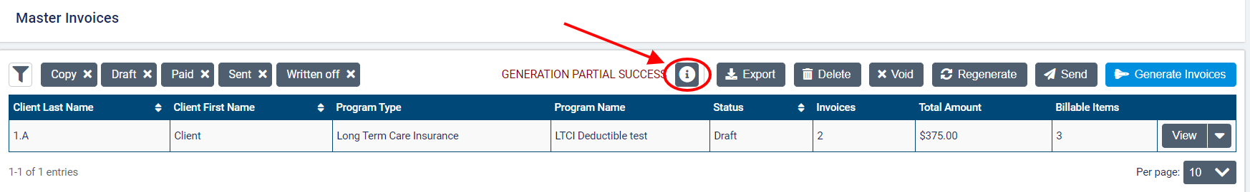
Click the icon to view the Background Job Report and identify which programs caused errors during the invoice generation.
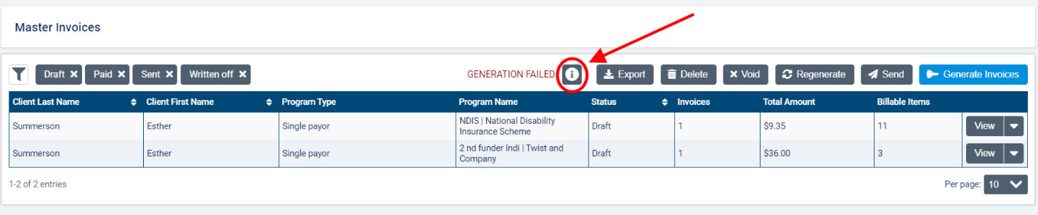
Once the generation background job has finished, the Master Invoices list will display the Program Name, Master Invoice Status, number of Invoices generated, Total Amount owed, and number of Billable Items for each master invoice. When using single payor, the program type will be Single Payor, and the Program Name will be the funder name.
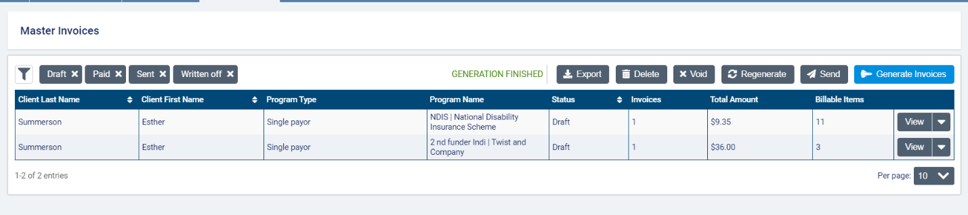
The status of the master invoice depends on the status of all invoices for that client and program. If all the invoices have the same status (draft, deleted, sent, paid, written off, or void), then that will be the status displayed in the master invoices list. If at least one of the invoices has a status of paid, written off, or copy, then the master invoice status is sent. Note that the master invoice cannot have a status of copy.
You can filter this list by Client Name, Status, and Program Type. By default, the list will filter to all statuses other than void and deleted.
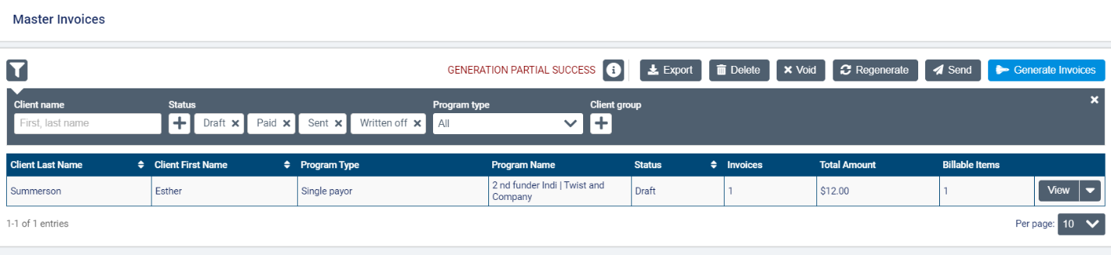
At the top of the list, you will see action buttons to Export, Delete, Void, Send, and Regenerate invoices. Use these buttons to perform actions on all invoices in the Master Invoices list. When choosing one of these actions, any master invoices that the selected action cannot apply to will be filtered out (only invoices in draft status can be deleted, sent, or regenerated, and only sent invoices can be voided).
After clicking the action button, you will be able to select which invoices you wish to perform the action by checking the box next to the client-program invoices you wish to include or clicking the box in the top left corner to select all. Then click the blue action button action (Export, Regenerate, Delete, Send, etc.)
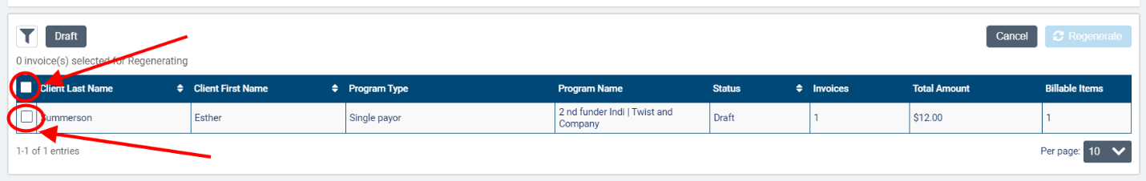
To perform actions on a specific master invoice, click the downward arrow next to View. For invoices with a status of draft, you have the option to Send, Delete, or Regenerate. For invoices that have been sent, you have the option to Void. None of these actions can be performed from this list on invoices with a status of deleted, paid, written off, void, or copy.
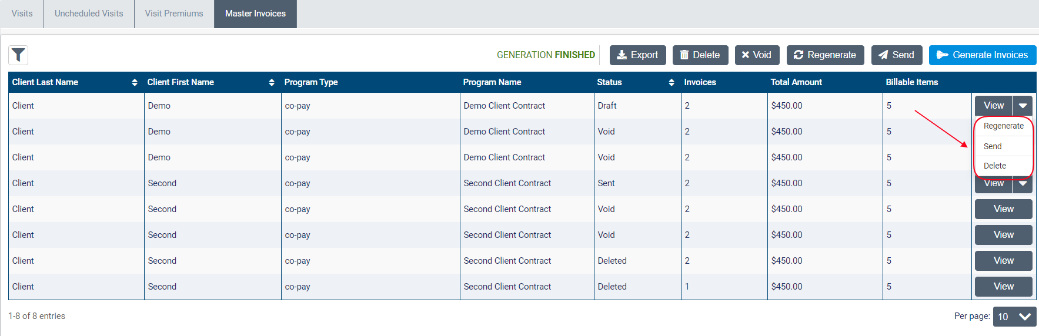
Keep in mind that clicking Generate Invoices again will create invoices for any client programs or single payor services and billing premiums that do not have a master invoice for the billing period yet but will not modify any existing invoices. Clicking Regenerate will delete the master invoice selected and re-run the background job to account for any changes to the source items. The version number of the invoice will be indicated in the invoice number for the individual draft invoices.

Reviewing single payor invoices

Click View to review an invoice generated for any single payor funded client services and premiums.
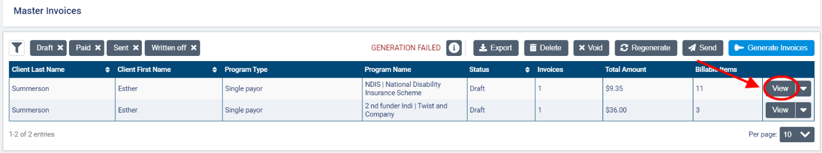
This will open a screen that displays the billing details along with a list of all billable items included on the invoice.
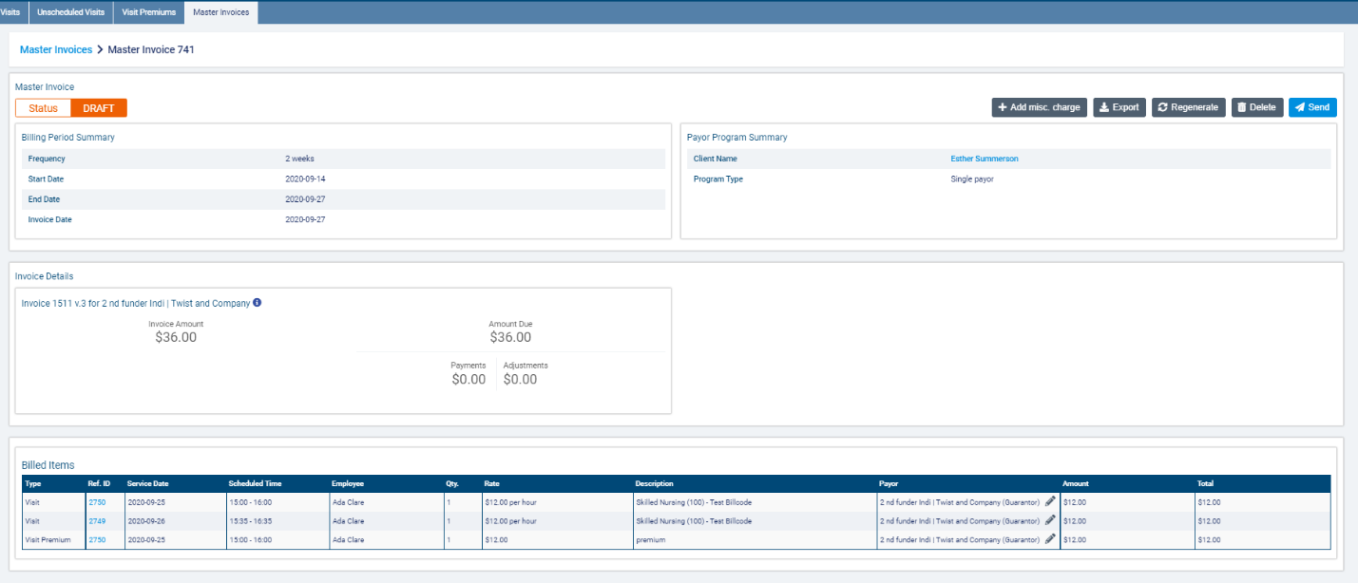
Depending on the status of the invoice, different action buttons will be available (+Add Misc. Charge, Delete, Send, and Regenerate if draft and Void if sent). Export will be available for invoices of all statuses.
For invoices in draft status, you will also be able to add miscellaneous charges by clicking the Add Misc. Charge button.
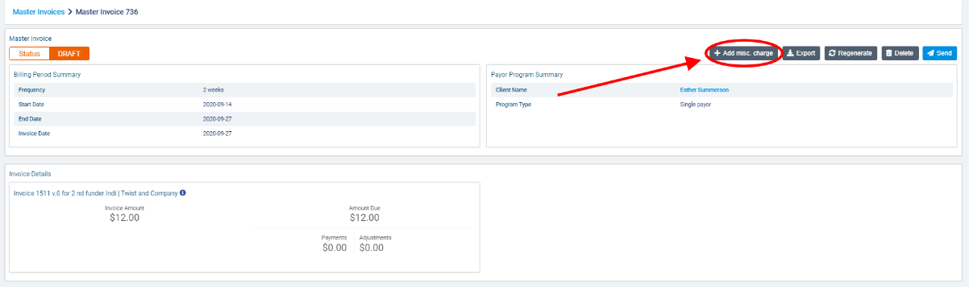
In the Add misc. charge dialogue, enter a Description of the charge being added. This description will appear on the invoice.
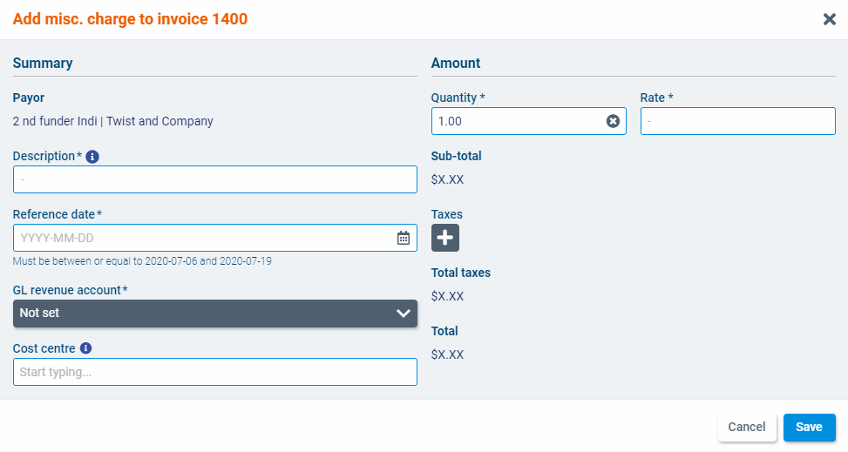
Select a Reference date, GL revenue account, and if applicable, a Cost Centre. The reference date will be the date shown for the charge on the invoice. Note that only dates within the current billing period can be select. The cost centre field will only be displayed if cost centres are configured for your organization.
Enter the Quantity and Rate of the charge. The quantity must be above 0 and can contain up to 2 decimals. Once entered, the Sub-total (excluding taxes) will appear below.
Finally, select one or more Tax that should apply on the charge if necessary. The taxes available to select will correspond to the taxes available in the branch that the payor program belongs to. The Total taxes and Total amount of the charge (including taxes) will appear in the corresponding fields.
When you have finished, click Save. The charge will be added to a Miscellaneous Charges list in the Invoice Billable Items section.
To download the invoice, click the Export button. In the dialogue box, AC Standard Invoice will be selected as the Invoice Export Type and PDF as the Format. If you are using the two-page invoice, you will also be able to select the AC Standard Invoice with Summary Page. When ready, click Export.
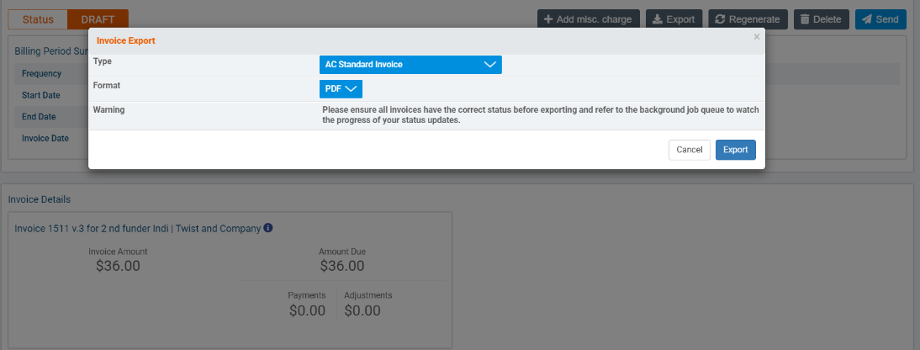
In the Invoice Details section, you will see the Invoice Number and Payor Name, Invoice Amount, Amount Due along with any Payments and Adjustments for the payor. If the invoice has been regenerated to account for any changes to the source items, the version number will be indicated in the invoice numbers (53 v.0, 53 v.1, etc.).
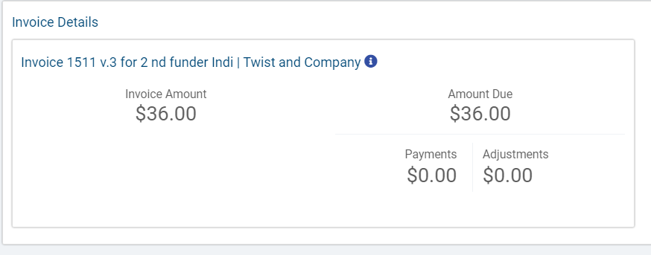

In the Billed Items section, you will see details about the visits and premiums included on the invoice. The Type, Reference ID, Service Date, Scheduled Time, Employee, Quantity, Rate, Description, Amount and Total cost charged will be listed for each item. You will also be able to click on a hyperlink for the billable item in the Ref ID field to view more details about the visit or premium.
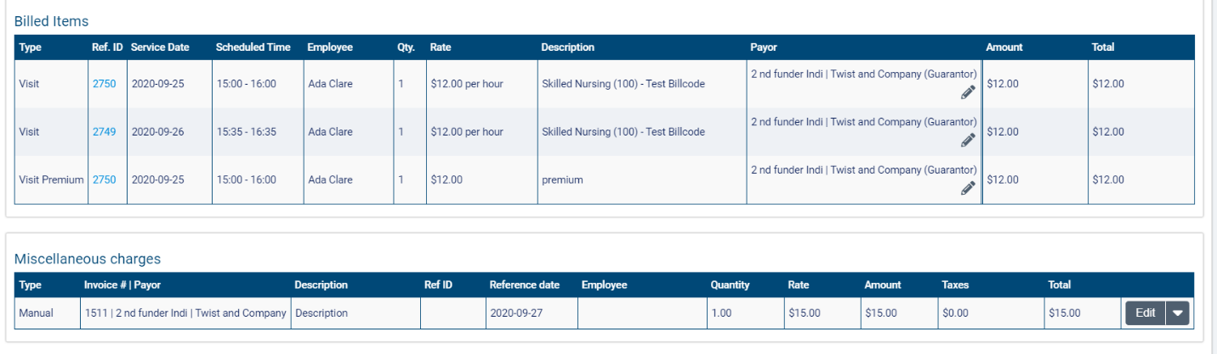
If any additional charges have been added to the invoices, the Invoice Billable Items section will also contain a Miscellaneous Charges list.
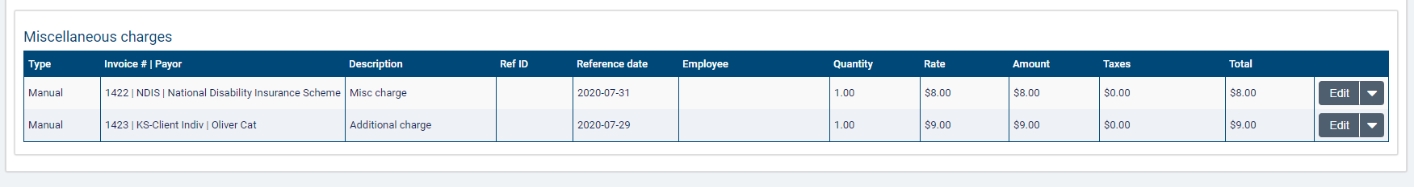
The Type, Invoice # and Payor (the funder name), Description, Ref ID (if applicable), Reference date, Employee (if applicable), Quantity, Rate, Amount, Taxes, and Total will be listed for each charge. The Type will be Manual if the charge was created on an invoice and Automatic if it was added to an invoice during the invoice generation process. Note that the Ref ID field will only be filled out for charges of type automatic. As with other billable items, it will contain a hyperlink that opens the visit, visit premium, or client billing premium. The Employee field will be filled out if the charge is a visit or visit premium. Select Edit to make changes to the charge.
When you are ready to mark the invoices as Sent, click Send.
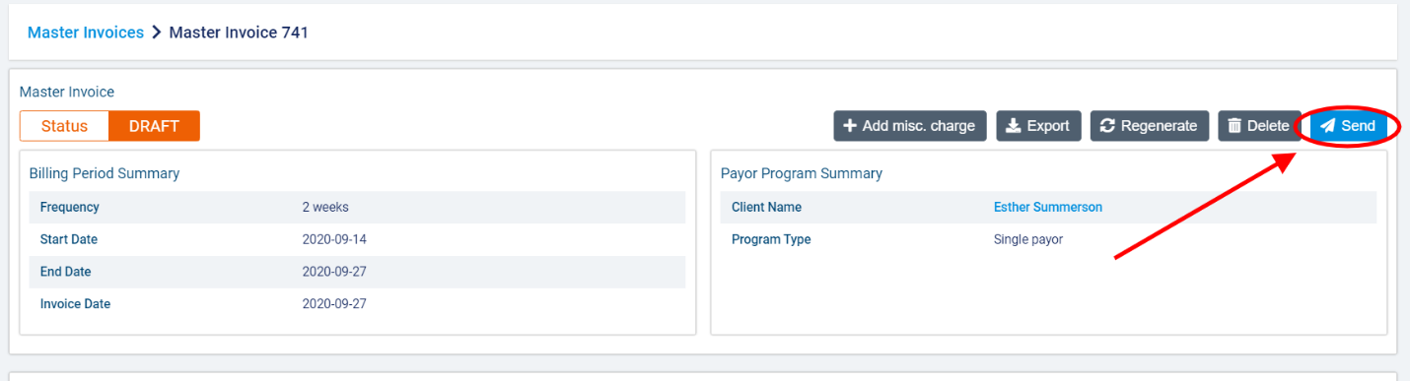
In the dialogue box, click Send to confirm.
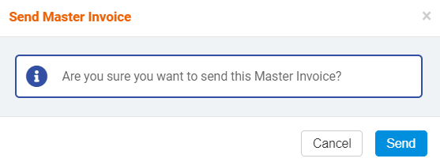
Once the invoices have been sent, you can add transactions to the individual invoices as necessary. Click the +Add Transaction button on the invoice.
Note that you must be in a role that has the Manage Transactions ACL to view this button.
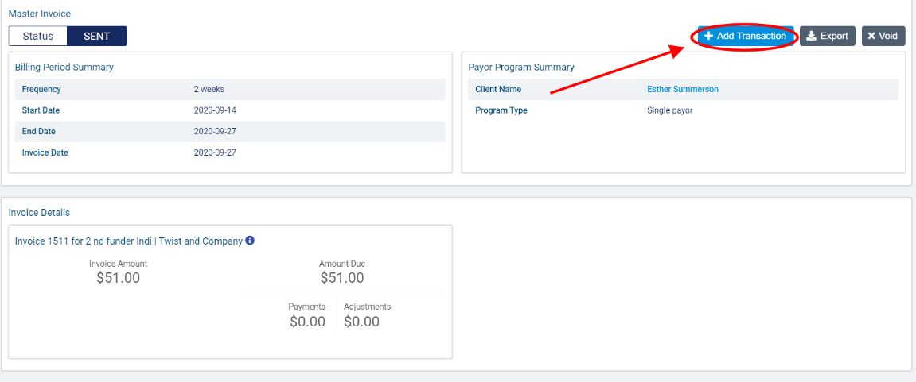
In the Add Transaction dialogue, select the Transaction Type (Payment, Credit Note, Writeoff) and complete the required fields. When you have finished, click Save.
