Creating Payor Programs for Clients
User Guide

Version 1.5
Contents
What are payor programs? 2
What are the different types of payor programs available? 3
Long-term care insurance 4
How do I add a long-term care insurance payor program for a client? 4
Co-Payment 18
How do I create a co-payment payor program for a client? 19
Split percentage 28
How do I create a split percentage payor program for a client? 28
Co-Contribution 35
How do I create a co-contribution payor program for a client? 35
Adding the payor program to client services and billing premiums 41
Appendix A: glossary of terms 44

What are payor programs?

Payor programs are configured at the client level to create a series of rules for determining which payors are invoiced for what portion of the billable items in a billing period.
Every payor program for a client contains a set of informational fields and benefit rules referred to as a policy or contract, depending on the type. The benefit rules determine how much will be billed to the payor on the policy/contract.
You can create different versions of the benefit rules on a policy or contract with different effective dates or start and end dates. The dates of different policy/contract versions cannot overlap with one another.
The payor on the policy or contract is the bill-to party who will be invoiced for a portion of the billable items dictated by the rule set on the policy/contract. The guarantor is the bill-to party who will be invoiced for the remainder of the invoice balances after the program rules have been applied to the billable items.
Once you have created your payor program, you must attach it to any client services or billing premiums for which the rules on the program should apply. When adding a program to a service or client billing premium, you will select a rating funder. This rating funder will use the associated bill codes to determine the rates that will be used to bill for the service or premium during the invoice generation process.
Once items are approved and you begin the invoice generation process, the system will apply the rules on the payor program using the rates associated with the rating funder and generate the invoices for the different bill-to parties.
There are different types of payor programs. The type determines the kinds of rules you can set to determine how to split an invoice during the billing process. The type that you select for a payor program will dictate which rule fields and informational fields will be available for completion when adding a policy or contract to a client’s profile.

What are the different types of payor programs available?
The table below provides an overview of the major differences between the types of payor programs currently available in AlayaCare:
Type | Program characteristics
Long-Term Care Insurance | - Ability to set benefit rules using a term and limit on policies  - Term types available: amount or percentage  - Lifetime maximum available as term and limit frequencies  - More than policy can be added to a program and sequenced in the desired order  - Deductibles can set on policies (as an amount or number of calendar or service days)  - Premiums must be 100% covered by either the payor on a policy or the guarantor  - Funder selected as the guarantor must be client individual  - The program can be versioned
Co-payment | - Ability to set benefit rules using a term and limit on contracts  - Term type available: amount  - Only one contract can be added to a program, but contracts can be deleted or versioned  - Deductibles can be set on contracts (as an amount or number of calendar or service days)  - Premiums must be 100% by either the payor on a contract or the guarantor  - Funder selected as the guarantor can be either funder individual or client individual  - The program can be versioned
Split percentage | - Ability to split the cost of billable items based on the distribution percentage set for each payor on the contract  - Ability to set different guarantors at the program and contract levels  - Premiums can either be 100% covered by a payor or contract guarantor or split according to the distribution percentage set for each payor  - Funder selected as guarantors (contract and program level) can be client individual or funder individual  - The program can be versioned
Co-contribution | - The co-contribution payor can either be the guarantor or a second payor  - Ability to create a service at any time using the program that is billed by a payor while billing the guarantor 100% of the client’s service costs  - Ability to set a limit on the payor contribution  - Selected premiums can either by covered in full by the payor or the guarantor  - Funder selected as the guarantor can be client individual or funder individual  - The program can be versioned

Long-term care insurance

Long-term care insurance is one type of payor program. This type of program is specifically designed for situations in which a portion of a client’s care is covered by one or more long-term care insurance policies.
In long-term care insurance, the set of rules added to a program is referred to as a policy. You can add multiple policies to a single program and determine the sequence in which the policies will apply (in other words, once the rules on one policy have been applied to a billable item, the rules on the next policy in the sequence will be applied, as long as multiple policies are currently in effect).
Lifetime maximum is also an available term or limit frequency in long-term care insurance programs. The lifetime maximum is the total amount that can be used for coverage. The policy will no longer be in effect as soon as the lifetime maximum is reached.
Additionally, you have the option to add a deductible for long-term care insurance policies. You can either to choose to set a deductible amount that the guarantor will be invoiced for before the benefit rules on the policy go into effect or set an elimination period representing the number of days during which the guarantor will be invoiced for the full amount of the billable items until the benefit rules can be applied. You can select either Elimination by service days or Elimination by calendar days depending on how the policy determines the elimination period.
Note that the funder type of the guarantor must be client individual in long-term care insurance policies.

How do I add a long-term care insurance payor program for a client?

Payor programs are set up at the client level.
You must be in a role configured with the View Payor Program and Manage Payor Program ACLs in Settings>Roles and Permissions to view, add, and edit payor programs for clients.
To add a new program, go to Accounting>Payor Invoicing on the client’s profile and select +Add Program.
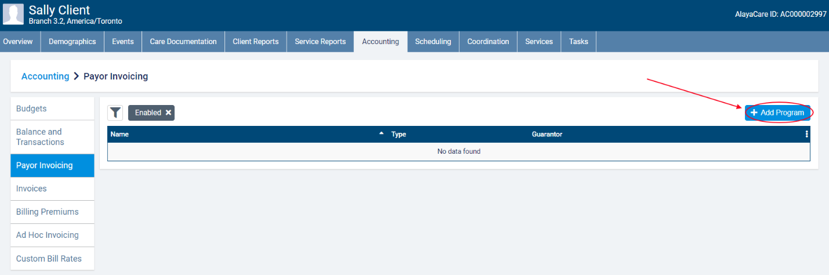
In the Add Payor Program dialogue, enter the Name of the Payor Program and select Long-Term Care Insurance as the Type.
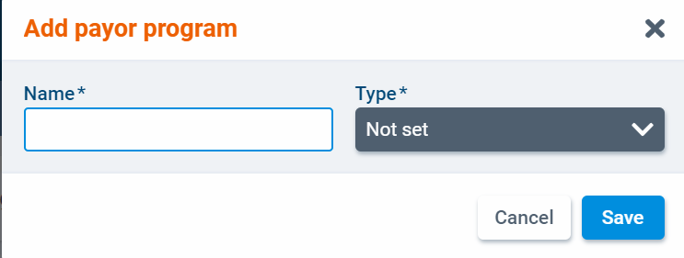
Next, select a client individual-type funder as the program guarantor. You will also need to select a billing contact.
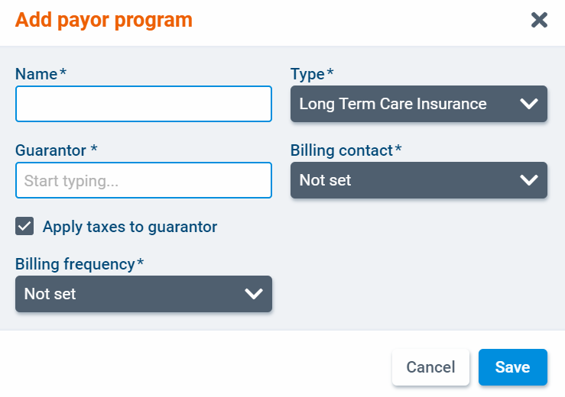
Check the box next to Apply taxes to guarantor if applicable. This setting will determine if taxes set at the bill code level should be applied to items billed to the guarantor.
Finally, select a billing frequency. In payor invoicing, billing periods are determined by the billing frequency. The available billing frequencies for payor programs are 1 Week, 2 Weeks, 4 Weeks, and Calendar Month. When you have finished, click Save.
The program will open as a new screen. Select Edit to make changes to the program details.
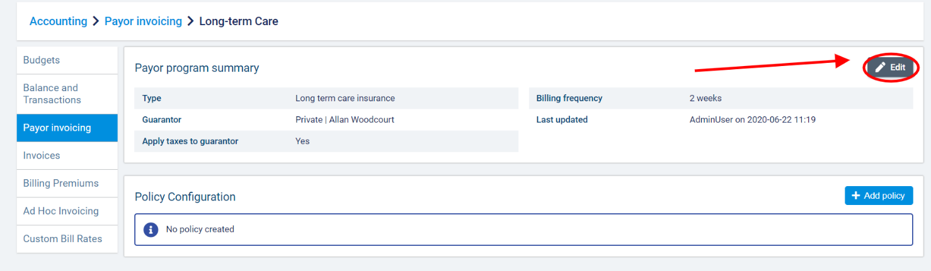
Once you have created a program, you can add one or more insurance policies. A policy specifies the benefit rules that will be used to determine how billable items linked to the program are invoiced. To add a policy to the program, select +Add Policy.
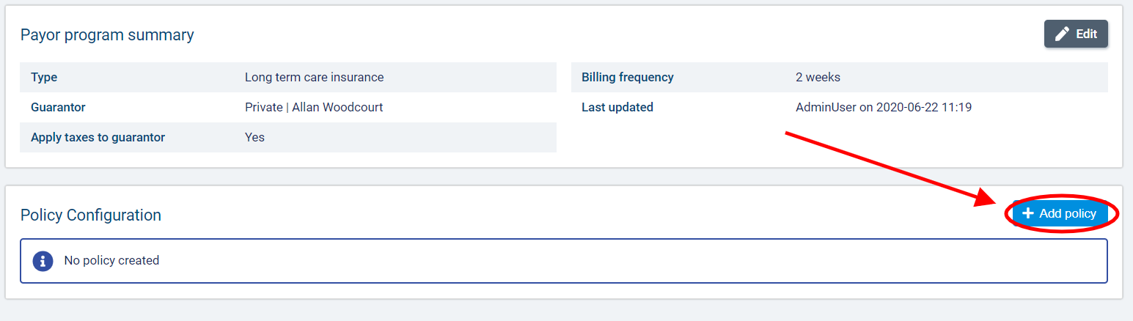
In the Add Policy dialogue, complete the required fields.
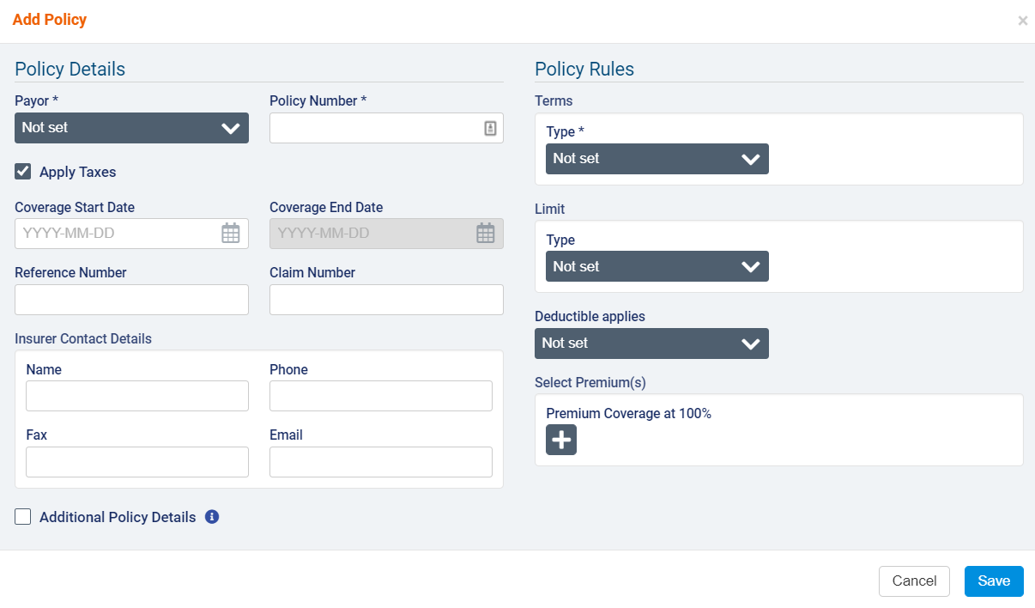
Under Policy Details, select a funder to represent the Payor. You can select any enabled funder individual or client individual funders available to the branch that the client belongs to. Next, enter the Policy Number and Start Date. If necessary, enter the Coverage Start and End Date, Reference Number, and Claim Number and fill out the Insurer Contact Details section.
Use the Apply Taxes checkbox if you wish to apply taxes set at the bill code level to billable items covered by this policy.
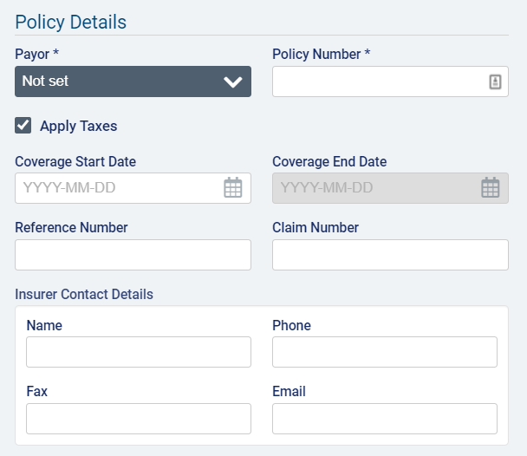
Select the box next to Additional Policy Details to complete more informational fields specific to long-term care insurance. The fields are Inflation Rider (%), Anniversary Date, Restoration Policy (in number of days), and Assignment of Benefits (yes or no). Note that these fields are for informational purposes only and will not in any way affect how the rules are applied to billable items.
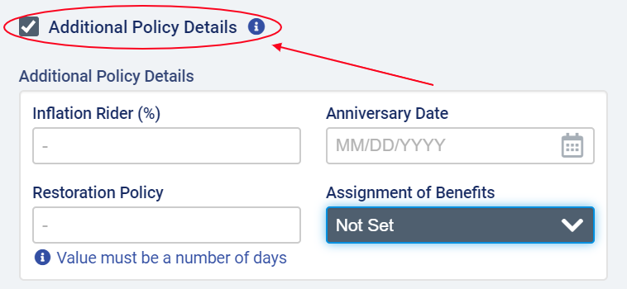

Under Policy Rules, select Amount or Percentage as the Term Type.
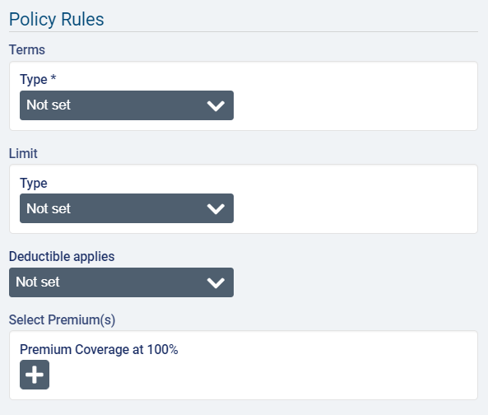
If you select Percentage, enter the value in the Percentage field.
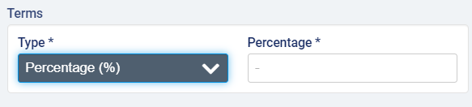
Example scenario for term in percentage: for instance, if you enter 60% as the percentage and do not enter a limit, the payor on the policy will be invoiced for 60% of a visit’s total cost once the program rules are applied during invoice generation for a billing period. The remaining amount will be passed down to the payor on the next policy or the guarantor. If there are multiple policies in effect with percentage terms, then the percentage rule for the second payor will be applied to the remaining amount (not the total amount) of the billable items.
If you select Amount, you must also select a frequency. The available frequencies are Per Hour, Per Day, Per Week, Per Calendar Month, Per Calendar Year, Per Benefit Year, and Lifetime Maximum.
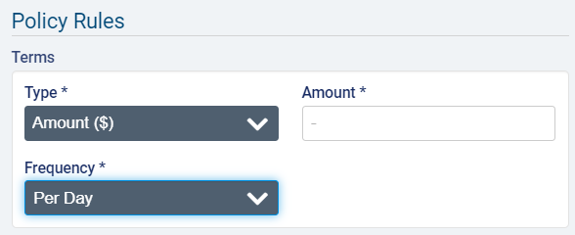
If you select Per Week as the frequency, you must also select a day for Start of Week.
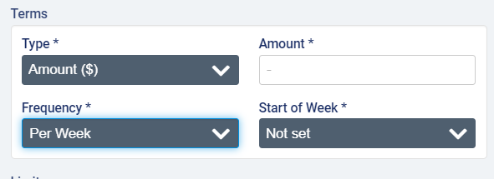

If you select Per Benefit Year as the Frequency, you must also select the Month and Day of the month on which the benefit year begins.
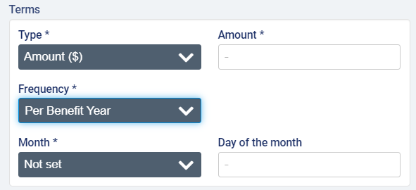
If you select Lifetime Maximum as the Frequency, you also have the option to enter any Outside Expenditures that have already counted toward the lifetime maximum. This could be used in cases where a client has recently transferred and has already used up a portion of their lifetime maximum or in any scenario where you are creating payor programs for clients who have already gone through a portion of the lifetime maximum on a policy. Entering a value here will reduce the lifetime maximum when the policy rules are applied during invoice generation.
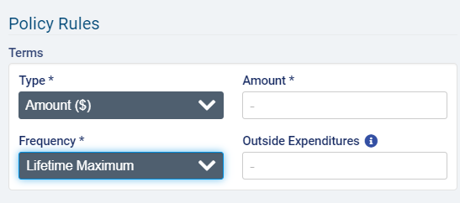
Example scenario for terms in amount (frequency not lifetime maximum): the amount specifies the maximum amount that the payor on the policy will cover for the length of time specified by the frequency. So if $400 is entered as the amount and Per Week is selected as the frequency, when generating invoices for a week in which 3 visits valued at $200 each occurred, the payor will be invoiced $400 for the first two visits and the next payor or the guarantor will be invoiced $200 for the last visit.
Example scenario for terms in amount with lifetime maximum frequency: if lifetime maximum is selected as the frequency, the payor on the policy will no longer be invoiced for any portion of the billable items once the lifetime maximum is reached. For example, if the lifetime maximum is $4000, once the payor has been invoiced for a total of $4000, the rules on the policy will no longer be in effect, and all services tied to the program will be billed to the next payor or guarantor.
After adding the term details, you can also add a limit to the policy. The limit can be an amount or a number of hours or visits over a specific frequency. Per Hour is not an available frequency for limits.
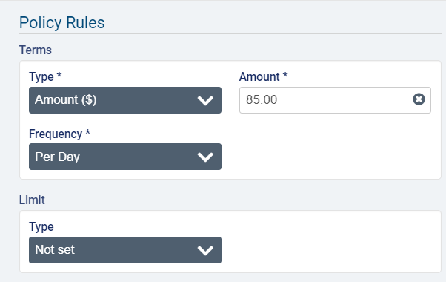
Note that when Amount is selected as the Term Type and Limit Type, the Limit Frequency must always be larger than the Term Frequency (Per Day < Per Week < Calendar Month < Calendar Year/Benefit Year < Lifetime Maximum). If the term has the maximum frequency selected (Lifetime Maximum), then you will not be able to select Amount as the Limit Type.
Example scenario for limit in amount: For instance, the term percentage is 50% and the limit is $100 per week, and the follow visits occurred in one week (visit #1 cost $120 and visit #2 cost $100). The payor will be invoiced $100 (because 50% of visit #1 + 50% of visit #2 = $110, which is over the weekly limit). The guarantor will be billed $120, the total remaining from both visits.
For Limits in Hours, the frequencies Per Day, Per Week, and Per Calendar Month will be available to select.
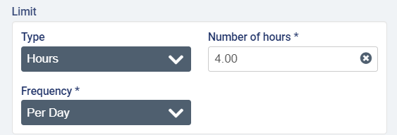
Example scenario with a limit in hours: there are two visits in one week; visit #1 lasted 3 hours and cost $150 and visit #2 lasted 2 hours and cost $100. If the term is a fixed amount of $60 per hour, and the limit is 2 hours per week, the payor will be invoiced $120 for the first visit ($60 x 2h), and the guarantor will be billed the remaining amount of $130.
For Limits in Visits, the frequencies Per Week, Per Calendar Month, Per Calendar Year, and Per Benefit Year will be available to select.
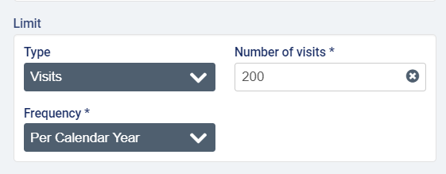
Example scenario with a limit in visits: The term is a fixed amount of $200 per week and the limit is 2 visits per week, and there are two visits in one week (one on Monday charged at $120 and one on Wednesday charged at $100). The payor will be invoiced $120 for the first visit, and the guarantor will be invoiced $100 for the second visit, since the limit on the term has been reached.
If Per Week is selected as the Limit Frequency, you will also need to specify a day as the Start of Week.
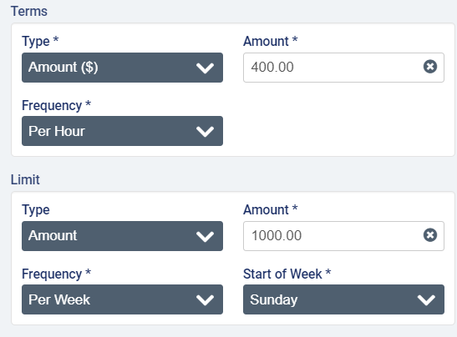

If Amount is selected as the Term Type, the Limit Type is Amount, and the Term Frequency is NOT Lifetime Maximum, you can select Lifetime Maximum as the Limit Frequency and enter the Limit Amount. You will also have the option to enter Outside Expenditures.
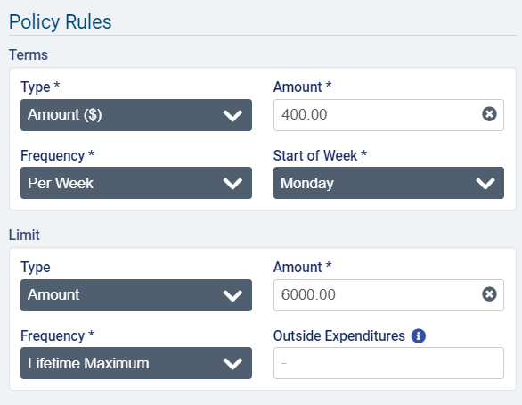
To set a deductible or elimination period on the policy, select an option from the Deductible applies dropdown.
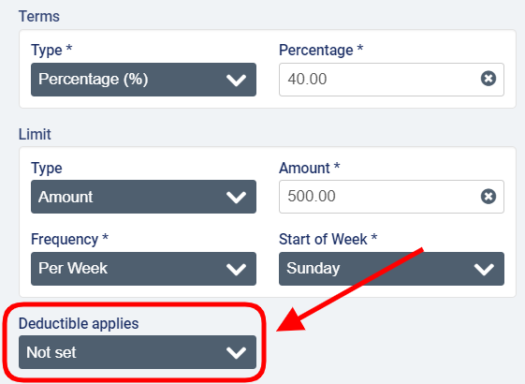
To set an elimination period, select either Elimination by Calendar Days or Elimination by Service Days and then enter the number of days in the period.
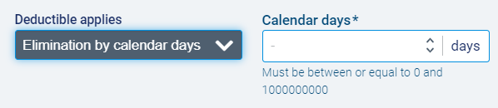

To enter an amount, select deductible amount and enter the value of the deductible.
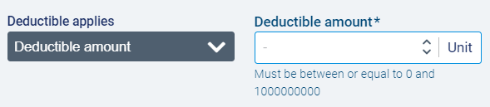
In the Select Premium(s) section, click to select one or more billing premiums configured in Accounting>Accounting Settings>Premiums that should be fully covered by the payor on the policy. Note that premiums must be 100% covered by either the payor or the guarantor (in other words, the cost of premiums cannot be split between two bill-parties if using a long-term care insurance payor program).
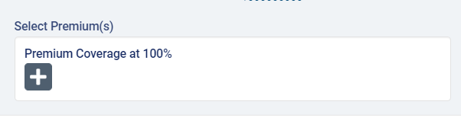
When you have completed on required fields, click Save.
The program page will open with the policy details listed under Policy Configuration. To make changes, select the Edit button.
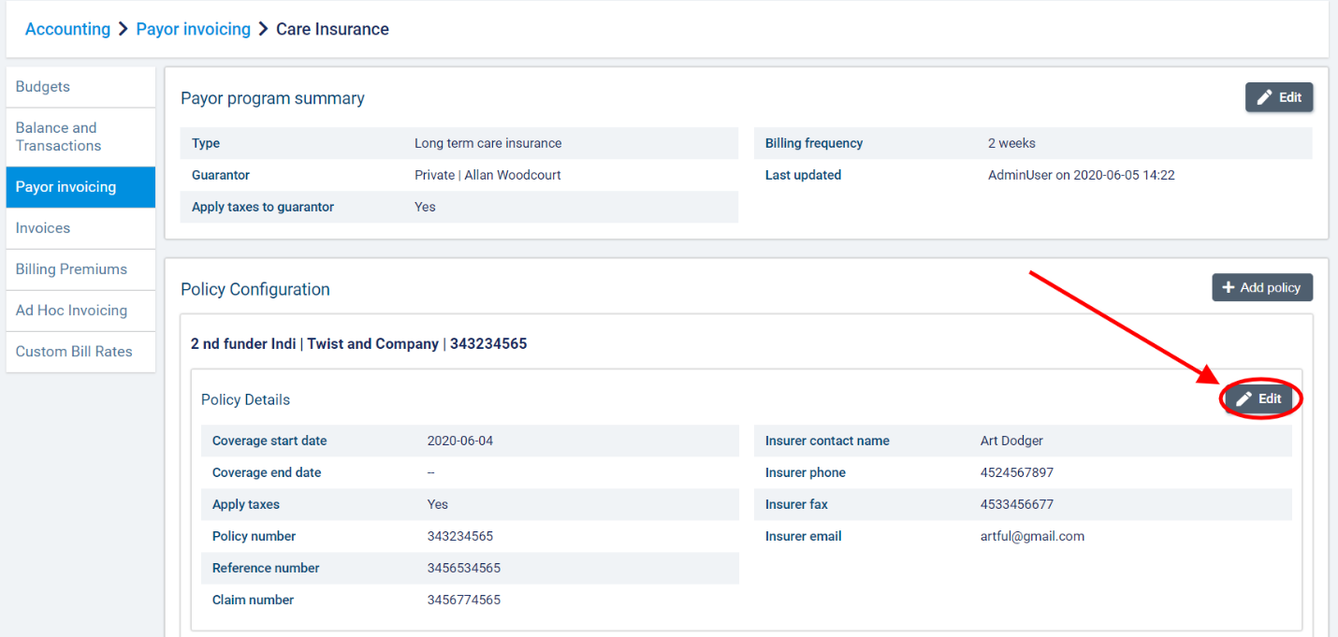

If the policy has never been used to generate invoices, you will be able to edit all the informational fields.
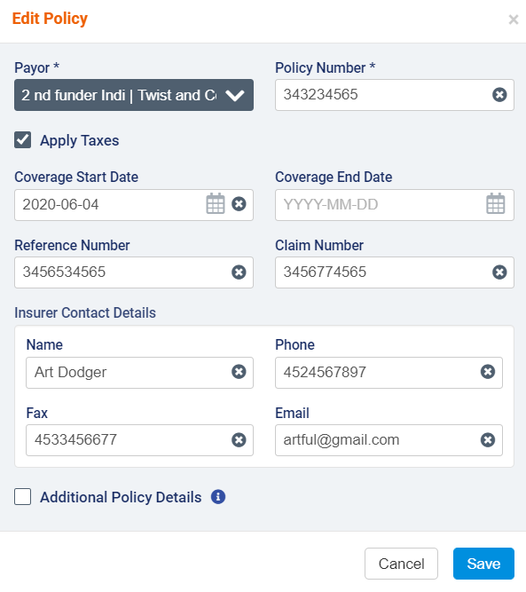
If any draft or sent invoices exist against the policy, certain fields will be disabled for editing (Payor, Policy Number, and Coverage Start Date).
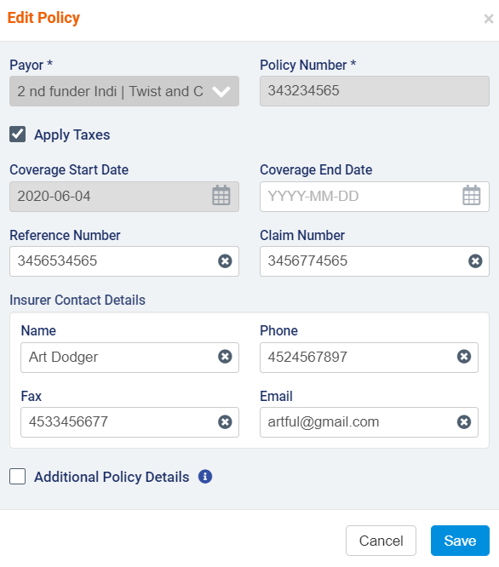

If you need to change the rules for a policy or contract, you can create a new version of the policy. Note that versions cannot have any gaps or overlaps in terms of dates.
To create a version, click the +Add Version button.
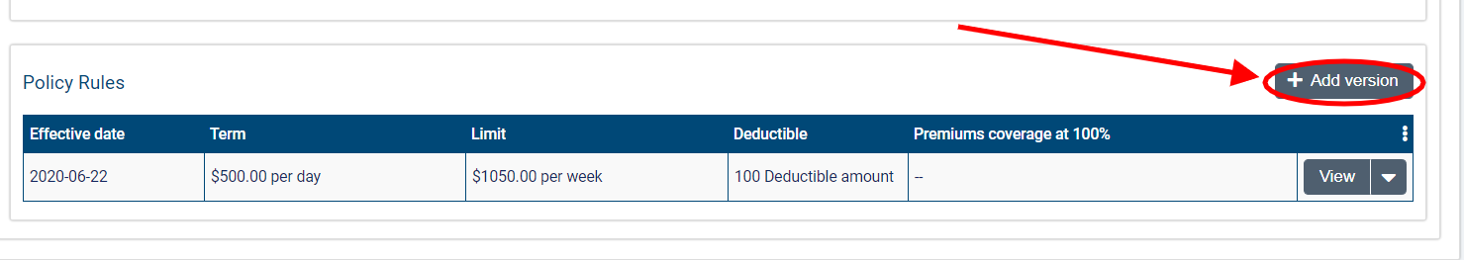
In the Add Version dialogue, enter the Effective Date on which the changes to the policy/contract will apply. This date must be past the Coverage Start Date by at least one day. You will not be able to modify Term Type or Limit Type, but you can make changes to the Term Value, Term Frequency, Limit Value, and Limit Frequency or attach more premiums.
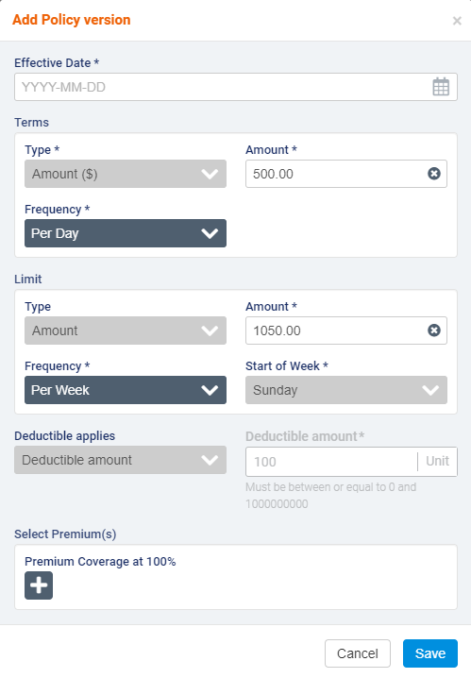
If more than one version of a policy exists, you will not be permitted to modify the Coverage Start Date. If Per Calendar Month is selected as the Term Frequency, note that the Coverage Start Date must be the first day of a month.
When you have finished, click Save to create the new version.
To edit or delete a version, select the downward arrow next to view and select Edit or Delete.
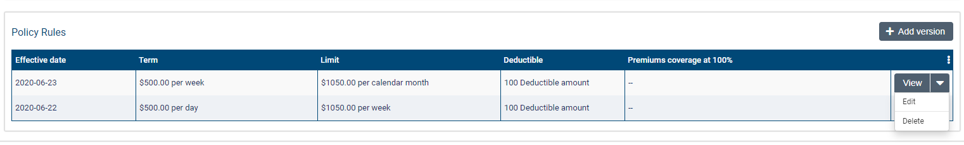
You will not be able to make changes if invoices have been generated for the version.
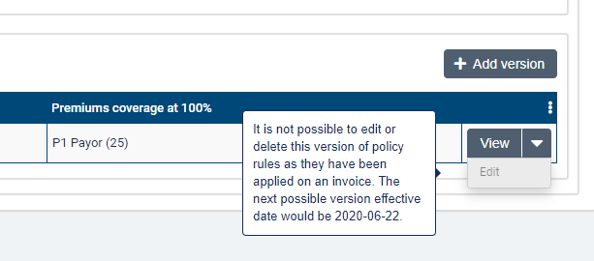
Note that having more than one version will lock the Coverage Start Date field for editing regardless of whether invoices exist against the policy.
You can multiple policies to long-term care insurance policies. Click +Add Policy again to add a new policy to the program.
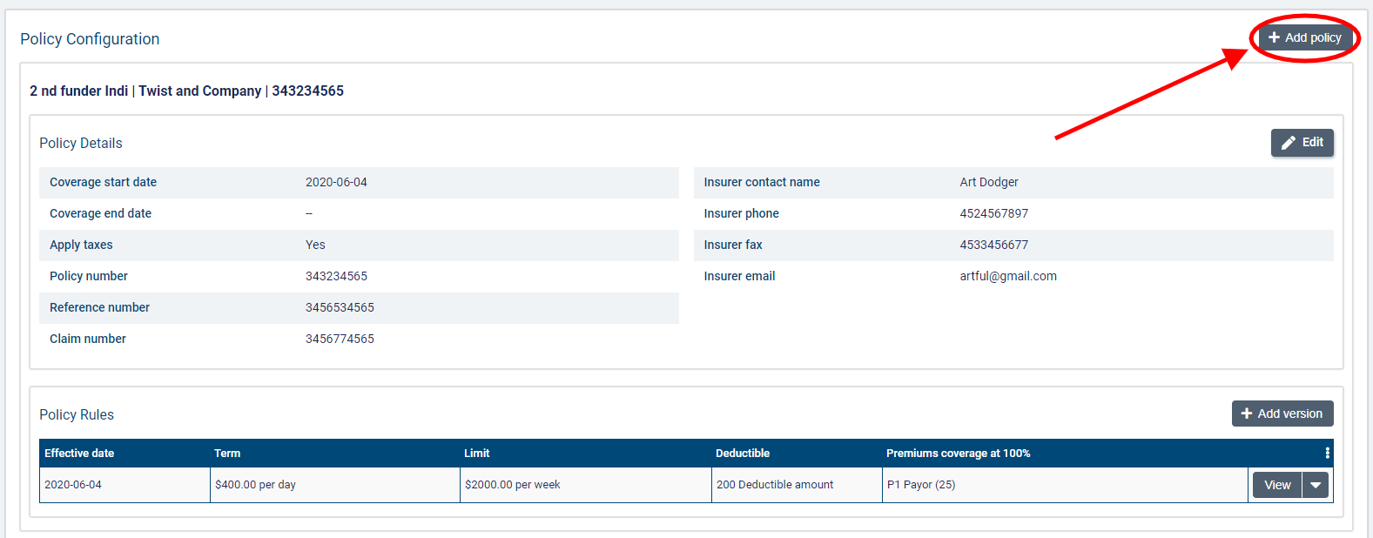

Once you have added another policy, you can choose the sequence in which the policies should apply. Click the Sequence Policies button to adjust the sequencing order as permitted.
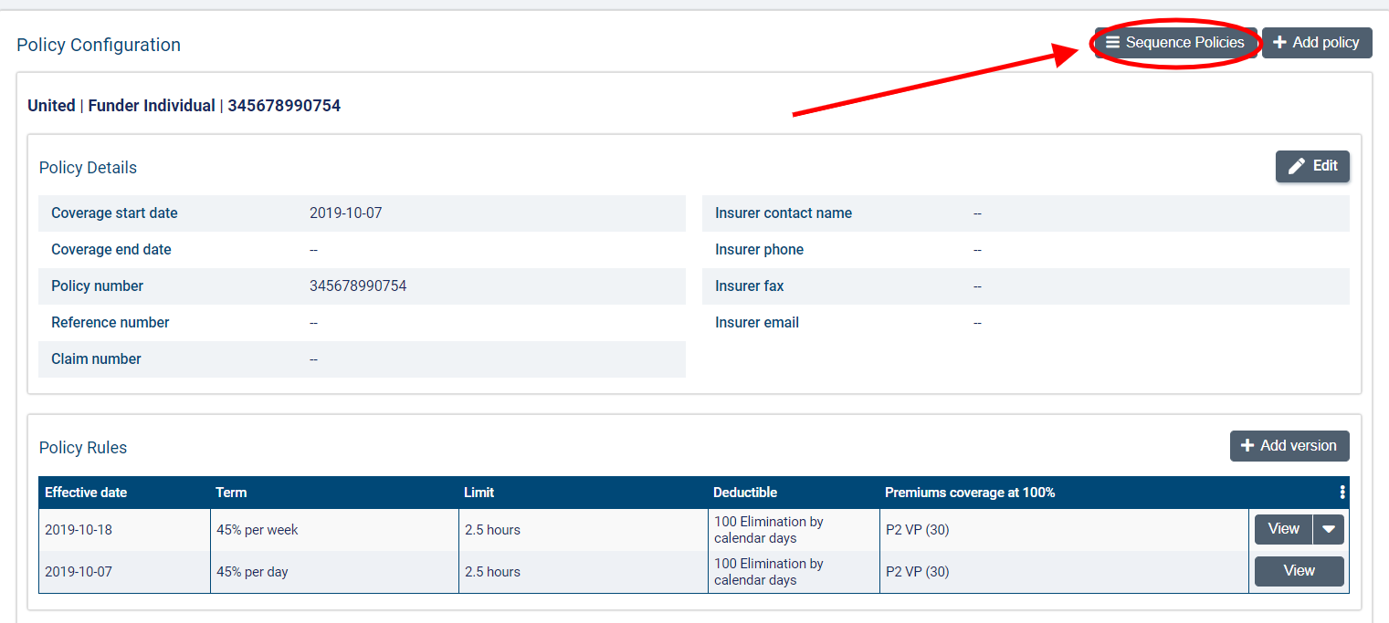
You can then drag and drop the policies into the order in which they should apply. Click Confirm when you are ready to save the order.
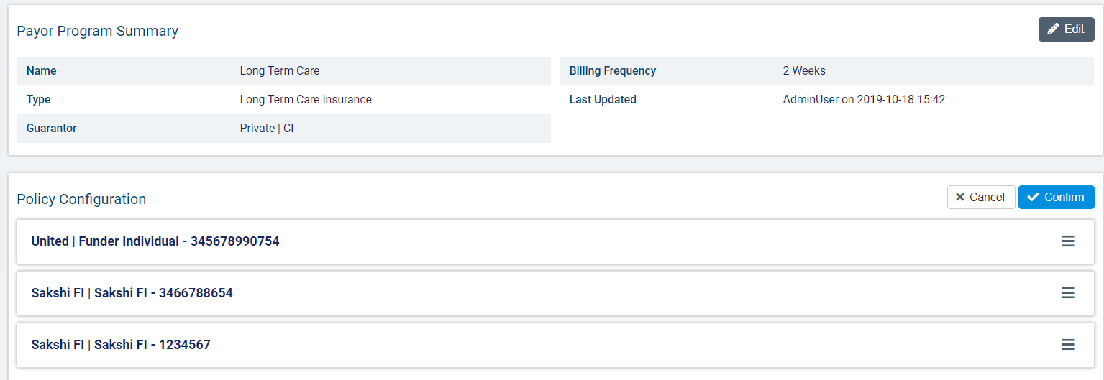
Note that policies with a limit in visits or hours must be sequenced before policies with a limit in amount. Once a policy has invoices against it, it will no longer be available for sequencing.
If you try to sequence the policies in an order that is not permitted, you will receive an error message.
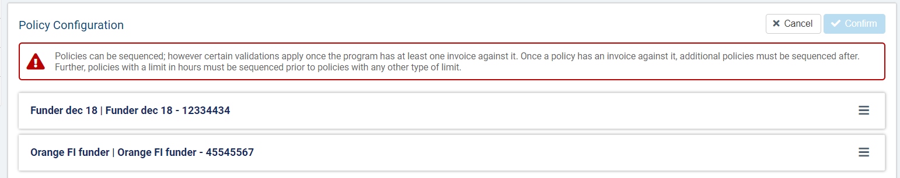

Co-Payment

Co-payment is a type of payor program that is used when there is an agreement that a client will share the cost of care with another provider. Co-payment works well in many split billing scenarios where government funding or another type of coverage will cover up to a certain amount of the client’s care, and the client/guarantor is responsible for the rest of the cost.
In co-payment, the set of rules added to a program is referred to as a contract. Only one contract can be added to a program (in other words, sequencing multiple contracts so that different rule sets are all in effect at one time is not possible). However, you can still create different versions of the contract rules with different effective dates.
The funder type of the guarantor can be client individual or funder individual for co-payment programs.

How do I create a co-payment payor program for a client?

Payor programs are set up at the client level.
You must be in a role configured with the View Payor Program and Manage Payor Program ACLs in Settings>Roles and Permissions to view, add, and edit payor programs for clients.
To add a new program, go to Accounting>Payor Invoicing on the client’s profile and select +Add Program.
In the Add Payor Program dialogue, enter the Name of the Payor Program and select Co-Payment as the Type.
Select a funder to serve as the guarantor.
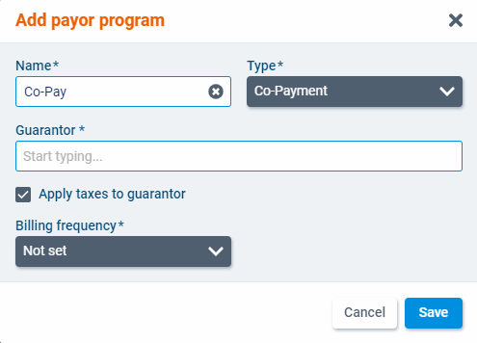
If you select a guarantor of type client individual, you will also need to choose a billing contact.
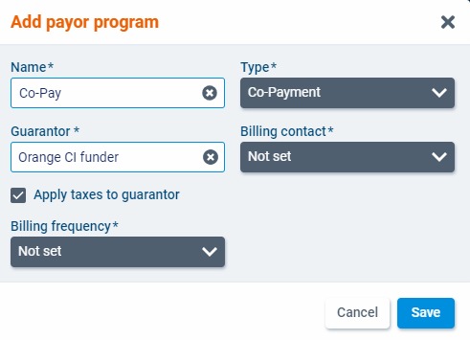
Check the box next to Apply taxes to guarantor if applicable. This setting will determine if taxes set at the bill code level should be applied to items billed to the guarantor.
Finally, select a billing frequency for the program. In payor invoicing, the billing periods are determined by the billing frequency. The available frequencies are 1 Week, 2 Weeks, 4 Weeks, and Calendar Month. When you have finished, click Save.
The program will open as a new screen. Select Edit to make changes to the program details.
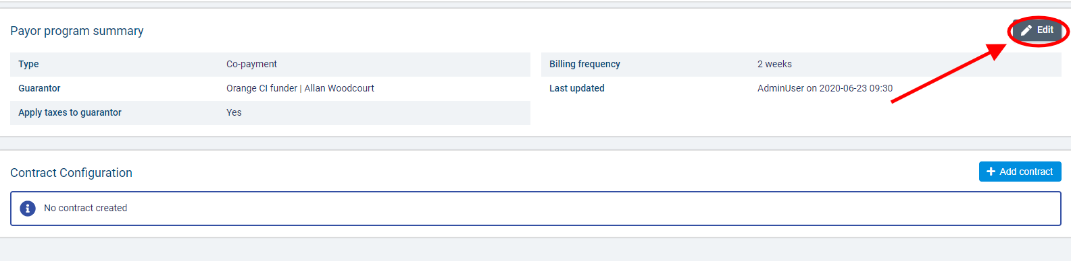
Once you have created a program, you can a contract. The contract specifies the benefit rules that will be used to determine how billable items linked to the program are invoiced. To add a contract to the program, select +Add contract.
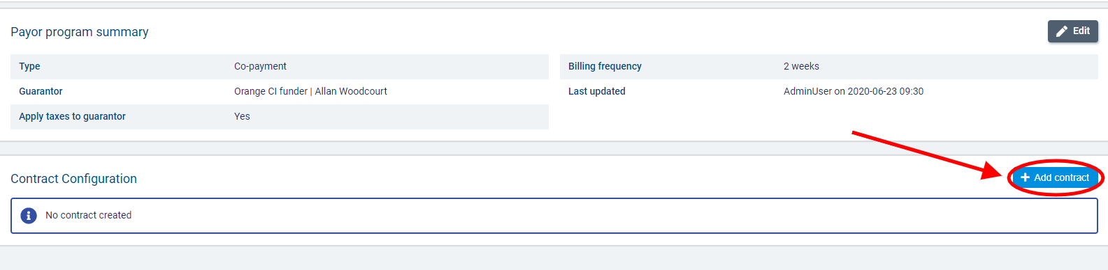
In the Add Contract dialogue, complete the required fields.
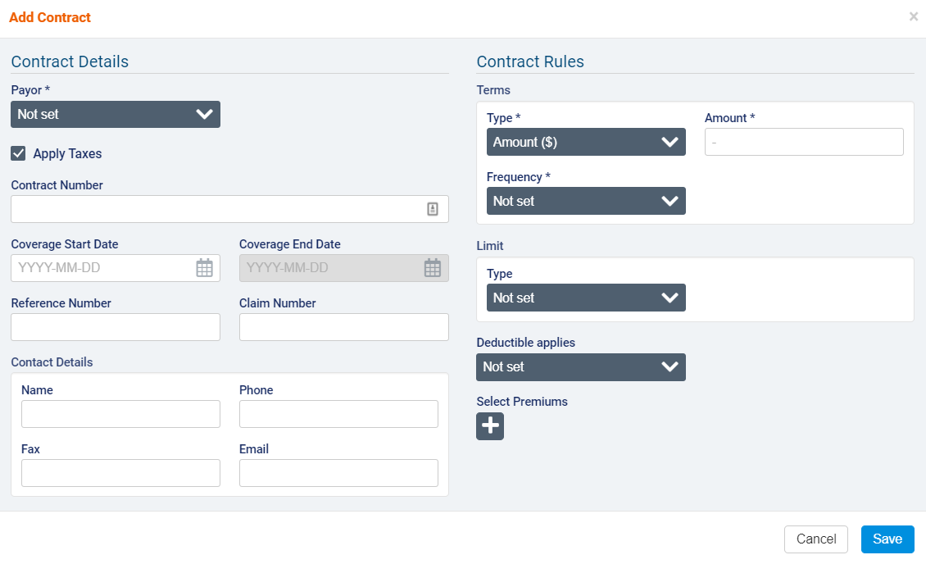
Under Contract Details, select a funder to represent the Payor. You can select any enabled funder individual or client individual funders available to the branch that the client belongs to. If necessary, enter the Contract Number, Coverage Start and End Date, Reference Number, and Claim Number and fill out the Contact Details section.
Use the Apply Taxes checkbox if you wish to apply taxes set at the bill code level to items covered by this contract.
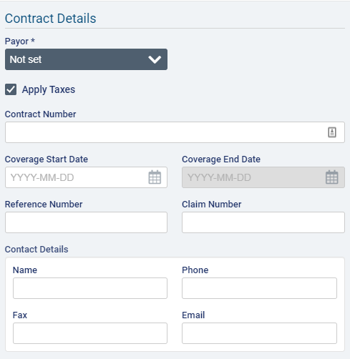
Under Contract Rules, Amount will be pre-selected as the Term Type. Select a Term Frequency and enter the Term Amount. The available frequencies are Per Hour, Per Day, Per Week, Per Calendar Month, Per Calendar Year, and Per Benefit Year. If you select Per Week as the frequency, you must also select a day for Start of Week.
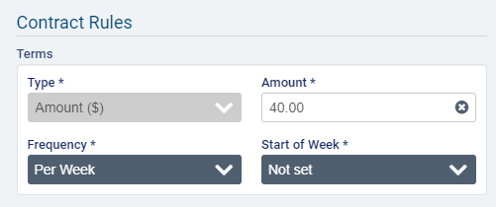
If you select Per Benefit Year as the Frequency, you must also select the Month and Day of the month on which the benefit year begins.
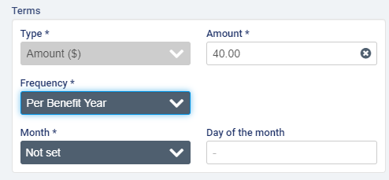
Example scenario for terms in amount: the amount specifies the maximum amount that the payor on the policy will cover for the length of time specified by the frequency. So if $400 is entered as the amount and Per Week is selected as the frequency, when generating invoices for a week in which 3 visits valued at $200 each occurred, the payor will be invoiced $400 for the first two visits and the next payor or the guarantor will be invoiced $200 for the last visit.
After adding the term details, you can also add a limit to the policy. The limit can be an amount or a number of hours or visits over a specific frequency. Per Hour is not an available frequency for limits.
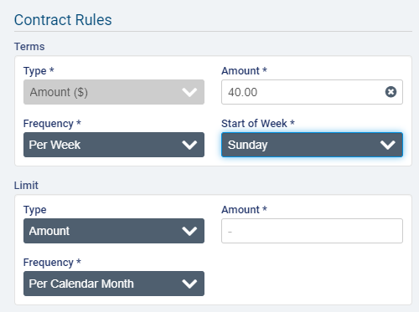
Note that when Amount is selected as the Limit Type, the Limit Frequency must always be larger than the Term Frequency (Per Day < Per Week < Per Calendar Month < Per Calendar Year/Benefit Year). If the term has the maximum frequency selected (Per Calendar Year or Per Benefit Year), then you will not be able to select Amount as the Limit Type.
Example scenario for limit in amount: The term amount is $50 per day and the limit is $100 per week, and the following visits occurred in one week (Monday visit: $120 and visit #2 cost $100). The payor will be invoiced $100 (because the total cost of both visits is over the weekly limit). The guarantor will be billed $120, the total remaining from both visits.
For Limits in Hours, the frequencies Per Day, Per Week, and Per Calendar Month will be available to select.
Example scenario with a limit in hours: there are two visits in one week; visit #1 lasted 3 hours and cost $150 and visit #2 lasted 2 hours and cost $100. If the term is a fixed amount of $60 per hour, and the limit is 2 hours per week, the payor will be invoiced $120 for the first visit ($60 x 2h), and the guarantor will be billed the remaining amount of $130.
For Limits in Visits, the frequencies Per Week, Per Calendar Month, Per Calendar Year, and Per Benefit Year will be available to select.
Example scenario with a limit in visits: The term is a fixed amount of $200/week and the limit is 2 visits/week, and there are two visits in one week (one on Monday charged at $120 and one on Wednesday charged at $100). The payor will be invoiced $120 for the first visit, and the guarantor will be invoiced $100 for the second visit, since the limit on the term has been reached.
If Per Week is selected as the Limit Frequency, you will also need to specify a day as the Start of Week.
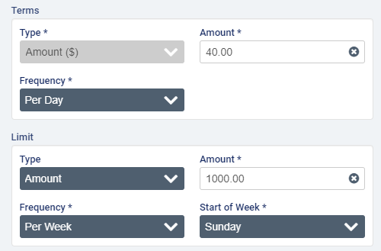

To set a deductible or elimination period on the policy, select an option from the Deductible applies dropdown. To set an elimination period, select either Elimination by Calendar Days or Elimination by Service Days and then enter the number of days in the period.

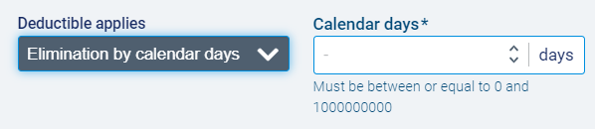

To enter an amount, select deductible amount and enter the value of the deductible.

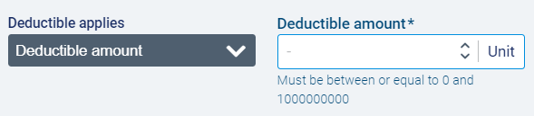
In the Select Premium(s) section, click to select one or more billing premiums configured in Accounting>Accounting Settings>Premiums that should be fully covered by the payor on the policy. Note that premiums must be 100% covered by either the payor or the guarantor (in other words, the cost of premiums cannot be split between two bill-parties if using a long-term care insurance payor program).
When you have completed on required fields, click Save.
The program page will open with the policy details listed under Contract Configuration. To make changes, select the Edit button.
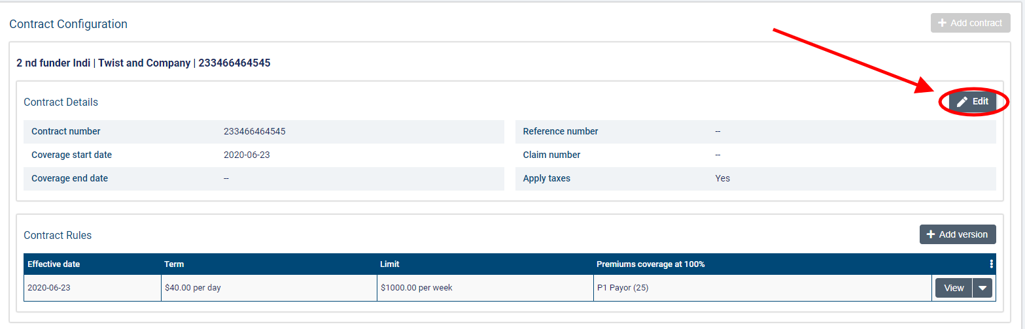
If the policy has never been used to generate invoices, you will be able to edit all the informational fields.
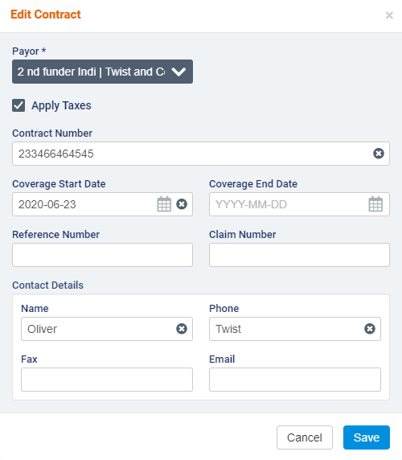
If any draft or sent invoices exist against the policy, certain fields will be disabled for editing (Payor, Contract Number, and Coverage Start Date).
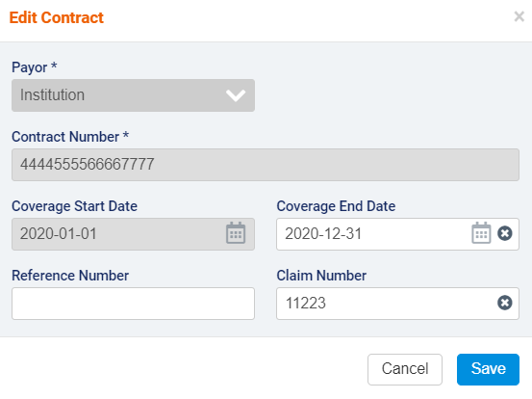

If you need to change the rules for a policy or contract, you can create a new version of the policy. Note that versions cannot have any gaps or overlaps in terms of dates.
To create a version, click the +Add Version button.
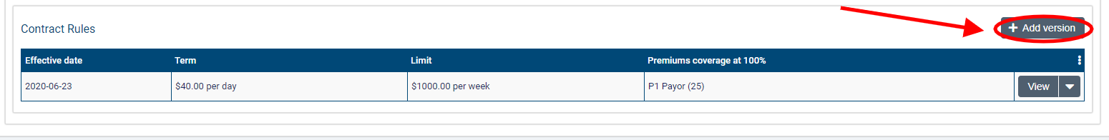
In the Add Version dialogue, enter the Effective Date on which the changes to the contract will apply. This date must be past the Coverage Start Date by at least one day. You will not be able to modify Term Type or Limit Type, but you can make changes to the Term Value, Term Frequency, Limit Value, and Limit Frequency or attach more premiums.
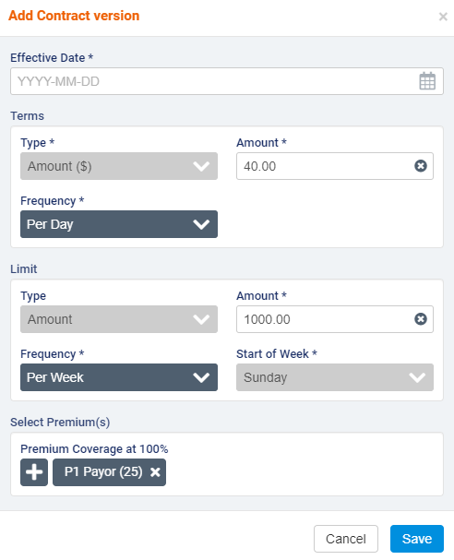
If more than one version of a contract exists, you will not be permitted to modify the Coverage Start Date. If Per Calendar Month is selected as the Term Frequency, note that the Coverage Start Date must be the first day of a month.
When you have finished, click Save to create the new version.
To edit or delete a version, select the downward arrow next to view and select Edit or Delete.
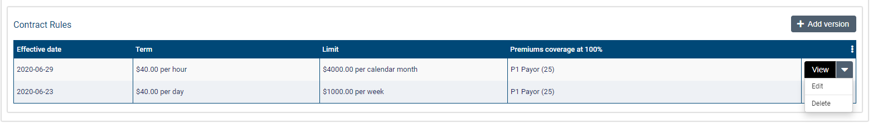
You will not be able to make changes if invoices have been generated for the version.
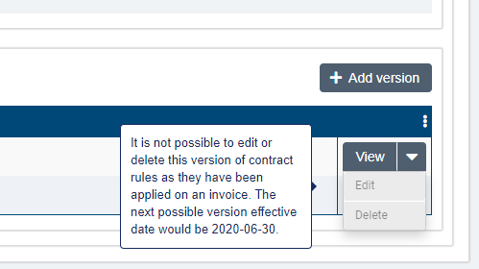
Note that having more than one version will lock the Coverage Start Date field for editing regardless of whether invoices exist against the contract.

Split percentage

Split percentage is a type of payor program that allows you to generate invoices for billable items according to the percentages set for each payor on the contract version currently in effect on the program. Split percentage works well in billing scenarios where various payors are responsible for a fixed percentage of the overall cost of a client’s care.
You can only have one contract on a program in effect at one time. However, you can delete contracts and create multiple versions with effective dates, payors, and percentage breakdowns.
For this program type, you can set different guarantors at the program and contract levels. The guarantor at the program level is responsible for covering the full cost of billable items when there is no contract coverage in effect. In this scenario, only one invoice will be generated with the program guarantor as the bill-to party. The guarantor at the contract level is responsible for covering the remaining cost of billable items for client in a billing period after the distribution percentages for all the payors have been applied.
Note that the distribution percentages for each payor on a contract are always applied to the total cost of billable items, not the remaining amount after the percentage covered by the first payor has been applied. (For example, if payor 1 covers 50%, payor 2 30%, and the guarantor 20%, for a visit that costs $100, payor 1 will be invoiced $50, payor 2 $30, and the guarantor $20).
You also have the option to split premiums as well as visits between multiple bill-to parties. When setting up the program for the client, you can choose whether you wish to split premiums based on distribution percentages or whether all premiums will be 100% covered by either a payor or guarantor.

How do I create a split percentage payor program for a client?

Payor programs are set up at the client level.
You must be in a role configured with the View Payor Program and Manage Payor Program ACLs in Settings>Roles and Permissions to view, add, and edit payor programs for clients.

To add a new program, go to Accounting>Payor Invoicing on the client’s profile and select +Add Program.
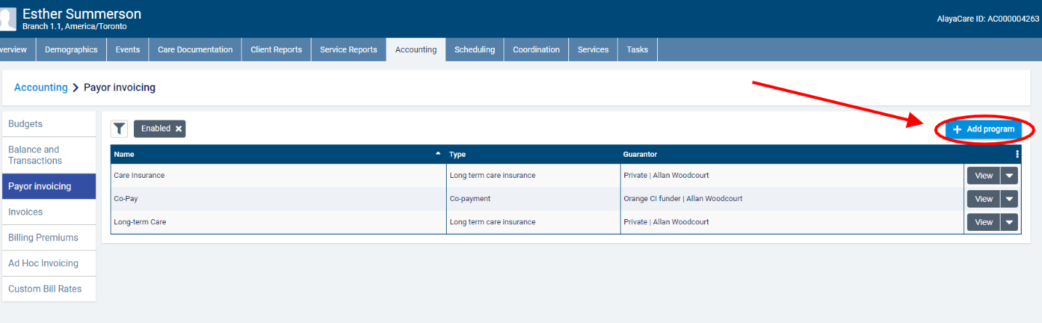
In the Add payor program dialogue, enter a name for the program and select Split percentage as the program type.
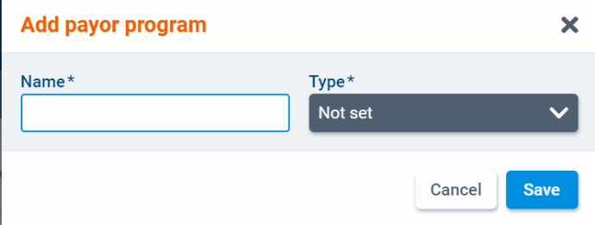
Select a client individual or funder individual funder as the Guarantor outside of coverage. This the program level guarantor who will cover the total cost of any billable items linked to a program that do not fall within the coverage range defined on a contract.
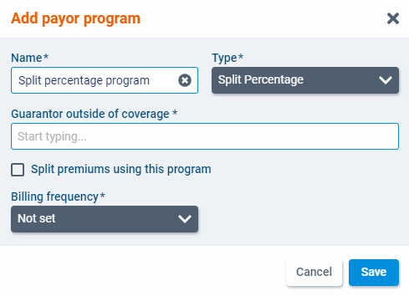

If you select a client individual funder, you will also need to select a billing contact.
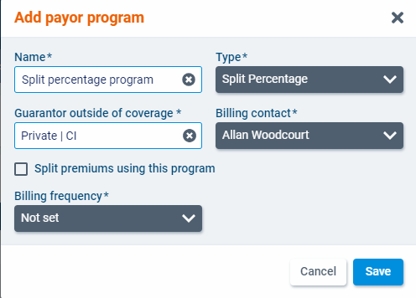
Check the box next to Split premiums using this program if you wish to split the cost of premiums between more than one bill-to party.
Finally, select a billing frequency for the program. In payor invoicing, the billing periods are determined by the billing frequency. The available frequencies are 1 Week, 2 Weeks, 4 Weeks, and Calendar Month. When you have finished, click Save.
The program will open as a new screen. Select Edit to make changes to the program details.
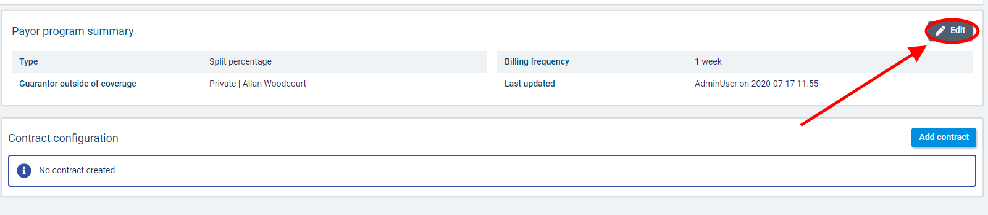

Note that once a contract has been added to the program, you will not be able to change whether you are splitting premiums for this program. Once invoices have been generated for a program, you will only be able to edit the program name and billing frequency.
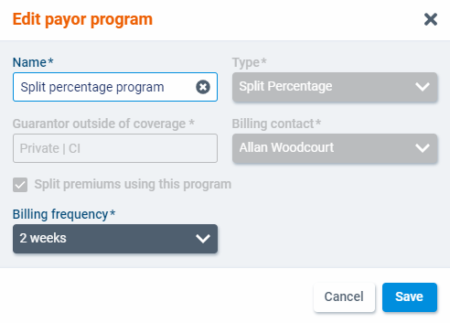

To add a contact to the program, select +Add contract.
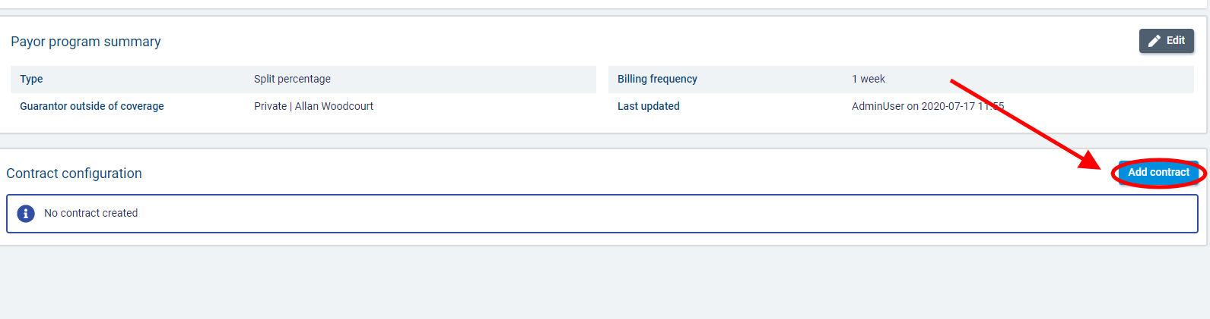
In the Add contract dialogue, enter the contract start date along with the contract number if necessary. The coverage end date will be updated when a new version of the contract is created. Note that you cannot manually enter an end date for a contract.
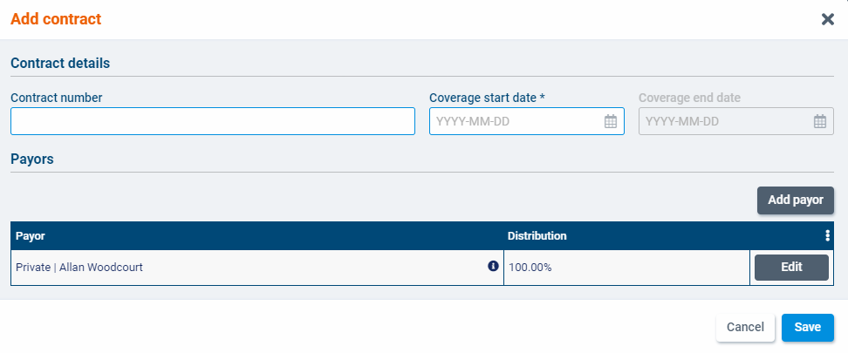
In the Payors section, the guarantor that you selected at the program level will already be listed with 100% as the distribution percentage.
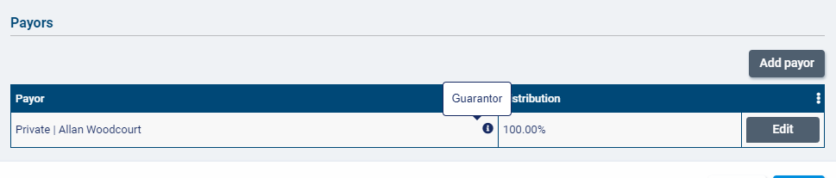
Click Edit if you wish to have a different guarantor at the contract level. This guarantor will cover the percentage not covered by any other payors you add to the contract.
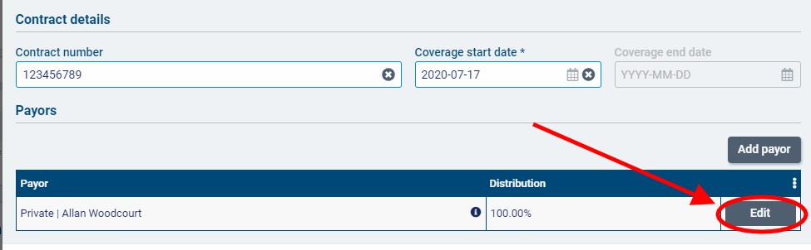
Select Add payor to add a payor to the contract.
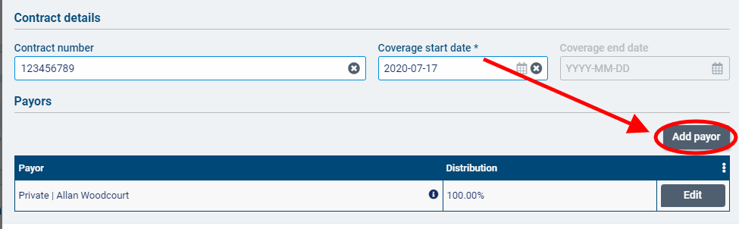
Select a funder of type client individual or funder individual in the Payor column. In the Distribution column, enter the percentage of the billable items that this payor will be responsible for. The distribution percentage of the guarantor will be automatically adjusted.
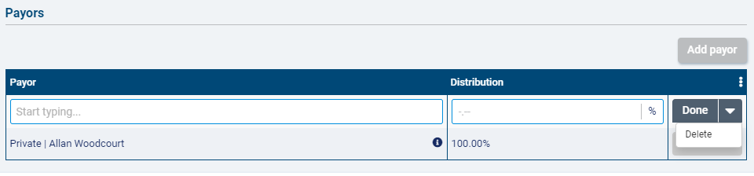
If you select a funder of type client individual, you will also need to select a billing contact.
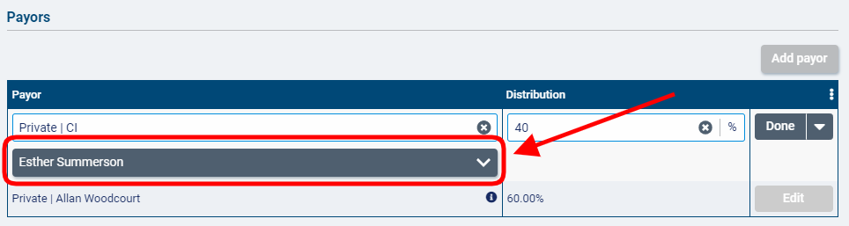
If Split premiums using this program is selected, the distribution percentage for each payor entered will apply to premiums funded by the program as well as visits.
If you did not select Split premiums using this program, an additional column will appear in the payors list called Premium(s) covered in full. For each payor you add to the list, you will be able to select the premiums from Accounting>Accounting Settings>Premiums using the button that should be 100% covered by that payor.
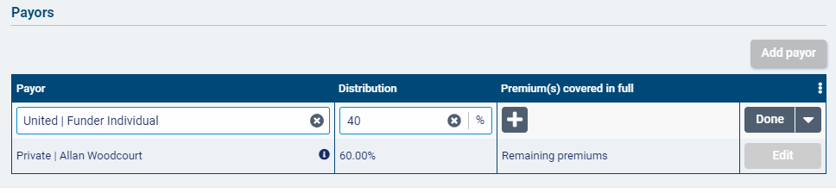
Note that you can delete a payor from the list, but you cannot delete the guarantor. Every contract must have a guarantor listed.
When you are finished adding the payor, select Done.
Click Add Payor again to add more payors to the contract. Note that you cannot add the same funder of type funder individual more than once.
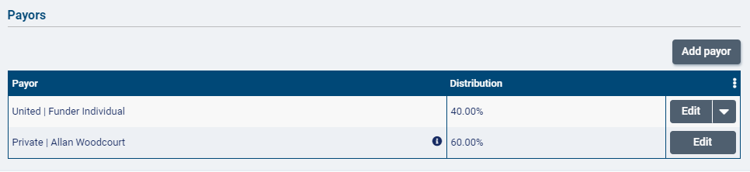
For contracts where premiums are covered in full, the number of premiums covered by each payor will be displayed in the Premium(s) covered in full column. The guarantor will be responsible for covering in full any premiums funded by the program that are not selected for coverage by one of the payors on the contract.
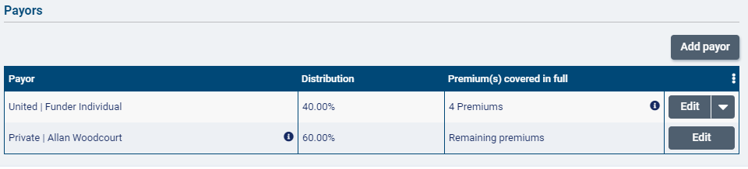
When you have finished with the contract, click Save.

Once a contract has been created, the Add contract button will change to Add version. To delete the contract, select Delete. To edit the contract, select Edit.
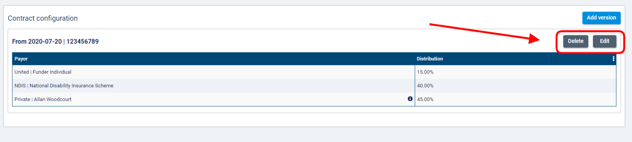
If invoices have not yet been generated for the contract (or if any generated invoices have been voided or deleted), you will be able to edit all fields on the contract.
To add a new version of the contract, select Add Version.
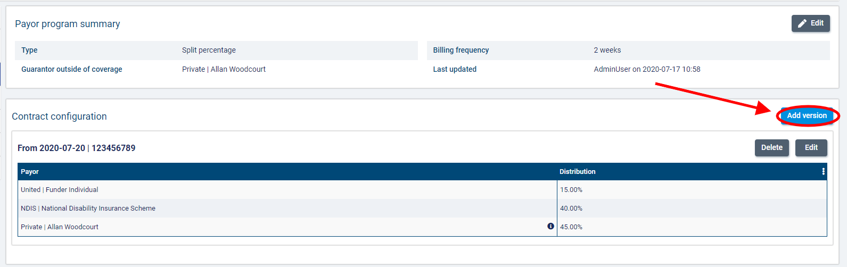
In the Add Version dialogue, you can adjust the contract number, coverage start and end dates, and payors list as needed. The guarantor set on the previous version of the contract will automatically populate in the new version but can be edited as needed.
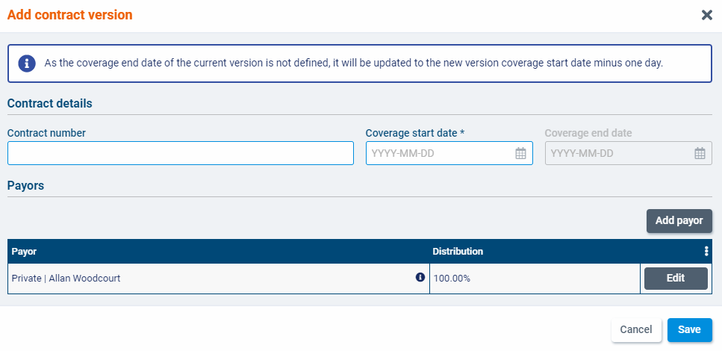
If a coverage end date was not on the previous version of the contract, it will be set as the coverage start date of the new version minus one date.
When you have finished entering the version details, click Save.
Note that only the most recent version of the contract can be edited or deleted.
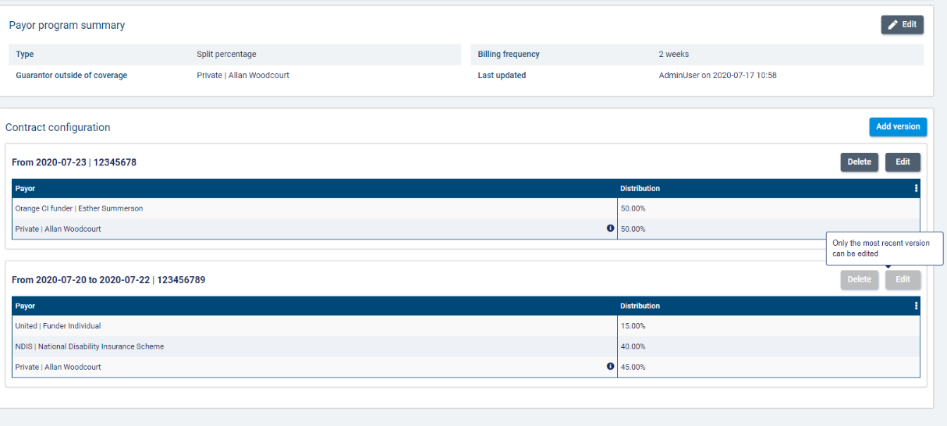

Co-Contribution

Co-contribution is a type of payor program that allows a single bill-to party (the guarantor) to cover 100% of a client’s services while another party (the payor on a contract or the same payor as the guarantor) pays a contribution on a set frequency and any selected premiums.
In co-contribution, the set of rules added to a program is referred to as a contract. The rules determine how much and how frequent the payor’s contribution will be. Only one contract can be added to a co-contribution payor program. However, you can add multiple versions of the contract to the program with different effective dates.
You can also set a limit on how much the payor can contribute over a specific frequency on the contract. For example, the payor might have a contribution of $40 per day with a limit of $200 per week. Once the limit is reached, the remaining amount will be billed to the guarantor.
On the master invoice screen and AlayaCare standard invoice, payor contributions will be displayed as miscellaneous charges of type automatic.

How do I create a co-contribution payor program for a client?

Payor programs are set up at the client level.
You must be in a role configured with the View Payor Program and Manage Payor Program ACLs in Settings>Roles and Permissions to view, add, and edit payor programs for clients.
To add a new program, go to Accounting>Payor Invoicing on the client’s profile and select +Add Program.
In the add payor program dialogue, enter a unique name for the program and select co-contribution as the program type.
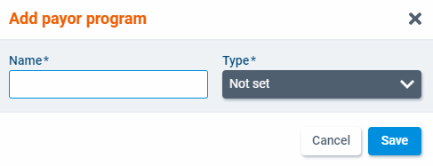
Select a client individual or funder individual funder as the guarantor. If a client individual-type funder is selected, you will also need to select a billing contact.
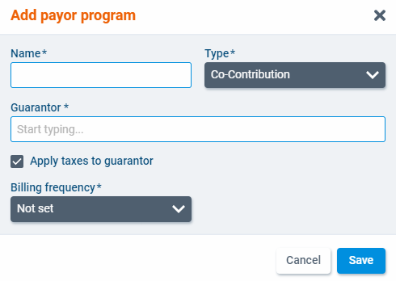
Check the box next to Apply taxes to guarantor if you wish to apply the taxes set at the bill code level to items billed to the guarantor.

Finally, select a billing frequency for the program. In payor invoicing, the billing periods are determined by the billing frequency. The available frequencies are 1 Week, 2 Weeks, 4 Weeks, and Calendar Month. When you have finished, click Save.
The program will open as a new screen. Select Edit to make changes to the program details.
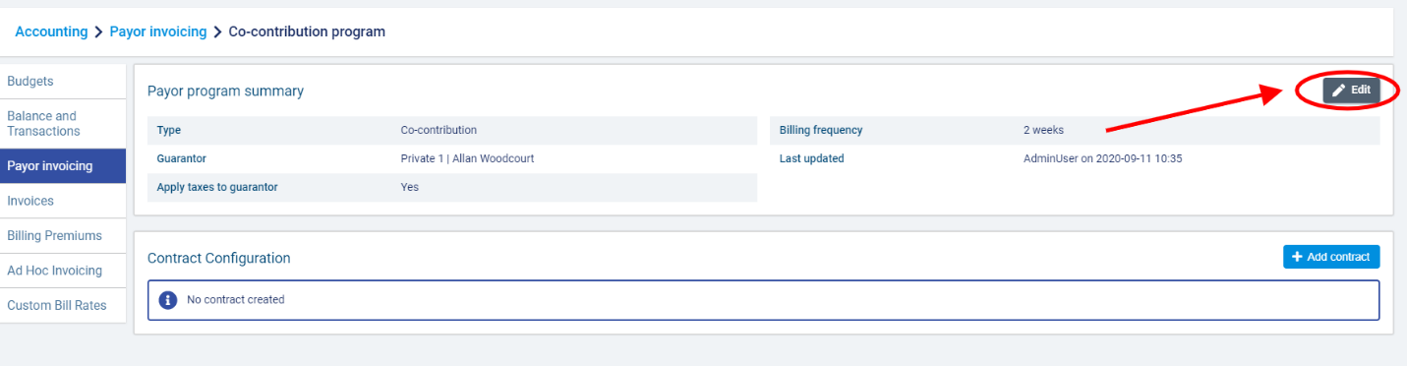
To add a contact to the program, select +Add contract.
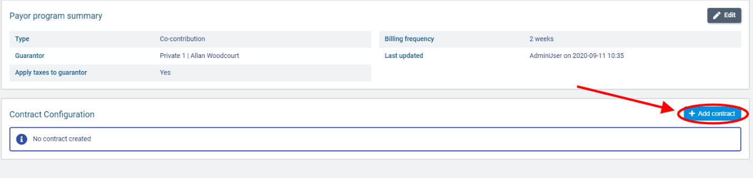
In the add contract dialogue, select a payor from the enabled client individual and funder individual-type funders available to your branch.
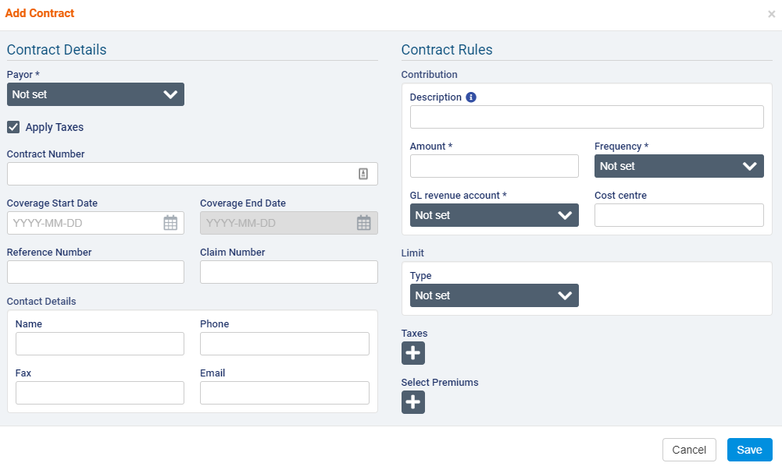
Select whether you wish to apply taxes to the payor’s contribution and enter the Contract Number, Coverage Start Date, Coverage End Date, Reference Number, Claim Number, and Contract Details if necessary.
Use the Apply Taxes checkbox if you wish to apply taxes set at the bill code level to items covered by this contract.

Under Contract Rules, enter a description of the payor’s contribution. Note that if the description field is left empty, the service name associated with the visit will appear in its place on the invoice.
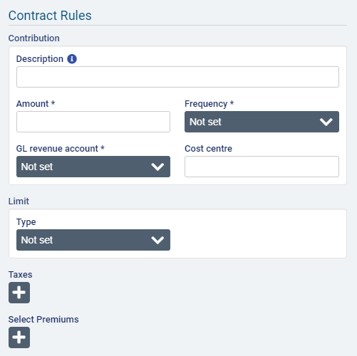
Enter the amount of the contribution and select the frequency at which the amount will be contributed (Per Hour, Per Day, Per Visit). Select a GL revenue account and enter a cost centre if applicable.
In the limit section, select amount as the limit type. The limit will impose a cap on the total amount that the payor can be charged over a certain frequency. Enter the limit amount and select a limit frequency (Per Day, Per Week, Per Calendar Month, Per Calendar Year, or Per Benefit Year).
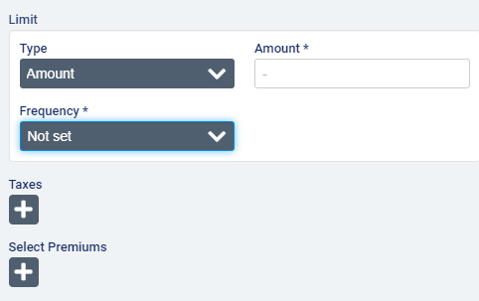
If you select per week as the frequency, you will also need to select the day on which the week should begin.
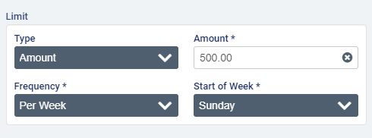
If you select per benefit year as the frequency, you also need to select the month and day on which the benefit year should begin.
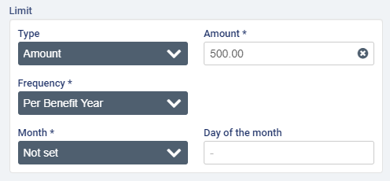
In the Taxes field, one or more taxes that you wish to apply to the contract.
If the cost of any premiums will be 100% covered by the payor on the contract, select the applicable premiums.
When you have finished with the contract, click Save.

Once a contract has been created, the Add contract button will be disabled. To edit the contract, select Edit.
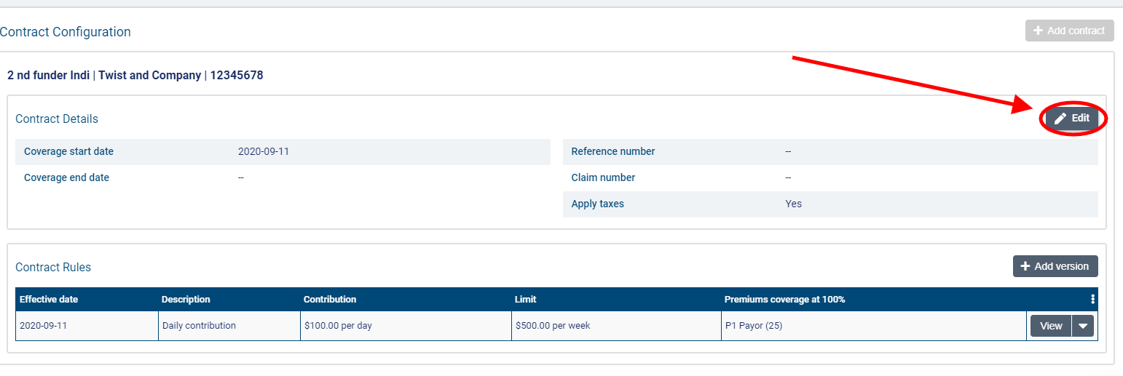
If invoices have not yet been generated for this version of the contract (or if any generated invoices have been voided or deleted), you will be able to edit all fields on the contract.
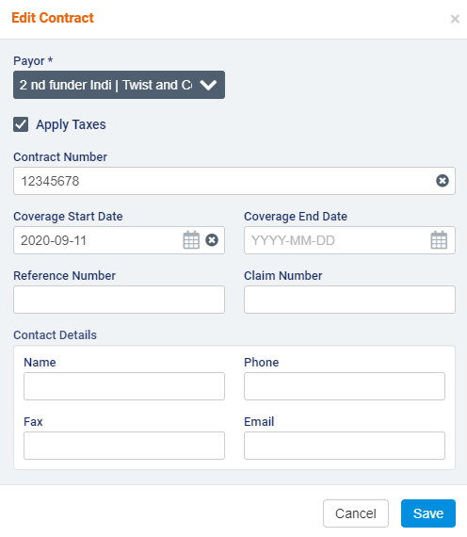
To add a new version of the contract, select Add Version.
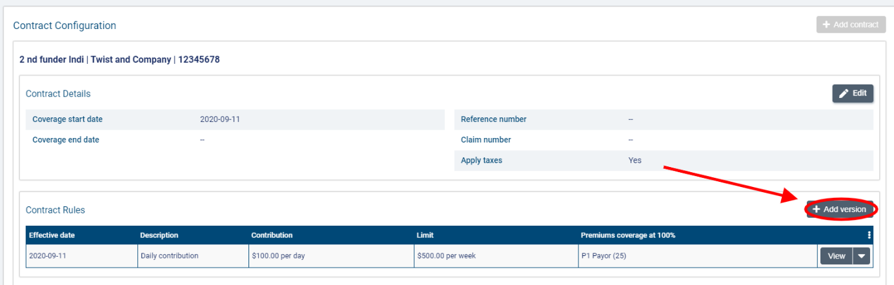
In the Add Version dialogue, enter an effective date that the changes should go into effect. You can adjust the contribution description, amount, frequency, GL revenue account, and cost centre (if applicable) as well as the limit amount and frequency. You can also add or remove any taxes or premiums from the contract.
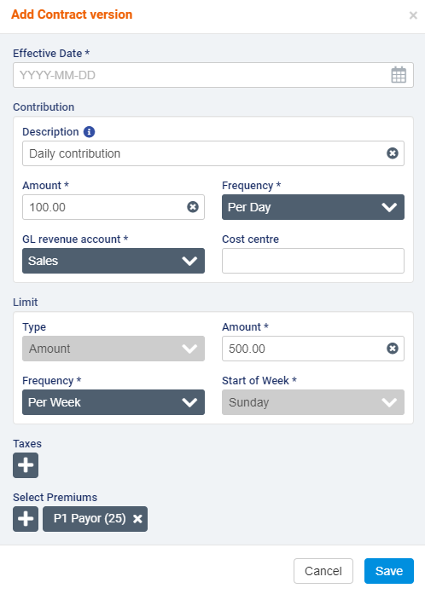
When you have finished entering the version details, click Save.
Note that you can only edit or delete the most version of the contract. Previous versions cannot be edited or deleted.
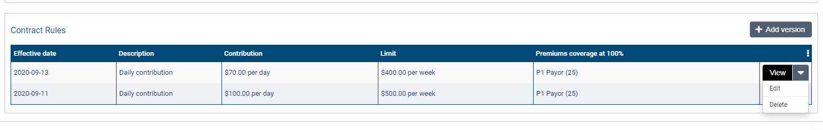

Adding the payor program to client services and billing premiums

Once you have set up a program for a client, you can attach it to services and client billing premiums.
To add a program for a client, go to a Services list on the client’s profile and select +Create a Service.
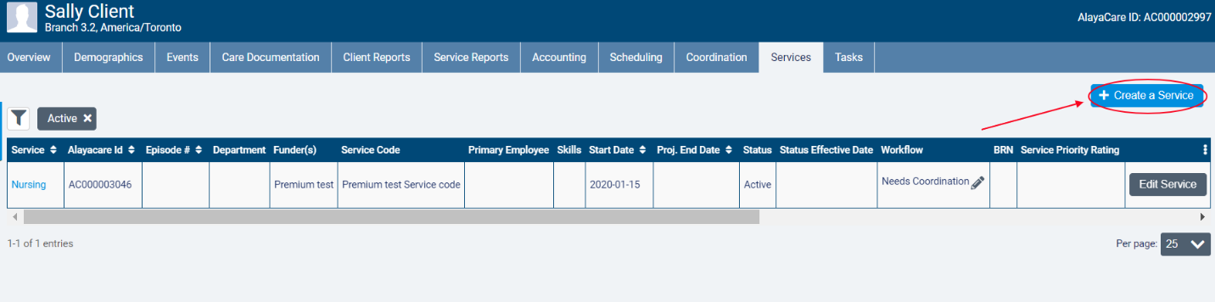
In the Funder Methodology dropdown, the different types of payor programs will be available for selection. Choose the type of the program you wish to apply. Next, select the name of the program in the Program dropdown and choose the correct Rating Funder. The funder you select here will determine which bill codes will be used to invoice billable items tied to the program.
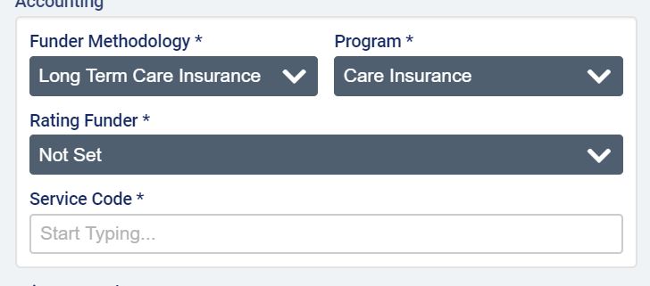
Note that the rating funder does not have to be the funder selected for either the payor or guarantor on the payor program. It is simply used to determine the rates that should be applied the billable items tied to the program.
When you have finished completing all required fields, click Create.
Note that the program on the service cannot be changed after an invoice is generated for the service.
To add a program to a client billing premium, go to Accounting>Billing Premiums on the client’s profile and select +Create Premium.
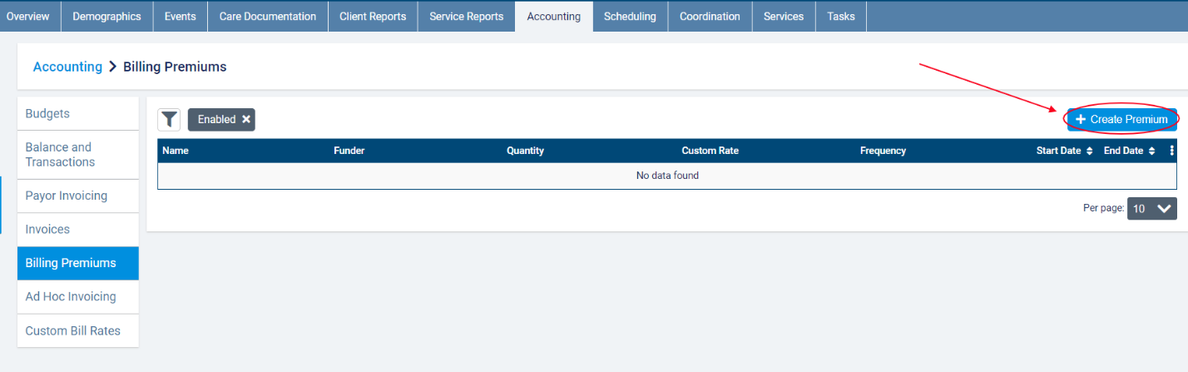
In the funder methodology dropdown, the different types of payor programs will be available for selection. Choose the type of the program you wish to apply. Next, select the name of the program in the program dropdown and choose the correct rating funder.
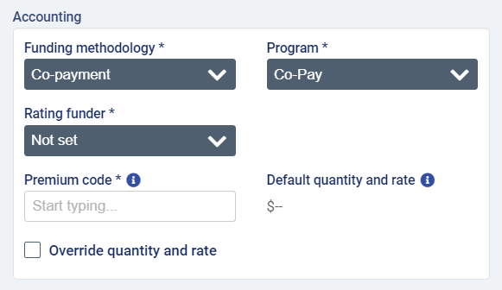
Select a premium code, complete the remaining required fields, and save the billing premium.
Note that the funder methodology cannot be modified on the client billing premium once it has been invoiced.

Appendix A: glossary of terms

- Billable item: any source item (visit, visit premium, or client billing premium) that has been approved for billing and has a rate.
- Billing periods: billing periods in payor invoicing must have a set frequency of 1 weeks, 2 weeks, 4 weeks, or per calendar month. When generating invoices for a billing period, any billable items tied to a program with that billing period frequency that have not yet been invoiced will be included. The end date serves as the cut-off date for the billing period. Start dates of billing periods cannot be modified to avoid gaps between billing periods.
- Bill-to party: the party to whom an invoice is addressed. In payor invoicing, the bill-to party will either be a payor or the guarantor.
- Distribution percentage: in split percentage programs, the percentage of a billable item that the payor or guarantor will be invoiced for.
- Co-contribution: a payor program type in which the payor contributes a set amount for a specific frequency and covers the cost of any selected premiums while the guarantor covers 100% of the client’s services and any remaining premiums.
- Contract: in certain program types, the name of the rule set that is added to a payor program.
- Co-payment: a payor program type used when there is an agreement that the client will pay for a portion of the services being covered.
- Guarantor: the bill-to party that is responsible for covering the remainder of invoice balances after the rules on any policies or contracts in effect have been applied. In split percentage programs, you can set different guarantors at the program and contract level.
- Limit: a cap on the term or contribution set on the contract/policy in amount, hours, or visits based on a set frequency.
- Long-term care insurance: a payor program type used when there is a long-term insurance policy that is activated to cover the services being provided.
- Master invoice: the master invoice contains information about all the billable items covered by a client’s payor program for a specific billing period. When viewing the master invoice screen, you will be able to see the breakdown of what will be invoiced to the payor(s) and what will be invoiced to the guarantor. Exporting invoices at the master invoice level will generate one invoice per bill-to party.
- Payor: the party that is subject to the rules defined on the program. The payor on the policy or contract will become the bill-to party that is invoiced for the amount dictated by the benefit rules on the policy/contract.
- Payor invoicing: an invoicing methodology where you create rules at the client level to determine how the cost of billable items will be split between different bill-to parties.
- Payor program: a billing configuration at the client level to which you can add rule sets (policies or contracts) to determine how a client’s services or client billing premiums will be invoiced. Once created, programs must be added to the client’s relevant services and billing premiums.
- Policy: in certain program types, the name of the rule set that is added to a payor program.
- Rating funder: a funder that is used to link bill codes and their rates to a service covered by a payor program. The rating funder will not be invoiced for any items.
- Split percentage: a payor program type to which you can add a contract with a list of payors each of whom are responsible for a fixed percentage of the cost of a client’s billable items (including or excluding premiums, depending on the program setup). The contract guarantor covers the remaining percentage. If no contract is in effect, all billable items are invoiced to the program guarantor.
- Term: the amount of a client’s services that will be covered by the payor on the policy/contract (either a fixed amount over a set frequency or, in certain program types, a percentage).

