Co-Contribution Payor Programs
User Guide

Contents
What are payor programs? 2
Co-Contribution 3
How do I create a co-contribution payor program for a client? 3
Adding the payor program to client services and billing premiums 9
Appendix A: glossary of terms 11

What are payor programs?

Payor programs are configured at the client level to create a series of rules for determining which payors are invoiced for what portion of the billable items in a billing period.
Every payor program for a client contains a set of informational fields and benefit rules referred to as a policy or contract, depending on the type. The benefit rules determine how much will be billed to the payor on the policy/contract.
You can create different versions of the benefit rules on a policy or contract with different effective dates or start and end dates. The dates of different policy/contract versions cannot overlap with one another.
The payor on the policy or contract is the bill-to party who will be invoiced for a portion of the billable items dictated by the rule set on the policy/contract. The guarantor is the bill-to party who will be invoiced for the remainder of the invoice balances after the program rules have been applied to the billable items.
Once you have created your payor program, you must attach it to any client services or billing premiums for which the rules on the program should apply. When adding a program to a service or client billing premium, you will select a rating funder. This rating funder will use the associated bill codes to determine the rates that will be used to bill for the service or premium during the invoice generation process.
Once items are approved and you begin the invoice generation process, the system will apply the rules on the payor program using the rates associated with the rating funder and generate the invoices for the different bill-to parties.
There are different types of payor programs. The type determines the kinds of rules you can set to determine how to split an invoice during the billing process. The type that you select for a payor program will dictate which rule fields and informational fields will be available for completion when adding a policy or contract to a client’s profile.

Co-Contribution

Co-contribution is a type of payor program that allows a single bill-to party (the guarantor) to cover 100% of a client’s services while another party (the payor on a contract or the same payor as a guarantor) pays a contribution on a set frequency and any selected premiums.
In co-contribution, the set of rules added to a program is referred to as a contract. The rules determine how much and how frequent the payor’s contribution will be. Only one contract can be added to a co-contribution payor program. However, you can add multiple versions of the contract to the program with different effective dates.
You can also set a limit on how much the payor can contribute over a specific frequency on the contract. For example, the payor might have a contribution of $40 per day with a limit of $200 per week. Once the limit is reached, the remaining amount will be billed to the guarantor.
On the master invoice screen and AlayaCare standard invoice, payor contributions will be displayed as miscellaneous charges of type automatic.

How do I create a co-contribution payor program for a client?

Payor programs are set up at the client level.
You must be in a role configured with the View Payor Program and Manage Payor Program ACLs in Settings>Roles and Permissions to view, add, and edit payor programs for clients.
To add a new program, go to Accounting>Payor Invoicing on the client’s profile and select +Add Program.
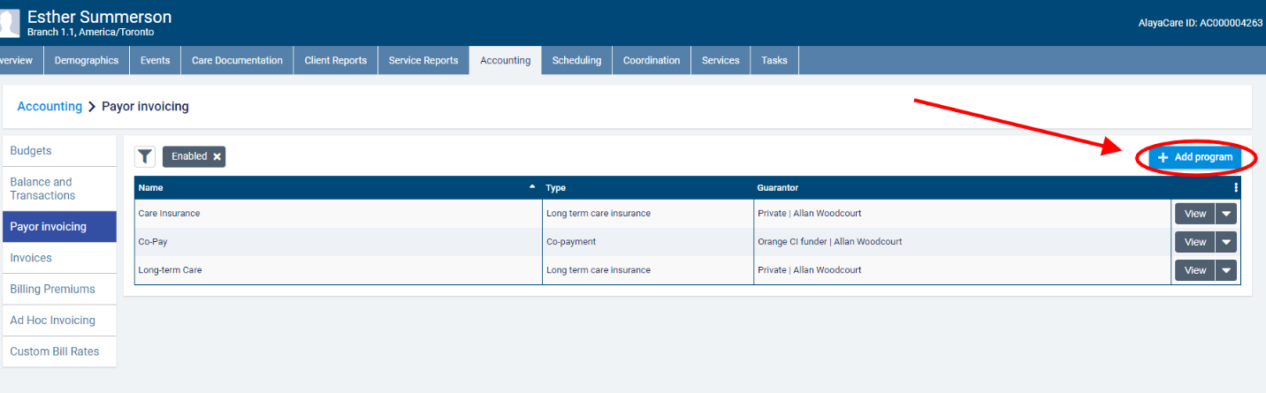
In the add payor program dialogue, enter a unique name for the program and select co-contribution as the program type.
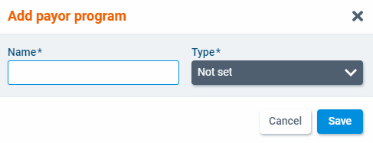
Select a client individual or funder individual funder as the guarantor. If a client individual-type funder is selected, you will also need to select a billing contact.
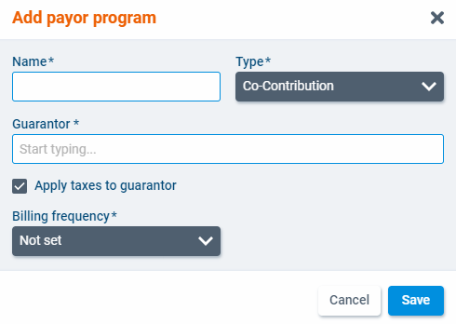
Check the box next to Apply taxes to guarantor if you wish to apply taxes. This setting will determine if taxes set at the bill code level should be applied to items billed to the guarantor.
Finally, select a billing frequency for the program. In payor invoicing, the billing periods are determined by the billing frequency. The available frequencies are 1 Week, 2 Weeks, 4 Weeks, and Calendar Month. When you have finished, click Save.
The program will open as a new screen. Select Edit to make changes to the program details.
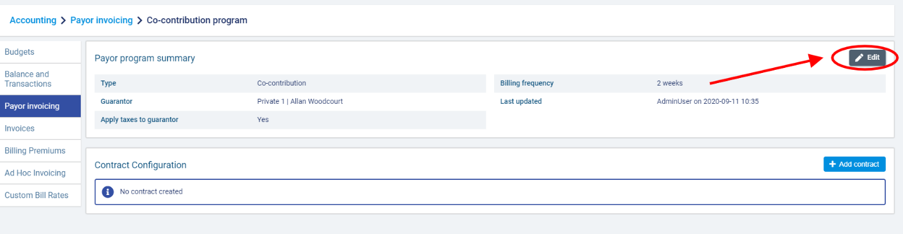
To add a contact to the program, select +Add contract.
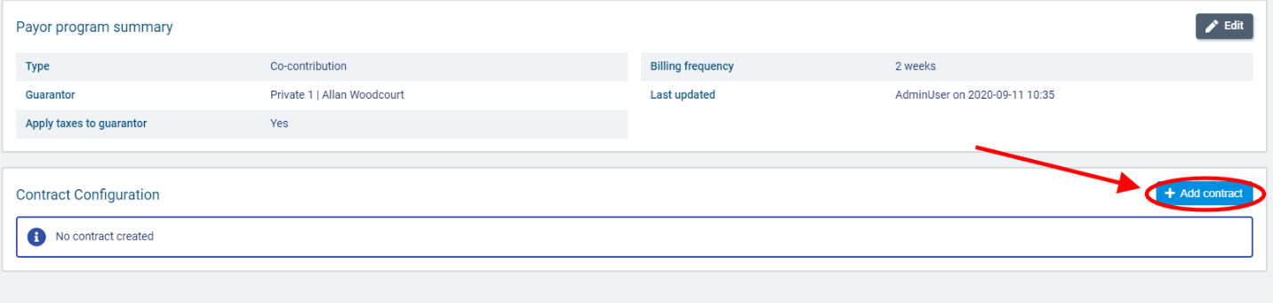
In the add contract dialogue, select a payor from the enabled client individual and funder individual-type funders available to your branch.
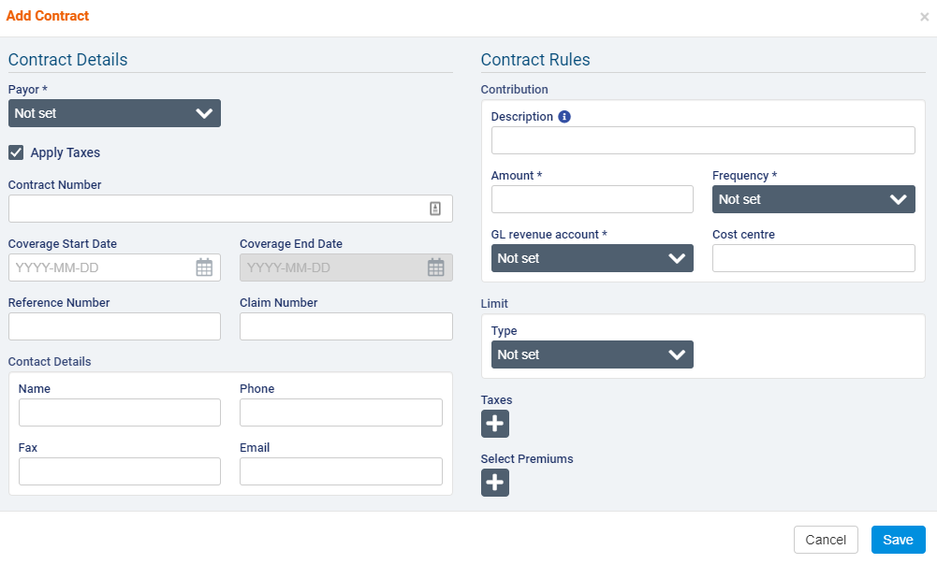
Select whether you wish to apply taxes to the payor’s contribution and enter the Contract Number, Coverage Start Date, Coverage End Date, Reference Number, Claim Number, and Contract Details if necessary.
Use the Apply Taxes checkbox if you wish to apply taxes set at the bill code level to items covered by this contract.
Under Contract Rules, enter a description of the payor’s contribution. Note that if the description field is left empty, the service name associated with the visit will appear in its place on the invoice.
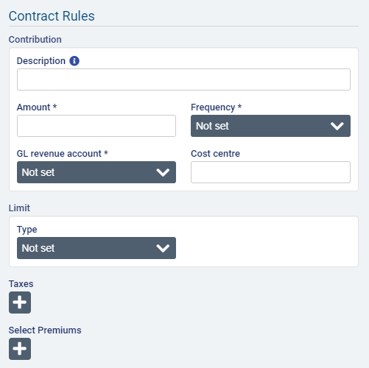
Enter the amount of the contribution and select the frequency at which the amount will be contributed (Per Hour, Per Day, Per Visit). Select a GL revenue account and enter a cost centre if applicable.
In the limit section, select amount as the limit type. The limit will impose a cap on the total amount that the payor can be charged over a certain frequency. Enter the limit amount and select a limit frequency (Per Day, Per Week, Per Calendar Month, Per Calendar Year, or Per Benefit Year).
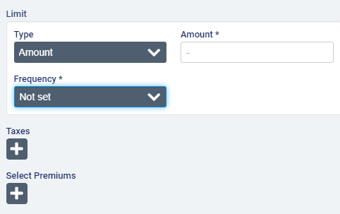
If you select per week as the frequency, you will also need to select the day on which the week should begin.
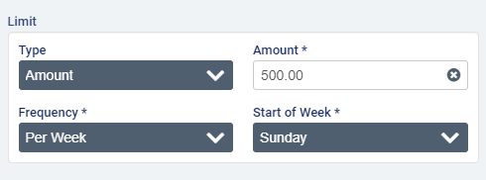
If you select per benefit year as the frequency, you also need to select the month and day on which the benefit year should begin.
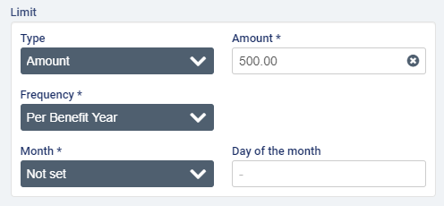
In the Taxes field, one or more taxes that you wish to apply to the contract.
If the cost of any premiums will be 100% covered by the payor on the contract, select the applicable premiums.
When you have finished with the contract, click Save.

Once a contract has been created, the Add contract button will be disabled. To edit the contract, select Edit.
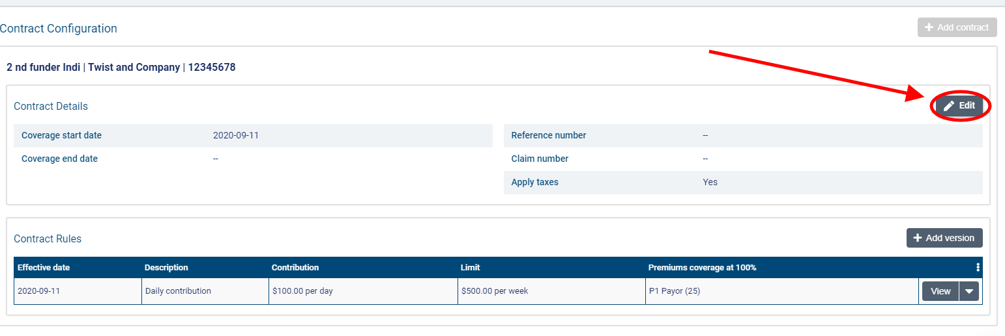
If invoices have not yet been generated for this version of the contract (or if any generated invoices have been voided or deleted), you will be able to edit all fields on the contract.
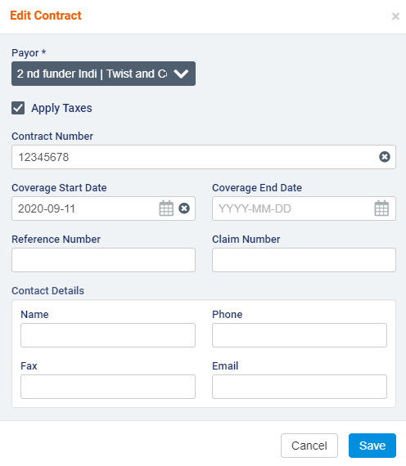
To add a new version of the contract, select Add Version.
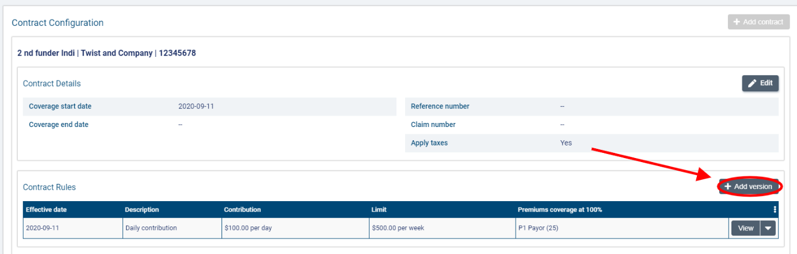
In the Add Version dialogue, enter an effective date that the changes should go into effect. You can adjust the contribution description, amount, frequency, GL revenue account, and cost centre (if applicable) as well as the limit amount and frequency. You can also add or remove any taxes or premiums from the contract.
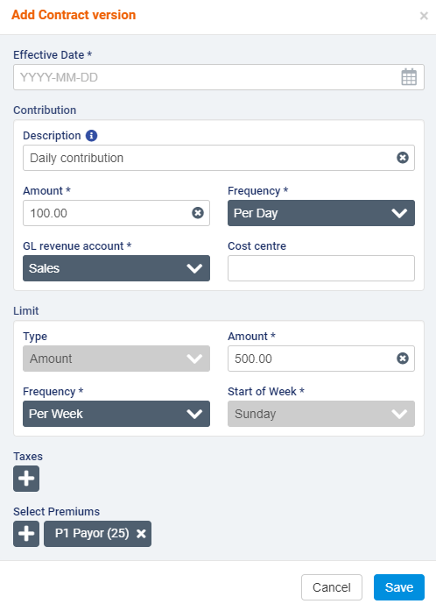
When you have finished entering the version details, click Save.
Note that you can only edit or delete the most version of the contract. Previous versions cannot be edited or deleted.
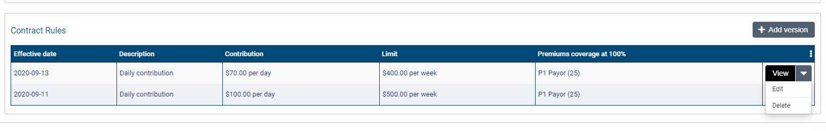

Adding the payor program to client services and billing premiums

Once you have set up a program for a client, you can attach it to services and client billing premiums.
To add a program for a client, go to a Services list on the client’s profile and select +Create a Service.
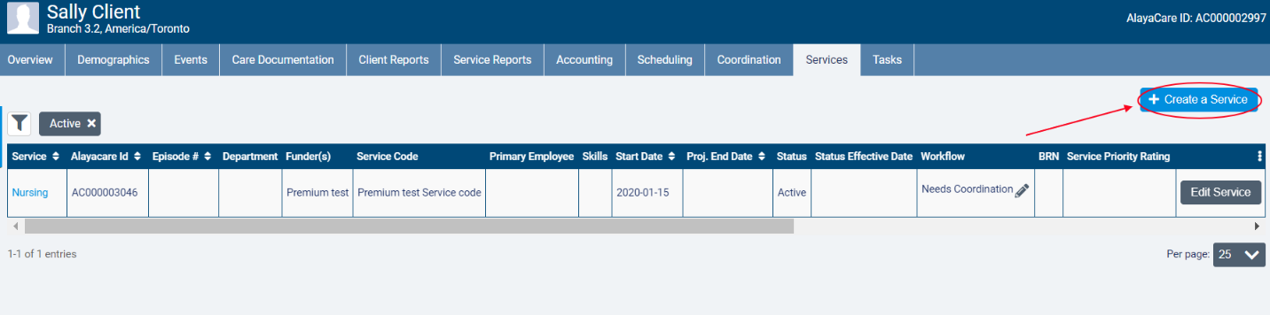
In the Funder Methodology dropdown, the different types of payor programs will be available for selection. Choose the type of the program you wish to apply. Next, select the name of the program in the Program dropdown and choose the correct Rating Funder. The funder you select here will determine which bill codes will be used to invoice billable items tied to the program.
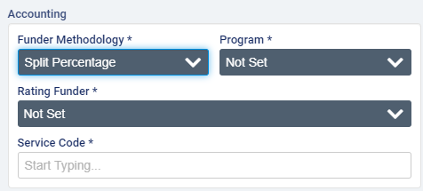
Note that the rating funder does not have to be the funder selected for either the payor or guarantor on the payor program. It is simply used to determine the rates that should be applied the billable items tied to the program.
When you have finished completing all required fields, click Create.
Note that the program on the service cannot be changed after an invoice is generated for the service.
To add a program to a client billing premium, go to Accounting>Billing Premiums on the client’s profile and select +Create Premium.
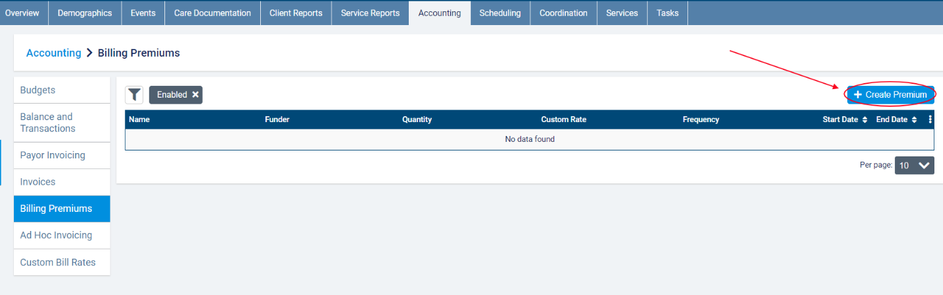
In the dialogue, select the name of the program as the Funder Methodology. After completing all required fields, click Save.
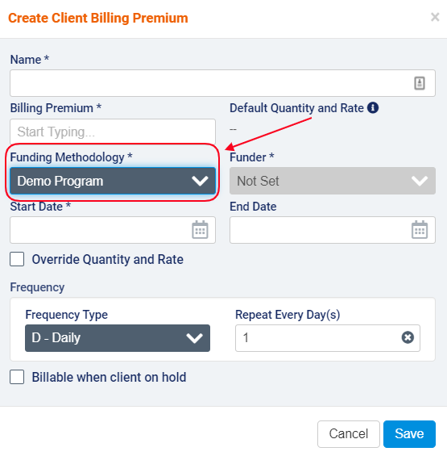
Note that the funder methodology cannot be modified on the client billing premium once the invoice is created. A new premium will need to be created if the program no longer applies to the premium.

Appendix A: glossary of terms

- Billable item: any source item (visit, visit premium, or client billing premium) that has been approved for billing and has a rate.
- Billing periods: billing periods in payor invoicing must have a set frequency of 1 weeks, 2 weeks, 4 weeks, or per calendar month. When generating invoices for a billing period, any billable items tied to a program with that billing period frequency that have not yet been invoiced will be included. The end date serves as the cut-off date for the billing period. Start dates of billing periods cannot be modified to avoid gaps between billing periods.
- Bill-to party: the party to whom an invoice is addressed. In payor invoicing, the bill-to party will either be a payor or the guarantor.
- Co-contribution: a payor program type in which the payor contributes a set amount for a specific frequency and covers the cost of any selected premiums while the guarantor covers 100% of the client’s services and any remaining premiums.
- Contract: in certain program types, the name of the rule set that is added to a payor program.
- Contract guarantor: in split percentage, the bill-to party who is responsible for covering the remaining percentage of a client’s billable items in a billing period once the percentages for the payors on the contract have been applied.
- Co-payment: a payor program type used when there is an agreement that the client will pay for a portion of the services being covered.
- Distribution percentage: in split percentage programs, the percentage of a billable item that the payor or guarantor will be invoiced for.
- Limit: a cap on the term set on the contract/policy in amount, hours, or visits based on a set frequency.
- Long-term care insurance: a payor program type used when there is a long-term insurance policy that is activated to cover the services being provided.
- Master invoice: the master invoice contains information about all the billable items covered by a client’s payor program for a specific billing period. When viewing the master invoice screen, you will be able to see the breakdown of what will be invoiced to the payor(s) and what will be invoiced to the guarantor. Exporting invoices at the master invoice level will generate one invoice per bill-to party.
- Payor: the party that is subject to the rules (in terms, limits, or distribution percentages) defined on the program. The payor on the policy or contract will become the bill-to party that is invoiced for the amount dictated by the benefit rules for that payor on the policy/contract.
- Payor invoicing: an invoicing methodology where you create rules at the client level to determine how the cost of billable items will be split between different bill-to parties.
- Payor program: a billing configuration at the client level to which you can add rule sets (policies or contracts) to determine how a client’s services or client billing premiums will be invoiced. Once created, programs must be added to the client’s relevant services and billing premiums.
- Policy: in certain program types, the name of the rule set that is added to a payor program.
- Program guarantor: the bill-to party that is responsible for covering the cost of any billable items funded by a split percentage payor program for which a contract is not currently in effect.
- Rating funder: a funder that is used to link bill codes and their rates to a service covered by a payor program. The rating funder will not be invoiced for any items.
- Split percentage: a payor program type to which you can add a contract with a list of payors each of whom are responsible for a fixed percentage of the cost of a client’s billable items (including or excluding premiums, depending on the program setup). The contract guarantor covers the remaining percentage. If no contract is in effect, all billable items are invoiced to the program guarantor.
- Term: the amount of a client’s services that will be covered by the payor on the policy/contract (either a fixed amount over a set frequency or, in certain program types, a percentage).

