Creating Payor Programs for Clients
Split Percentage

Contents
What are payor programs? 2
Split percentage 3
How do I create a split percentage payor program for a client? 3
Adding the payor program to client services and billing premiums 10
Appendix A: glossary of terms 12

What are payor programs?

Payor programs are at the client level to create a series of rules for determining which payors are invoiced for what portion of the billable items in a billing period.
Every payor program for a client contains a set of informational fields and benefit rules referred to as a policy or contract, depending on the type. The benefit rules determine how much will be billed to the payor on the policy/contract.
You can create different versions of the benefit rules on a policy or contract with different effective dates or start and end dates. The dates of different policy/contract versions cannot overlap with one another.
The payor on the policy or contract is the bill-to party who will be invoiced for a portion of the billable items dictated by the rule set on the policy/contract. The guarantor is the bill-to party who will be invoiced for the remainder of the invoice balances after the program rules have been applied to the billable items.
Once you have created your payor program, you must attach it to any client services or billing premiums for which the rules on the program should apply. When adding a program to a service or client billing premium, you will select a rating funder. This rating funder will use the associated bill codes to determine the rates that will be used to bill for the service or premium during the invoice generation process.
Once items are approved and you begin the invoice generation process, the system will apply the rules on the payor program using the rates associated with the rating funder and generate the invoices for the different bill-to parties.
There are different types of payor programs. The type determines the kinds of rules you can set to determine how to split an invoice during the billing process. The type that you select for a payor program will dictate which rule fields and informational fields will be available for completion when adding a policy or contract to a client’s profile.

Split percentage

Split percentage is a type of payor program that allows you to generate invoices for billable items according to the percentages set for each payor on the contract version currently in effect on the program. Split percentage works well in billing scenarios where various payors are responsible for a fixed percentage of the overall cost of a client’s care.
You can only have one contract on a program in effect at one time. However, you can delete contracts and create multiple versions with effective dates, payors, and percentage breakdowns.
For this program type, you can set different guarantors at the program and contract levels. The guarantor at the program level is responsible for covering the full cost of billable items when there is no contract coverage in effect. In this scenario, only one invoice will be generated with the program guarantor as the bill-to party. The guarantor at the contract level is responsible for covering the remaining cost of billable items for client in a billing period after the distribution percentages for all the payors have been applied.
Note that the distribution percentages for each payor on a contract are always applied to the total cost of billable items, not the remaining amount after the percentage covered by the first payor has been applied. (For example, if payor 1 covers 50%, payor 2 30%, and the guarantor 20%, for a visit that costs $100, payor 1 will be invoiced $50, payor 2 $30, and the guarantor $20).
You also have the option to split premiums as well as visits between multiple bill-to parties. When setting up the program for the client, you can choose whether you wish to split premiums based on distribution percentages or whether all premiums will be 100% covered by either a payor or guarantor.

How do I create a split percentage payor program for a client?

Payor programs are set up at the client level.
You must be in a role configured with the View Payor Program and Manage Payor Program ACLs in Settings>Roles and Permissions to view, add, and edit payor programs for clients.
To add a new program, go to Accounting>Payor Invoicing on the client’s profile and select +Add Program.
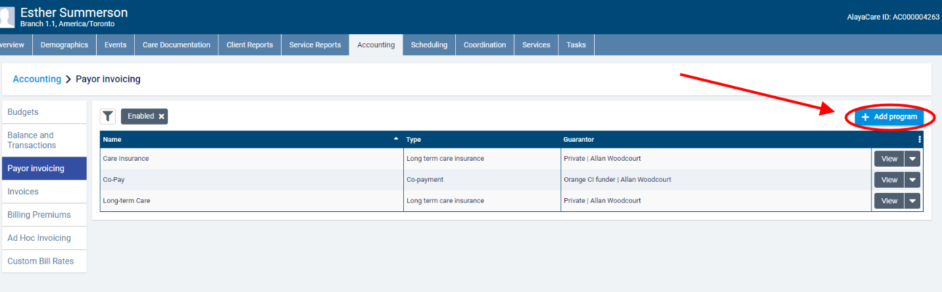
In the Add payor program dialogue, enter a name for the program and select Split percentage as the program type.
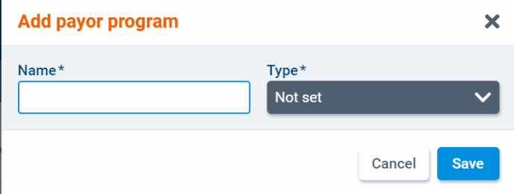
Select a client individual or funder individual funder as the Guarantor outside of coverage. This the program level guarantor who will cover the total cost of any billable items linked to a program that do not fall within the coverage range defined on a contract.
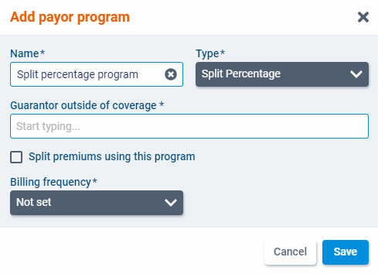
If you select a client individual funder, you will also need to select a billing contact.
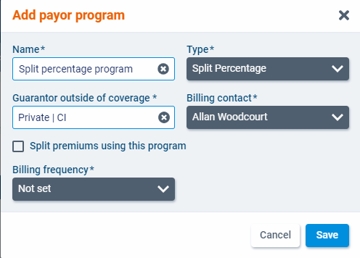
Check the box next to Split premiums using this program if you wish to split the cost of premiums between more than one bill-to party.
Finally, select a billing frequency for the program. In payor invoicing, the billing periods are determined by the billing frequency. The available frequencies are 1 Week, 2 Weeks, 4 Weeks, and Calendar Month. When you have finished, click Save.
The program will open as a new screen. Select Edit to make changes to the program details.
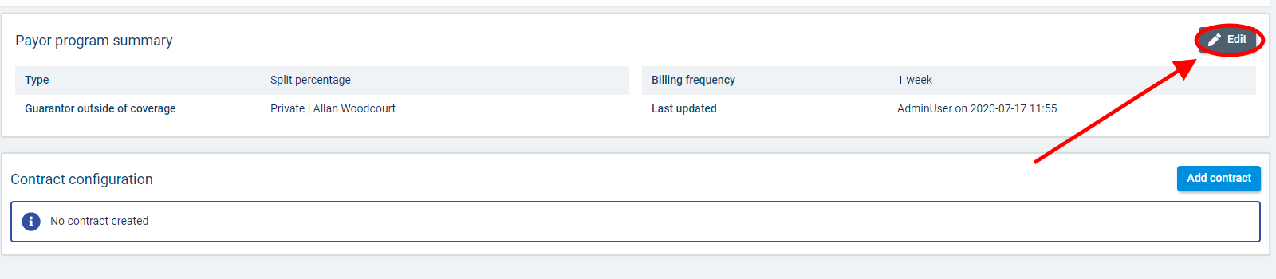

Note that once a contract has been added to the program, you will not be able to change whether you are splitting premiums for this program. Once invoices have been generated for a program, you will only be able to edit the program name and billing frequency.
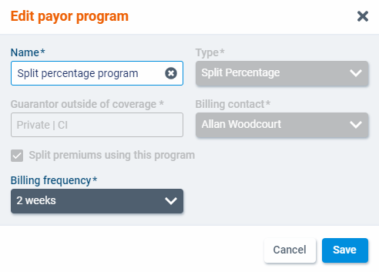
To add a contact to the program, select +Add contract.
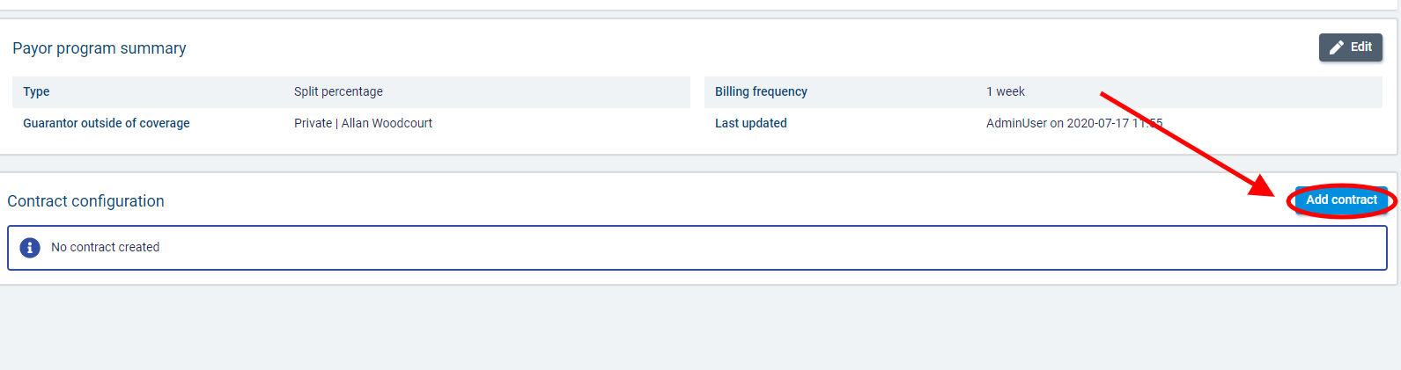

In the Add contract dialogue, enter the contract start date along with the contract number if necessary. The coverage end date will be updated when a new version of the contract is created. Note that you cannot manually enter an end date for a contract.
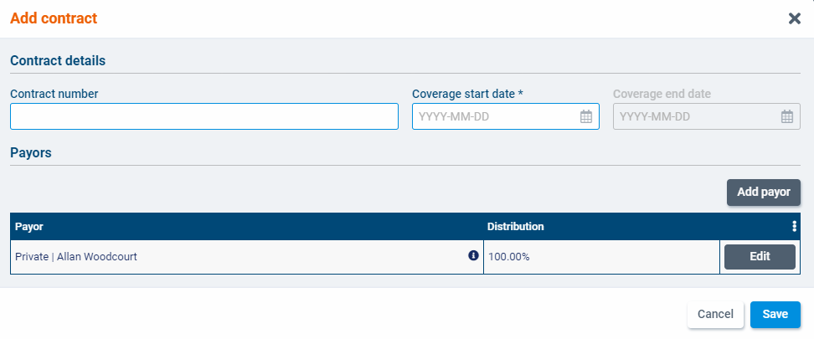

In the Payors section, the guarantor that you selected at the program level will already be listed with 100% as the distribution percentage.
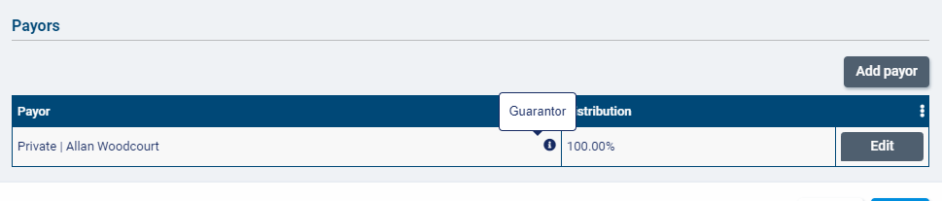
Click Edit if you wish to have a different guarantor at the contract level. This guarantor will cover the percentage not covered by any other payors you add to the contract.
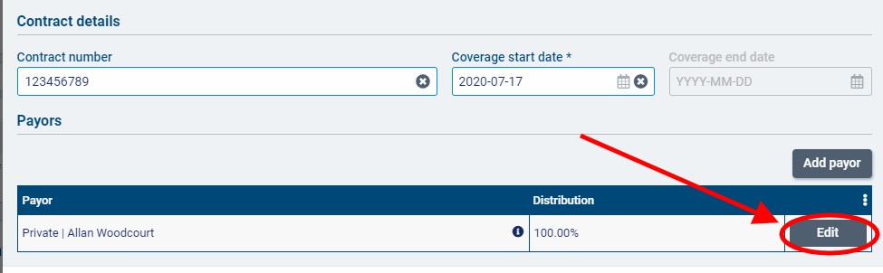
Select Add payor to add a payor to the contract.
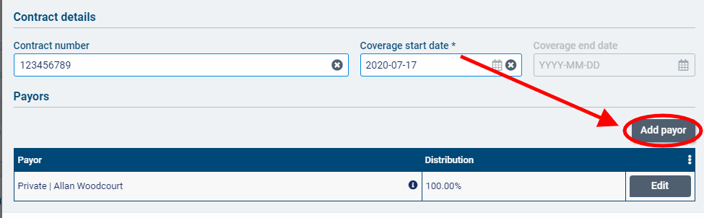
Select a funder of type client individual or funder individual in the Payor column. In the Distribution column, enter the percentage of the billable items that this payor will be responsible for. The distribution percentage of the guarantor will be automatically adjusted.
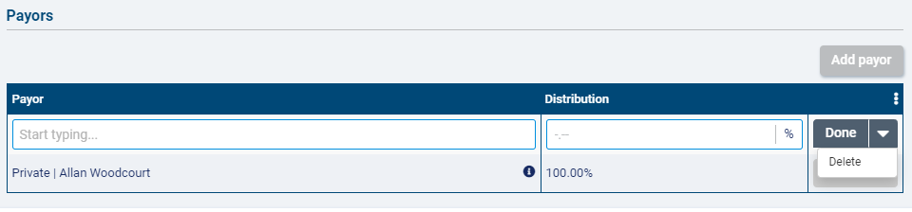
If you select a funder of type client individual, you will also need to select a billing contact.
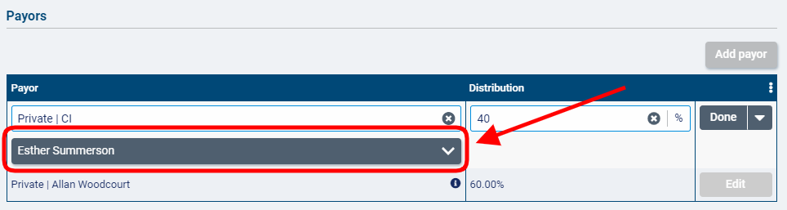
If Split premiums using this program is selected, the distribution percentage for each payor entered will apply to premiums funded by the program as well as visits.
If you did not select Split premiums using this program, an additional column will appear in the payors list called Premium(s) covered in full. For each payor you add to the list, you will be able to select the premiums from Accounting>Accounting Settings>Premiums using the button that should be 100% covered by that payor.
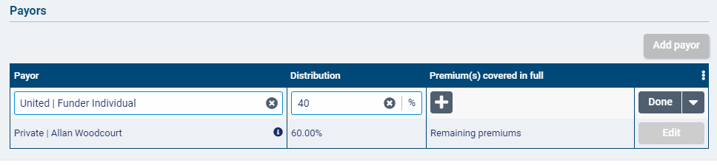
Note that you can delete a payor from the list, but you cannot delete the guarantor. Every contract must have a guarantor listed.
When you are finished adding the payor, select Done.
Click Add Payor again to add more payors to the contract. Note that you cannot add the same funder of type funder individual more than once.
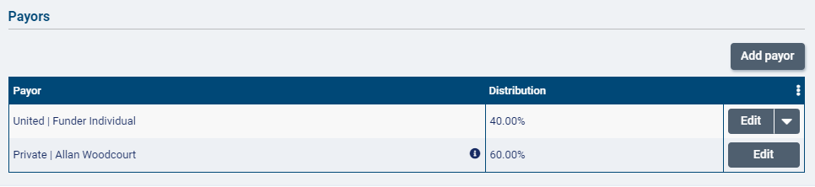
For contracts where premiums are covered in full, the number of premiums covered by each payor will be displayed in the Premium(s) covered in full column. The guarantor will be responsible for covering in full any premiums funded by the program that are not selected for coverage by one of the payors on the contract.
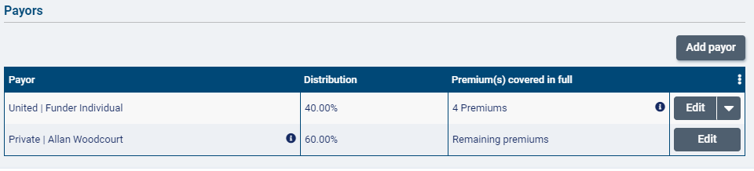
When you have finished with the contract, click Save.
Once a contract has been created, the Add contract button will change to Add version. To delete the contract, select Delete. To edit the contract, select Edit.
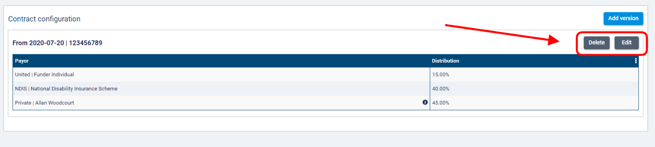
If invoices have not yet been generated for the contract (or if any generated invoices have been voided or deleted), you will be able to edit all fields on the contract.
To add a new version of the contract, select Add Version.
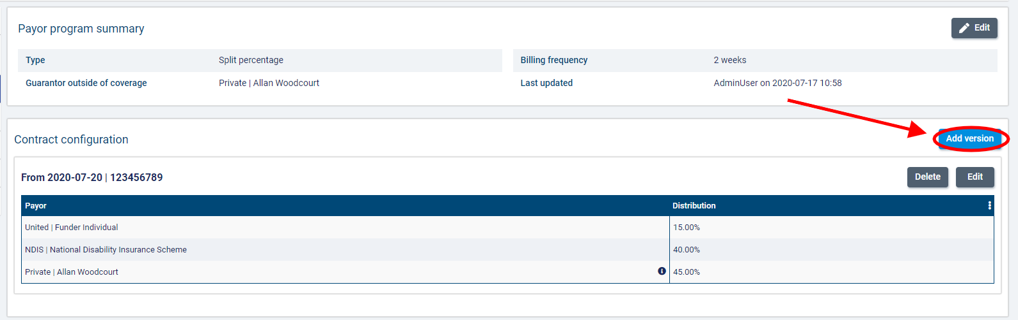
In the Add Version dialogue, you can adjust the contract number, coverage start and end dates, and payors list as needed. The guarantor set on the previous version of the contract will automatically populate in the new version but can be edited as needed.
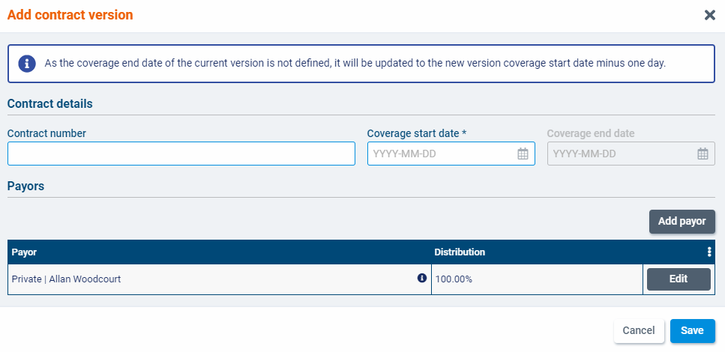
If a coverage end date was not on the previous version of the contract, it will be set as the coverage start date of the new version minus one date.
When you have finished entering the version details, click Save.
Note that only the most recent version of the contract can be edited or deleted.
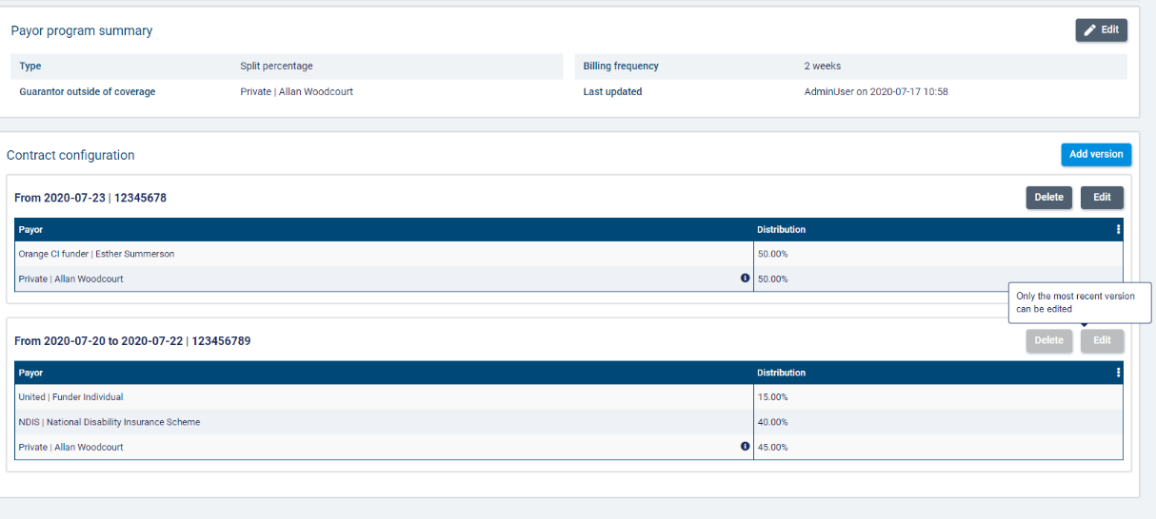

Adding the payor program to client services and billing premiums

Once you have set up a program for a client, you can attach it to services and client billing premiums.
To add a program for a client, go to a Services list on the client’s profile and select +Create a Service.
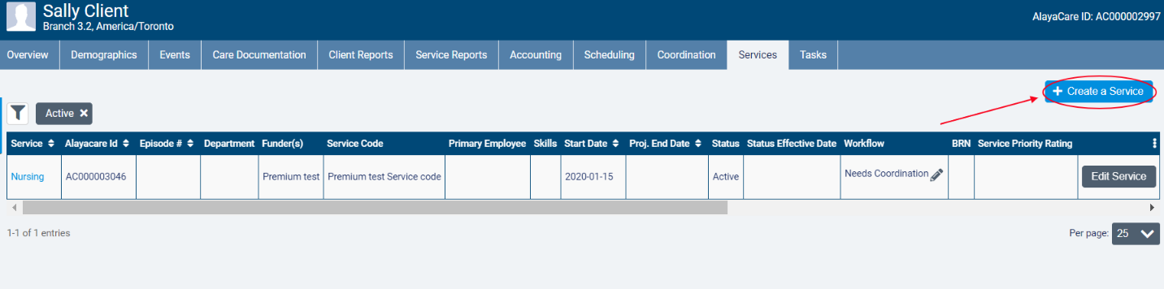
In the Funder Methodology dropdown, the different types of payor programs will be available for selection. Choose the type of the program you wish to apply. Next, select the name of the program in the Program dropdown and choose the correct Rating Funder. The funder you select here will determine which bill codes will be used to invoice billable items tied to the program.
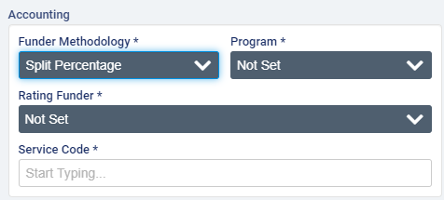
Note that the rating funder does not have to be the funder selected for either the payor or guarantor on the payor program. It is simply used to determine the rates that should be applied the billable items tied to the program.
When you have finished completing all required fields, click Create.
Note that the program on the service cannot be changed after an invoice is generated for the service.
To add a program to a client billing premium, go to Accounting>Billing Premiums on the client’s profile and select +Create Premium.
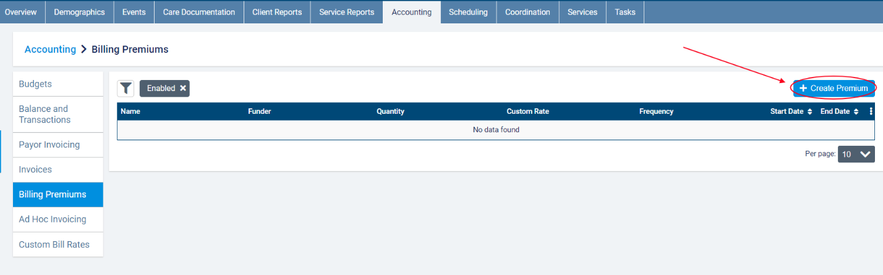
In the dialogue, select the name of the program as the Funder Methodology. After completing all required fields, click Save.
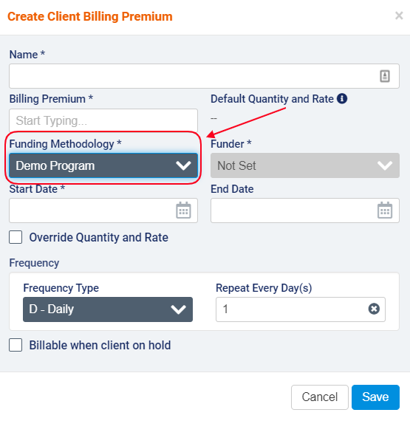
Note that the funder methodology cannot be modified on the client billing premium. A new premium will need to be created (and the current one disabled) if the program no longer applies to the premium.

Appendix A: glossary of terms

- Billable item: any source item (visit, visit premium, or client billing premium) that has been approved for billing.
- Billing periods for payor programs: billing periods in payor invoicing must have a set frequency of 1 weeks, 2 weeks, 4 weeks, or per calendar month. When generating invoices for a billing period, any billable items tied to a program with that billing period frequency that have not yet been invoiced will be included. The end date serves as the cut-off date for the billing period. Start dates of billing periods cannot be modified to avoid gaps between billing periods.
- Bill-to party: the party to whom an invoice is addressed. In payor invoicing, the bill-to party will either be a payor or the guarantor.
- Contract: in certain program types, the name of the rule set that is added to a payor program.
- Contract guarantor: in split percentage, the bill-to party who is responsible for covering the remaining percentage of a client’s billable items in a billing period once the percentages for the payors on the contract have been applied.
- Co-payment: a payor program type used when there is an agreement that the client will pay for a portion of the services being covered.
- Distribution percentage: in split percentage programs, the percentage of a billable item that the payor or guarantor will be invoiced for.
- Limit: a cap on the term set on the contract/policy in amount, hours, or visits based on a set frequency.
- Long-term care insurance: a payor program type used when there is a long-term insurance policy that is activated to cover the services being provided.
- Master invoice: the master invoice contains information about all the billable items covered by a client’s payor program for a specific billing period. When viewing the master invoice screen, you will be able to see the breakdown of what will be invoiced to the payor(s) and what will be invoiced to the guarantor. Exporting invoices at the master invoice level will generate one invoice per bill-to party.
- Payor: the party that is subject to the rules (in terms, limits, or distribution percentages) defined on the program. The payor on the policy or contract will become the bill-to party that is invoiced for the amount dictated by the benefit rules for that payor on the policy/contract.
- Payor invoicing: an invoicing methodology where you create rules at the client level to determine how the cost of billable items will be split between different bill-to parties.
- Payor program: a billing configuration at the client level to which you can add rule sets (policies or contracts) to determine how a client’s services or client billing premiums will be invoiced. Once created, programs must be added to the client’s relevant services and billing premiums.
- Policy: in certain program types, the name of the rule set that is added to a payor program.
- Program guarantor: the bill-to party that is responsible for covering the cost of any billable items funded by a split percentage payor program for which a contract is not currently in effect.
- Rating funder: a funder that is used to link bill codes and their rates to a service covered by a payor program. The rating funder will not be invoiced for any items.
- Split percentage: a payor program type to which you can add a contract with a list of payors each of whom are responsible for a fixed percentage of the cost of a client’s billable items (including or excluding premiums, depending on the program setup). The contract guarantor covers the remaining percentage. If no contract is in effect, all billable items are invoiced to the program guarantor.
- Term: the amount of a client’s services that will be covered by the payor on the policy/contract (either a fixed amount over a set frequency or, in certain program types, a percentage).

