Billing for Payor Programs

User Guide

Version 1.4
Contents
AlayaCare’s new approach to billing 1
Setting up billing periods for payor programs 2
Reviewing the master invoice list 4
Reviewing the invoices 7
Appendix A: glossary of terms 14

Introduction to the new billing

AlayaCare’s new billing methodology allows you to configure rules at the client level to determine how payors will be invoiced for the client’s billable items over a set billing period. A billable item refers to a source item (visit, visit premium, or client billing premium) that has been approved and has a rate.
Please note that equipment and supplies and income items are not currently supported.
Billable items can be billed to either a single payor or multiple payors. If the cost of items is split between multiple payors, you must create a payor program for a client to determine how items will be split and attach the program to the services and premiums to which it applies. If you need to invoice items to a single bill-to party, you must select single payor as the funding methodology on the client’s services and premiums.
The new billing periods follow a set frequency of 1 weeks, 2 weeks, 4 weeks, or per calendar month. You must select a billing period frequency when setting up a payor program for a client or selecting single payor as the funding methodology on a service or premium. Once you create a billing period for a specific frequency, you will not be able to choose the start date for the period because there can be no gaps between billing periods of the same frequency.
If you are using payor programs, when you click to generate invoices for a billing period the system will apply the rules set on the payor program to the billable items and generate the invoices for the bill-to parties. For programs in which the cost of billable items can be split between bill-to parties, at least two invoices will be generated, one for the payor on the policy or contract and one for the guarantor. For services and premiums funded by a single payor, only once invoice will be generated.
For more information on how to set up a payor program for a client and attach it services and premiums, please see the Creating Payor Programs for Clients user guide. For information about single payor only, please see the Single Payor Billing guide.

Setting up billing periods

To generate invoices, you will need to create a billing period for the frequency you wish to bill for by going to Accounting>Billing>Billing Period for Payor Program.
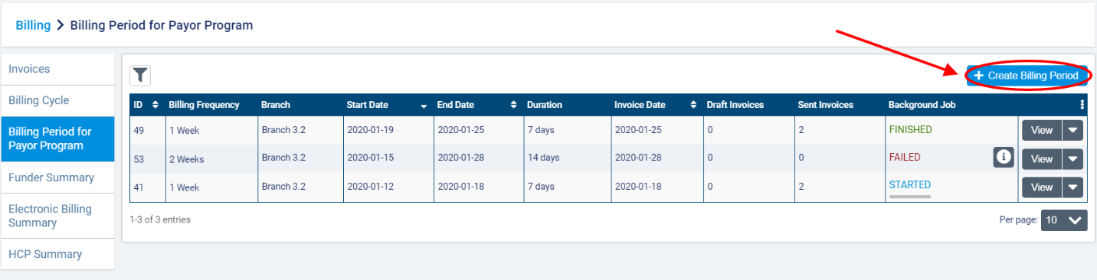
You will see all existing billing periods by frequency listed along with their Billing Frequency, Branch (if applicable), Start Date, End Date, Duration, Invoice Date, number of Draft Invoices, number of Sent Invoices, and status of any Background Jobs listed here. Note that billing periods are created by branch and billing frequency. There can be no overlap between periods in terms of branch and frequency.
Select +Create Billing Period.
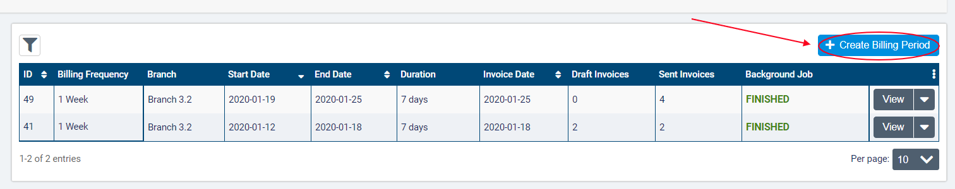
In the dialogue, select the Branch and Billing Frequency (1 Week, 2 Weeks, 4 Weeks, or Calendar Month) and enter a Start and End Date along with an Invoice Date. The Start Date can only be set on the first period created for the Billing Frequency (of the same branch).
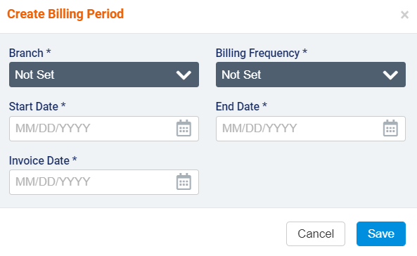
If a billing period already exists for the Billing Frequency selected, the Start Date will be set to the End Date of the previous period plus one day.
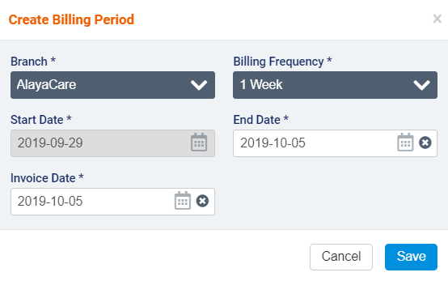
When you have finished, click Save.
Click the downward arrow next to View if you need to Edit or Delete the billing period or Restrict New Shifts.
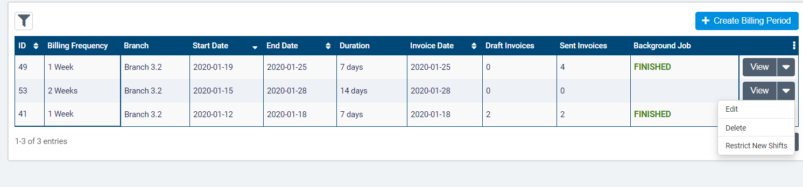
Note that you can only edit the most recent billing period for the branch and frequency. You can modify the Invoice Date, End Date, and Start Date (if it is the first billing period for the branch and frequency) as long as there are no invoices for the billing period yet. If invoices have already been generated for the billing period, you will not be able to edit it.
The status in the Background Job column refers to the status of invoice generation and regeneration processes. If a status of Failed or Partial Success is displayed, you can click the icon to view more details.
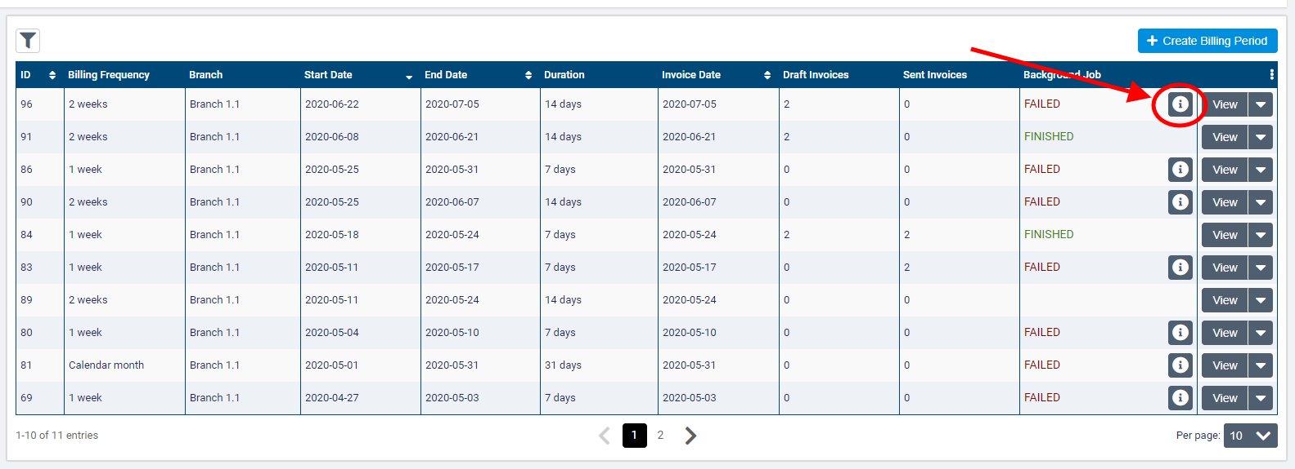
The Background Job Report dialogue will provide more information about the client program and specific error that caused the job to fail.
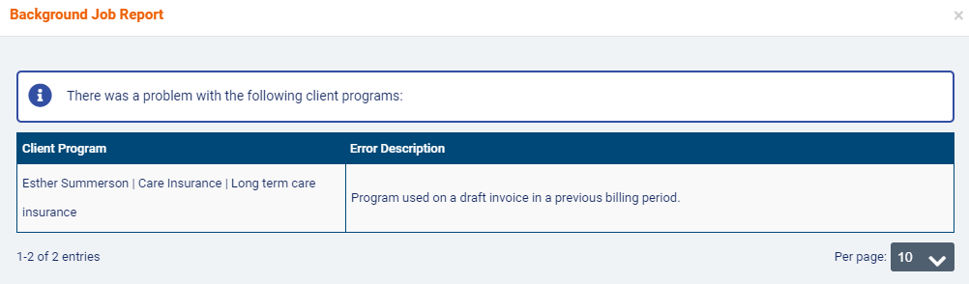

Reviewing the master invoice list

When you are ready to proceed with the invoicing process, click View to open the billing period. Note that if your organization is multi-office, the application will switch to the branch that owns the billing period and filter content accordingly.
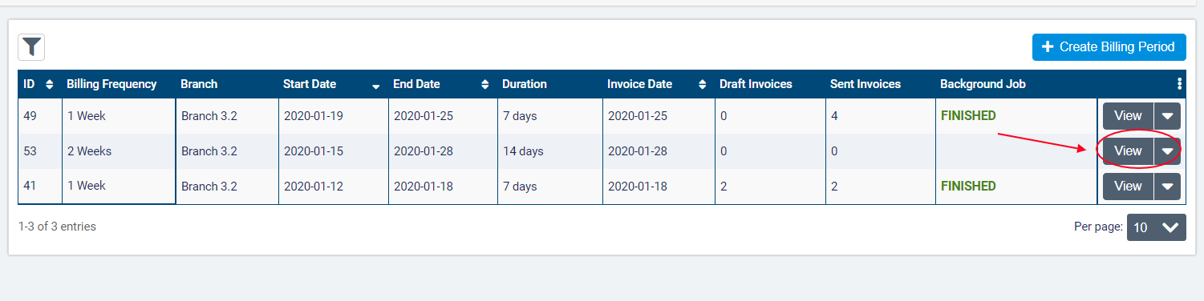
Clicking View will open the Visits tab within the billing period. From here, you can approve all visits and premiums included in the billing period and resolve any unscheduled visits as you would before generating invoices using the old billing methodology in AlayaCare.
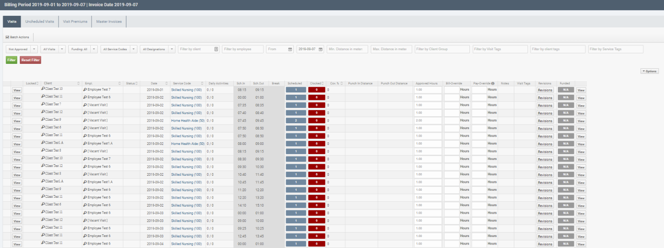
When you have finished approving source items, click on the Master Invoices tab and select Generate Invoices. This action will queue a background job to generate invoices for client programs that do not yet have a master invoice in the billing period.
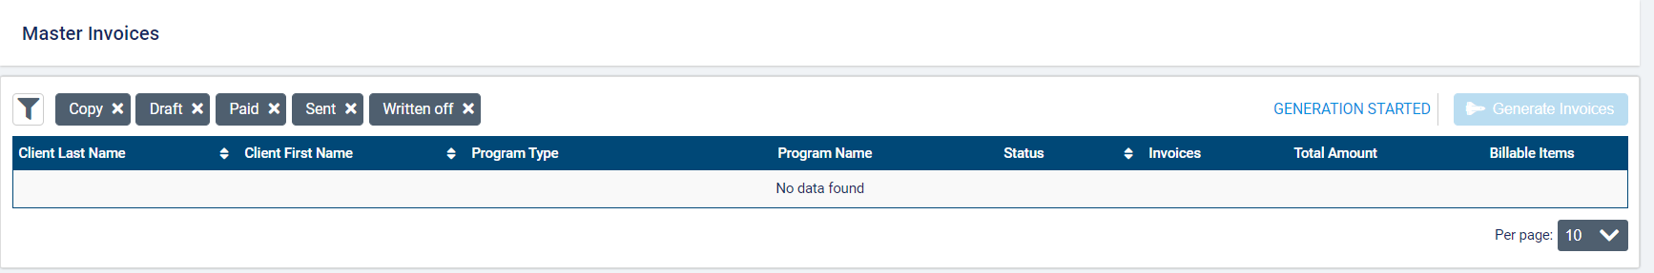

Once you click to generate the invoices for the approved source items during the billing process, the system will check each billable item in a billing period to see if it is associated with a payor program. If the item is tied to a program, the system will check to see how the item should be billed according to the benefit rules set on the program. The rates applied to each item will be determined by the rating funder selected for the service or client billing premium.
If the status if the generation background job is Partial Success or Failure, an info icon will appear next to the status.
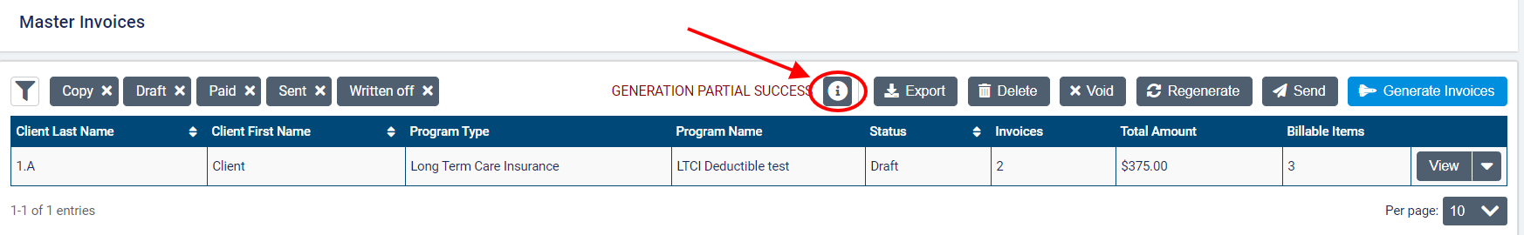
Click the icon to view the Background Job Report and identify which programs caused errors during the invoice generation.
Once the generation background job has finished, the Master Invoices list will display the Program Name, Master Invoice Status, number of Invoices generated, Total Amount owed, and number of Billable Items for each master invoice.
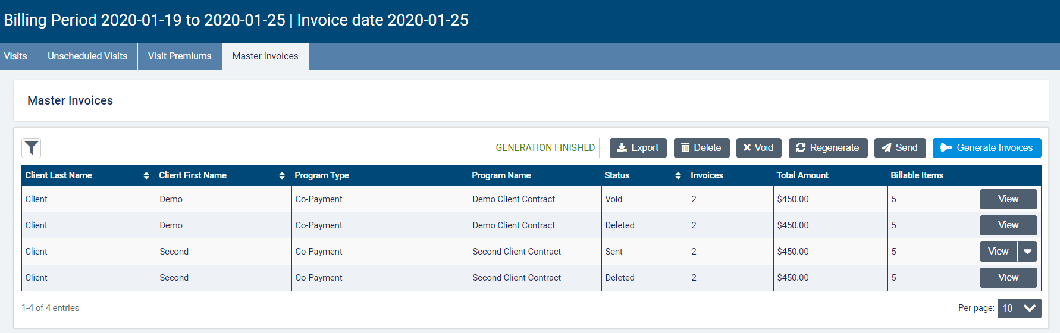
The status of the master invoice depends on the status of all invoices for that client and program. If all the invoices have the same status (draft, deleted, sent, paid, written off, or void), then that will be the status displayed in the master invoices list. If at least one of the invoices has a status of paid, written off, or copy, then the master invoice status is sent. Note that the master invoice cannot have a status of copy.
You can filter this list by Client Name, Status, and Program Type. By default, the list will filter to all statuses other than void and deleted.
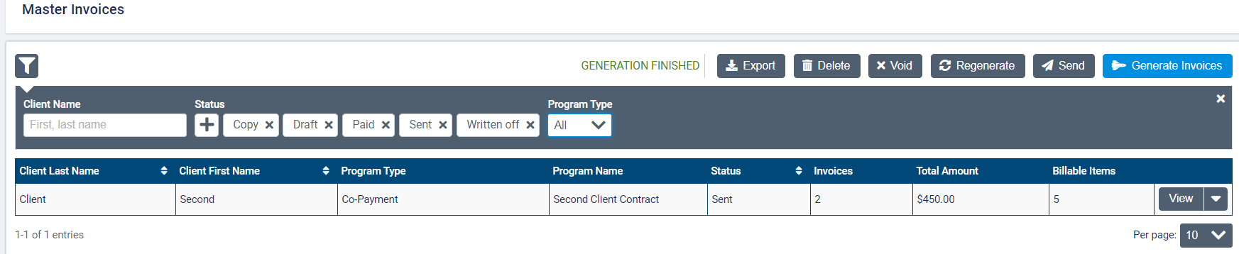
At the top of the list, you will see action buttons to Export, Delete, Void, Send, and Regenerate invoices. Use these buttons to perform actions on all invoices in the Master Invoices list. When choosing one of these actions, any master invoices that the selected action cannot apply to will be filtered out (only invoices in draft status can be deleted, sent, or regenerated, and only sent invoices can be voided).
After clicking the action button, you will be able to select which invoices you wish to perform the action by checking the box next to the client-program invoices you wish to include or clicking the box in the top left corner to select all. Then click the blue action button action (Export, Regenerate, Delete, Send, etc.)
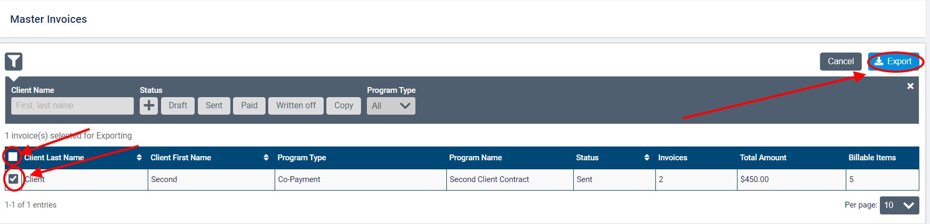
To perform actions on a specific master invoice, click the downward arrow next to View. For invoices with a status of draft, you have the option to Send, Delete, or Regenerate. For invoices that have been sent, you have the option to Void. None of these actions can be performed from this list on invoices with a status of deleted, paid, written off, void, or copy.
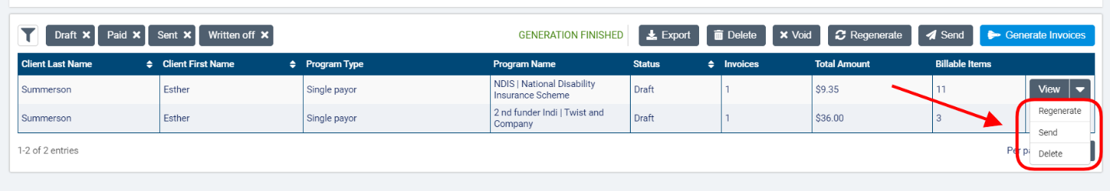
Keep in mind that clicking Generate Invoices again will create invoices for any client programs or single payor services and billing premiums that do not have a master invoice for the billing period yet but will not modify any existing invoices. Clicking Regenerate will delete the master invoice selected and re-run the background job to account for any changes to the source items. The version number of the invoice will be indicated in the invoice number for the individual draft invoices.

Reviewing the invoices

To review the individual invoices, click View for the master invoice you wish to review.
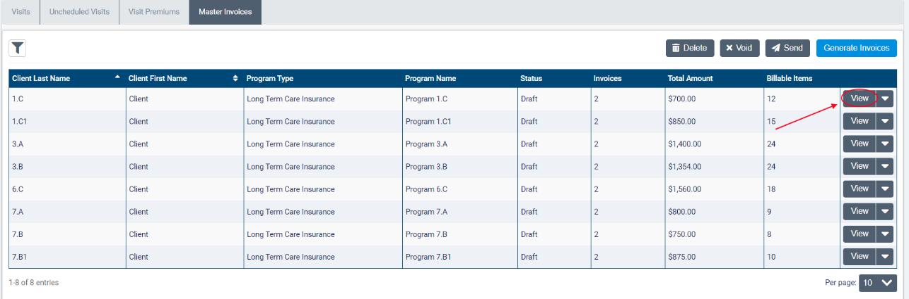
This will open a screen that displays the Master Invoice Status, Billing Period Summary, Payor Program Summary, and Invoice Details for the Guarantor and Payor along with a list of all billable items included on the invoices.
Payor program example master invoice screen:
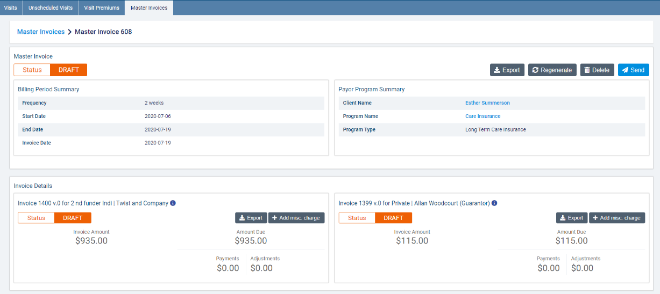
Depending on the status of the master invoice, different action buttons will be available (Delete, Send, and Regenerate if draft and Void if sent). Export will be available for invoices of all statuses. Note that if you use these buttons, the actions will be performed on the invoices for both the payor and the guarantor (in other words, you cannot delete/regenerate/send/export a single invoice from these buttons).

Single payor example:
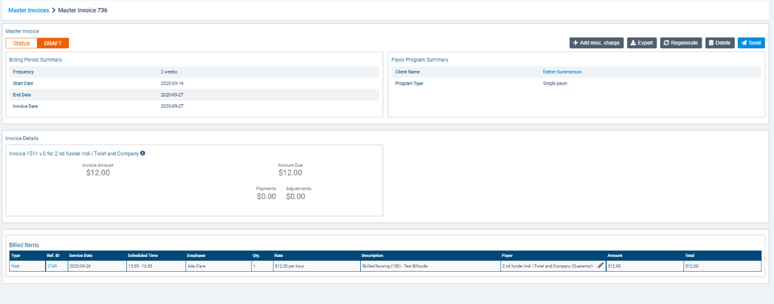
In the Invoice Details section, you will see invoice details listed for all invoices generated (one or more depending on whether you are using single payor or payor programs). The Invoice Number and Payor/Guarantor Name, Invoice Amount, Amount Due along with any Payments and Adjustments for the payor/guarantor will be listed. If the invoices have been regenerated to account for any changes to the source items, the version number will be indicated in the invoice numbers (53 v.0, 53 v.1, etc.).
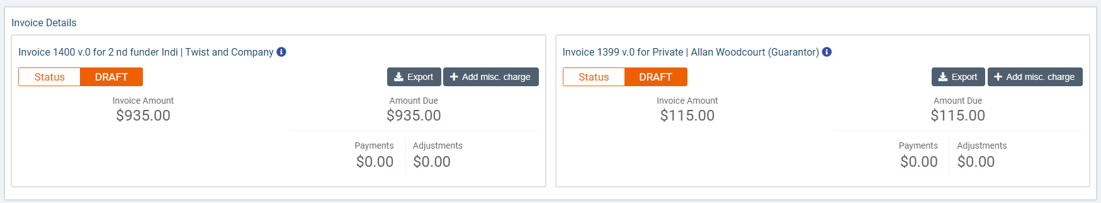
To download an individual invoice, click the Export button. In the dialogue box, AC Standard Invoice will be selected as the Invoice Export Type and PDF as the Format. If you are using the two-page invoice, you will also be able to select the AC Standard Invoice with Summary Page. When ready, click Export.
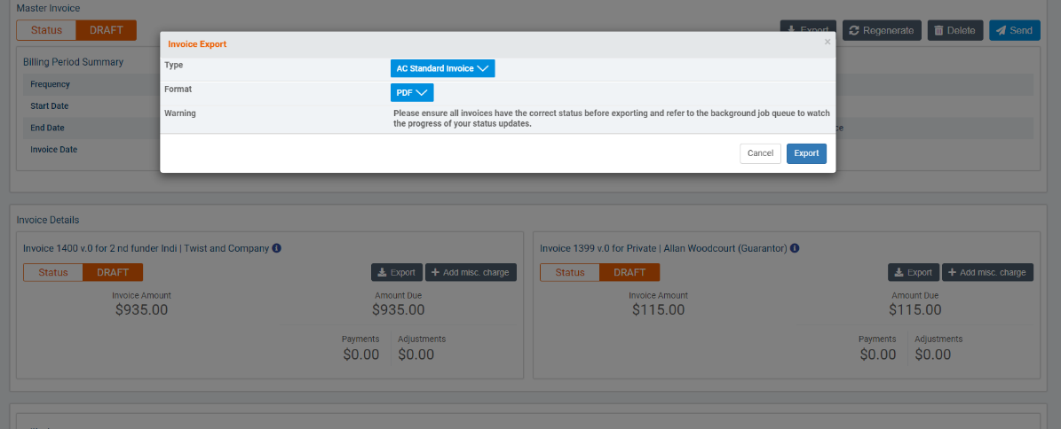
To learn more about the new AC Standard invoice and the information that will be included for payor invoicing, please see the last section of this guide.
For invoices in draft status, you will also be able to add miscellaneous charges to individual invoices from the Invoice Details section. To add a charge, click the Add Misc. Charge button.
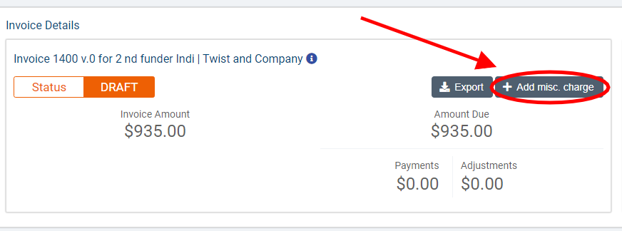
For single payor invoices, the button will appear at the top of the screen:
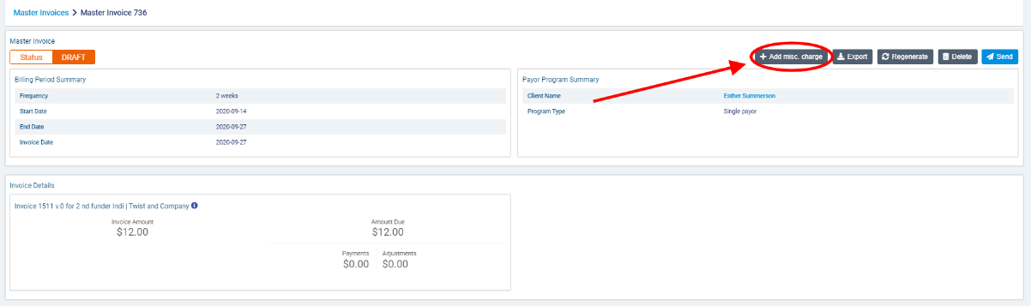
In the Add misc. charge dialogue, enter a Description of the charge being added. This description will appear on the invoice.
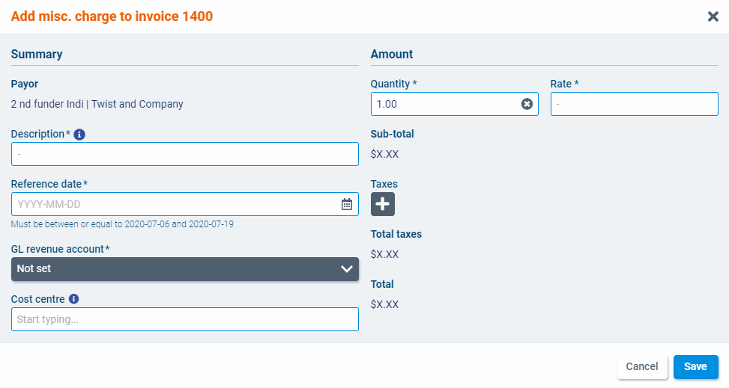
Select a Reference date, GL revenue account, and if applicable, a Cost Centre. The reference date will be the date shown for the charge on the invoice. Note that only dates within the current billing period can be select. The cost centre field will only be displayed if cost centres are configured for your organization.
Enter the Quantity and Rate of the charge. The quantity must be above 0 and can contain up to 2 decimals. Once entered, the Sub-total (excluding taxes) will appear below.
Finally, select one or more Tax that should apply on the charge if necessary. The taxes available to select will correspond to the taxes available in the branch that the payor program belongs to. The Total taxes and Total amount of the charge (including taxes) will appear in the corresponding fields.
When you have finished, click Save. The charge will be added to a Miscellaneous Charges list in the Invoice Billable Items section.
In the Invoice Billable Items section, the billable items will be divided into Billed Items and Split Billed Items depending on whether the item is covered by a single bill-to party or divided among multiple bill-to parties.
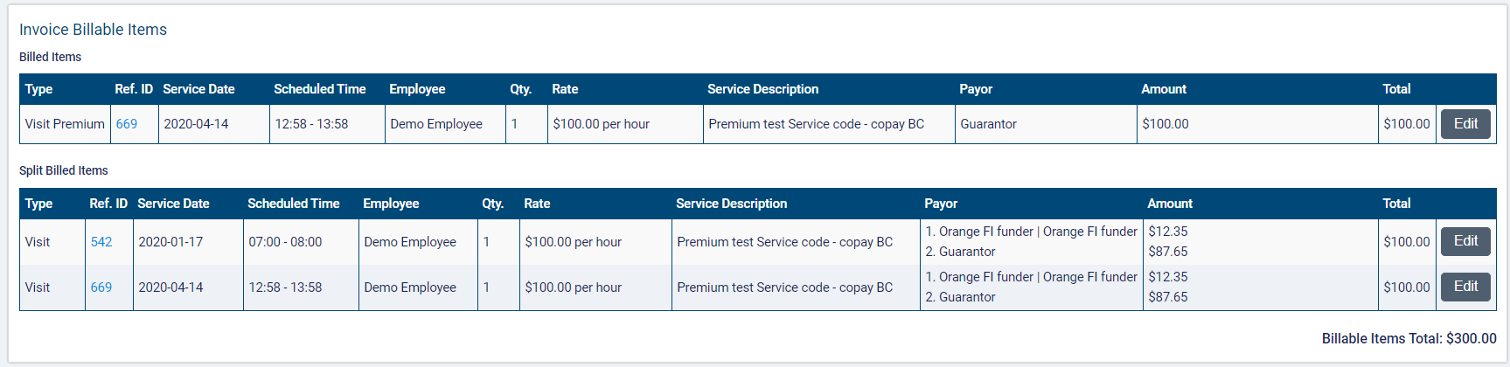
The Type, Reference ID, Service Date, Scheduled Time, Employee, Quantity, Rate, Service Description, Payor(s), Amount and Total cost charged will be listed for each item. You will also be able to click on a hyperlink for the billable item in the Ref ID field to view more details about the visit or premium.
If you wish to edit how much of the item’s total cost will be paid by the payor versus the guarantor, click the Edit button next to the billable item.
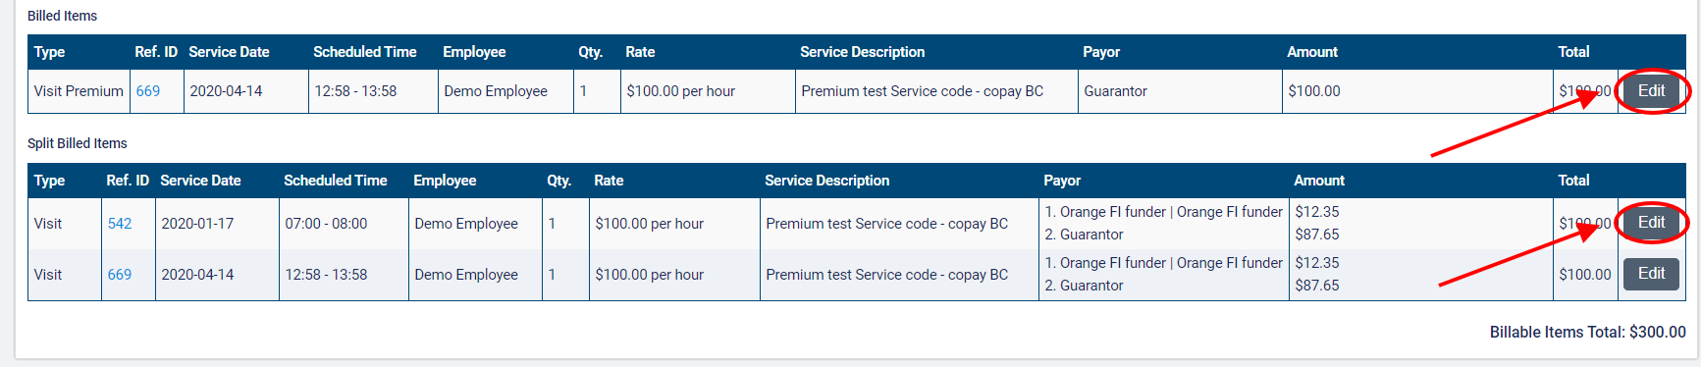
For Split Billed Items, you can then adjust the Amount paid by the guarantor and payor(s) in the Amount column. When redistributing the Total, the sum of the amounts of the new distribution must equal the total value of the billable item.
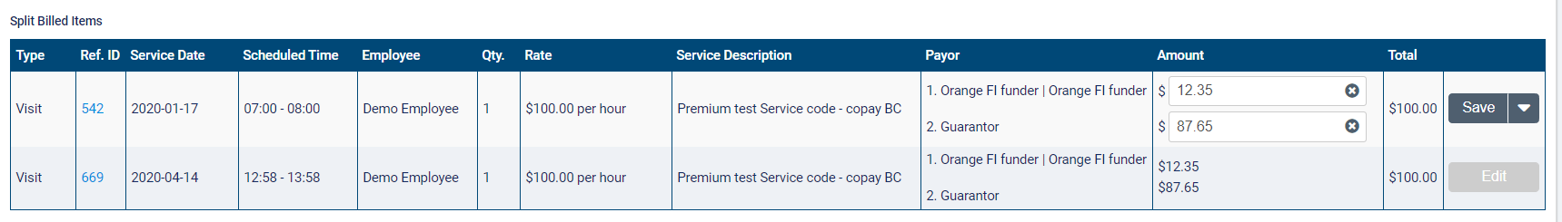
For Billed Items like premiums that are not split, you can select whether the guarantor or payor should cover the total cost of the item using a dropdown in the Payor field.
When you have finished making changes, click Save.
If any additional charges have been added to the invoices, the Invoice Billable Items section will also contain a Miscellaneous Charges list.
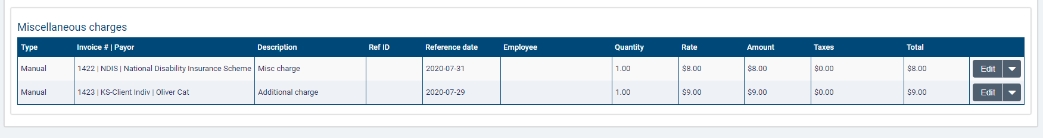
The Type, Invoice # and Payor (the funder name), Description, Ref ID (if applicable), Reference date, Employee (if applicable), Quantity, Rate, Amount, Taxes, and Total will be listed for each charge. The Type will be Manual if the charge was created on an invoice and Automatic if it was added to an invoice during the invoice generation process. Note that the Ref ID field will only be filled out for charges of type automatic. As with other billable items, it will contain a hyperlink that opens the visit, visit premium, or client billing premium. The Employee field will be filled out if the charge is a visit or visit premium. Select Edit to make changes to the charge.
When you are ready to mark the invoices as Sent, click Send.
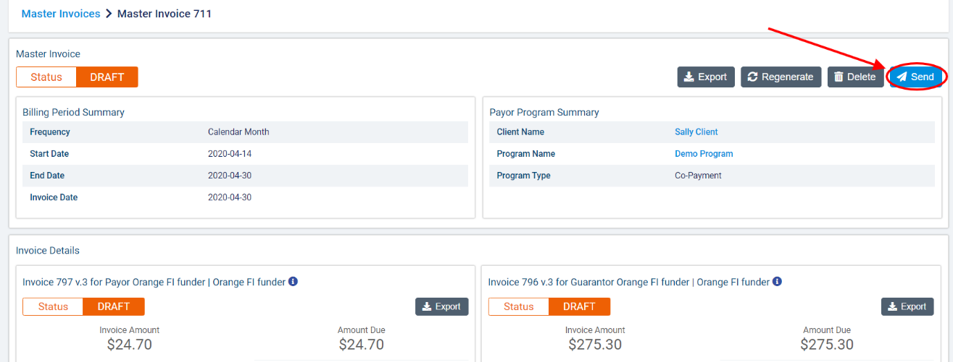
In the dialogue box, click Send to confirm.
Once the invoices have been sent, you can add transactions to the individual invoices as necessary. Click the +Add Transaction button on the invoice.
Note that you must be in a role that has the Manage Transactions ACL to view this button.
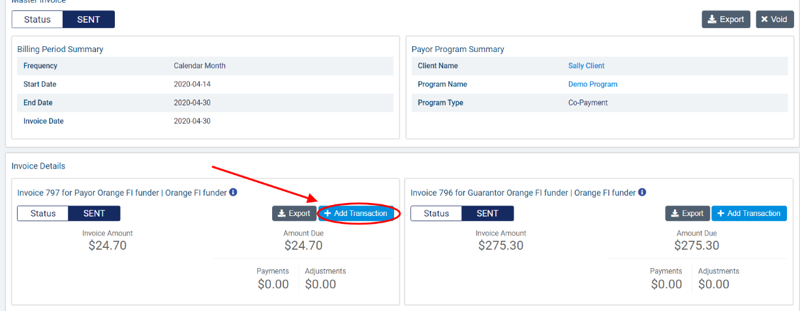
In the Add Transaction dialogue, select the Transaction Type (Payment, Credit Note, Writeoff) and complete the required fields. When you have finished, click Save.
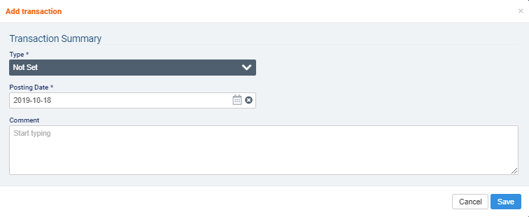

Appendix A: glossary of terms

- Billable item: any source item (visit, visit premium, or client billing premium) that has been approved for billing and has a rate.
- Billing periods: billing periods in payor invoicing must have a set frequency of 1 weeks, 2 weeks, 4 weeks, or per calendar month. When generating invoices for a billing period, any billable items tied to a program with that billing period frequency that have not yet been invoiced will be included. The end date serves as the cut-off date for the billing period. Start dates of billing periods cannot be modified to avoid gaps between billing periods.
- Bill-to party: the party to whom an invoice is addressed. In payor invoicing, the bill-to party will either be a payor or the guarantor.
- Contract: in certain program types, the name of the rule set that is added to a payor program.
- Co-payment: a payor program type used when there is an agreement that the client will pay for a portion of the services being covered.
- Guarantor: the bill-to party that is responsible for covering the remainder of invoice balances after the rules on any policies or contracts in effect have been applied.
- Limit: a cap on the term set on the contract/policy in amount, hours, or visits based on a set frequency.
- Long-term care insurance: a payor program type used when there is a long-term insurance policy that is activated to cover the services being provided.
- Master invoice: the master invoice contains information about all the billable items covered by a client’s payor program for a specific billing period. When viewing the master invoice screen, you will be able to see the breakdown of what will be invoiced to the payor(s) and what will be invoiced to the guarantor. Exporting invoices at the master invoice level will generate one invoice per bill-to party.
- Payor: the party that is subject to the rules defined on the program. The payor on the policy or contract will become the bill-to party that is invoiced for the amount dictated by the benefit rules on the policy/contract.
- Payor invoicing: an invoicing methodology where you create rules at the client level to determine how the cost of billable items will be split between different bill-to parties.
- Payor program: a billing configuration at the client level to which you can add rule sets (policies or contracts) to determine how a client’s services or client billing premiums will be invoiced. Once created, programs must be added to the client’s relevant services and billing premiums.
- Policy: in certain program types, the name of the rule set that is added to a payor program.
- Rating funder: a funder that is used to link bill codes and their rates to a service covered by a payor program. The rating funder will not be invoiced for any items.
- Single payor: a funding methodology in the new billing that can be selected on services and premiums to allow all items to be billed to a single bill-to party on a single invoice.
- Term: the amount of a client’s services that will be covered by the payor on the policy/contract (either a fixed amount over a set frequency or, in certain program types, a percentage).

