Notifications Outbox

User Guide

Contents
What is the notifications outbox? 1
Accessing the notifications outbox 2
Permissions 2
Reviewing message groups in the outbox 2
Message group details 5
Message details 7

What is the notifications outbox?

The notifications outbox is a new feature that allows you to view information about notifications sent from the AlayaCare web application.
This feature allows you to review details about all visit offer notifications sent out of AlayaCare, including information about the message type, date and time of sending, sender and recipient names, and whether each message was successfully delivered. You can also resend any messages that were not successfully delivered the first time.
While only visit offer notifications will be visible in the notifications outbox for now, the plan is for all messages sent out of AlayaCare to eventually be displayed through the outbox. Upcoming features that will be displayed through the outbox once they are ready to be released include bulk invoice emails and push notifications.

Accessing the notifications outbox

Permissions
Required ACLs: the following ACLs in the new Outbox folder in Settings>Roles and Permissions control access to the notifications outbox:
- Outbox>View Visit Notifications: this ACL allows you to view information about visit notifications sent from AlayaCare in the outbox.
- Outbox>Manage Visit Notifications: this ACL allows you to resend visit notifications sent from AlayaCare from the outbox
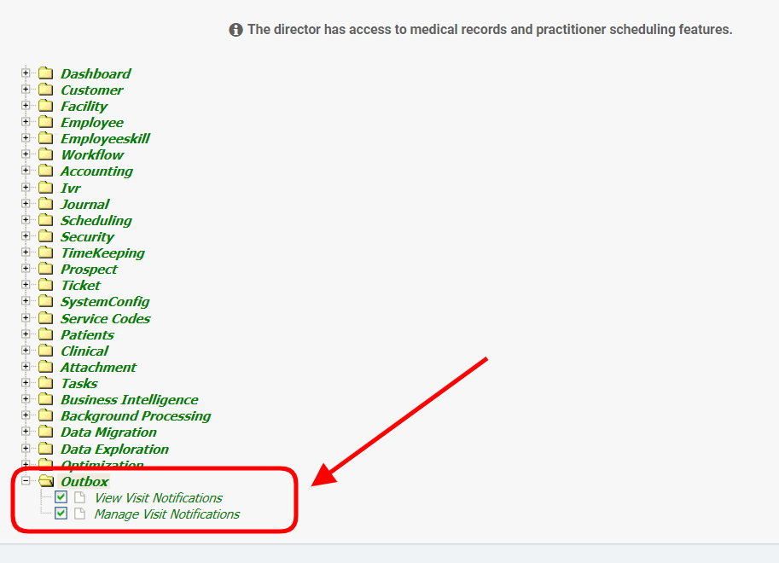

Reviewing message groups in the outbox

To view the notifications outbox, go to Dashboard>Messages>Outbox to see information about notifications sent out of listed by message group.
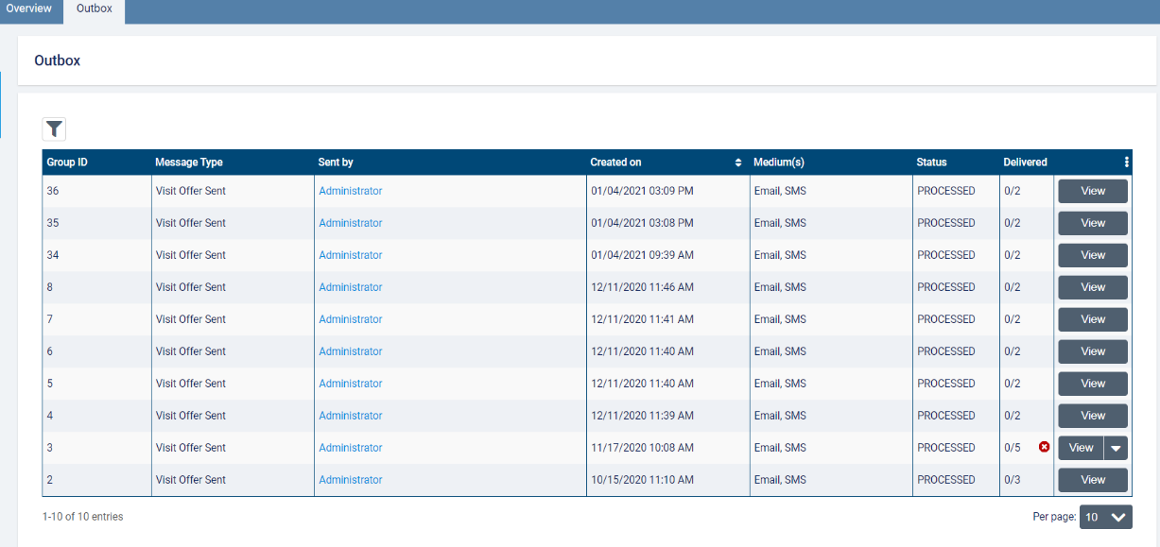
A message group refers to the group of messages sent together by a single sender (for example, a visit offer notification sent to multiple employees). Note that an SMS and email notification sent to the same employee when a visit is offered or assigned are considered separate messages but part of the same message group.
For each message group, you will see the group ID, message type (for example, visit offer sent or visit offer assigned), name of the employee that the messages were sent by, date/time the group was created on, message medium (email, SMS), and status (pending, processed, failed).
Note that in multi-office environments, you will only be able to see visit offer notifications in the outbox sent from the branch you are currently in as well as any child branches.
The delivered column will display how many messages out of the total number of messages in the group were successfully delivered to their intended recipients from AlayaCare. If an error occurred when sending one or more messages in the group, a red icon will appear in the column. Hover over the warning icon to view the error message.
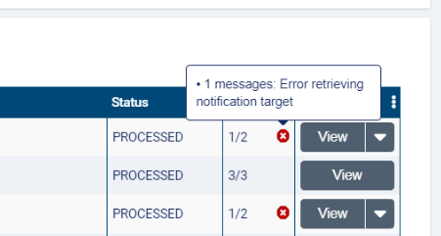
Note that error messages will only be available for messages sent after the notifications outbox is enabled for your organization.
To try resending the failed messages in the group, click the downward arrow next to view and select resend failed.
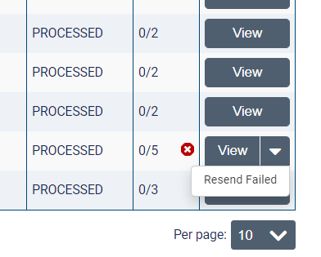
Click resend to confirm that you wish to resend the failed messages in the message group.
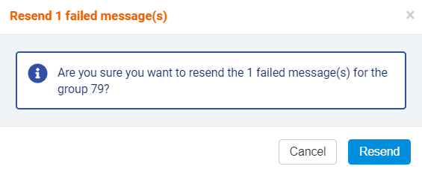
You can filter message groups by message type (visit offer sent or visit offer assigned), the employee the messages were sent by, the employee the messages were sent to, date range, and medium (SMS or email). Use the messages with internal error toggle to show only message groups with one or more internal sending errors.
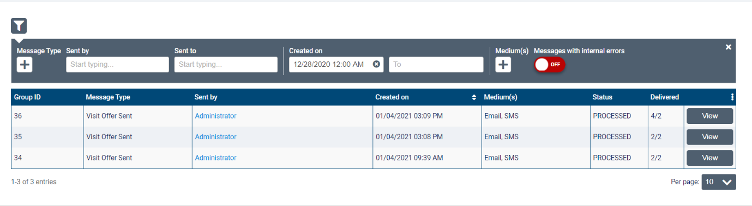

Select view for a message group to see more information.
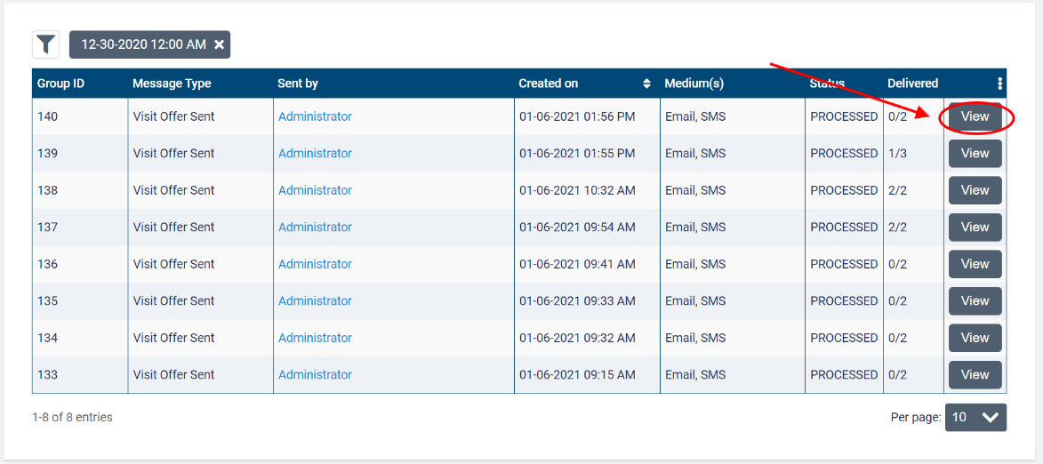

Message group details

In the next screen, you will see further details about each of the messages sent as part of the message group. Each message will be listed by message ID, employee it was sent to, date/time it was updated on, medium (SMS or email), target (the employee’s phone number or email on their profile), status (pending, failed, sent, or delivered), and the branch of the employee it was sent to (for multi-office environments only).
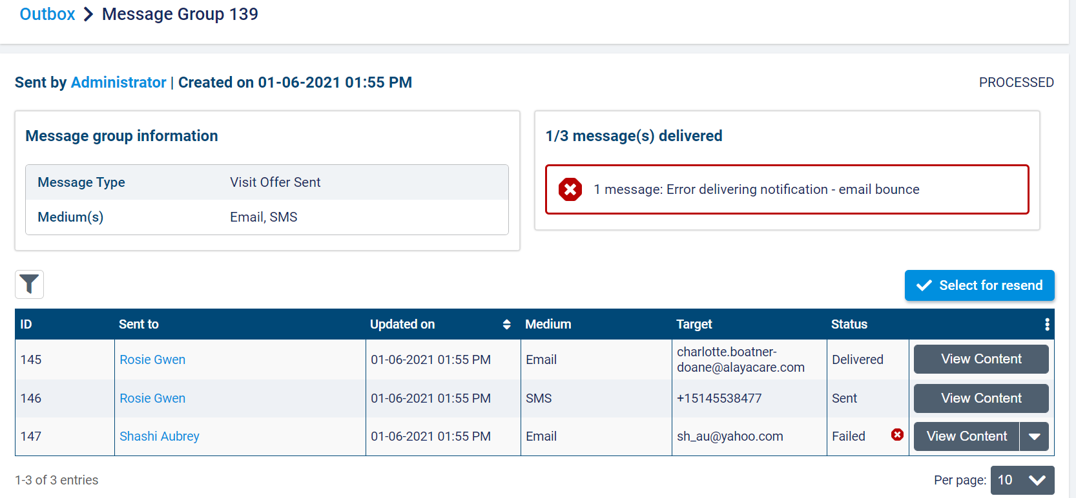
A message will have a status of delivered once it has reached the recipient’s email or mobile device. A status of sent indicates that the message has been sent successfully from AlayaCare. A status of failed indicates that the message was not successfully sent or delivered.

You can filter the individual messages in the group by the message recipient, date range, medium, branch of the recipient (in multi-office environments), group(s) (if using group associations), and status.
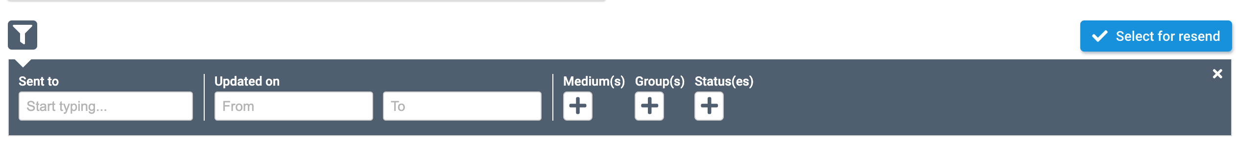
Note that the group association feature flag must be enabled to access the group(s) filter. The group(s) filter will allow you to see all groups if you are a system administrator. Other employees will only be able to filter by the group(s) they have access to.
If one or more messages could not be sent, information about the errors will be displayed. For example, in the image below, the error occurred because the email notification bounced back when sending.
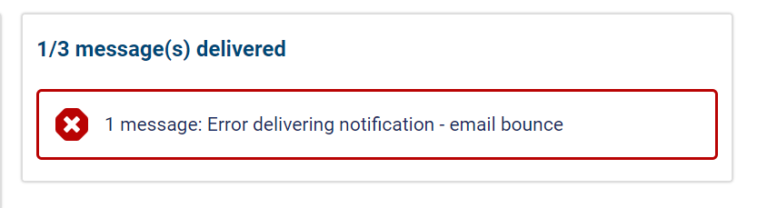
To try resending one or more messages in the group, click select for resend.
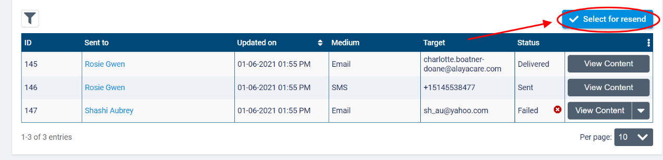
Next, check the boxes to select the messages you wish to resend. Only failed messages will be available to select. Once you have made your selection, click resend selected.
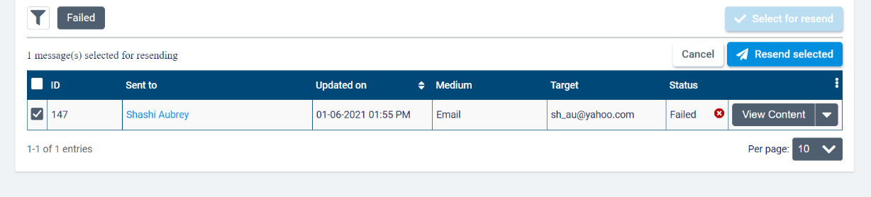

To resend an individual message, click the downward arrow next to view content and select resend.
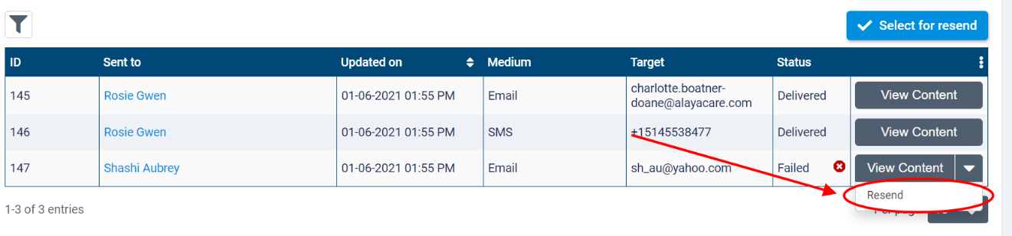

Message details

To review details about a specific message sent from AlayaCare, click view content.
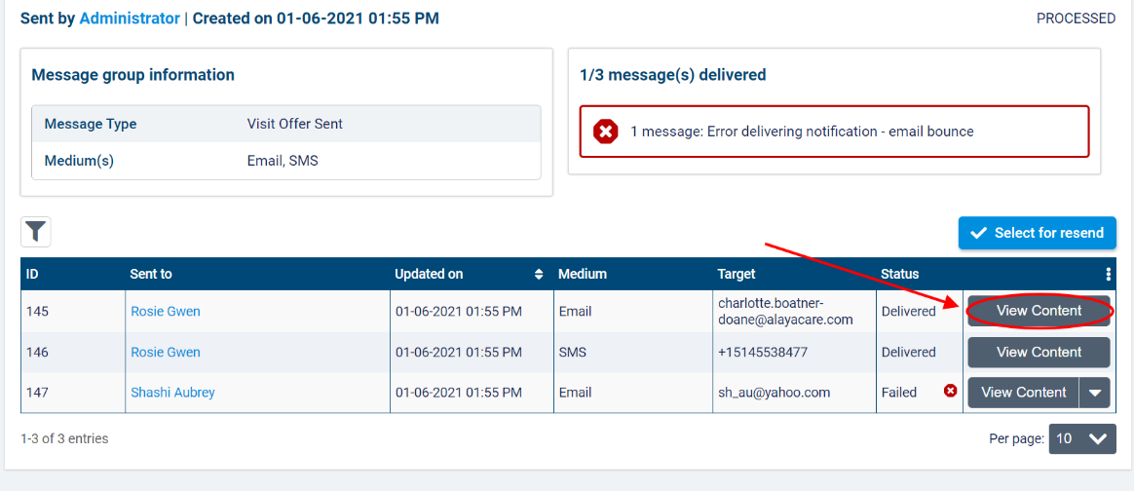
On the message page, you will see the offer ID, visit ID, start date, start and end time, offer expiration date time, service code, and location area (city and zip code) for the offered visit.
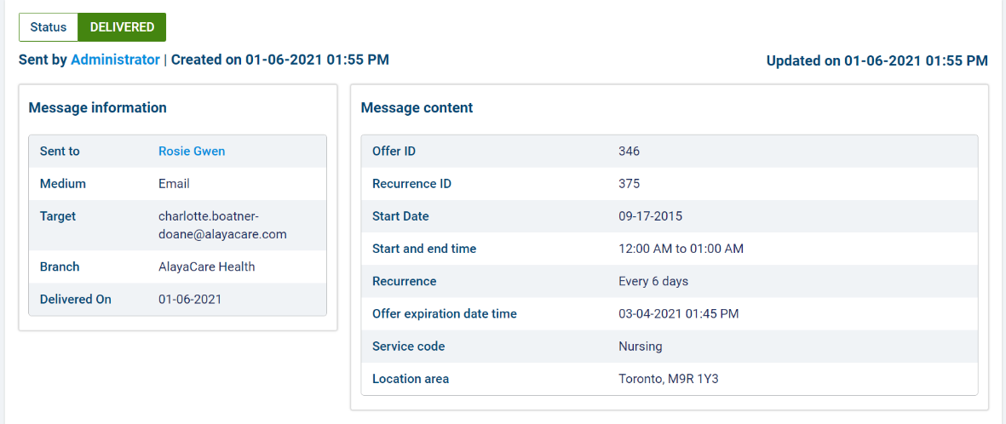
Note that you can select the hyperlinked names of the employee who sent or received the message to open their employee profile in a new tab.
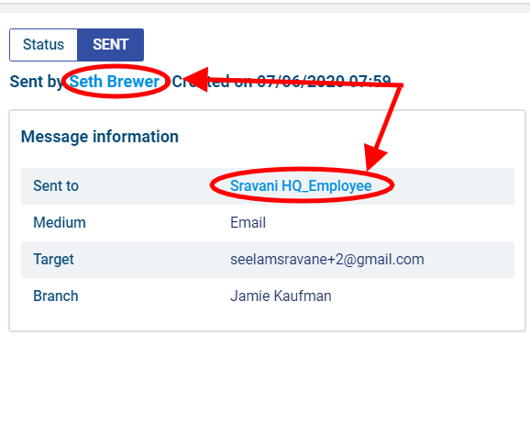
If the status of the message is failed, the reason for the sending failure will be displayed beneath the status. To try resending the message, click the resend button.
