Configuring Visit Verification (VV)

User Guide

Contents
Visit Verification (VV) in AlayaCare 2
Configuring accounting settings for VV 2
Rounding rules for bill codes and pay codes 2
Bill Codes 2
Pay codes 4
VV Reasons and Resolutions 5
Reasons 6
Resolutions 7
Associations 10
VV rule set configuration 12
Create a new rule set or new version of the rule set 13
Add rule types to a rule set 15
Link a branch to a rule set 19
Link payor to a rule set 20
Link a service code to a rule set 21
VV glossary of terms 23

Visit Verification (VV) in AlayaCare

Visit Verification (VV) is a process that automates most of the visit approval workflow, by comparing completed visits against a set of configurable rules, to flag any issues that require review or further investigation. You can review these visits in detail and document the actions to validate compliance.
Within the U.S. market, VV helps organizations to electronically verify information related to home health care visits covered by Medicaid. VV helps organizations ensure that clients are receiving care accordingly and reduce the number of fraudulent care claims submitted.
The VV workflows in AlayaCare allow organizations to determine whether any visits are in violation of the VV requirements configured for your organization. If any VV exceptions are found during the verification process, you will need to review the visits that have failed verification and, where required, select the correct reason and resolution codes before you can approve the bill and pay quantities for the visit and proceed to billing/claim generation and payroll. The visit verification information can then be exported and sent to a third-party aggregator, when required.
You must first configure your VV accounting settings before using VV to identify visits that are in violation of related requirements:
- Set up rounding rules to calculate approved time for visits during visit verification.
- Create the reasons, resolutions and associations that will be used to resolve exceptions found during visit verification.
- Set your desired unit for distance thresholds in Settings>Locale>Unit of distance
- Create rule sets with different rule types and attach them to service codes, payors and branches.

Configuring accounting settings for VV

Before you can use VV, the feature must be enabled for your organization by AlayaCare. Please reach out to your Client Success Manager or Client Relationship Manager to request to enable VV for your organization’s environments.
Roles and permissions: to configure VV specific features in accounting settings, you need the Accounting>Edit accounting settings ACL.

Rounding rules for bill codes and pay codes

When configuring bill codes and pay codes, you will have the option to set rounding rules for calculating the approved time during the visit verification process.

Bill Codes

In the bill code configuration screen, a rounding rules section will appear after selecting per hour as the units.
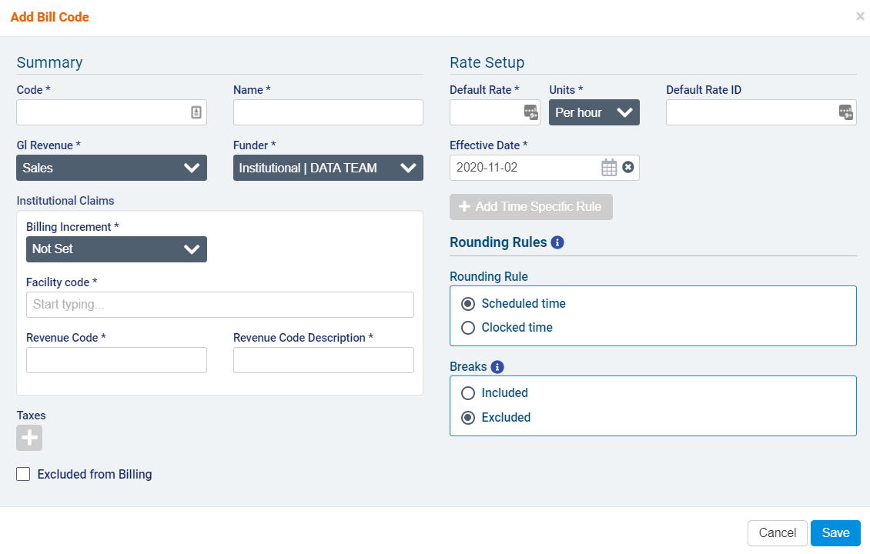
You can select either scheduled time or clocked time for the rounding rule that will be used for determining the approved time during visit verification.
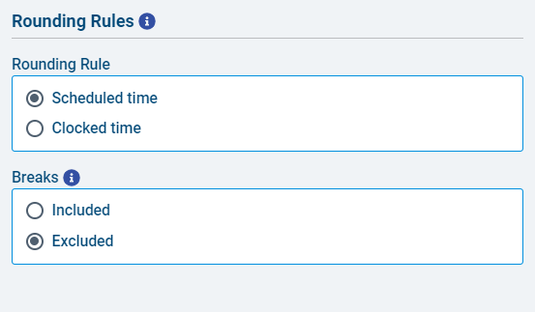
If you select scheduled time, you can choose whether you wish to include or exclude breaks.
If you select clocked time, you must select a rounding method. The available selections are no rounding, round up, round down, or round to the nearest.
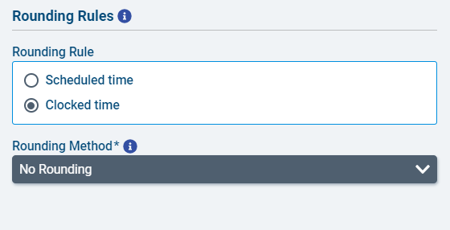
If you select round down, round up, or round to the nearest, you must also select a rounding increment (5, 10, 15, 30, or 60).
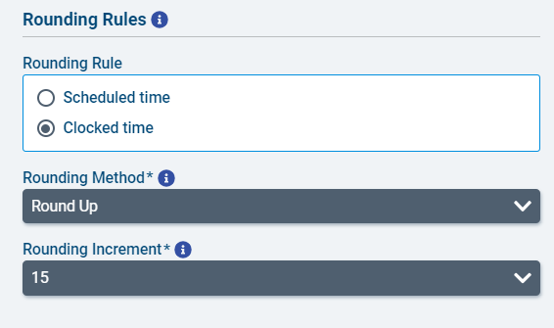

Pay codes

When setting up a new pay code, the rounding rules section will appear when you select hours as the units.
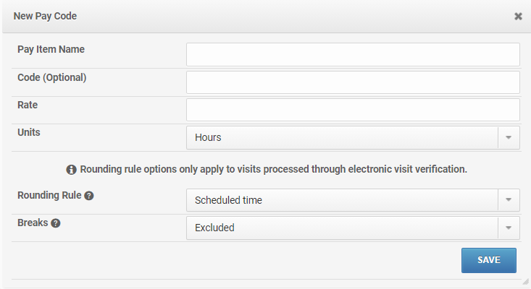
You can select either scheduled time or clocked time for the rounding rule that will be used for determining the approved time during visit verification.
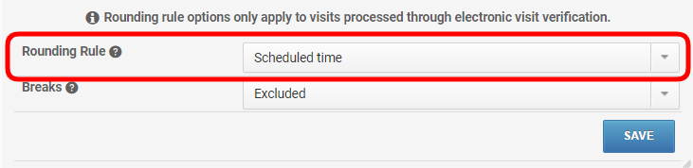
If you select scheduled time, you can choose whether you wish to include or exclude breaks.
If you select clocked time, you must select a rounding method. The available selections are no rounding, round up, round down, or round to the nearest.
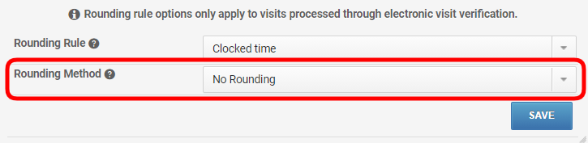
If you select round down, round up, or round to the nearest, you must also select a rounding increment (5, 10, 15, 30, or 60).
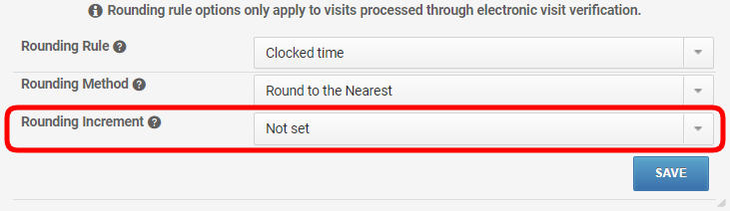

VV Reasons and Resolutions

Reasons and resolutions can be required before a visit can be approved, when certain VV exceptions are raised during the visit verification process. This is configured at the time of adding a rule type to a rule set. A single reason code can have multiple resolution codes.
Multi-office rules: reasons and resolutions are multi-office aware, meaning that reasons and resolutions configured at parent branches will be available to child branches. However, associations between reasons and resolutions will need to be configured for each branch.
To configure reason and resolution codes, go to accounting>accounting settings>verification reasons. You will see three tabs for reasons, resolutions, and associations.
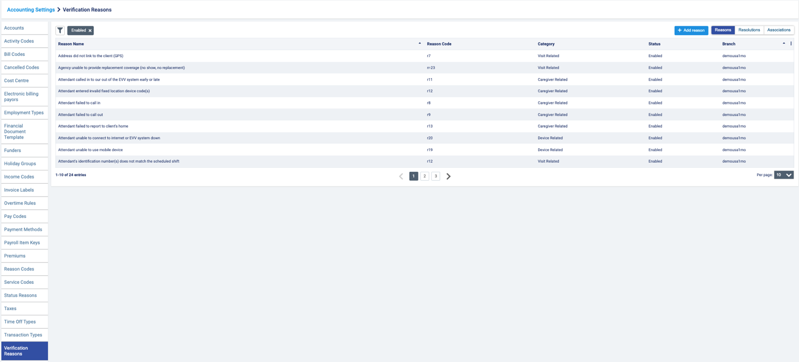

Reasons

Under the reasons tab, you will see the reason name, reason code, category, and status (enabled or disabled) of previously configured reasons. If your organization is multi-office, you will also see the branch at which the reason was configured. The list can be filtered by searching for the reason code or reason name or by category or status or by selecting a branch (for multi-office organizations).
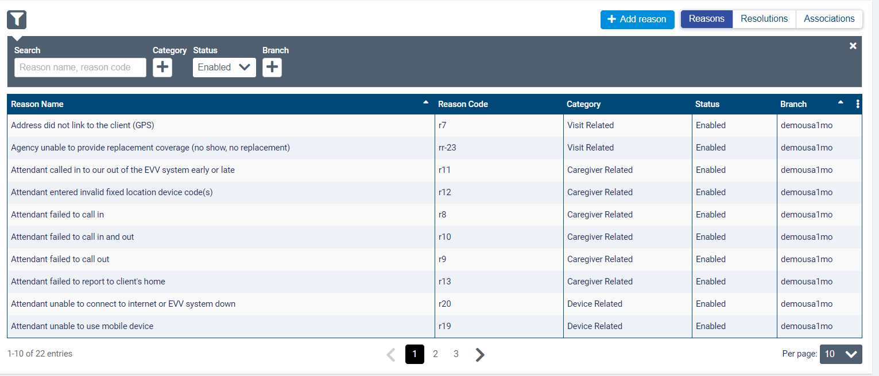
To add a new reason to the list, select the add reason button.
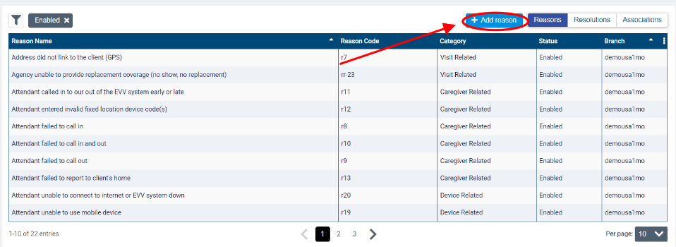
Enter a reason name and reason code, then select a category (caregiver related, client related, device related, punch in, punch out, or visit related). Note that the reason name must be unique across your organization. In multi-office environments, reason names must be unique to parent branches and any subsidiary branches. Branches at the same level can reuse the same reason names.
When you have finished, click save.
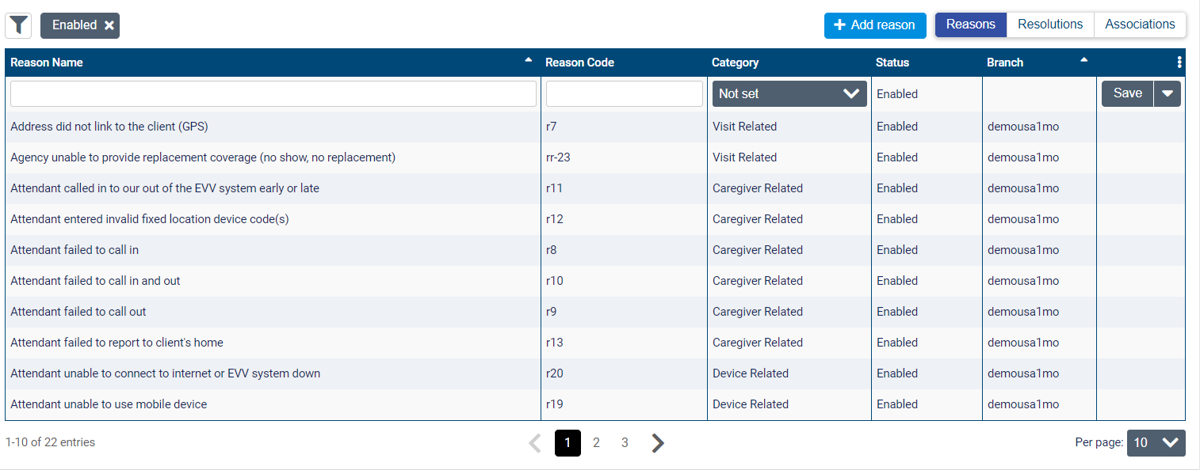
You can edit the reason by selecting the edit button. Note that in multi-office environments, you will only be able to edit or disable reasons created at your branch or a subsidiary branch.
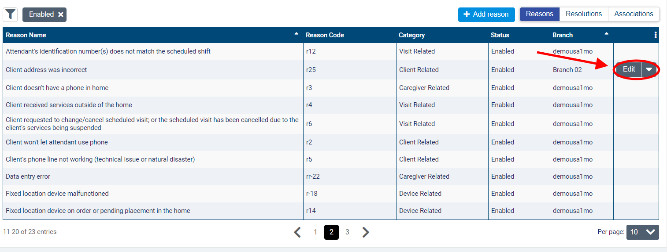
Make the necessary changes and then click save.
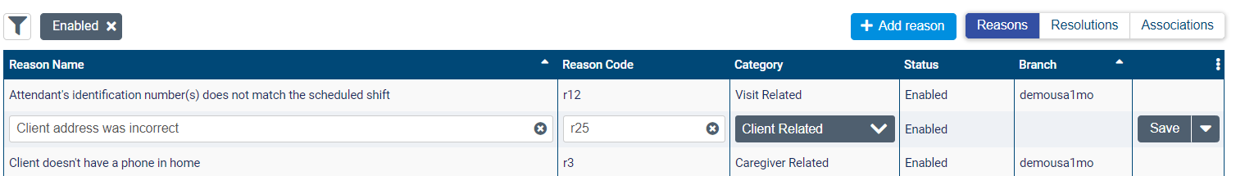
To disable a reason, select the downward arrow next to edit and select disable. Note that disabling a reason will also disable any associations it belongs to.
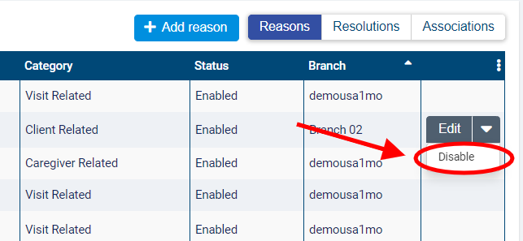

Resolutions

Under the resolutions tab, you will see the resolution name, resolution code, whether a comment is required (yes or no), status for previously configured resolutions, and the branch at which it was configured (if your organization is multi-office). Resolutions are listed alphabetically.
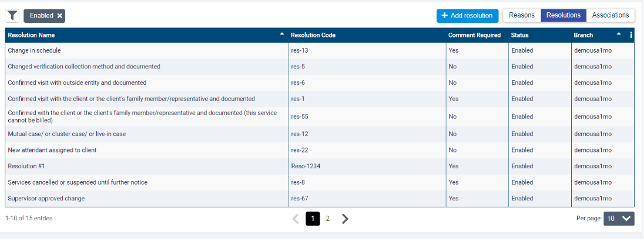
You can filter the resolutions list by searching for the resolution code or name or by status (enabled or disabled) or branch (if multi-office).
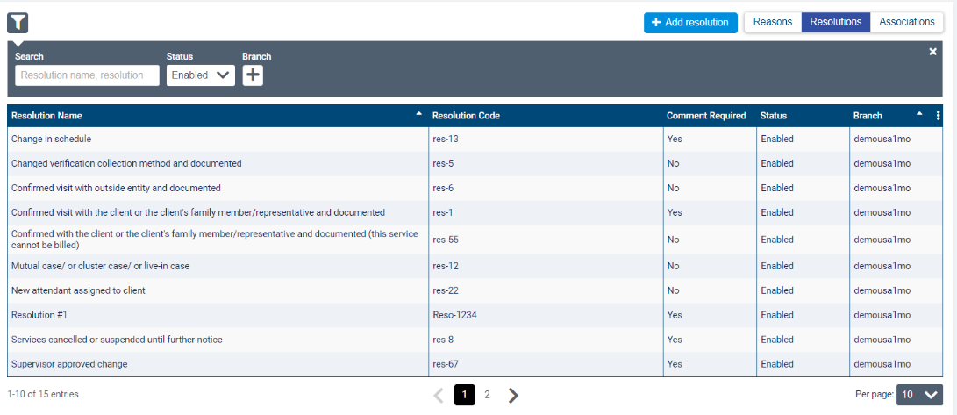
To add a new resolution, select the add resolution button.
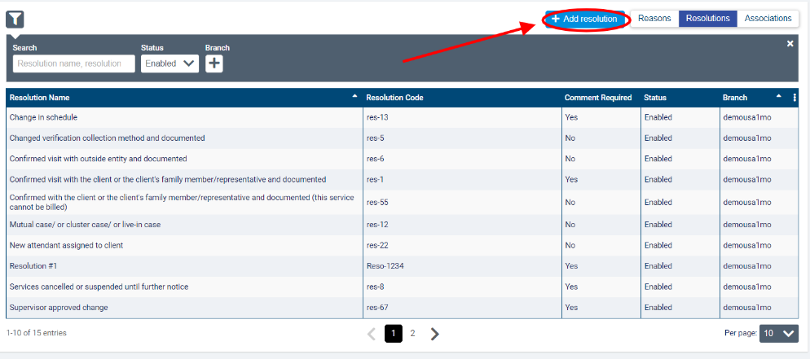
Enter a resolution name, resolution code, and select whether a comment will be required for this resolution type (yes or no). The resolution name must be unique within your organization. In multi-office environments, reason names must be unique to parent branches and any subsidiary branches. Branches at the same level can reuse the same reason names. When you are finished, click save.
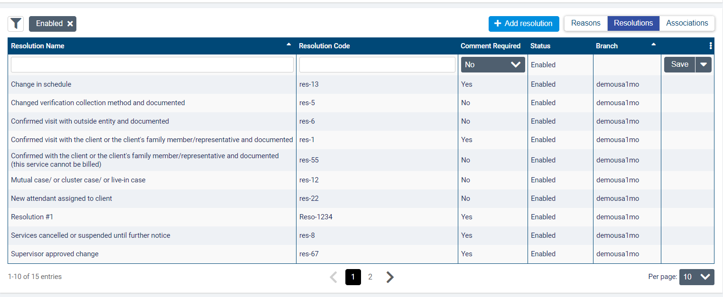
To edit a resolution, select the edit button. Note that in multi-office environments, you will only be able to edit or disable resolutions created at the same branch or a subsidiary branch.
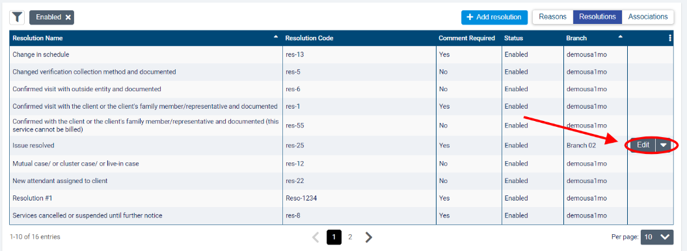
Make the necessary changes and then click save.
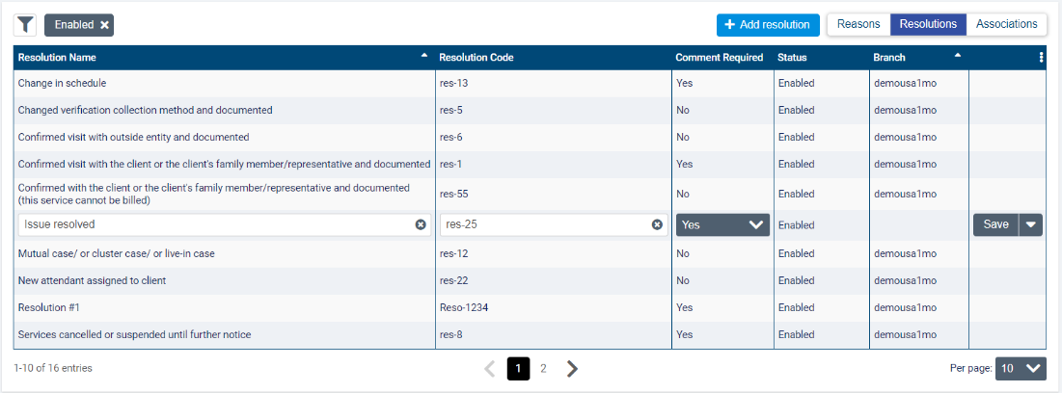

To disable a resolution, click the downward arrow next to edit and select disable. Note that disabling a reason will disable any associations it belongs to as well.

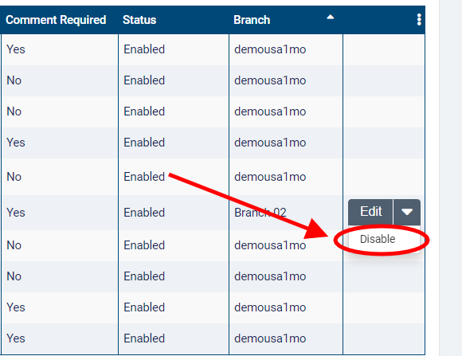

Associations

To associate reasons with specific resolutions, go to the associations tab. Associations that have already been configured will be listed with the reason name and the name of the associated resolution.
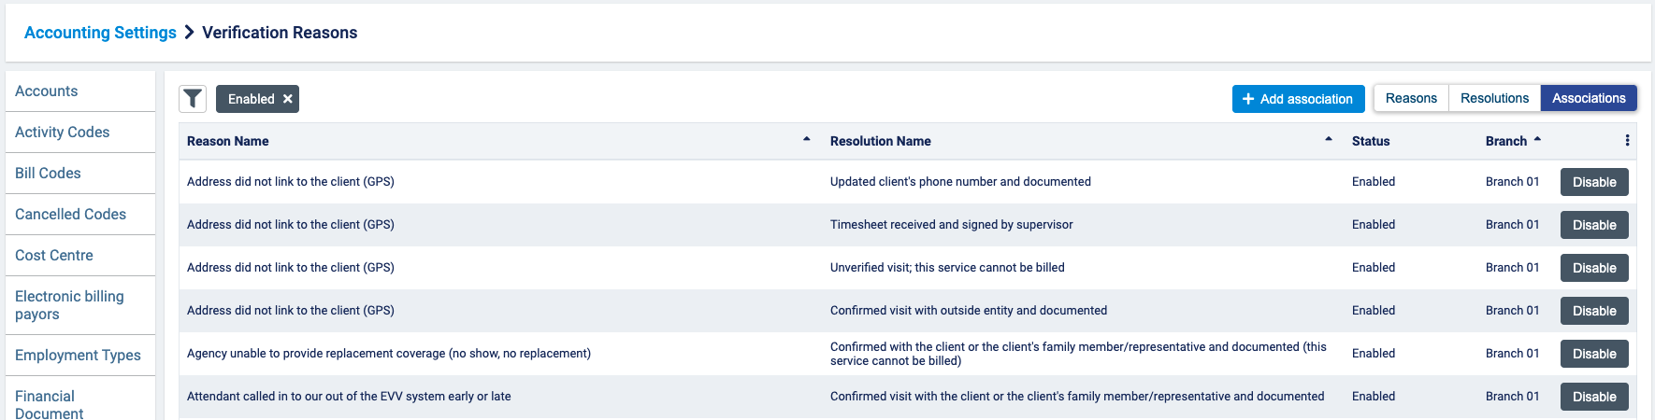
You can filter the associations list by searching for a reason or resolution name or by status (enabled or disabled) or branch (if multi-office).
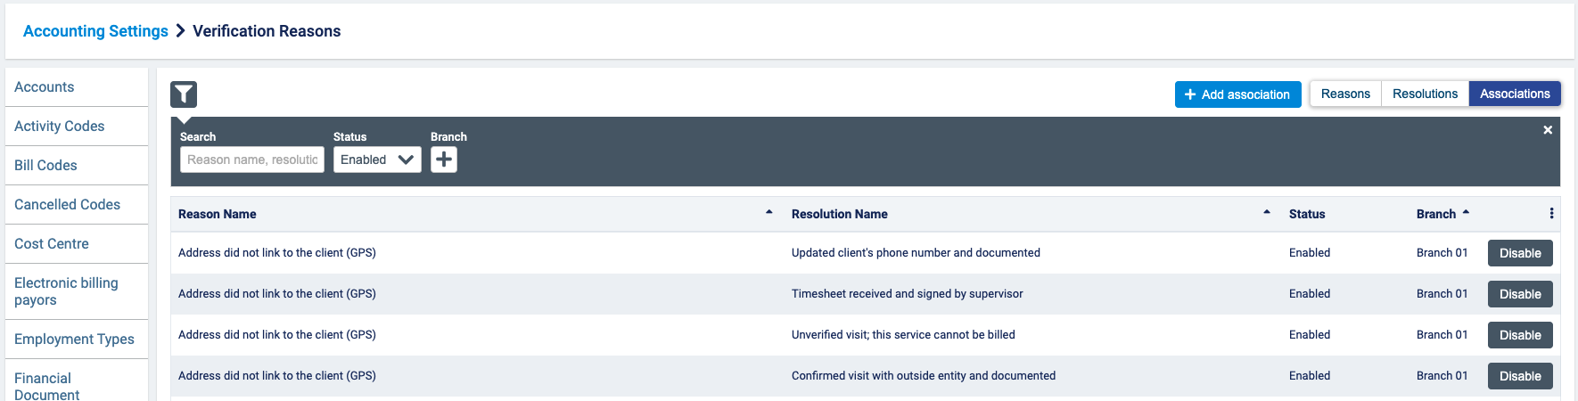

To create a new association, select add association.
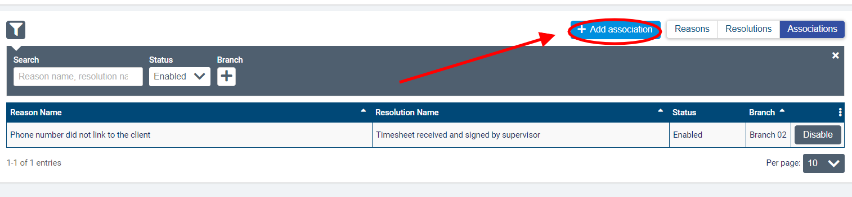

In the add association dialogue, start typing to select the reason name you wish to associate with one or more resolutions. In multi-office environments, you will also need to select which branch you wish to configure the association for. The branch selected in the dropdown will default to the branch you are currently in.
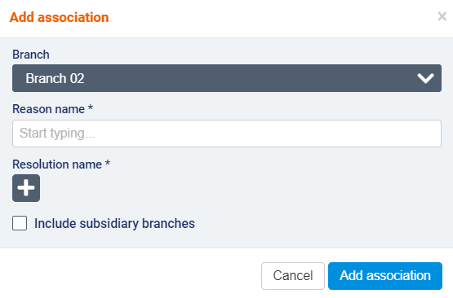
Then click to select the resolutions you wish to associate with the reason. Check the box next to include subsidiary branches if you wish the association to apply for any child branches.
When you are finished, select add association.
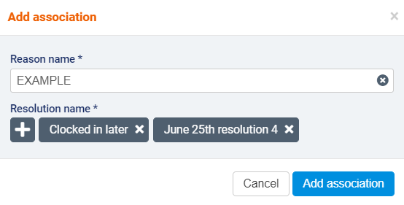
To disable an association, select the disable button.
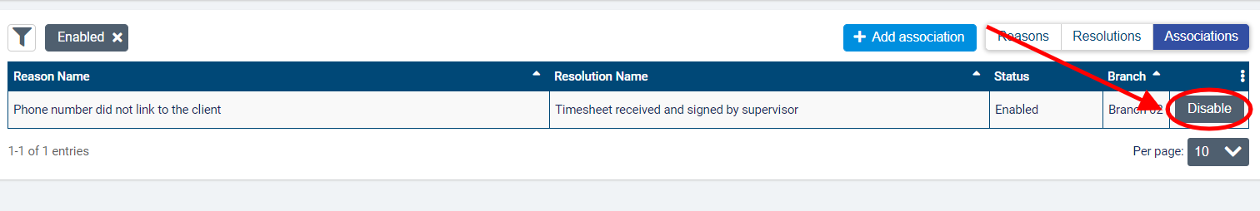
In the disable association dialogue, you will see a warning that this action will make the reason and resolution combination unavailable to select during visit verification.
To continue, click disable association.
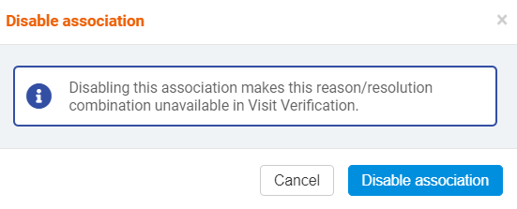

VV rule set configuration

Rule sets are used during the visit verification process to link exceptions on visits that don't respect these rules, allowing a user to intervene before the visit is approved. Exceptions can require a reason and resolution in order to be verified, or simple acknowledgement. These rule sets are linked to the service code, payor or branch associated with the visit, in that order of priority.
Note that in multi-office environments, exception lists are created at the branch level rather than the HQ level and are not shared across branches.
To set up or manage a rule set, go to accounting>accounting settings>verification rule sets. Existing rule sets will be displayed by name with their effective date (if multiple versions exist) and version details. By default, the list will be filtered to the latest versions of the rule sets.
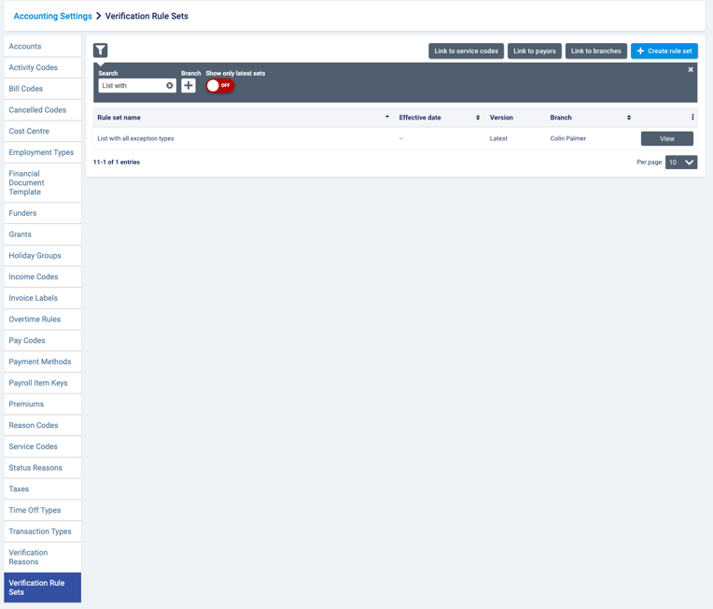

Click the icon to search for a rule set by name or branch (if multi-office).
Turn off the show the latest sets toggle if you wish to see older versions displayed. Previous versions will be identified by a version number. 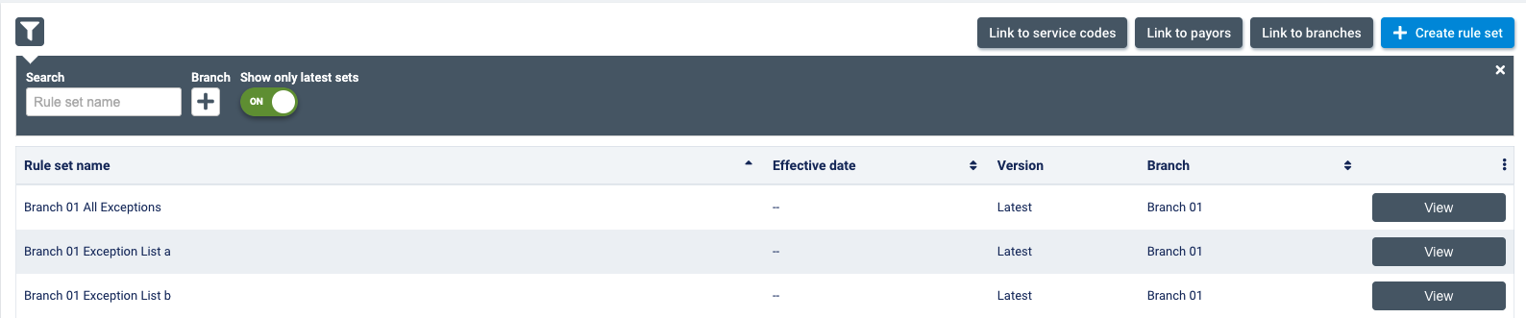

Click view to review the rules included on each set. 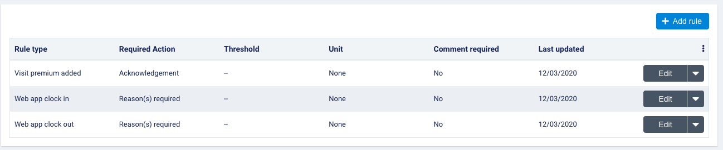

Once a rule set has been used during the visit verification process, you will not be able to change attributes or add new rule types. To edit the set, create a new version of the rule set instead.

Create a new rule set or new version of the rule set

To create a new rule set or a new version of an existing set, select +create rule set.
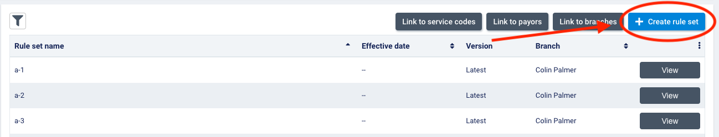

A dialogue box will appear. Create a new set, or create a new version of an existing set.
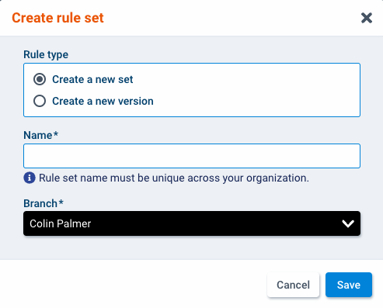
If you are creating a new set, enter a unique name for your set.
If you are creating a new version, select the rule set you wish to create a new version of from the dropdown.
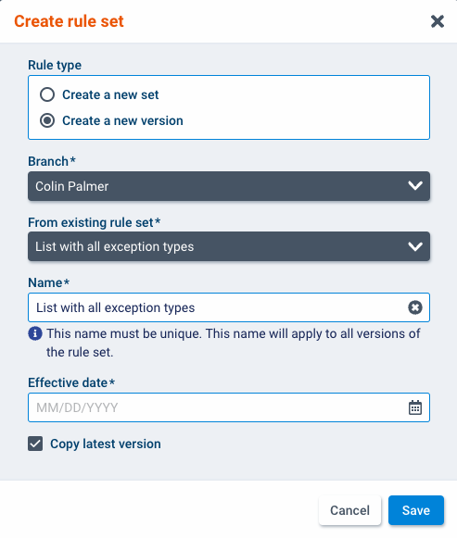
The name of the set selected will appear in the name field by default, but you can change the name if necessary. Note that the new name will apply to all versions of the set.

Select the effective date of the new version. Uncheck copy latest version if you do not wish to copy the rule types from previous versions. Click save to save all selections.

Add rule types to a rule set

To add rule types to a rule set, click view.
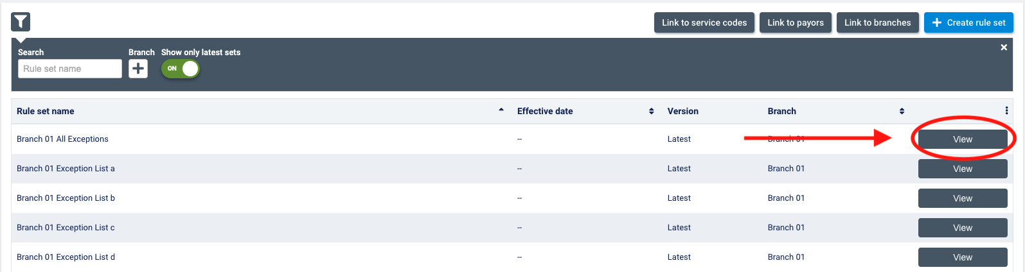
Previously added rules will be listed on the next screen.
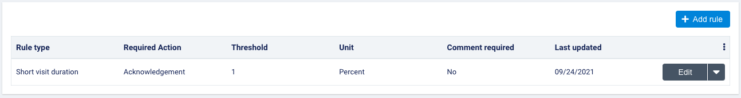
The following information will be displayed for each rule in the list:
- Rule type: for the complete list of rule types available, please see the rule types section.
- Required action (if applicable): reason(s) required or acknowledgement. If reasons are required, you will need to select the reasons that can be selected to verify this exception. If reasons are not required, the user will simply need to acknowledge the exception to proceed to billing/claim generation and payroll.
- Threshold (if applicable): the threshold value that determines whether an exception will be raised.
- Unit (if applicable): the units in which the threshold for the rule type is measured.
- Comment required: yes or no. You can choose to require a comment for any rule type along with the required reason and resolution.
To add a new exception to the list, click +add rule.
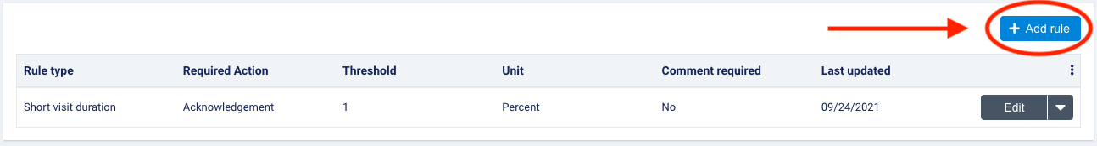
In the dialogue, select which type of rule you wish to add to the list. The additional required fields will depend on the rule type you select.
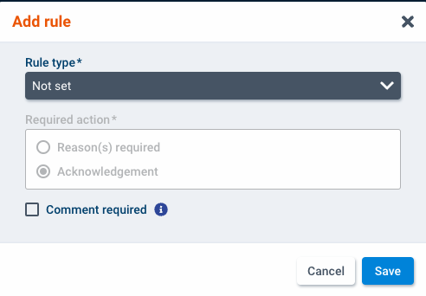
You will be able to choose whether an acknowledgement or selecting specific reasons is required to verify an exception. If you select reason(s) required, you will also need to select which reasons are required to verify the exception. Note that only enabled reasons associated with one or more resolutions will be available to select.
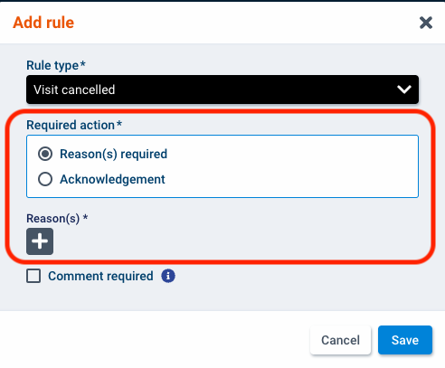
For certain rule types, you also need to enter a threshold.
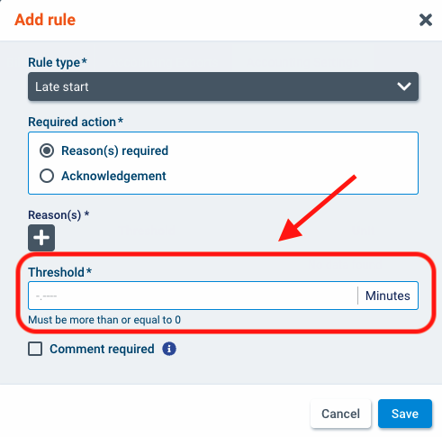
Once you have completed all fields, click save to add the rule type to the set.

Available rule types

The following rule types are available to add:
- Incorrect clock-in location: this exception will be raised during the verification process if the distance between the GPS location captured when a care provider clocks in using a mobile device and the address where the visit is scheduled to occur exceeds the permitted distance configured as the threshold for this exception. The exception will also be raised if no GPS location was captured upon clock-in or if no visit location is available. Enter a threshold that equals the maximum distance from the visit address that clock-in should occur. The threshold units will be measured in kilometers (km) or miles (mi) depending on which is configured for your organization in Settings>Locale>Time format. Note that this rule type only considers clock-outs from the mobile application.
- Incorrect clock-out location: this exception will be raised if the distance between the GPS location captured when a care provider clocks out using the mobile device and the address where the visit is scheduled to occur exceeds the permitted distance configured as the threshold for this exception. This exception will also be raised if no GPS location was captured upon clock-out or if no visit location is available. Enter a threshold that equals the maximum distance from the visit address that clock-out should occur. The threshold units will be measured in kilometers (km) or miles (mi) depending on which is configured for your organization in Settings>Locale>Time format. Note that this rule type only considers clock-outs from the mobile application.
- Incorrect home phone number on clock in: this exception will be raised if the Interactive Voice Recognition (IVR) system was used to clock in to a visit, and the phone number used for clocking in did not match the home phone number on the client’s profile. No threshold is required for this rule type.
- Incorrect home phone number on clock out: this exception will be raised if the Interactive Voice Recognition (IVR) system was used to clock out of a visit and the phone number used for clocking out did not match the home phone number on the client’s profile. No threshold is required for this rule type.
- Web app clock in: this exception will be raised if the web application was used to clock in to a visit. No threshold is required for this rule type.
- Web app clock out: this exception will be raised if the web application was used to clock out of a visit. No threshold is required for this rule type.
- Early start: this exception will be raised if a care provider clocks in to a visit earlier than the scheduled start time by more than the permitted number of minutes configured as the threshold. Enter a threshold in minutes that equals the amount of time that clock-in should occur prior to the visit scheduled start time.
- Late start: this exception will be raised if a care provider clocks into a visit later than the scheduled start time by more than the permitted number of minutes configured as the threshold. Enter a threshold in minutes that equals the maximum amount of time that clock-in should occur after the visit scheduled start time.
- Incorrect visit date: this exception will be raised if the date that a care provider clocked in to a visit does not match the scheduled start date of the visit. No threshold is required for this rule type.
- Early end: this exception will be raised if a care provider clocks out of a visit earlier than the scheduled end time by more than the permitted number of minutes configured as the threshold. Enter a threshold in minutes that equals the maximum amount of time that clock-out should occur prior to the visit’s scheduled end time.
- Late end: this exception will be raised if a care provider clocks out of a visit later than the scheduled end time by more than the permitted number of minutes configured as the threshold. Enter a threshold in minutes that equals the maximum amount of time that clock-out should occur after the visit’s scheduled end time.
- No clock out: this exception will be raised if a care provider did not clock out of a visit the same number of times that they clock in to a scheduled visit. No threshold is required for this rule type.
- Short visit duration: this exception will be raised if the clocked duration of the visit was shorter than the scheduled duration by more than the permitted percentage of the total duration or number of minutes configured as the threshold. You can enter a threshold as a percentage of the total scheduled duration or in minutes where the threshold equals the maximum amount of time under the scheduled duration that a visit can be without raising an exception.
- Long visit duration: this exception will be raised if the clocked duration of the visit was longer than the scheduled duration by more than the permitted percentage of the total duration or number of minutes configured as the threshold. You can choose to enter a threshold either as a percentage of the total scheduled duration or in minutes where the threshold equals the maximum amount of time above the scheduled duration that a visit can be without raising an exception.
- No work session: this exception type will be raised if there are no work sessions (clock-ins and clock-outs) for a visit. No threshold is required for this rule type.
- Multiple work sessions: this exception type will be raised if there is more than one work session for a visit. No threshold is required for this rule type.
- Incorrect employee: this exception type will be raised if the employee who clocked in or out of a visit is not the employee assigned to the visit.
- Service tasks not completed: this exception type will be raised if all required interventions (care plan 2.0) or all daily activities/ADLs (care plan 1.0) were not completed for the visit. No threshold is required for this rule type.
- Visit premium added: this exception type will be raised if there is a visit premium added to the visit. No threshold is required for this rule type.
- Not funded: this exception type will be raised if there is no funding configured for a visit according to the funding block logic for the service. No threshold is required for this rule type.
- Visit cancelled: this exception type will be raised if a visit has a cancelled code applied to it. If an exception of this type is raised, the system will not check for other exception types. No threshold is required for this rule type.
- Visit forms attached: this exception type will be raised if any forms are attached to the visit at the visit or service level. No threshold is required for this rule type.

Link a branch to a rule set

To attach a branch to a rule set or detach a branch from a rule set, select Link to Branches.
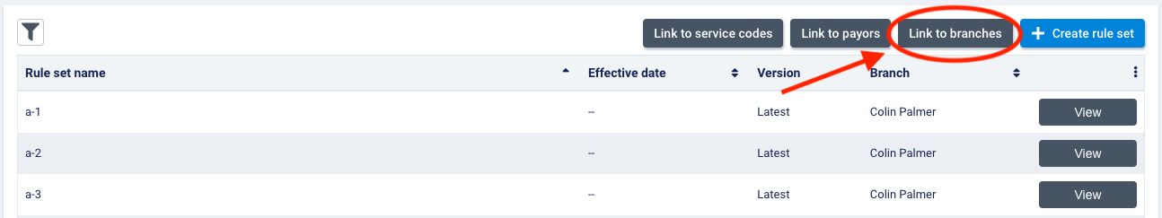
In the dialogue, you will see current branch, as well as other branches you have scope to for multi-office organizations.
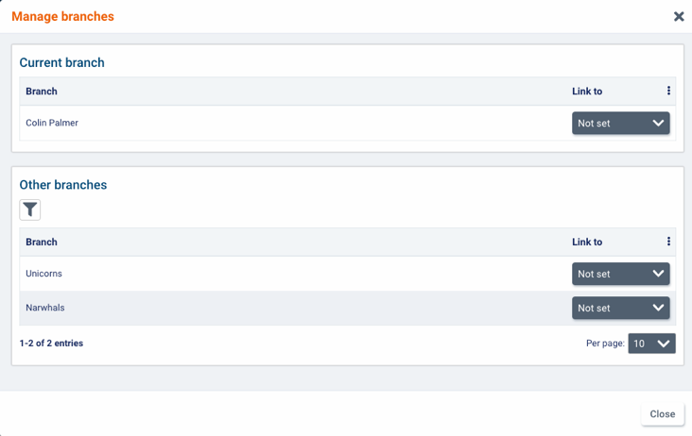
You can filter this list of branches by name and rule sets they are linked to.
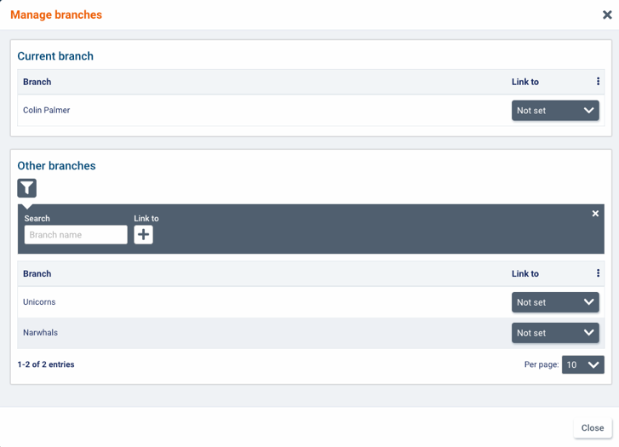
If the branch is not currently linked to any rule sets, not set will be displayed. Click the arrow to select a rule set to link it to.
To unlink a branch from a rule set, select not set. Once a branch has been unlinked from a set, not set will always be displayed.

When you are finished linking and unlinking branches, click close to exist the dialogue. Rule sets can be linked to multiple branches. However, a branch can only be linked to one rule set.

Link payor to a rule set

To link a payor to a rule set or unlink a payor from a rule set, select Link to payors.
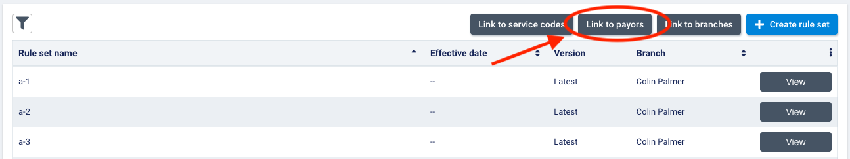
In the dialogue, you will see payors configured for your organization. For multi-office organizations, you can choose which branch you wish to view payors by. Note that the branch in the branch dropdown will default to the branch you are currently in.
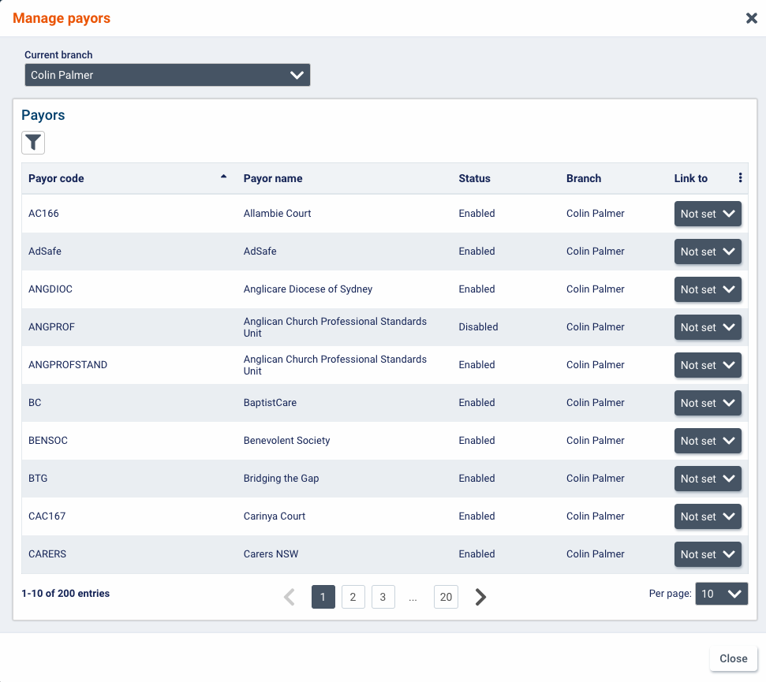
You can filter this list of payors by payor code, status (enabled, disabled), and rules sets they are linked to.
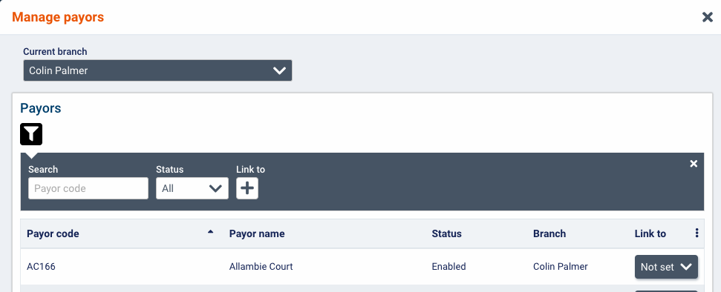
If the payor is not currently linked to any rule sets, not set will be displayed. Click the arrow to select a rule set to link it to.
To unlink a payor from a rule set, select not set. Once a payor has been unlinked from a set, not set will always be displayed.
When you are finished linking and unlinking electronic billing payors, click close to exist the dialogue.
Rule sets can be linked to multiple electronic billing payors. However, an electronic billing payor can only be linked to one rule set at the selected branch.

Link a service code to a rule set

To link or unlink a service code to/from a rule set, select manage service codes.
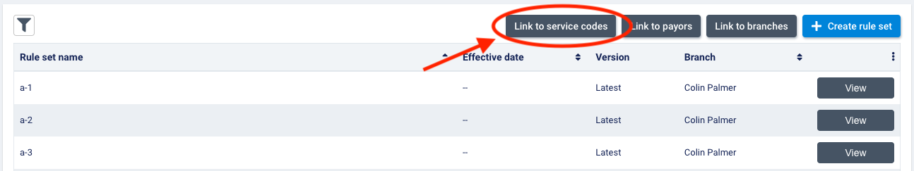
In the dialogue, you will see service codes configured for your organization.
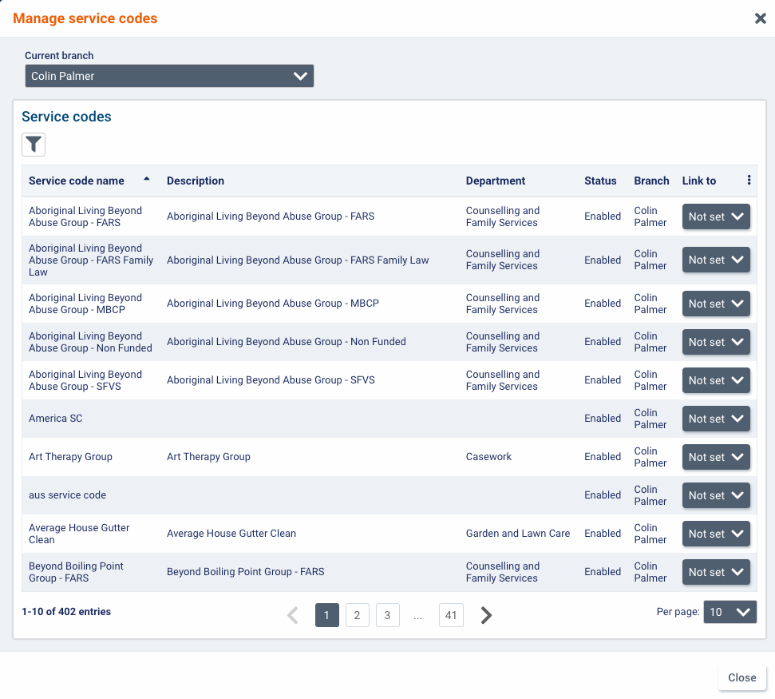
You can filter this list of service codes by status (enabled, disabled), code name, departments, and rule sets they are linked to.
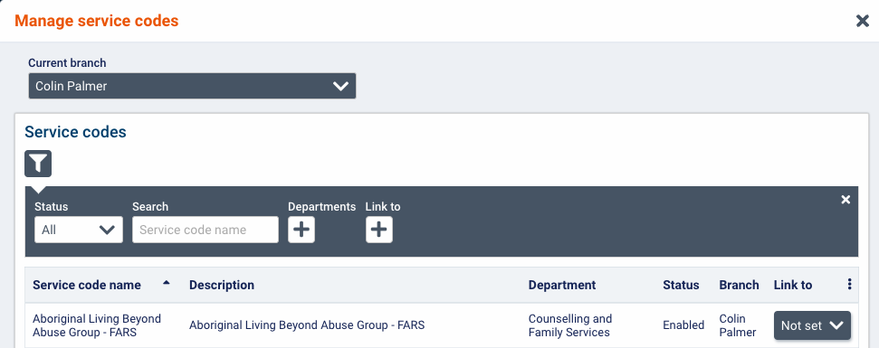
If the service code is not currently linked to any rule sets, not set will be displayed. Click the arrow to select a rule set to link it to.
To unlink a service code from a rule set, select not set. Once a service code has been unlinked from a set, not set will always be displayed.
When you are finished linking and unlinking service codes, click close to exist the dialogue.
Rule sets created at a branch can be linked to multiple service codes. However, a service code can only be linked to one rule set at the selected branch.

VV glossary of terms

- Association: associations link reasons with the correct resolutions. It is only possible to select reasons that have been associated with one or more resolutions when resolving exceptions found during the visit verification process. You will only be able to select resolutions that have been associated with the selected reason. You can configure associations from the associations tab found under accounting>accounting settings>verification reasons.
- Electronic Visit Verification (EVV): EVV refers to the process of using electronic means to verify information related to home health care visits that are covered by U.S. Medicaid. EVV is intended to ensure clients are receiving the proper care and reduce the number of fraudulent care claims submitted.
- Electronic billing payor: electronic billing payors are the designated payors for electronic billing claims. If a visit has a bill code associated with an electronic billing payor, has an end date in the past, and is not vacant or on hold, it will be checked for exceptions as part of the visit verification process for EVV. Once it is approved, it can be included on electronic billing claims and sent to the electronic billing payor as part of an 837 EDI file.
- EVV export: the EVV export in billing>electronic billing summary v2 allows you to export the visit verification details out of AlayaCare to send to an aggregator as proof that all visits billed to electronic billing payors met EVV requirements.
- Exception: exceptions are irregularities related to visits that the system will check for during the verification process. When a rule is not respected, an exception is raised. Visits that are found to contain exceptions require further action before they can be approved so that the agency can make sure any exceptions to the VV requirements are permissible and do not affect the visit’s eligibility to be approved for billing and payroll. Depending on their configuration, exceptions are resolved either by simply acknowledging them or selecting the reason and corresponding resolution to explain why the exception occurred and justify why the visit is still billable and payable.
- Rule type: rule types are configurable rules made available for users to configure what checks they wish they system do when verifying visits for approval. They can be seen as individual criteria of compliance required by an agency or payor.
- Rule set: rule sets contain various types of rules and can be link to branches, payors and service codes. During visit verification, the system will check a visit for the exceptions to the rule set associated with its service code, payor or branch, in this order.
- In violation: a new visit approval status in AlayaCare between not approved and approved for visits that failed verification. During visit verification, the status of any visits found to contain exceptions will be updated from not approved to in violation. The status of the visit will remain in violation (unless it is manually updated) until all exceptions are resolved and the bill and pay quantities for the visit are approved.
- Reason: reasons are codes that explain why an exception occurred and can be required to resolve certain exceptions, depending on your agency’s VV configuration. The reasons available to select for a specific exception will depend on which reasons were selected when configuring the exception. Only reasons that have been associated with a resolution will be available to select.
- Resolution: resolutions are codes that explain how the reason for an exception on a visit was resolved and may be required to resolve certain exceptions, depending on your agency’s VV configuration. Resolutions must be associated with a reason before they can be used to resolve exceptions. The resolutions available to select will depend on which reason was selected for the exception.
- Rounding rules: rounding rules can be set on bill and pay codes. If you are using the visit’s scheduled time to calculate bill and pay quantities, you can choose whether you wish to include breaks in the duration. If you are using the visit’s clocked time to calculate bill and pay quantities, you must choose a rounding method and rounding interval for the system to use when determining the correct billable and payable amounts.
- Time approval: time approval refers to the second part of the new visit approval process that occurs after all exceptions on the visit have been resolved. It involves approving (and adjusting if necessary) the bill and pay quantities calculated for the visit during the verification process.

