**OASIS**

**(Outcome and Assessment**

**Information Set)**

**User Guide  
May 2022**

**Table of Contents:**

Background & Purpose 4

Using OASIS 5

Step 1: Publish forms within Form Builder 5

Additional support 6

Step 2: Filling in an OASIS form 7

Fields pulled to OASIS 8

Step 3: approval and correction 10

Approving the OASIS form 10

Correcting the OASIS form 10

Step 4: Batch export and download 12

Exporting OASIS forms 12

Batch download 13

Step 5: Corrections workflow 15

Step 6: OASIS Inactivation workflow 17

Decoding common error messages 18

Copyright © 2022 Alaya Care Inc.  All rights reserved.

This document and any other technical documentation that is made available by AlayaCare is the copyrighted work of Alaya Care Inc., a Canadian corporation (dba “AlayaCare”).

Information contained in this document is subject to change without notice and does not represent a commitment on the part of AlayaCare, unless such commitment is set out in a written agreement by AlayaCare and its customer or partner, in which case the terms of such written agreement shall govern this document. AlayaCare has made all reasonable efforts to ensure the accuracy and completeness of the information in this document and accepts no liability nor responsibility for errors or omissions contained in this document.

No part of this document or other AlayaCare guides, manuals or other information may be reproduced or transmitted in any form or by any means, electronic or mechanical, including photocopying, recording, or information storage and retrieval systems, for any purpose other than the purchaser’s personal use, without the prior written consent of AlayaCare.

# Background & Purpose

The objective of this user guide is to introduce the **OASIS (Outcome and Assessment Information Set)** feature and offer step-by-step instructions which address some of the most frequent challenges associated to using this feature within AlayaCare Cloud (ACC).

Briefly, OASIS is an assessment which home health agencies need to complete at specific time points, as a part of the Conditions of Participation (CoPs) by the Center for Medicaid and Medicare Services (CMS) in the United States. ACC now supports this feature, enabling caretakers to complete, submit and send an OASIS assessment directly within our platform.

For additional support and feedback, we invite users to post their queries at the [Zendesk Community Forum](https://alayacare.zendesk.com/hc/en-us/community/topics), or to reach out to your account manager and/or client success representative.

# Using OASIS

## Step 1: Publish forms within Form Builder

To start, select the form type “OASIS”. Then, select the OASIS “Reason for Assessment (RFA)” and select the appropriate version. Please note that AlayaCare Cloud supports OASIS-D1 and onwards. OASIS-E will come into effect on January 1, 2023.

Be sure to add the appropriate form configuration settings, name, and instructions. Once complete, click on “save” and you may now customize the OASIS form. Once it is published, this agency-specific OASIS form will be available to view.

Please note that OASIS questions corresponding with the selected RFA and version will be pre-populated into the form builder. They will be displayed as read-only fields with a fixed ranking, meaning that the order of “M00” fields cannot be changed. OASIS questions are created based on the CMS’ OASIS specifications. To prevent user error, they will *not* be editable within the builder. Please note that permissions required for this task will be the same as a regular form building task. You can access this by navigating to Workflow> Create and edit custom forms.

### Additional support

For more information, refer to the [How to build and publish a new form](https://alayacare.zendesk.com/hc/en-us/articles/360029686011-How-do-I-create-configure-build-publish-a-new-Form-) article on Zendesk.

## Step 2: Filling in an OASIS form

To start, navigate to Care Documentation> Client profile> Forms, click on the drop down menu “Add Client Form” and select “Add OASIS form”.

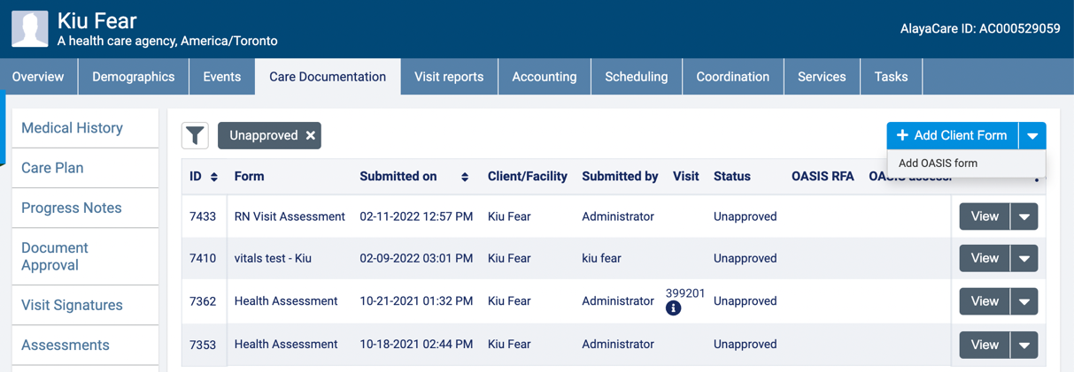

Select the “Service”, “RFA (Reason for Assessment)” and “OASIS version”. Click on “Start Filling”.

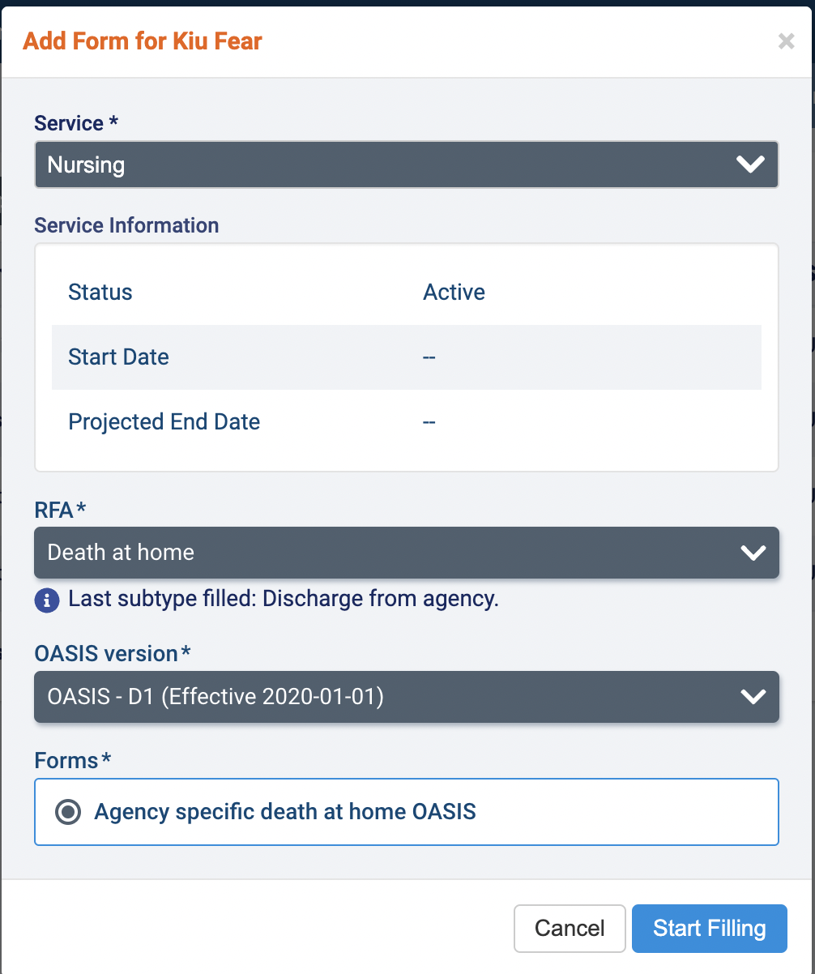

⚠️ Please note that based on the latest OASIS completed for the patient against the service, the next suggested OASIS will be displayed as a guide. This will not restrict the form selection if a different OASIS RFA is required.

Please note that permissions required for this task will be the same as a regular form building task. The form-specific roles are “Restrict View to” and “Restrict Submit to”.

At this point in time, when you start pre-filling the OASIS form, you will notice that patient demographic and ICD-10 codes are already pre-populated into the corresponding OASIS fields.

### Fields pulled to OASIS

The following fields will be pulled into the OASIS fields from the patient profile:

* **M0020 Patient ID**: ACC ID associated with the patient profile
* **M0040 Patient first name**: First name of the client profile
* **M0040 Patient last name**: Last name of the client profile
* **M0050 Patient state of residence**: State listed in the client profile that lives within patient demographics; the pathway to access this is patient demographics> address > state. If the state listed on the profile does not map directly to one of the state dropdown options in the OASIS question, it will be displayed as “not set”.
* **M0060 Patient zip**: Zip code listed under the client profile’s address
* **M0069 Patient gender**: Gender listed on the client profile. If listed as “other” on the profile, the OASIS question will be displayed as “not set”.
* **M1021** **Primary diagnosis code**: ICD-10 code from the patient’s medical history. The pathway to access this is medical history> current diagnoses.
* **M1023 Other diagnosis 1-5**: the remaining first five ICD-10 codes from the patient’s medical history (pathway: medical history> current diagnoses). The order will be listed from top to bottom per the patient’s profile.

Please note that while the above-mentioned fields will pre-populate into the respective OASIS fields, they will still be editable within the form. To change any of these fields in your future submissions, data must be updated on the profile itself.

Now, navigate to the “Review” section to validate the OASIS field entries according to their sections

If certain required OASIS fields have yet to be filled, these fields will now appear as “Errors”. Users will not be able to submit the form until these fields are filled in accordingly.

All OASIS fields will now go through validation for clinical logic checks, which is done via an integrated third-party library. Any warning messages generated will appear in-line within the corresponding OASIS field.

Once all errors have been resolved, the form can be submitted.

Permissions required: Same as normal form submission ACLs

## Step 3: approval and correction

### Approving the OASIS form

This is the step where you will approve or edit your OASIS form as needed. If the form is not set to “auto-approve”, users are to review and approve the OASIS form submission using the same workflow as other client forms. Once the form is in the “approved” status, the OASIS file can be exported for transmission.

### Correcting the OASIS form

Once the form is approved, corrections can be made prior to export. Follow the below steps to correct your form as needed.

1. Change the form status to “Correcting”. Click on the “Edit” button to make changes.

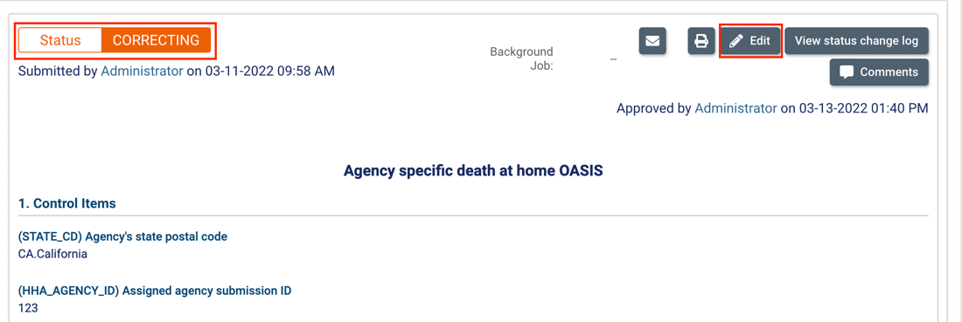

Please note that only OASIS and basic form fields can be edited when they are in the “Correcting” status. Advanced components such as *Vitals components*, *embedded progress notes* and certain others cannot be edited. Doing so would duplicate data within the patient’s profile.

Permissions required: Workflow > “Unlock Approved Forms”. The full pathway is System settings >Roles and Permissions > Admin Portal roles > Role > open Workflow folder > check “Unlock approved forms”

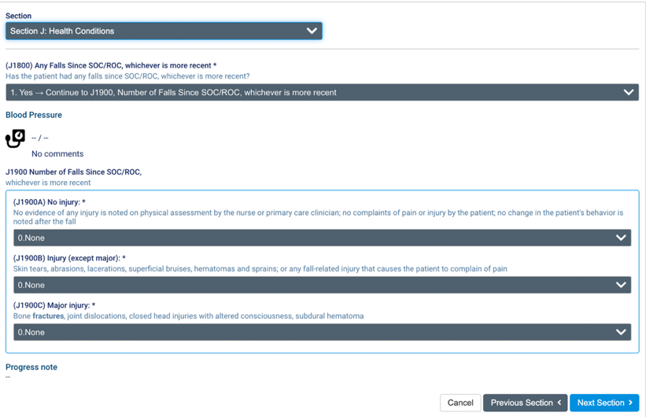

1. Once changes are made, navigate to the final “Review” section to follow the same error/warning validation as outlined in “**Step 2: filling in an OASIS form**”. Once submitted, the form will move back to the “Approved” status, as shown below.

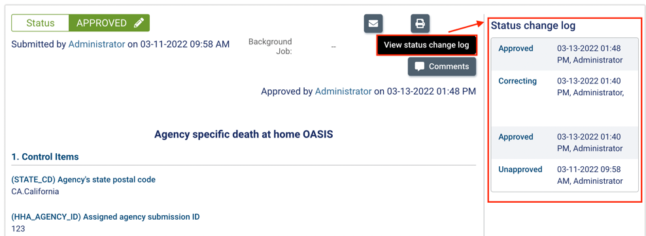

The “View status change log” offers an overview of the statuses of all prior forms, as well as the user who made the change.

## Step 4: Batch export and download

### Exporting OASIS forms

1. Under the “Client forms” tab, users will now see all form submissions including the completed OASIS assessments. To start downloading, click on “Export OASIS forms”.

1. The data grid will now filter to show only OASIS type forms that are in the “Approved” or “Inactive” status.

Please note that the following new OASIS filters can be used to further narrow the selection of forms to export:

* OASIS Reason for Assessment (RFA)
* OASIS assessment period (using the M0090 date entered per form)
* Has corrections number (yes/no)

1. Users may now select the appropriate OASIS assessments and click on “Export selected OASIS forms” to continue.

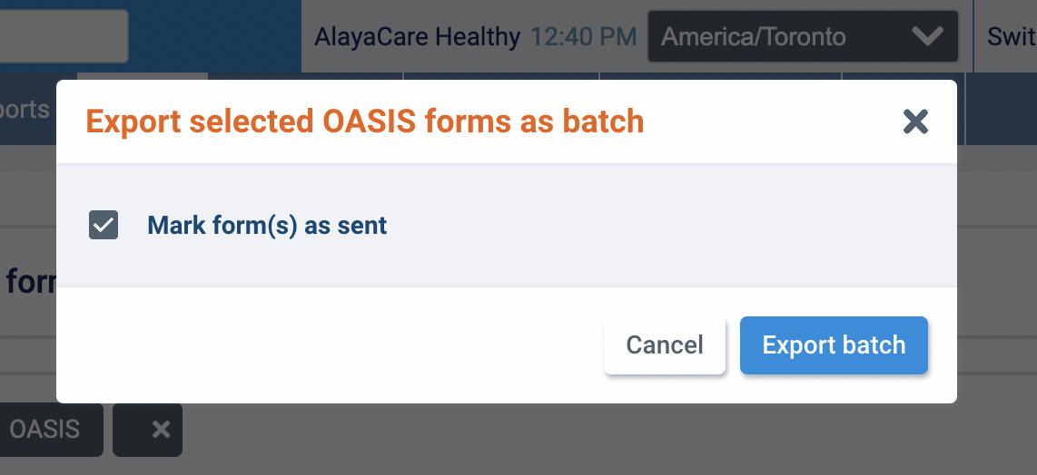

Please note that the action “Mark form(s) as sent” is a default setting. It will be automatically checked to change the status of all OASIS forms included in the batch from “Approved” to “Sent”, once the export batch is generated successfully.

Permissions required: Customer > Create OASIS Batch Export

### Batch download

1. Users may now navigate to the “OASIS Batches” tab as shown below. Here, you can view the status of the batch creation background jobs and download the batches once they are listed as “success” under “Progress tracking”. Click on “Download CMS” to download the files.

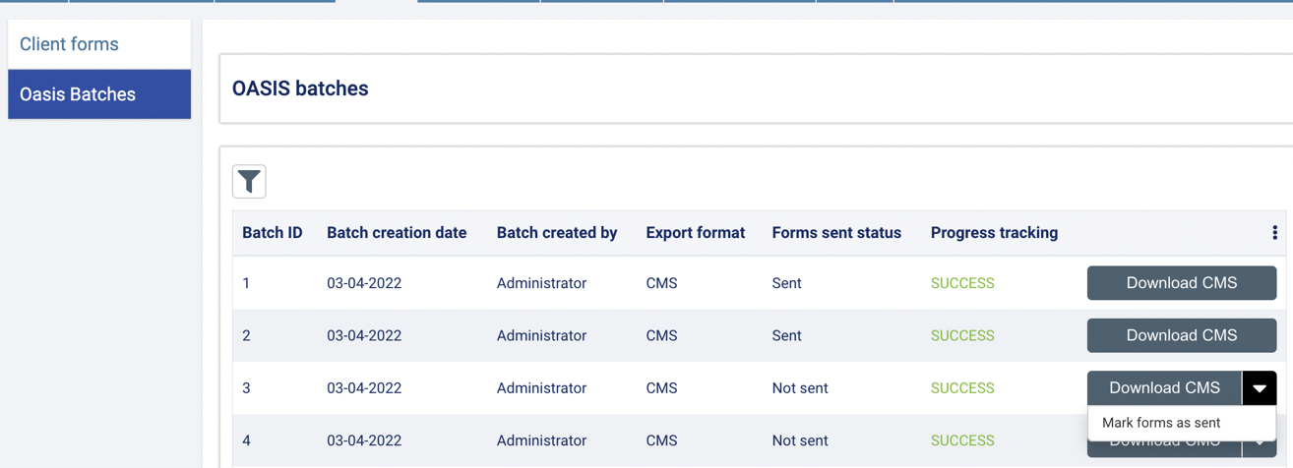

Please note that if the form batch setting “Mark form(s) as sent” is unchecked, the batch can be marked as sent by navigating to the “Download CMS” dropdown menu as shown above. Users will then select the “Mark form(s) as sent” action to mark the whole batch as sent.

1. After clicking on “Download CMS”, users will then see the following dialog. You may now download the zip file containing the individual xml files for the OASIS assessment.

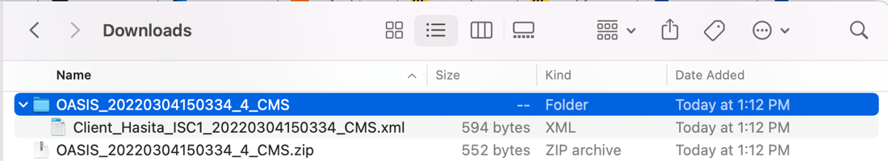

The downloaded zip file can be used to upload into IQIES for CMS upload.

Permissions required: Customer> View/Download OASIS Batch Exports

## Step 5: Corrections workflow

Please note that this step is only applicable in cases of need. You may skip this step if no corrections are required for your OASIS submissions.

1. Change the status from “Sent” to “Correcting”

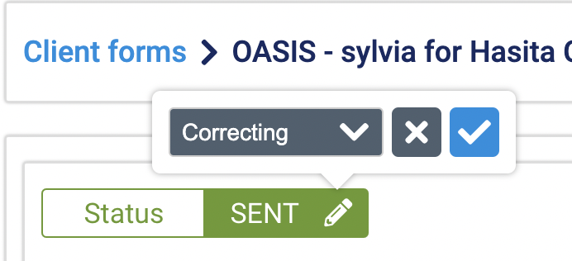

1. Select the appropriate corrections workflow

**If the OASIS assessment was rejected by IQIES** and was never uploaded, users are to follow the below corrections workflow so to make changes *without* increasing the correction number:

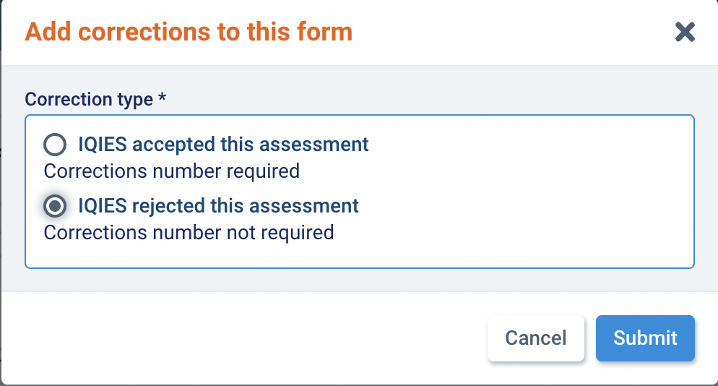

Please note that users are to follow the same corrections flow as outlined for forms in the “approved” status to continue to re-export.

**If the OASIS assessment was successfully uploaded to IQIES,** users are to follow the below corrections workflow so to make changes *with* a new corrections number:

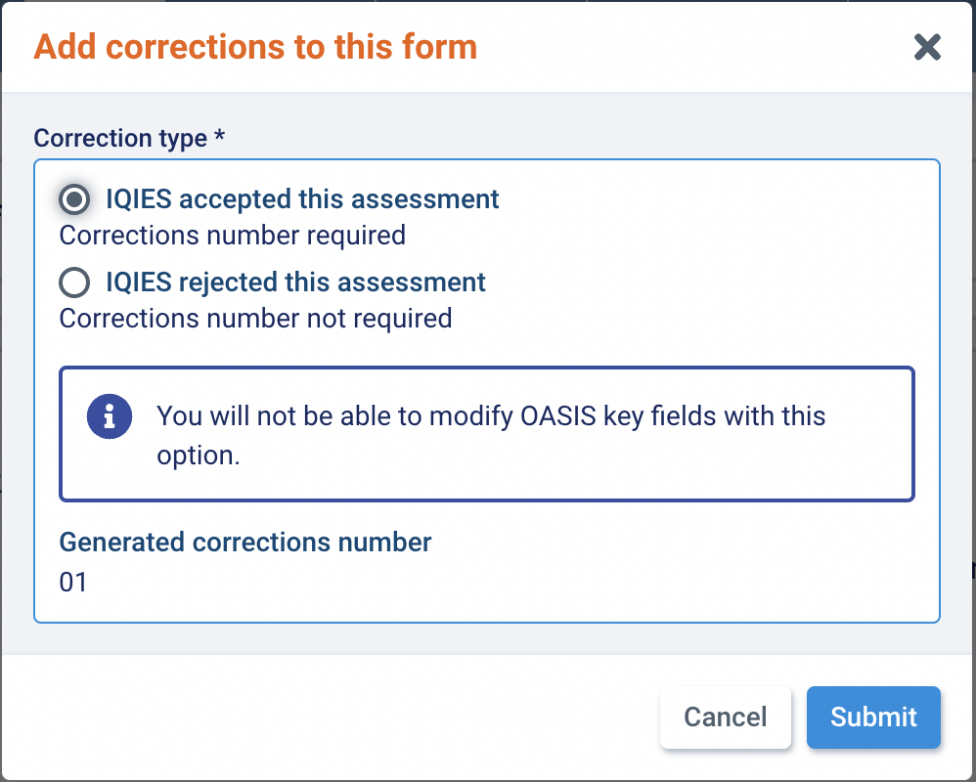

Please note that **OASIS key fields** and advanced components **cannot be modified** within this workflow**.** Once changes have been made, users are to re-submit the form to move it back to the “approved status” for re-export.

If any changes are needed for “Key Fields”, follow the “Inactivation” workflow below.

Permissions required: workflow > "Unlock sent OASIS forms"

## Step 6: OASIS Inactivation workflow

If an OASIS assessment needs to be inactivated, such as the case where the file had been previously uploaded to IQIES, or a key field error was made, users can choose to deactivate the assessment. This can be done per form submission.

1. From “Client forms”, navigate to the appropriate form submission and change the status from “Sent” to “Inactive”, as shown below.

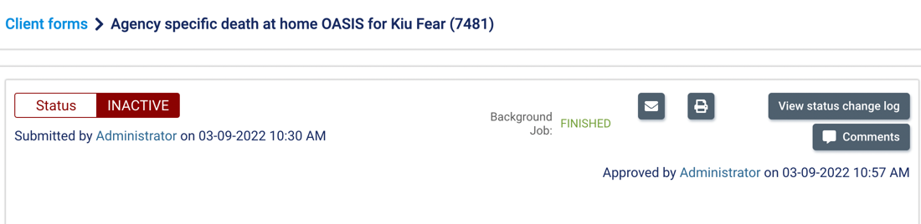

Once the status is changed to “Inactive”, the form will no longer be editable. This form can now be included in a new export and marked as “sent” for upload to IQIES.

Permissions required: Customer> Inactivate OASIS forms

## Decoding common error messages

Field: M0032_ROC_DT Resumption of Care Date (when filled)

DATE ITEM CONSISTENCY: PATTERN 2 Each active item in the list below that contains a valid date (not blank) must be in the specified order. If M0032_ROC_DT is NOT equal to [^], then the following rules apply: M0066_PAT_BIRTH_DT < M0030_START_CARE_DT <= M1005_INP_DISCHARGE_DT <= M0102_PHYSN_ORDRD_SOCROC_DT <=M0032_ROC_DT <=M1307_OLDST_STG2_ONST_DT <=M0906_DC_TRAN_DTH_DT <=M0090_INFO_COMPLETED_DT <=Current date

If there is an applicable Resumption of Care Date (M0032_ROC_DT is filled), then the following dates must be in chronological order:

|  |
| --- |
| **Date of Birth** (M066_PAT_BIRTH_DT) comes before the **Start of Care Date** (M0030_START_CARE_DT); that comes before or is equal to the **Inpatient Discharge Date** (M1005_INP_DISCHARGE_DT); that comes before or is equal to the **Physician Ordered SOC/ROC Date** (M0102_PHYSN_ORDRD_SOCROC_DT); that comes before or is equal to the **Resumption of Care Date** (M0032_ROC_DT); that comes before or is equal to the **Date of onset of oldest stage 2 pressure ulcer** (M1307_OLDST_STG2_ONST_DT); that comes before or is equal to **Discharge, transfer, death date** (M0906_DC_TRAN_DTH_DT); that comes before the **Date of assessment** (M0090_INFO_COMPLETED_DT); that comes before or is equal to the upload date. |

Field: M0032_ROC_DT Resumption of Care Date (when blank)

“Each active item in the list below that contains a valid date (not blank) must be in the specified order. If M0032_ROC_DT is equal to [^], then the following rules apply: M0066_PAT_BIRTH_DT < M1005_INP_DISCHARGE_DT <= M0102_PHYSN_ORDRD_SOCROC_DT <= M0030_START_CARE_DT <= M1307_OLDST_STG2_ONST_DT <= M0906_DC_TRAN_DTH_DT <= M0090_INFO_COMPLETED_DT <= Current date”

If the Resumption of Care Date (M0032_ROC_DT) is left blank, then the following dates must be in chronological order:

|  |
| --- |
| **Date of Birth** (M066_PAT_BIRTH_DT) comes before the **Inpatient Discharge Date** (M1005_INP_DISCHARGE_DT); that comes before or is equal to the **Physician Ordered SOC/ROC Date** (M0102_PHYSN_ORDRD_SOCROC_DT); that comes before or is equal to the **Start of Care Date** (M0030_START_CARE_DT); that comes before or is equal to the **Resumption of Care Date** (M0032_ROC_DT); that comes before or is equal to the **Date of onset of oldest stage 2 pressure ulcer** (M1307_OLDST_STG2_ONST_DT); that comes before or is equal to **Discharge, transfer, death date** (M0906_DC_TRAN_DTH_DT); that comes before the **Date of assessment** (M0090_INFO_COMPLETED_DT); that comes before or is equal to the upload date. |

Field: Branch ID (M0016_BRANCH_ID)

If the branch ID field (M0016) contains a branch ID (not N or P), then a branch state (M0014) is required.

|  |
| --- |
| If the assessment was performed by an HHA which has a branch, then the Branch State (M0014_BRANCH_STATE) must be answered, in addition to a Branch ID (M0016_BRANCH_ID). |

|  |
| --- |
| If there is no Branch ID, then enter the corresponding code (N - Assessment was performed by an HHA which has no branches or by a subunit which has no branches OR  P - Assessment was performed by the home office of an HHA which has branches or by the home office of a subunit which has branches) in the text box for (M0016_BRANCH_ID) and leaving the Branch State (M0014_BRANCH_STATE) unanswered. |

Field: M0140 Race/Ethnicity

Ethnicity (M0140) must be answered.

|  |
| --- |
| At least one of the checkboxes within the M0140 question box must be checked. |

Field: This Assessment is Currently Being Completed for the Following Reason (M0110_ASSMT_REASON)

If M0100_ASSMT_REASON = [01,03] and M1322_NBR_PRSULC_STG1 and M1311_NBR_PRSULC_STG2_A1 and M1311_NBR_PRSULC_STG3_B1 and M1311_NBR_PRSULC_STG4_C1 are all equal to [00,^], then if M1324_STG_PRBLM_ULCER is active it must be equal to [NA].

If the reason for assessment is a Start of Care (M0100_ASSMT_REASON = 01) or Resumption of Care (M0100_ASSMT_REASON = 03), then, the following rules apply for the “Integumentary Status” section:

|  |
| --- |
| IF all of the questions within the **1311 Current Number of Unhealed Pressure Ulcers/Injuries** at Each Stage are skipped (ie. If the previous question, **M1306_UNHLD_STG2_PRSER_ULCR** is answered **0.No**) OR all answered with the value **“0”** or **“00”,** THEN **Stage of Most Problematic Unhealed Pressure Ulcer/Injury that is Stageable** (1324_STG_PRBLM_ULCER) should be marked as **“NA.Patient has no pressure ulcers or no stageable pressure ulcers”** |

Field: Primary diagnosis M1021_PRIMARY_DIAG_ICD (also applicable for Other Diagnosis 1-5)

If M0100_ASSMT_REASON=[01,03] and if the Primary/Other ICD code in Column 2 is NOT equal to [^] AND character 1 of the ICD code is NOT equal to [V,W,X,Y,Z,v,w,x,y,z], then the corresponding severity code must not equal [^].

|  |
| --- |
| If the Diagnosis ICD code entered does not start with any of the letters: V,W,X,Y,Z,y,w,x,y,z; then the Diagnosis Severity Rating (**M1021_PRIMARY_DIAG_SEVERITY** and the equivalents for **Other Diagnosis 1-5 Severity**) must be answered. Otherwise, leave the severity rating BLANK. |

Field: M1030 Therapies the patient receives at home

 If M0100_ASSMT_REASON=[01,03] AND M1030_THH_NONE_ABOVE = [0], then at least one active item from M1030_THH_IV_INFUSION through M1030_THH_ENT_NUTRITION must equal [1]

|  |
| --- |
| At least one of the three therapies listed (**M1030_THH_IV_INFUSION**, **M1030_THH_PAR_NUTRITION**, **M1030_ENT_NUTRITION**) must be checked OR None of the Above (M1030_THH_NONE_ABOVE) is checked. |

Field: Does this patient have at least one Unhealed Pressure Ulcer/Injury at Stage 2 or Higher or designated as Unstageable? (M1306_UNHLD_STG2_PRSR_ULCR)

Error message:

If M0100_ASSMT_REASON = [01,03,09] and M1306_UNHLD_STG2_PRSR_ULCR = [1], then at least one of the following items must be greater than [00]: M1311_NBR_PRSULC_STG2_A1, M1311_NBR_PRSULC_STG3_B1, M1311_NBR_PRSULC_STG4_C1, M1311_NSTG_DRSG_D1, M1311_NSTG_CVRG_E1, and M1311_NSTG_DEEP_TSUE_F1.

|  |
| --- |
| In other words: If this field is answered as “1.Yes”, indicating that the patient has at least one unhealed pressure ulcer/injury at Stage 2 or higher or designated as unstageable, then at least one of the M1311 Unhealed Pressure Ulcers/Injuries should have an entered value greater than 1. |

Field: M2200 Therapy Need

Error message:

 If M0100_ASSMT_REASON = [01,03] and M2200_THER_NEED_NA = [1], then if M2200_THER_NEED_NBR is active it must equal [^].

|  |
| --- |
| In other words: Either a number of therapy visits (M2200_THER_NEED_NBR) should be entered OR not applicable (M2200_THER_NEED_NA) should be checked. |

Field: Any falls since SOC/ROC (J1800)

 If J1800=[1], then all active items from J1900A through J1900C must not equal [^] and at least one of these items must equal [-,1,2]

|  |
| --- |
| In other words: If there are reported falls answered in J1800 as “1.Yes”, then all of the following three questions for the number of falls (J1900A, J1900B, J1900C) must be answered. |