Visit Verification (VV): Verifying and Approving Visits

User Guide



Contents
Visit Verification (VV) in AlayaCare 3
VV workflows 3
Setting criteria and running visit verification 3
Reviewing visits that failed verification and resolving exceptions 5
Possible exception types 10
Approving visits for billing and payroll 12
VV and visit locking 13
Reviewing approved and rejected visits 14

Visit Verification (VV) in AlayaCare

Visit Verification (VV) is a process that automates most of the visit approval workflow, by comparing completed visits against a set of configurable rules, to flag any issues that require review or further investigation. You can review these visits in detail and document the actions to validate compliance.
Within the U.S. market, VV helps organizations to electronically verify information related to home health care visits covered by Medicaid. VV helps organizations ensure that clients are receiving care accordingly and reduce the number of fraudulent care claims submitted.
The VV workflows in AlayaCare allow organizations to determine whether any visits are in violation of the VV requirements configured for your organization. If any VV exceptions are found during the verification process, you will need to review the visits that have failed verification and, where required, select the correct reason and resolution codes before you can approve the bill and pay quantities for the visit and proceed to billing/claim generation and payroll. The visit verification information can then be exported and sent to a third-party aggregator, when required.

VV workflows

Please note that the VV feature must be enabled for your organization by AlayaCare before you can use the new features. Your organization must also set up reasons, resolutions, associations, and rule sets before you will be able to run verification for visits. To learn more, see the VV configuration guide.
 To perform the visit verification and approval process, you must have the following permission:
- Scheduling> Manage Visit Verification

Setting criteria and running visit verification

To verify and approve visits according to the VV requirements in effect for your organization, go to Schedules>Visit Verification.
In this page, you will see three tabs: unverified, failed verifications, and approved & rejected.
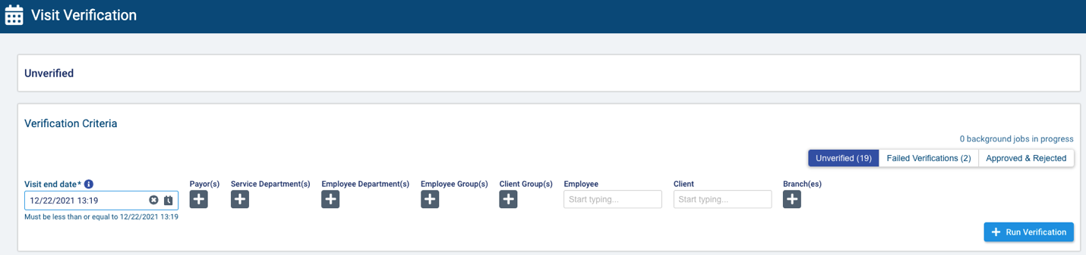
The number in parentheses for unverified represents the number of visits up to the current date and time that have an approval status of not approved. Vacant and on-hold visits will not be included in the count. Note that in multi-office environments, this number will be filtered by branch.
The number in parentheses for failed verifications represents the current number of visits for which one or more exception to the VV requirements has been found during the verification process, which now have the status in violation. These visits will require further action before they can be approved for billing/claim generation and payroll. Note that in multi-office environments, this number will be filtered by branch.
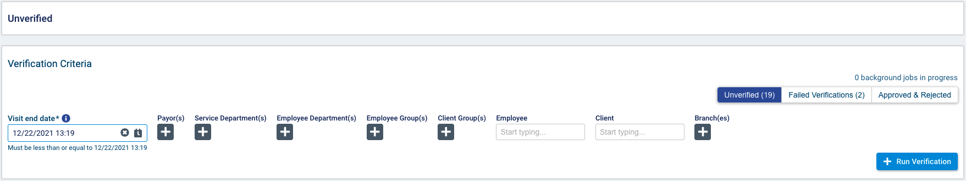
To begin the verification and approval process, use the fields provided to select the visits you wish to verify and approve.
Use the visit end date field to select the cut-off date and time for the verification process. The system will include all not approved visits up to this date and time. The field will default to today’s date and time. Note that you cannot select a time or date in the future as visits must be in the past before they can be verified and approved.
In the additional fields, select one or more payors, service departments, employee departments, employee groups, client groups, or branches (multi-office environments only) by which you wish to filter the not approved visits. You can also choose to filter visits by a single employee or client.
Note that in multi-office environments, you will be able to select payors, departments, groups, employees, and clients that belong to the current branch, parent branch, or child branch but not sibling branches.
When you have selected the criteria you wish to apply, select run verification.
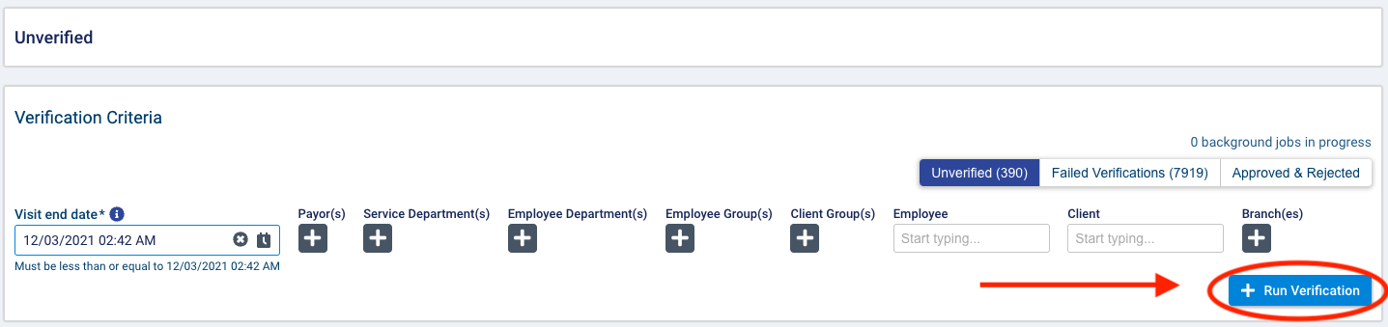
Clicking the action button will launch a background job to verify the not approved visits that meet the selected criteria. The number of visits found with exceptions displayed in the failed verifications tab will update once the verification process is run on new visits.
Any visits for which no exceptions were found will be automatically approved for the bill and pay quantities determined by the rounding rules set on the bill and pay code in effect for the service. You can review approved visits and override the bill and pay quantities if necessary by going to approved and rejected visits tab.

Reviewing visits that failed verification and resolving exceptions

Select the failed verifications tab to review the exceptions found during the verification process.
Each visit will be listed with its visit ID, client (or facility), employee, visit start date, associated payors, number of remaining exceptions, and corresponding branch (multi-office environments only).
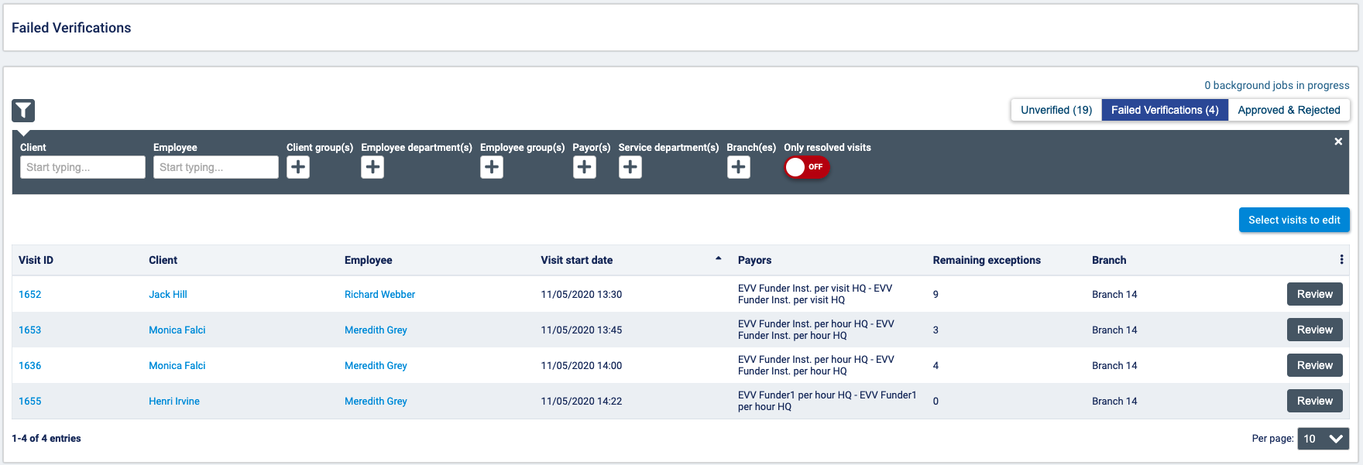
You can filter the list of visits by client/facility, employee, client groups, employee groups, payors, service departments, or branches (multi-office environments only).
Turn the only resolved visits toggle on to filter to visits that still require time approval but for which all exceptions have been resolved.
Select review for the visit you wish to review.
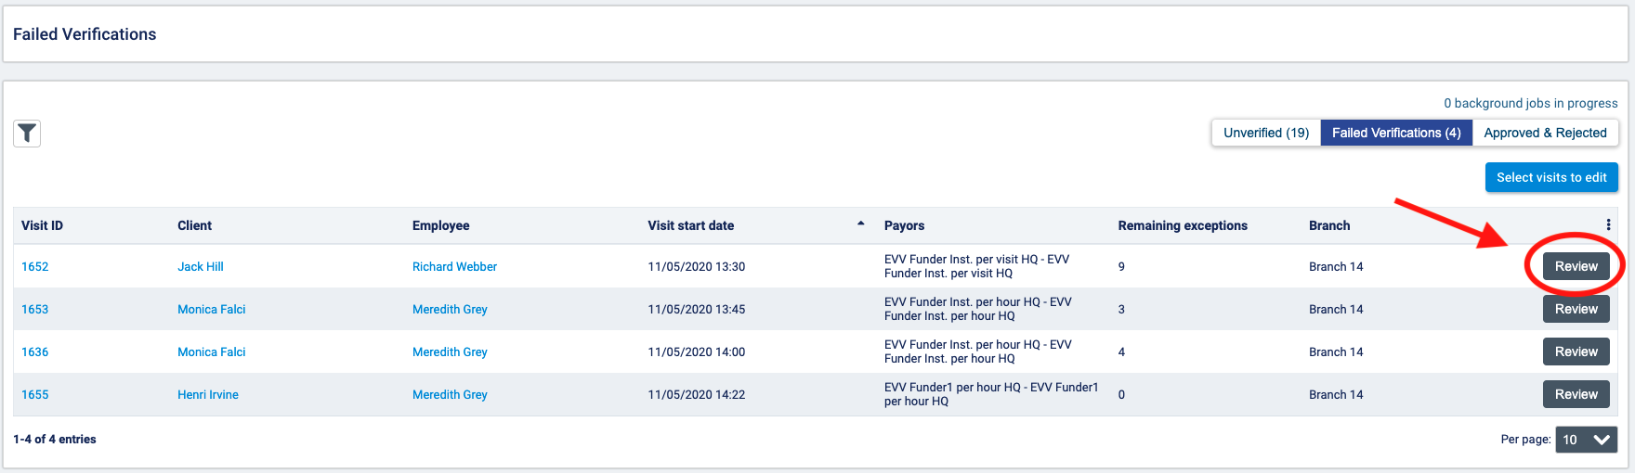
In this screen, you will be able to review visit information, resolve exceptions, and approve bill and pay quantities so you can proceed to generate billing/claims and run payroll.
Basic information about the visit will be displayed at the top of the screen. The client, employee, facility (if applicable), visit ID, service, and address will be displayed under visit information. Under scheduled visit details, you will see the scheduled start date, scheduled start time, scheduled end time, the duration of any scheduled breaks, and the total scheduled duration.
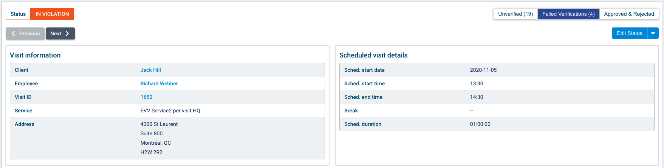
If you have the required permissions, you can edit the status of the visit from in violation to not approved or rejected from the edit status dropdown.
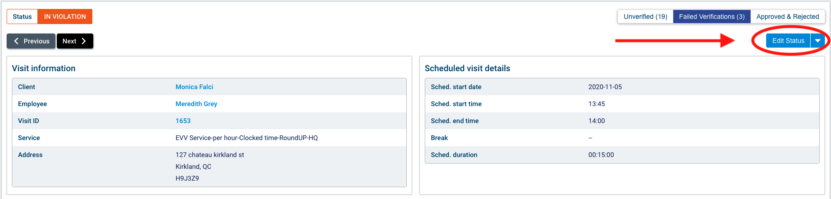
 The following ACLs are required to change the status of a visit to not approved or rejected:
- Accounting>Reset visit to not approved: this ACL is required to be able to set a visit back to not approved status.
- Accounting>Reject visit: this ACL is required to reject a visit.
Note that once you reject a visit, you will not be able to verify it for exceptions again.
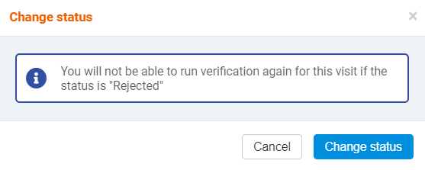
In the work session information section, you will see information about the total duration of the visit based on the clock-in and clock-out times as well as information about the location of the visit.
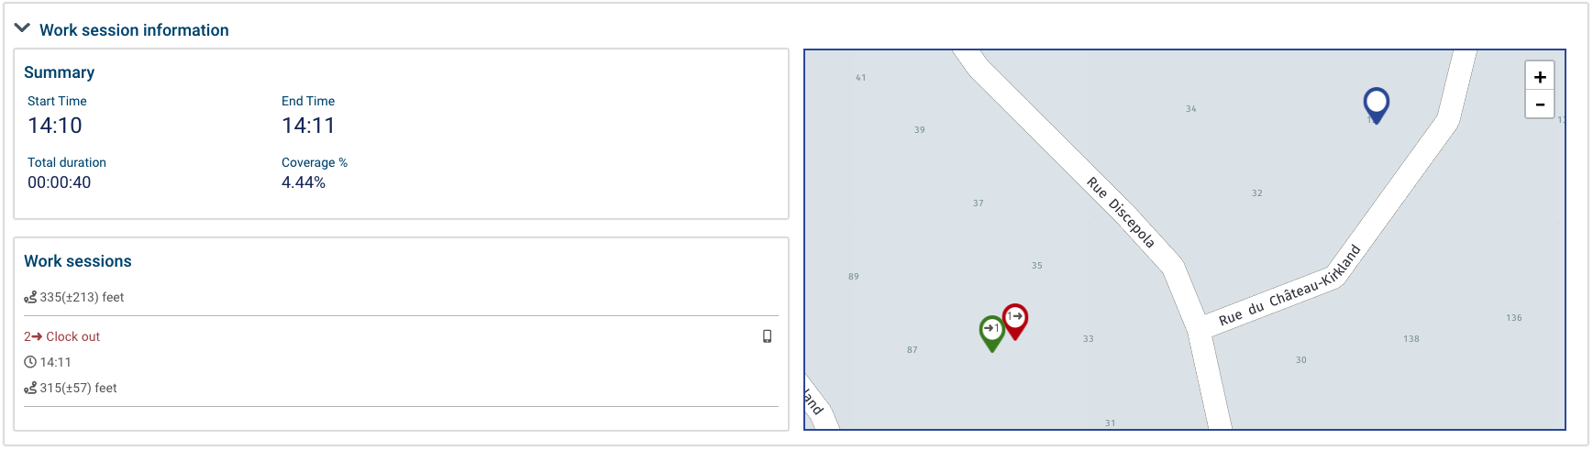
The total duration displays the actual duration of the visit based on the recorded clock-in and clock-out times. The coverage % represents the percentage of the scheduled time that the actual visit lasted (total duration/scheduled duration). Start time represents the first clock-in (if available), while end time represents the last clock-out (if available). A visit with an open work session would not have an end time displayed. Start time and end time value can be respectively adjusted via adjust start time and adjust end time buttons.
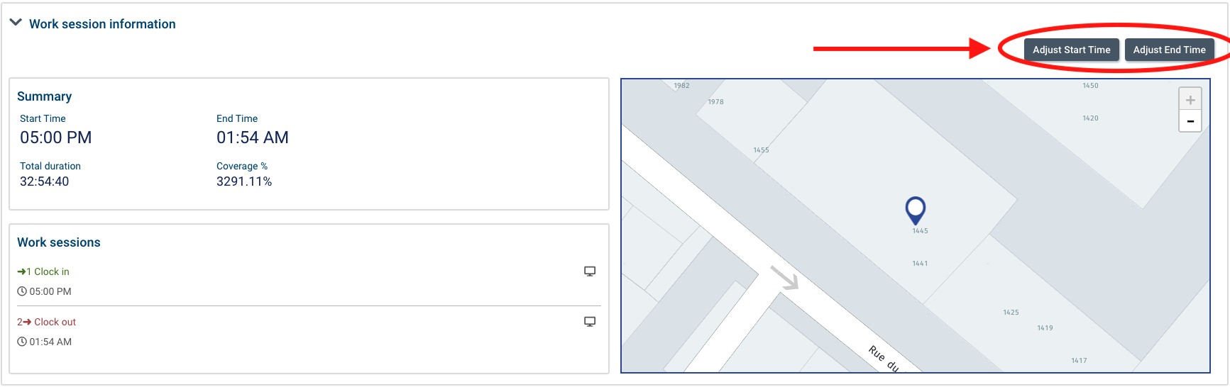

To perform the adjustments, you must have the following permission:
- Scheduling>Override Start Time Actuals
- Scheduling>Override End Time Actuals
- Scheduling>Override Start Time Actuals on a locked visit
- Scheduling>Override End Time Actuals on a locked visit

Once start time or end time value has been adjusted, a visual indicator is shown, to indicate that this value was entered by a user and is not from the work session. They can be reset to the work session values via the reset start time and reset end time buttons shown when a value has been adjusted.

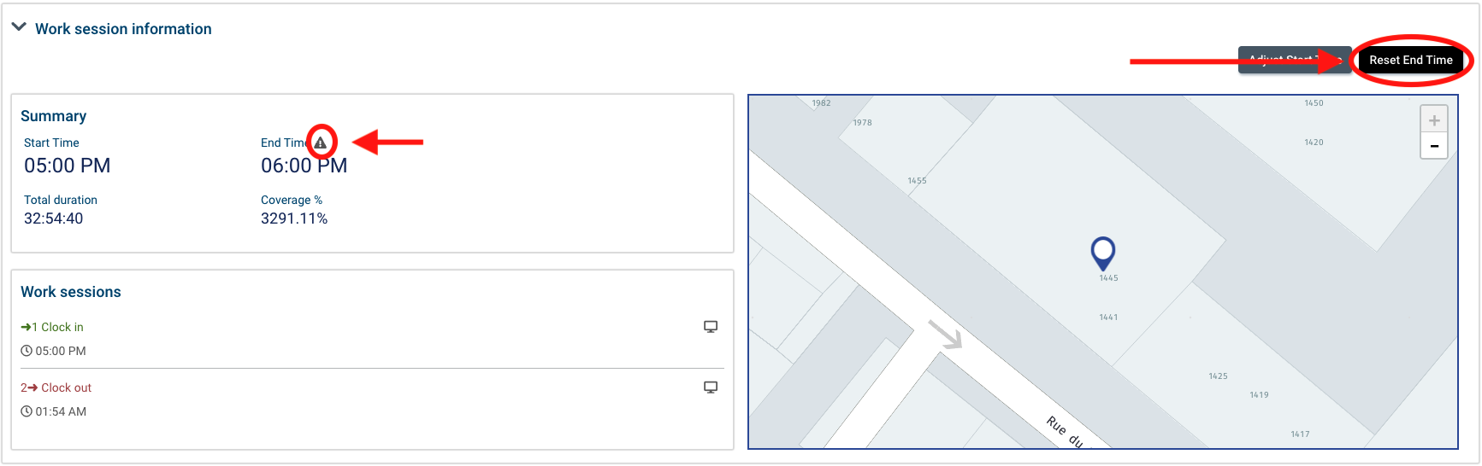

Under work sessions, you will see the times at which the employee clocked in and clocked out of the visit. An icon will indicate whether the clock-in and clock-out occurred via the web application, mobile application, or the interactive voice recognition (IVR) system.
Mobile application:
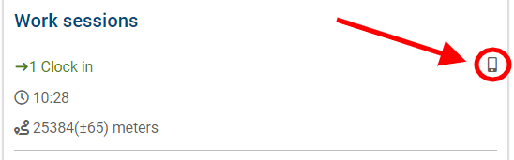
Web application:
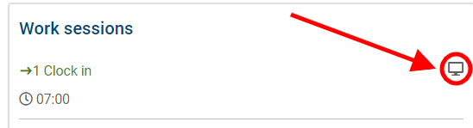
IVR:
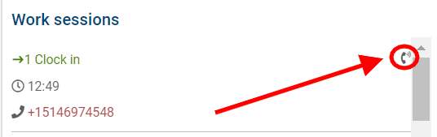

You may need to scroll to see all the information of all work sessions.
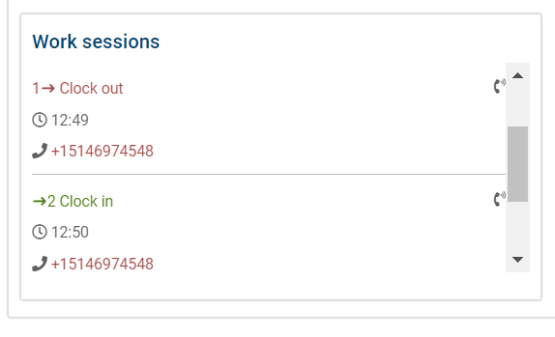
If the clock-in or clock-out occurred from the mobile application, the distance from the client’s address that the clock-in or clock-out occurred will be displayed below the clock-in/clock-out time in the units configured by your organization in settings>system settings> locale>unit of distance.
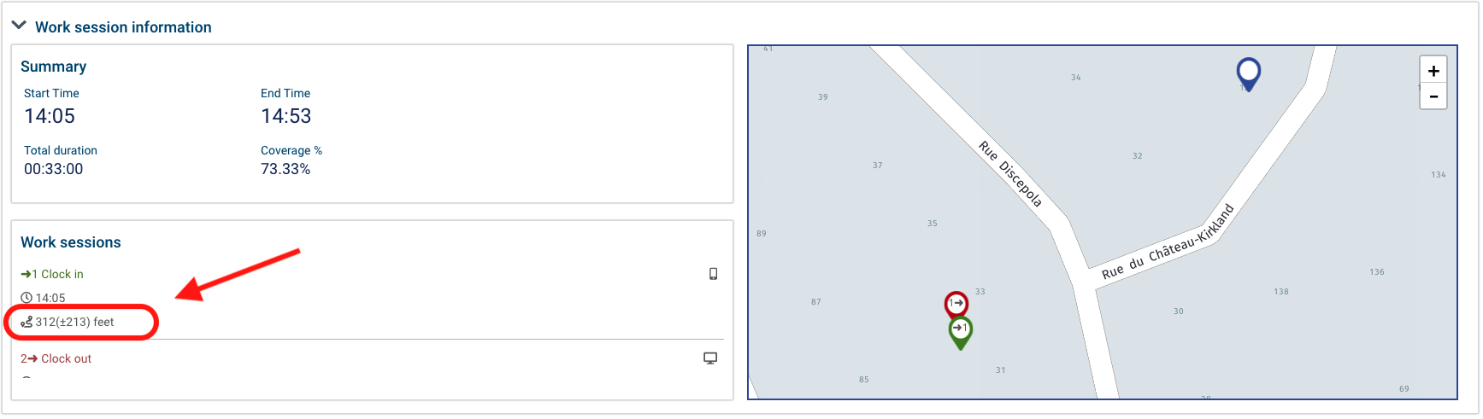
If the clock-in and clock-out occurred via IVR, the phone number that the employee used to clock in or clock out will also be displayed. If the phone number matches the client’s phone number, it will be displayed in green. If the phone number they used does not match the phone number on the client’s profile, it will be displayed in red.
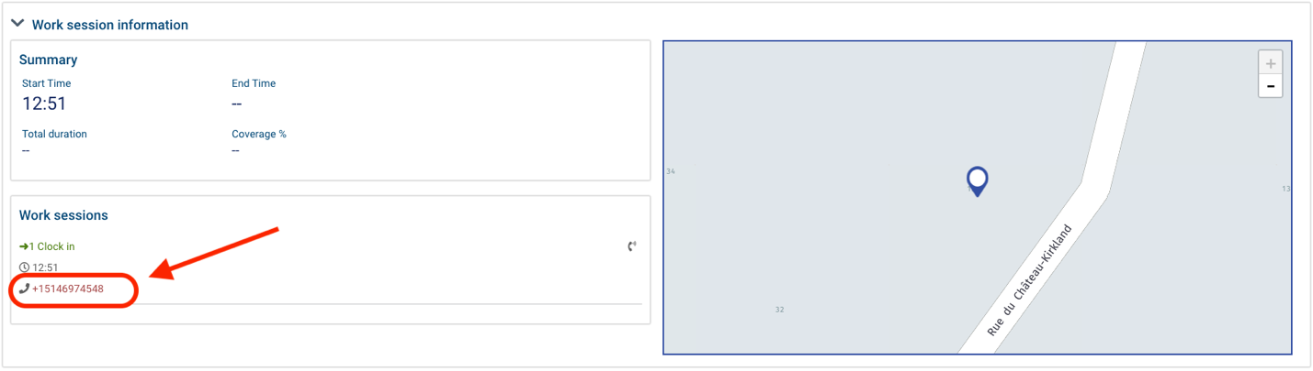
If the employee clocked in or out from the mobile application, the GPS coordinates of the location at which they clocked in (shown in green) and out (shown in red) will be displayed on the map as well as the location at which the visit was scheduled to occur (shown in blue).
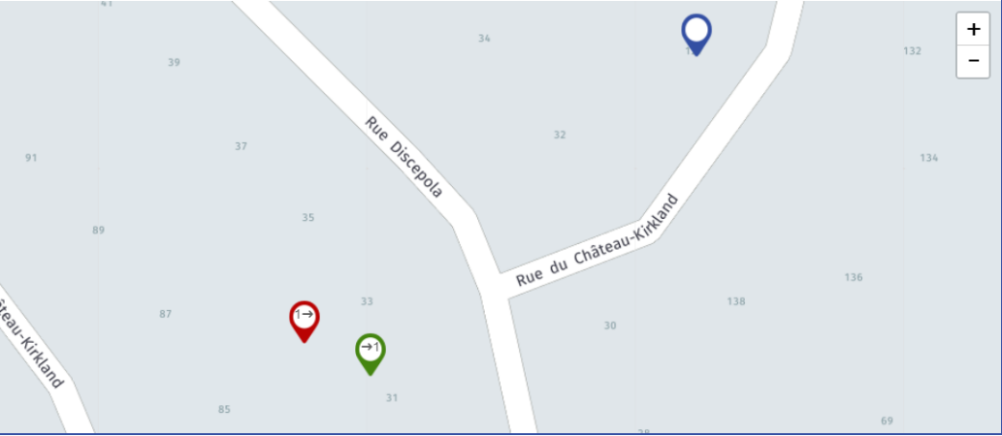
If the employee clocked in and out via the web application or IVR, the clock-in and clock-out coordinates will not be captured, and only the service location will be displayed on the map.
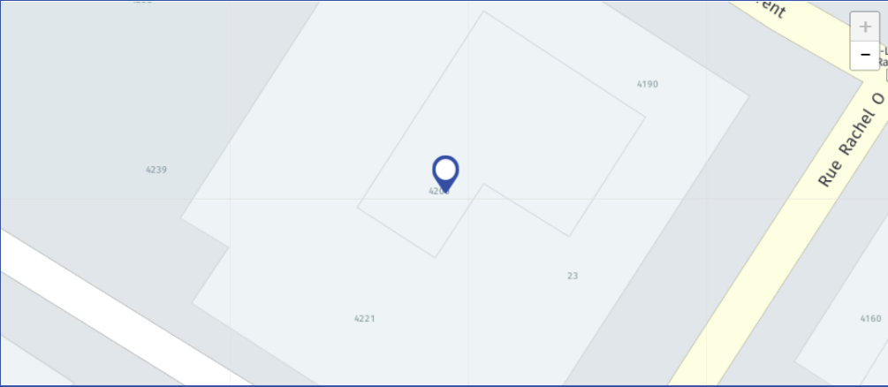
If your organization uses visit notes, click on visit notes section to review any notes written by care providers during the visit before you approve the visit and resolve exceptions.
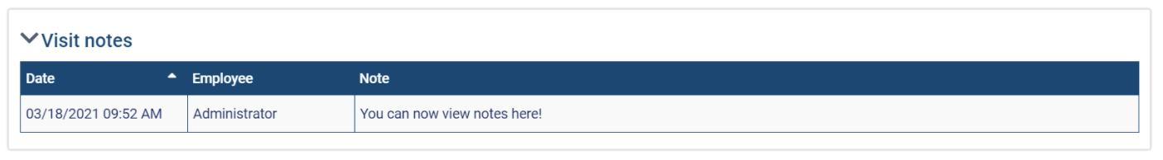
- Note that you must be in a role with the view visit notes ACL to view this section.

The exception list section will display the exceptions to the VV requirements that were identified for the visit. For details about the various exception types, please see the possible rule types section.
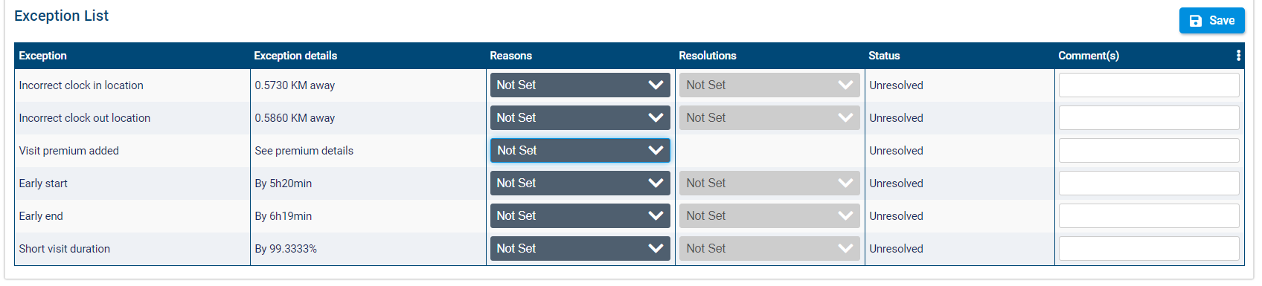
For each exception, you must select from the dropdown in the reasons column to resolve the exception. If you only need to acknowledge the exception to verify the visit, select acknowledge.
If you are required to select a reason and matching resolution, select a reason from the dropdown and then select the corresponding resolution. Note that only resolutions that have an association created in your branch with the reason you selected will be available to select.
If required, enter comments in the comment(s) field.
Click save to save your changes to the exception list.
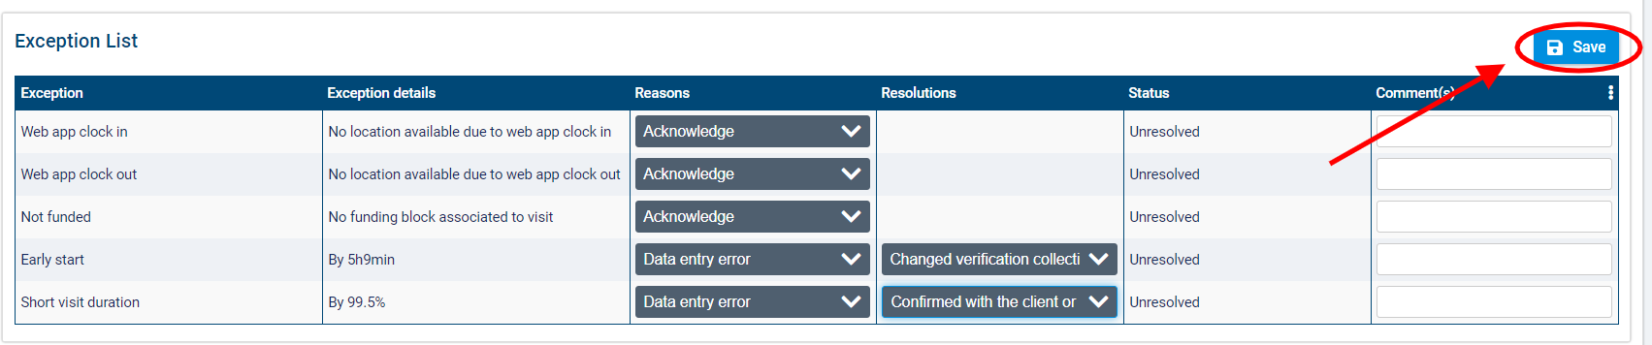
The status of the exceptions will change to resolved.
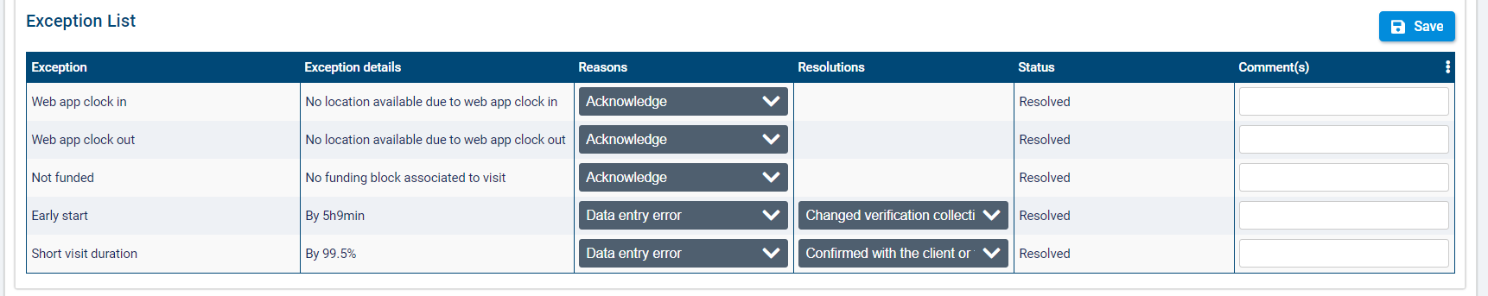
If a comment was not entered for an exception or resolution that requires a comment, you will be prevented from saving and receive the following error:
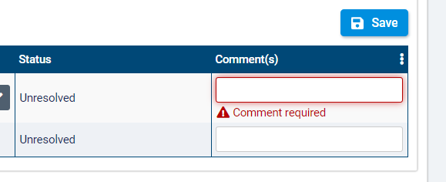

Possible exception types

Depending on the exception lists that your organization has configured, the following exception types may be found during visit verification:
- Incorrect clock-in location: this exception will be raised during the verification process if the distance between the GPS location captured when a care provider clocks in using a mobile device and the address where the visit is scheduled to occur exceeds the permitted distance configured as the threshold for this exception. The exception will also be raised if no GPS location was captured upon clock-in or if no visit location is available. Enter a threshold that equals the maximum distance from the visit address that clock-in should occur. The threshold units will be measured in kilometers (km) or miles (mi) depending on which is configured for your organization in Settings>Locale>Time format. Note that this rule type only considers clock-outs from the mobile application.
- Incorrect clock-out location: this exception will be raised if the distance between the GPS location captured when a care provider clocks out using the mobile device and the address where the visit is scheduled to occur exceeds the permitted distance configured as the threshold for this exception. This exception will also be raised if no GPS location was captured upon clock-out or if no visit location is available. Enter a threshold that equals the maximum distance from the visit address that clock-out should occur. The threshold units will be measured in kilometers (km) or miles (mi) depending on which is configured for your organization in Settings>Locale>Time format. Note that this rule type only considers clock-outs from the mobile application.
- Incorrect home phone number on clock in: this exception will be raised if the Interactive Voice Recognition (IVR) system was used to clock in to a visit, and the phone number used for clocking in did not match the home phone number on the client’s profile. No threshold is required for this rule type.
- Incorrect home phone number on clock out: this exception will be raised if the Interactive Voice Recognition (IVR) system was used to clock out of a visit and the phone number used for clocking out did not match the home phone number on the client’s profile. No threshold is required for this rule type.
- Web app clock in: this exception will be raised if the web application was used to clock in to a visit. No threshold is required for this rule type.
- Web app clock out: this exception will be raised if the web application was used to clock out of a visit. No threshold is required for this rule type.
- Early start: this exception will be raised if a care provider clocks in to a visit earlier than the scheduled start time by more than the permitted number of minutes configured as the threshold. Enter a threshold in minutes that equals the amount of time that clock-in should occur prior to the visit scheduled start time.
- Late start: this exception will be raised if a care provider clocks into a visit later than the scheduled start time by more than the permitted number of minutes configured as the threshold. Enter a threshold in minutes that equals the maximum amount of time that clock-in should occur after the visit scheduled start time.
- Incorrect visit date: this exception will be raised if the date that a care provider clocked in to a visit does not match the scheduled start date of the visit. No threshold is required for this rule type.
- Early end: this exception will be raised if a care provider clocks out of a visit earlier than the scheduled end time by more than the permitted number of minutes configured as the threshold. Enter a threshold in minutes that equals the maximum amount of time that clock-out should occur prior to the visit’s scheduled end time.
- Late end: this exception will be raised if a care provider clocks out of a visit later than the scheduled end time by more than the permitted number of minutes configured as the threshold. Enter a threshold in minutes that equals the maximum amount of time that clock-out should occur after the visit’s scheduled end time.
- No clock out: this exception will be raised if a care provider did not clock out of a visit the same number of times that they clock in to a scheduled visit. No threshold is required for this rule type.
- Short visit duration: this exception will be raised if the clocked duration of the visit was shorter than the scheduled duration by more than the permitted percentage of the total duration or number of minutes configured as the threshold. You can enter a threshold as a percentage of the total scheduled duration or in minutes where the threshold equals the maximum amount of time under the scheduled duration that a visit can be without raising an exception.
- Long visit duration: this exception will be raised if the clocked duration of the visit was longer than the scheduled duration by more than the permitted percentage of the total duration or number of minutes configured as the threshold. You can choose to enter a threshold either as a percentage of the total scheduled duration or in minutes where the threshold equals the maximum amount of time above the scheduled duration that a visit can be without raising an exception.
- No work session: this exception type will be raised if there are no work sessions (clock-ins and clock-outs) for a visit. No threshold is required for this rule type.
- Multiple work sessions: this exception type will be raised if there is more than one work session for a visit. No threshold is required for this rule type.
- Incorrect employee: this exception type will be raised if the employee who clocked in or out of a visit is not the employee assigned to the visit.
- Service tasks not completed: this exception type will be raised if all required interventions (care plan 2.0) or all daily activities/ADLs (care plan 1.0) were not completed for the visit. No threshold is required for this rule type.
- Visit premium added: this exception type will be raised if there is a visit premium added to the visit. No threshold is required for this rule type.
- Not funded: this exception type will be raised if there is no funding configured for a visit according to the funding block logic for the service. No threshold is required for this rule type.
- Visit cancelled: this exception type will be raised if a visit has a cancelled code applied to it. If an exception of this type is raised, the system will not check for other exception types. No threshold is required for this rule type.
- Visit forms attached: this exception type will be raised if any forms are attached to the visit at the visit or service level. No threshold is required for this rule type.

Approving visits for billing and payroll

Once all exceptions on the visit have been resolved, you can approve the bill and pay quantities for the visit so you can include the visit when running billing and payroll. This requires the following ACLs:
- Accounting>Override bill quantity: required to edit the bill quantity on a visit before it is approved.
- Accounting>Override pay quantity: required to edit the pay quantity on a visit before it is approved.
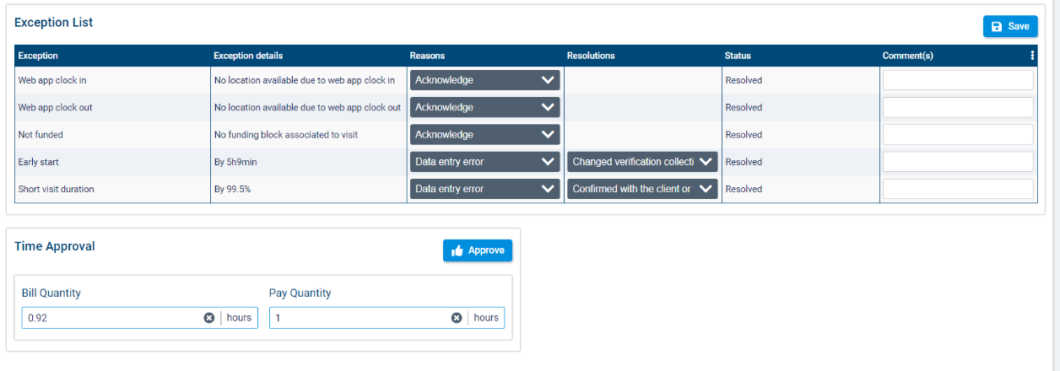
Adjust the bill and pay quantities for the visit if necessary. When you are ready, click approve.
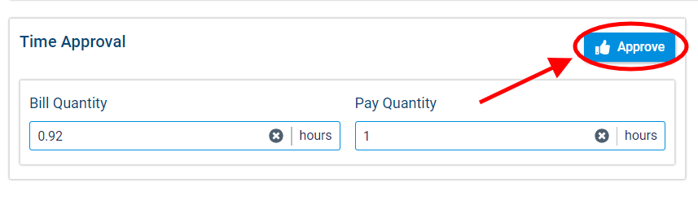
Once you click approve, the visit’s status will be changed to approved.
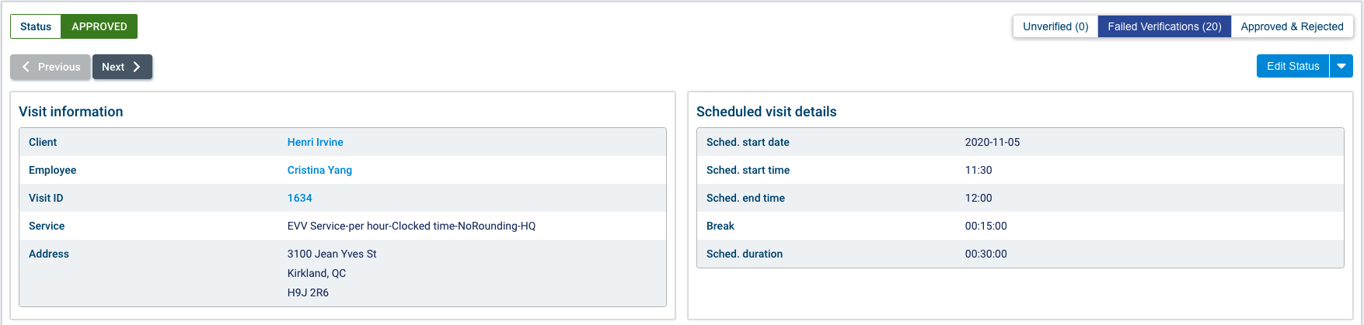
To review the next visit in the failed verifications list, click next.
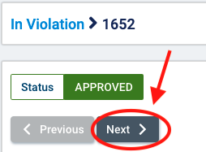

VV and visit locking
A visit gets locked when its status changes to approved or rejected. The visit will become unlocked again if its status is changed to not approved.
Note that this locking applies the reject all batch action on the vacant visits page, but only for visits where funder type is electronic billing payor.

Reviewing approved and rejected visits

To review visits that have already been approved or rejected, select the approved and rejected visits tab.
Approved and rejected visits will be listed by visit ID, client, employee, visit start date, associated payors, visit status, billable quantity, payable quantity, and branch (for multi-office environments). By default the list will be filtered to approved visits for the last week.
You can filter the list of visits by client, client group(s), employee, employee group(s), employee department(s), payor(s), service departments(s), branch(es) (multi-office environments only), status (approved or rejected), and to/from dates.
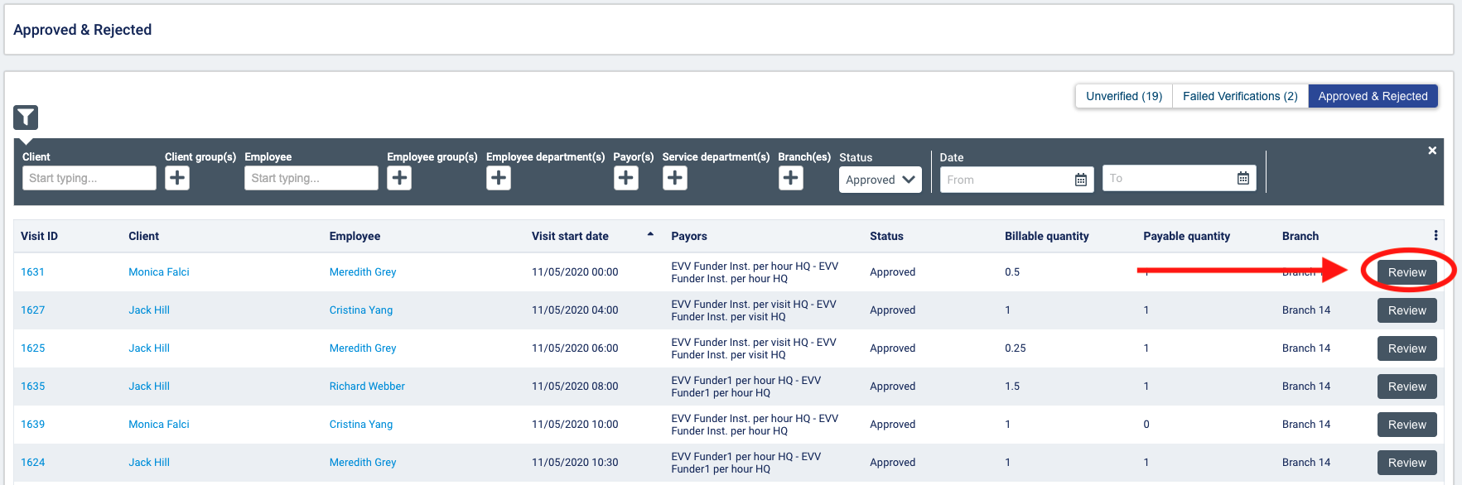
Select review to view the visit details.
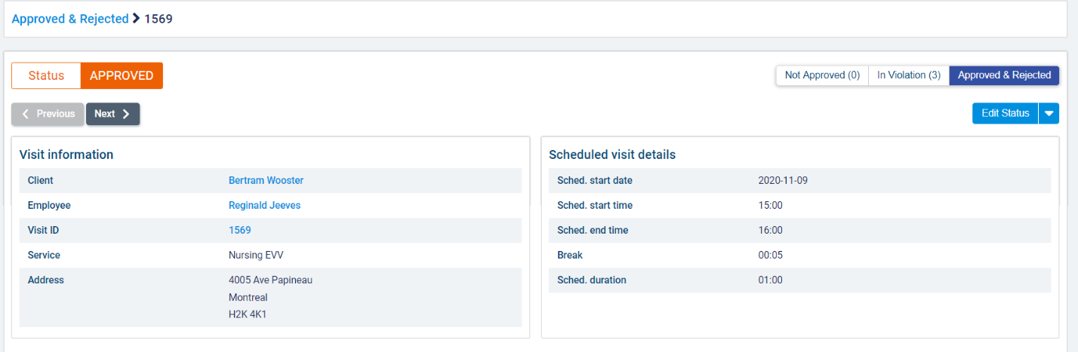
You can manually change the status of an approved visit to rejected or not approved. You can also set a rejected visit back to not approved status.
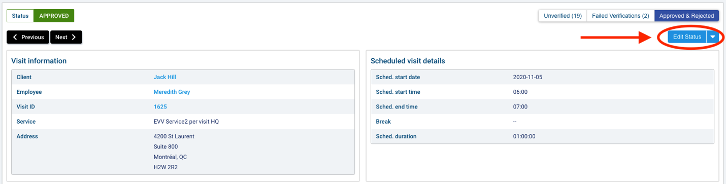
Edit the selected reasons and resolutions for the exceptions within the approved visit's exception list. Click save to save your changes.
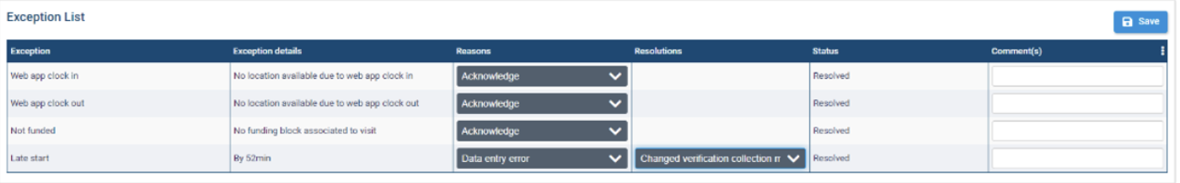
If you wish to override approved bill and pay quantities, adjust the values in the bill quantity or pay quantity field and then select override in the time approval section. Note that you must have the required permissions to override bill and pay quantities for an approved visit:
- Accounting>Override bill quantity on locked visit: required to edit the bill quantity on an approved visit.
- Accounting>Override pay quantity on locked visit: required to edit the pay quantity on an approved visit.
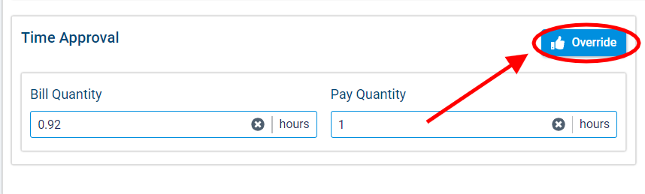
You will not be able to edit the exception list or time approval sections on a rejected visit.

